PROXEMICS

Let’s consider the layout for a typical meeting or group discussion (see Figure 11.xxx below).
Figure 11.xxx Proxemics: Seating Arrangements and Interpretations
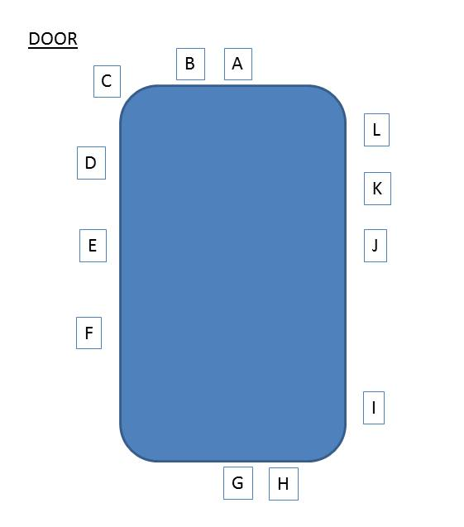

The best way to examine these is to ask certain questions. Assume for a moment that the leader of the discussion is sitting in position [A].
- The person sitting in which position(s) is least likely to get the chance to say anything? Why?
- Where is the person with the most aggressive view likely to sit, and where will the person who will likely be most supportive probably sit?
- The person sitting in which position(s) is most likely to get the chance to say anything?
- What role(s) is the person sitting in [B] likely to have? To take notes? To make contributions? To support the leader? No role at all?
- If the leader of the meeting arrives before anyone else and sits in [G], what message might that send to others entering the room? Might that change the kind of atmosphere in the room?
To emphasise how important proxemics might be, we could suggest that if the leader sat in location [E] or [J] we might find that there is less conflict between the leader and others, simply because of the physical distance (which usually has a similarity with the emotional distance).

