Teachers ‘communicating’ and ‘collaborating’ …

Overview
This is an interesting activity to do with colleagues. I have done this activity with both small and large groups of teachers and students. (Older children are also quite capable of successfully completing this activity.)

It allows those taking part to think about the need to communicate effectively in team situations. It also allows them to think about how and why teams sometimes fail to function effectively – perhaps discuss with the team Tuckman’s ideas about groups.
Activity

Step 1
Ensure that each small group working on the activity has no more than 5 people
Step 2
Provide the groups with the resources necessary to complete the task
Resources (see Image 1):
- Each group is to be provided with 4 pieces of wood measuring 20 x 200 x 3 mm – these are the ‘planks’ referred to in the Activity Information Sheet
- Each group is to be provided with 4 round pieces of wood measuring 40 mm in diameter and 15 mm high – these are the ‘barrels’ referred to in the Activity Information Sheet
- Each group is to be provided with the Activity Information Sheet
Step 3
Give the groups 15 minutes to undertake the task. Explain to the group(s) that there will be little further input – part of the challenge of this activity is for each group to work out how it wants to proceed
Step 4
If groups are struggling to complete the activity, you may want to consider giving them some clues as to how to approach it – i.e. provide them with a diagram that shows part of the solution (see Diagram 1)
Step 5
At the conclusion of the activity (which is often, but not always, when one group successfully completes the structure – see Images 2 and 3), provide each person with a solution diagram (see Diagram 2)
Step 6
Talk through the activity with the participants. This discussion sometimes needs to be approached cautiously because of the possibility of some people being insensitive to other group members, i.e. they criticise others’ efforts, aptitudes, etc. Ask people if they could perceive in their group Tuckman’s Forming – Storming – Norming – Performing

Image 1
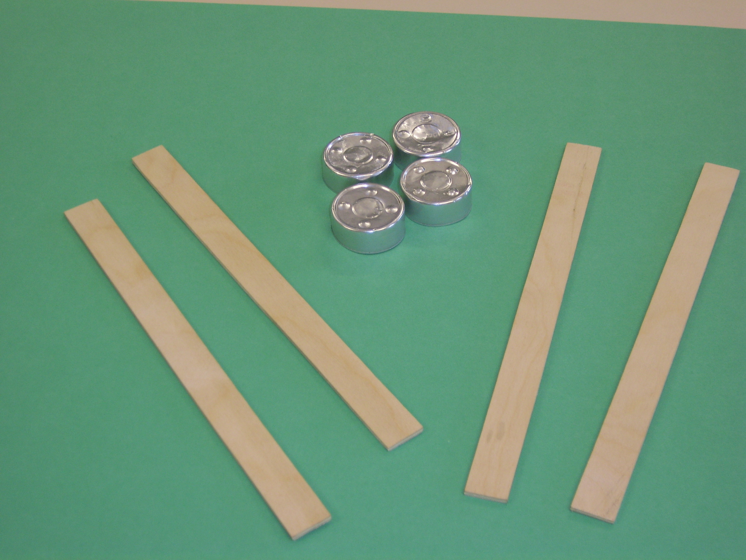
Please note that in this picture, the 4 ‘barrels’ are the outer cases of ‘night-lights’ – these are ideal ‘barrels’. However, it may be easier for you to obtain four pieces of wood or to use 4 cotton reels

Activity Information Sheet

Objective
To support an ‘object’ at least 2 cm above the table top

Limitations
- Only the ‘barrels’ and ‘planks’ supplied can be used
- Only the ‘barrels’ are allowed to rest on the table
- The distance between the ‘barrels’ is to be greater than the length of a ‘plank’, i.e. a plank cannot rest on 2 barrels
- The ‘object’ must be supported by the ‘planks’
- All ‘barrels’ and ‘planks’ must be used
- A ‘barrel’ may not be placed directly underneath the ‘object’

Images and diagrams …
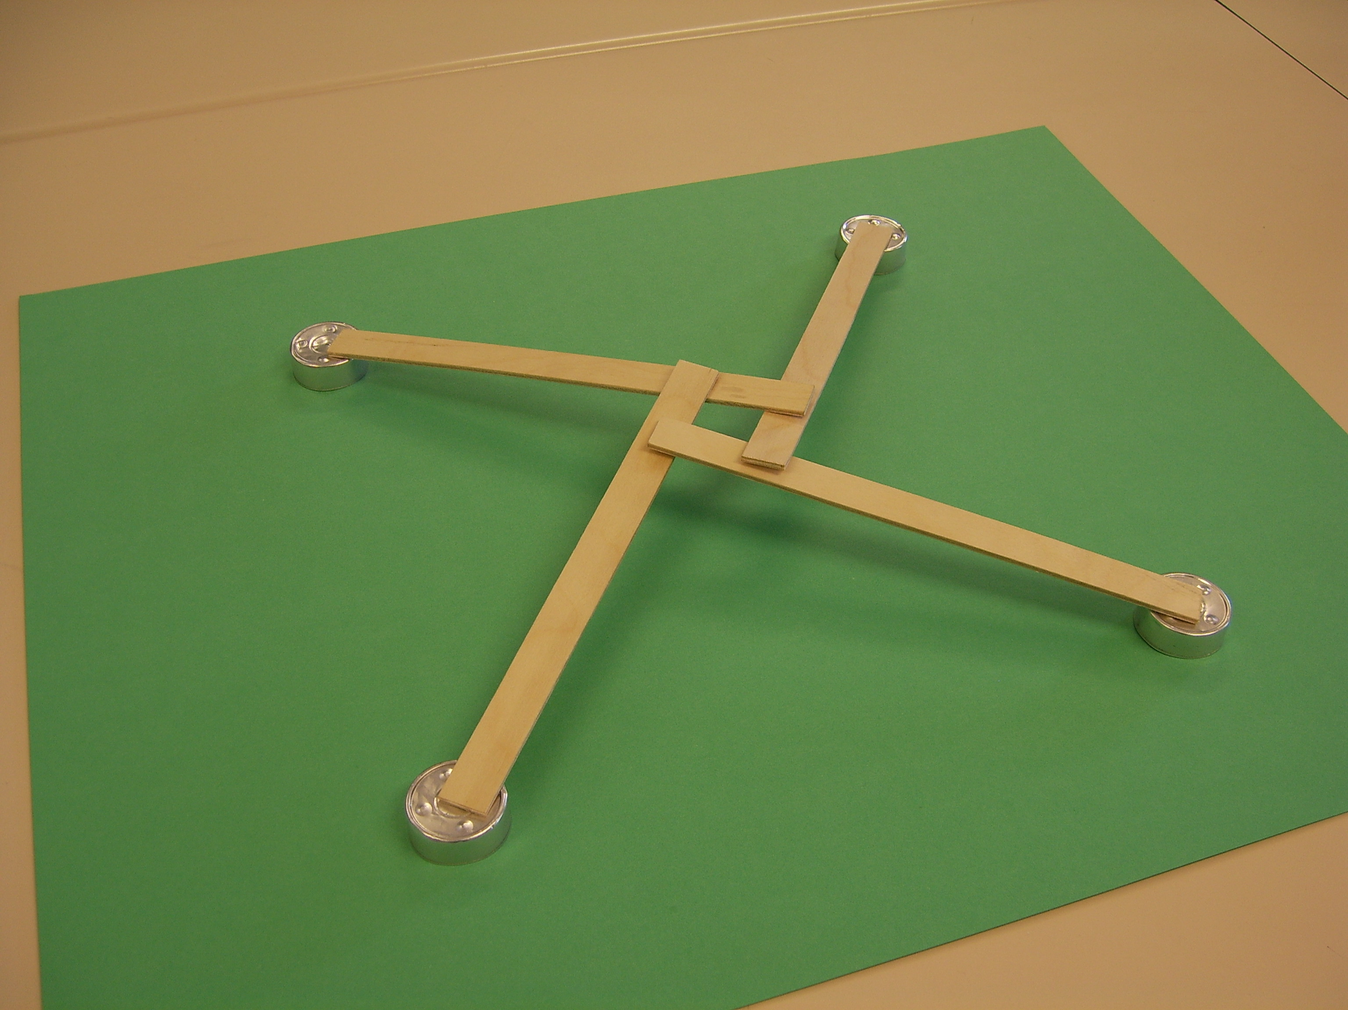
Image 2

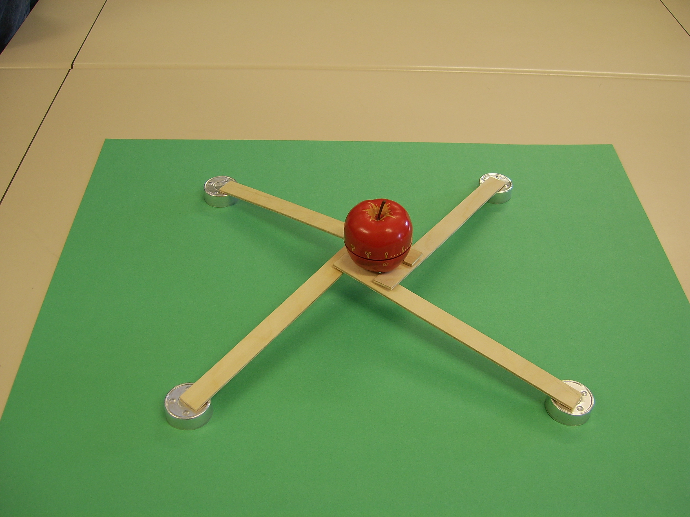
Diagram 2
Diagram 1
Image 3

