Situational Analysis Exemplar: Carrie Friese’s Project
  - A Situational Analysis of the Cloning of Endangered Species

Introductory Note: This exemplar of using situational analysis in a science and technology studies project was initially developed for inclusion in the second edition. After serious consideration, we decided that it was not adequately accessible for those not in this specialty. While scientific expertise is not requisite to understand it, this is a complex exemplar.
This exemplar includes a project map from Carrie Friese’s pilot project (discussed in the first edition of Situational Analysis [Clarke, 2005, pp. 139–140]). Friese’s pilot project is presented prior to the full discussion of the exemplar project on cloning of endangered species, which was based in part on that pilot study. A list of Friese’s publications from her cloning of endangered species project is at the end of this file.

FRIESE’S PROJECTS: LIST OF FIGURES
Figure 1: Friese’s Pilot Project Map: Reporting on Cloning—Journalists’ Perceptions About Relationships Among Science, Media, and Publics
Figure 2: Friese’s Messy Situational Map of Gaur and Banteng Cloning
Figure 3: Friese’s Ordered Situational Map of Gaur and Banteng Cloning
Figure 4: Friese’s Relational Map of the Gaur Cloning Situation
Figure 5: Friese’s Relational Map of the Banteng Cloning Situation
Figure 6: Friese’s Social Worlds/Arenas Map of Cloning Endangered Species
Figure 7: Friese’s Positional Map: Focus on Classification of Cloned Animals Created Through Interspecies Nuclear Transfer

CARRIE FRIESE’S PILOT PROJECT:
[Excerpted from 1st edition of Situational Analysis (Clarke, 2005, pp. 139–140)]
Carrie Friese, (then) a doctoral sociology student at UCSF, was interested in journalistic/print media discourses about cloning and new reproductive technologies and their production. Her initial project was a content analysis of articles on sex preselection in major American newspapers from circa 2000 to 2004. She also initiated an interview-based study of journalists who had produced in-depth articles on cloning, the focus here. She asked questions about the public understanding of science, the work of the print media in producing such understanding, and the conditions of work and production inside the media that may shape print media discourses on reproductive technologies. For example, does the fact that many newspapers now routinely run advertisements for infertility clinics affect reporting on cloning and stem cells? What are the consequences of the organization of science writers into different departments (business, science/medicine) in newspaper organizations? What are the consequences of the training sessions for science journalists on the latest science (offered by universities, medical schools, and industry, often in collaboration) in terms of producing ideoscapes (Appadurai, 1996) about reproductive technologies?
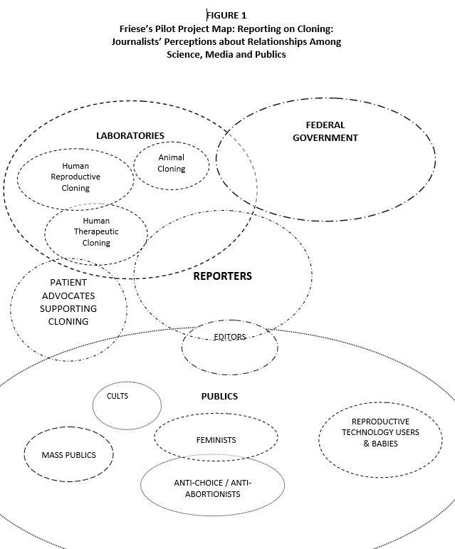

Figure 1: Friese’s Pilot Project Map: Reporting on Cloning—Journalists’ Perceptions About Relationships Among Science, Media, and Publics

Please look at Figure 1, “Friese’s Pilot Project Map: Reporting on Cloning—Journalists’ Perceptions About Relationships Among Science, Media, and Publics.” The reporters she interviewed essentially mapped their own positions as “in the middle,” somewhere between science with its deep governmental linkages and many different publics. They discussed “translating” science to the people—and also discussed how they had to translate it quite similarly to their editors in order to get their articles in print! This is an effective project map that nicely captures how the reporters saw the discursive worlds in which they dwelled.

INTRODUCTION TO FRIESE’S CLONING OF ENDANGERED SPECIES PROJECT
by Carrie Friese
I began this research by asking a number of questions regarding the uptake of nuclear transfer to clone animals of endangered species. What kinds of practices and discourses are involved in cloning such animals? How are relationships being forged between different sites, institutions, and scientific and other communities in order to enact these projects? What kinds of contestations are underway over this particular utilization of the nuclear transfer technology? How are varying understandings of and interests in cloning endangered animals negotiated across social worlds? What kinds of meanings, practices, and logics are being forged and/or reworked in taking up nuclear transfer with these animals? How is cloning constitutive of various humans, nonhumans, and human–animal relations? In addressing these questions, I interviewed people directly involved or implicated in the practice of cloning animals of endangered species. I also analyzed how this practice has been discussed in the popular media, scientific journals, position statements of organizations, and on websites. I used situational analysis and grounded theory in designing this project, conducting research, and analyzing data. Here, I discuss my use of situational, relational, social worlds/arenas, and position maps.

FRIESE’S SITUATIONAL AND RELATIONAL MAPS
Throughout the research process, I used situational and relational maps to develop an understanding of the varying situations in which animals of endangered species are cloned and to consider the relationships between these situations. Working with these maps was an iterative process; the maps continued to change and develop as my research moved along. I focus here on the situational and relational maps I created to understand two interrelated situations in which nuclear transfer was used to clone endangered animals.
There were other situations in my research that could have been used as exemplars, and there are other stories that could have been told about the situations that will be discussed. I tell this particular story because it shows how I came to appreciate the complexities of a particular situation through the analytic work of making and comparing messy, ordered, and relational situational maps.
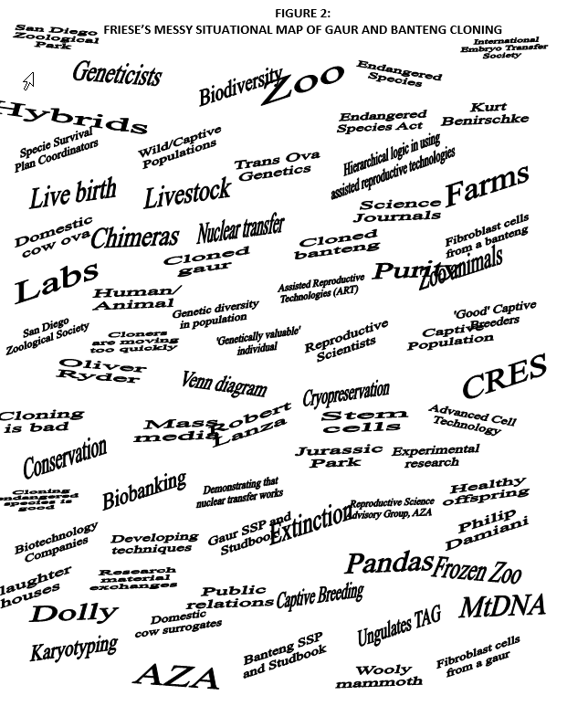

Figure 2: Friese’s Messy Situational Map of Gaur and Banteng Cloning

Figure 2 is my “messy map” of the endeavors to clone a gaur and a banteng. Both the gaur and banteng are endangered or threatened species of cattle that originate in Southeast Asia. In the messy map, I laid out all of the elements involved in these cloning projects. I positioned the projects together in the situation because these two undertakings occurred consecutively and, generally speaking, involved the same organizations. The initial project to clone a gaur was an integral part of the situation in which cloning the banteng was done. In this particular messy map, I used all data sources to list the elements involved. I actually included these data sources in the messy map in order to reflect upon their role in the situation itself.
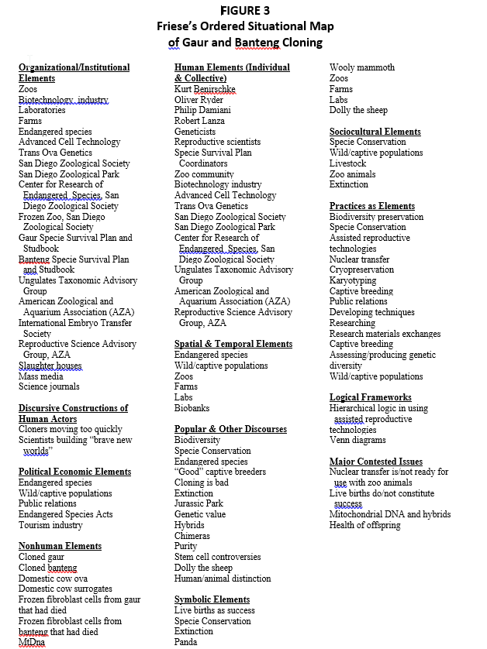
Figure 3: Friese’s Ordered Situational Map of Gaur and Banteng Cloning

Figure 3 shows the organization of the messy map into a neat map, where each element was defined. Many of the definitions used to categorize the elements were taken from Clarke (2005) while some were added because of their importance in this particular project. Notice that many elements are multiply defined. Endangered species are positioned as organizational/institutional elements because they now represent the institutionalization of certain practices. Endangered species are also positioned as symbolic elements. Just think of the kinds of emotional capital that the panda bear holds!
A gaur was the first cloned animal of an endangered species. The project to clone a gaur was enacted through agreements made between Kurt Benirschke, the then-president of the Zoological Society of San Diego, with Robert Lanza and Philip Damiani of Advanced Cell Technology (ACT), a well-known biotechnology company based in Massachusetts. Kurt Benirschke became involved in the project because he believed that cloning may be an important tool for creating genetic diversity among captive animal populations of endangered species and thereby sustaining endangered populations. In addition, he believed that using assisted reproductive technologies with endangered species could produce basic knowledge about the reproductive physiologies of animals that are generally under or not-at-all studied. ACT became involved in this project for public relations purposes and to prove the possible principle of interspecies nuclear transfer. Cloning animals of endangered species has largely been configured as a good application of this problematic technique in the popular press. By cloning an endangered animal, the company sought to improve public perceptions of cloning.
The project to clone the gaur was considered experimental research and was enacted somewhat informally through networks of professional friendship. Kurt Benirschke asked the Frozen Zoo at the Center for Research of Endangered Species (at the Zoological Society of San Diego) to send frozen cells taken from a gaur to ACT. Scientists at ACT then did the nuclear transfer procedure using nuclei taken from the gaur somatic cells and enucleated eggs from domestic cows. The resulting embryos were then sent to Trans Ova Genetics where they were implanted into domestic cow surrogates. One gaur was eventually birthed but died two days later. As is common in the biotechnology industry, exchange relations between these individual and organizational actors were short term and lasted for the duration of this project alone.
After the death of the gaur, broader questions arose in the Zoological Society of San Diego as to whether or not another cloning project should be pursued. More formal discussions and debates were conducted regarding the use of nuclear transfer and included a larger number of individuals and perspectives. People questioned whether the organization should be involved in another attempt at cloning, if a gaur should be cloned, and if the collaboration should again be forged with ACT. In light of these discussions, the Board of the Zoological Society of San Diego decided that nuclear transfer should again be attempted with ACT and Trans Ova Genetics but that the technique should be used to clone a banteng instead of a gaur. Similar exchanges in materials resulted, and two bantengs were born. Sadly, one banteng was born with enlarged-calf syndrome, weighing twice what a normal banteng should, and was euthanized. The other banteng is still alive and is currently on display at the San Diego Zoological Park.
The successful birth of a surviving offspring brought another set of organizational actors into the situation of cloning endangered animals: organizations responsible for managing the reproduction of zoo species to ensure that the captive population remains “viable” or genetically diverse. These organizations are Species Survival Plans (SSP). Following consultation with involved scientists, the SSP decided to include the cloned banteng in the managed population to see if he is capable of reproducing healthy offspring. For this group, the question of whether or not nuclear transfer can be a tool for conservation will begin to be addressed if and when the cloned banteng reproduces.
In mapping the situations in which the gaur and banteng were cloned, important distinctions became readily visible. I had originally mapped these two endeavors together because the same organizations were present, and the gaur project provided the basis for cloning the banteng. However, the analytic process itself indicated that the organizational elements were involved differently when the two projects were compared. Whereas the project to clone a gaur was informally initiated by individuals, the Zoological Society of San Diego itself initiated the project to clone the banteng. Whereas the decision to clone a gaur was made by only a few individuals, the decision to clone a banteng was brought about through broader organizational efforts.
Given these differences, I asked, What would happen analytically if I explored the situation to clone the gaur and the banteng as both interrelated and distinct? To do so, I then used relational maps in order to better understand the relationships and discontinuities in the gaur and banteng situations. By comparing the relations between the elements in the endeavors to clone the gaur and the banteng, I was able to better understand the situations per se. Through this “thick analysis” (Fosket, 2015), I came to better understand the social processes that work to make cloning meaningful in very particular and local ways.
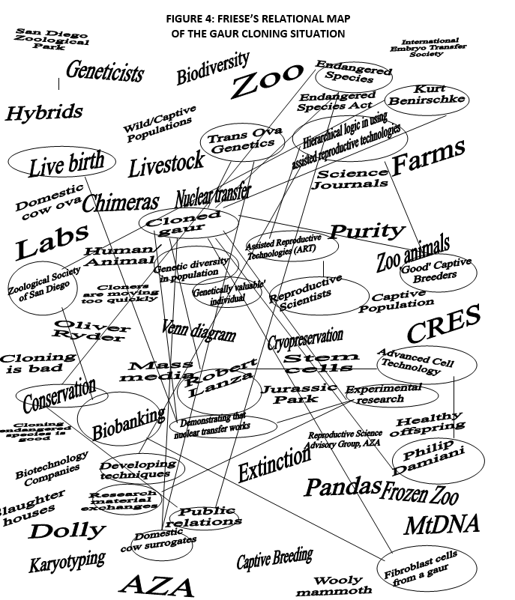

Figure 4: Friese’s Relational Map of the Gaur Cloning Situation

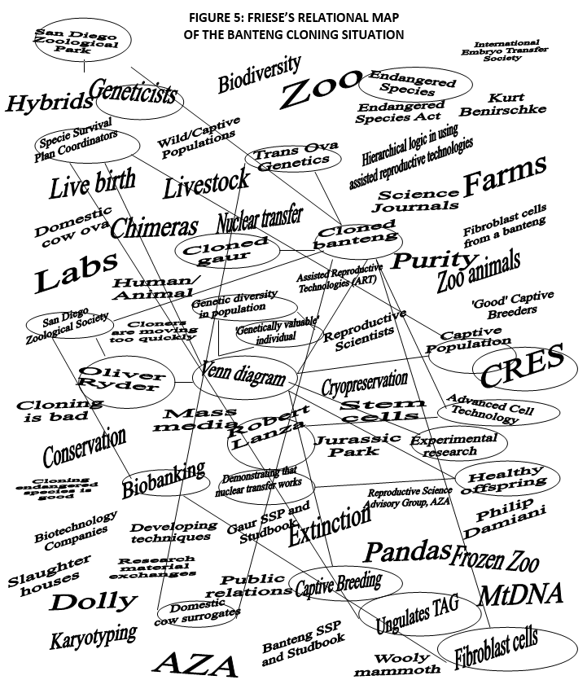

Figure 5: Friese’s Relational Map of the Banteng Cloning Situation

Figures 4 and 5 show my relational maps for the gaur and the banteng cloning projects respectively. One important difference in the relationships between the elements in these two situations is the varying logical frameworks used to address the question of what individual and from which species should be cloned. While the gaur project used a logic of hierarchy in technology development, the decision to clone a banteng was made through the use of a Venn diagram. These different logics for decision-making are situated in different social worlds. In turn, the gaur and the banteng stories illustrate the extent to which the meanings of cloning animals of endangered species are still being negotiated among the different worlds.
The gaur was originally chosen as the “right” species to clone because there were previous successes in using interspecies embryo transfer in which gaur embryos were implanted into domestic cows as surrogates. The logic that undergirds this decision was connected with the notion of a hierarchy of assisted reproductive technologies, ranging from least to most invasive. This logic is frequently used in the reproductive sciences when discussing issues related to the applicability of techniques. In general, the hierarchy assumes that artificial insemination is the least complicated, most useful, and most likely to be successful. In vivo and in vitro fertilization and embryo transfer are all more complicated and less often successful/useful while nuclear transfer is the most complicated and least successful/useful technique. Following this logic, it is often argued that techniques should be pursued in a hierarchical progression within a particular species, moving gradually up the ladder from least to most complicated, going only one rung at a time. Because of the previous success in using interspecies embryo transfer with the gaur, it was decided that the gaur was the best animal of an endangered species to try to clone.
Following the birth and death of the cloned gaur, there were several criticisms regarding both the use of this species and of the individual organism cloned. In terms of the population, it was argued that the gaur is easily bred in captivity, and nuclear transfer is unnecessary. In terms of the cloned individual, it was argued that this genome was already well represented in the captive population. Through both of these critiques, some people within and beyond the Zoological Society of San Diego contended that simply cloning an animal of an endangered species does not constitute a project in conservation. It was also argued that nuclear transfer should not be used with animals of endangered species simply because it is possible. Rather, critics asserted that for it to be a tool of conservation, cloning would need to be used to manage gene pools efficiently.
In the midst of debates within the Zoological Society of San Diego regarding whether or not cloning should once again be attempted, the head of the Genetics Division at the Center for Research on Endangered Species, Oliver Ryder, was asked to write a white paper on the topic—a paper engaging the potential use of nuclear transfer in light of the society’s policies. In this white paper, Ryder replaced the hierarchical logic in making reproductive decisions with a Venn diagram. The first factor in the Venn diagram was the available technologies. Ryder defined these broadly to include knowledge about the reproductive biology of the particular species, the availability of surrogate ova, the availability of gestational surrogates, knowledge about neonatal husbandry, and the ability of zoo staff to successfully maintain the resulting animal. The second factor was the existence of a gene pool management program for the species, specifically a Species Survival Plan that manages captive breeding. The third factor was the availability of saved fibroblast cells, something that the Zoological Society of San Diego has specialized in since the 1970s through its “Frozen Zoo.”
Using these three factors, Ryder created a Venn diagram made up of three overlapping circles that limited the scope of potential cloning to the small space where all the factors intersected. Based on this diagram, it was then decided that the gaur was not the best animal to clone. Rather, a genetically underrepresented banteng, who had died in puberty before reproducing, was chosen. Significantly, through applying the Venn diagram, Ryder rationalized cloning to make it a potential tool of species preservation that is premised upon managing genetic diversity and also incorporating the corresponding organizations and practices that were already capably conducting this work with captive populations. Some scientists I interviewed believe that the use of this Venn diagram was instrumental in convincing the ungulates Taxonomic Advisory Group to incorporate the cloned banteng into its captive breeding program on an experimental basis.
In comparing the relational maps of the gaur and banteng projects in Figures 4 and 5, we see that the differing logics that informed decision-making in each instance are situated in different kinds of institutional and organizational commitments to action. The hierarchical logic is associated with commitments to developing new technologies and thereby using techniques and research materials that are likely to work. However, the hierarchical logic failed to convince many involved in the social worlds of species conservation, which included other reproductive scientists, that cloning was a useful technique to develop for endangered species. While the hierarchical logic was associated with a definition of success based on live births of cloned individuals, in contrast, the Venn diagram was associated with a definition of success based on the ability of a cloned individual to reproduce healthy offspring. Both the hierarchical logic and the Venn diagram are parts of an experimental process, but the objective of each of these experiments differs. While the hierarchical logic was associated with the production of cloned live offspring, in contrast, the Venn diagram is associated with the production of healthy offspring by the clone itself. As such, negotiations are occurring over what constitutes success in using nuclear transfer, how this technology is to be delivered, and what it means to conserve endangered species.
Through using both situational and relational maps, I was able to see how the very meanings of cloning are constituted through negotiations over the relationships between the elements, all of which are part of the situation itself but differently constellated under different conditions. Drawing on Clarke’s conceptualization of situations, I understood how the situations that cloning became part of through distinctive commitments and activities thereby produced the very meanings of this technology. Situational and relational maps provided the methodological tools necessary to conduct this kind of analysis and to represent key differences as well.
I worked with messy and neat situational maps from the earliest design phase of this research project. These maps were my entry points in conceptualizing the situations of cloning animals of endangered species and their relations to one another. When I analyzed a new interview or article, I would return to my messy and neat maps and ask if there were any new elements brought to light through this data source or if my thoughts about the significance or definitions of elements had changed. The maps would then generate new kinds of questions and point me in new directions, providing a basis for my theoretical sampling—analytically determining the kinds of data I needed to look at next.
Making messy maps was a useful and user-friendly way of plunging into data. The messiness of the maps embodied the tentativeness of the analytic steps I was taking in a representational format. These tentative analytic moves could then be further discussed in a memo written afterwards. The co-constitutive processes of map making and memo writing helped to generate new ideas about the data. Whenever I felt stumped or overwhelmed, I would return to the messy maps. In turn, this process provided a window into my own changing understanding of the situations of cloning endangered animals as it developed over the research endeavor, a useful reference point, especially at later stages in the analytic process.
Neat maps were often important reminders that the elements in the situations were not self-evident, unified categories. Going through the messy maps and defining the elements was often a surprising challenge. For instance, when initiating this project, I had thought of endangered species as an institutionalized human–animal relationship. In creating the neat map, I realized that endangered species are also symbols, political economic elements, populations, embodied individuals, management practices, and popular and professional discourses. It is hard work, but grasping the contingent and multiple definitions of elements is precisely the point of situational analysis. Neat maps make the complexities of situations more readily visible. By rendering complexities, I was able to analyze their productivity within the situation itself.

FRIESE’S SOCIAL WORLDS ARENAS MAPS
Later in the research process, I started to work with social worlds/arenas maps to understand how the varied situations in cloning endangered animals came together at particular moments in time.
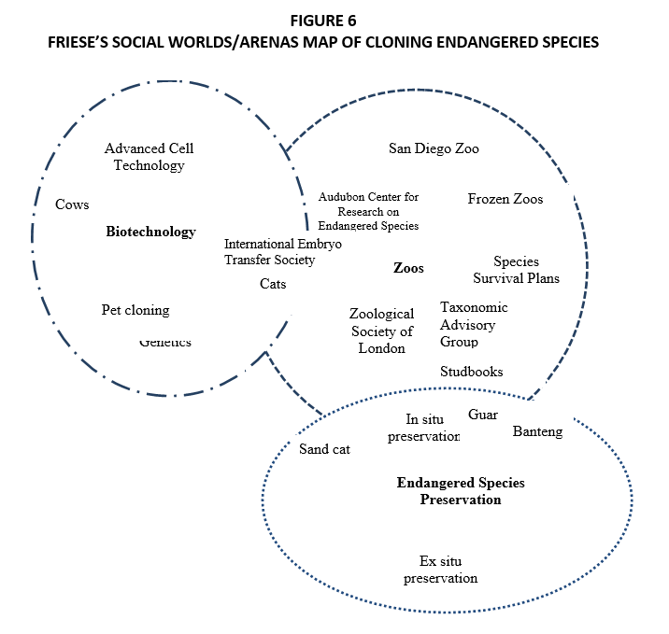

Figure 6: Friese’s Social Worlds/Arenas Map of Cloning Endangered Species

To develop Figure 6, my “Social Worlds/Arenas Map of Cloning Endangered Species,” I asked how the individuals involved in cloning were related to a social world, how tools associated with social worlds were deployed elsewhere, and what kinds of negotiations occurred when varying social worlds, ideologies, and tools intersected in a particular situation of cloning. Social worlds/arena maps thereby allowed me to continue the work of analyzing social processes through grounded theorizing and to analyze social worlds and arenas as they are implicated in and by situated cloning practices.
In making this map, I realized that cloning endangered animals was an arena in the making. Current-day endeavors to clone animals of endangered species are sporadic and fragmented. There were no organizations solely devoted to developing nuclear transfer with endangered species, nor were there any social worlds largely committed to using nuclear transfer with such animals. Moreover, this practice today remains highly contested with unclear futures. I was able to grasp the tenuous and uncertain status of the practice of cloning endangered animals through making the social worlds/arenas map, however partial. This unexpected outcome of my mapping efforts then became the focus of a paper Adele Clarke and I wrote (Clarke & Friese, 2007) about these distinctive challenges in social worlds/arenas mapping—what to do when there isn’t really a social world!
Looking at this map retrospectively, I can see how different it would be if made today. Efforts in de-extinction have solidified into an arena in ways that cloning endangered animals had not, adding new actors who play central roles in its mobilization.

FRIESE’S POSITIONAL MAPS
I used positional maps toward the end of data collection and analysis. The question of whether or not cloned endangered animals counted as part of the endangered species was a recurrent theme in my research. Some people argued that these animals did not count as part of the endangered species because they inherited mitochondrial DNA from the domestic egg donor. Other people argued that some cloned endangered animals could be included in the endangered population while others could not. For example, many would say that male clones could be included because they would not pass on the mitochondrial DNA inherited from a domestic animal to their offspring; in turn, these people would then argue that female clones could not be included in the endangered population because they would do so. And finally, others would argue that all cloned animals could be included in the endangered population. Here, mitochondrial DNA was deemed insignificant in the context of potential extinction.
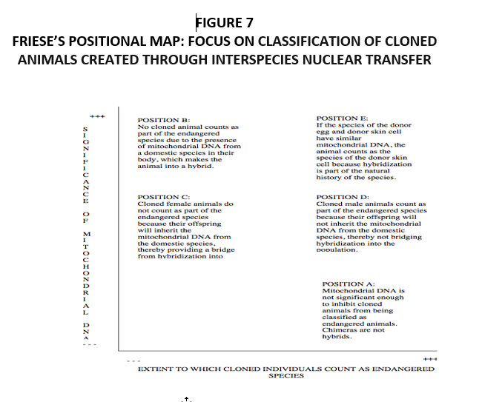
Figure 7: Friese’s Positional Map: Focus on Classification of Cloned Animals Created Through Interspecies Nuclear Transfer

I used a positional map in order to address this debate. Here, all positions regarding an area of interest, concern, or controversy are mapped vis-à-vis two key discursive elements in the discourse or debate. Figure 7 is a map of all positions taken in the data regarding the classification of chimeras. The positions are organized according to two axes: (1) the significance of mitochondrial DNA to species boundaries and (2) the degree to which animals produced by interspecies nuclear transfer can “count” as part of the endangered species in question. These axes were chosen because they reflect the key question (e.g., are these cloned animals part of endangered species?) and primary referent (e.g., mitochondrial DNA) in the debate. The different positions could be organized according to degree of salience along both axes, a necessary component of positional maps. Together, the axes provided a means to represent all positions encountered within the data set. While the map seems rather self-evident in its current form, finding the right axes was difficult. The long process involved in finding the key elements of the discourse that would capture all of the different positions was itself intensive data analysis.
Clarke advocates doing positional maps because they allow researchers to explore an area of contestation without engaging in identity politics—without linking positions to persons, groups, or organizations. It was incredibly helpful to explore these debates without referencing a social group, such as zoo scientist or biotechnology scientist. Indeed, the positions did not map onto social groups in any meaningful way.
Rather, what I realized in making this map was that the positions regarding whether or not cloned animals counted as part of the endangered populations were instead linked with particular cloned animals. Different cloned animals embodied these different positions. As such, the positional maps linked back to the relational maps that I had made for each cloning project. While the gaur embodied the position that all cloned endangered animals counted as part of the endangered population, the banteng embodied the position that male—but not female—clones could be considered endangered.
In my final project write-ups, bridging this positional map with the situational maps was the focus of my final major project map. It is not presented here, as that map takes up very complex facets of cloning, far beyond the methods goals of this website. To read about this project map, see Friese (2010, 2013; links below).

REFERENCES
Appadurai, A. (1996). Modernity at large: Cultural dimensions of globalization. Minneapolis: University of Minnesota Press.
Clarke, A. E., & Friese, C. (2007). Situational analysis: Going beyond traditional grounded theory. In A. Bryant & K. Charmaz (Eds.), Handbook of grounded theory (pp. 694–743). London, UK: Sage.
Fosket, J. R. (2015). Situating knowledge. In A.E. Clarke, C. Friese, & R. Washburn (Eds.), Situational analysis in practice: Mapping grounded theory (pp. 195–233). London, UK: Routledge.

FRIESE’S PROJECT PUBLICATIONS
The following publications are all based on Carrie Friese’s situational analysis project on the cloning of endangered species:
Friese, C. (2009). Models of cloning, models for the zoo: Rethinking the sociological significance of cloned animals. BioSocieties, 4, 367–390. https://doi.org/10.1017/S1745855209990275
Friese, C. (2010). Classification conundrums: Classifying chimeras and enacting species preservation. Theory and Society, 39(2), 145–172. https://doi.org/10.1007/s11186-009-9103-7
Friese, C., & Clarke, A. E. (2012). Transposing bodies of knowledge and technique: Animal models at work in reproductive sciences. Social Studies of Science, 42(1), 31–52. https://doi.org/10.1177/0306312711429995
Friese, C. (2013a). Cloning wild life: Zoos, captivity and the future of endangered animals. New York: New York University Press. https://books.google.com/books?id=0awjAAAAQBAJ&lpg=PR9&ots=JAqZzBiyTI&dq=1)%09Friese%2C%20C.%202013.%20Cloning%20Wild%20Life%3A%20Zoos%2C%20Captivity%20and%20the%20Future%20of%20Endangered%20Animals.%20New%20York%3A%20New%20York%20University%20Press.&lr&pg=PR9#v=onepage&q=1)%09Friese,%20C.%202013.%20Cloning%20Wild%20Life:%20Zoos,%20Captivity%20and%20the%20Future%20of%20Endangered%20Animals.%20New%20York:%20New%20York%20University%20Press.&f=false

. Venn diagrams were developed in mathematics and are illustrations of overlapping circles used to show relationships between different groups.

