Situational Analysis Exemplar: Janet Shim’s Project

INTRODUCTORY NOTE: This exemplar was included in Chapter 3 of the first edition of Situational Analysis (Clarke, 2005, pp. 98–135). It has been edited to serve as a free-standing exemplar of a situational analysis project on the SAGE companion website for the 2nd edition. Adele Clarke was a member of Janet Shim’s dissertation committee. Significantly, the situational maps and analyses of Shim’s project presented here were done by Clarke in consultation with Janet Shim, Jennifer Fishman, Jennifer Fosket, and Laura Mamo, on November 2, 2000. Shim’s was not originally a situational analysis project, as the method did not exist at the time she did her research. Readers are encouraged to consult Shim’s published works from this project for her own analyses (and for citations to the appropriate substantive literatures not duplicated here). Shim is currently professor of sociology and director of the doctoral program in sociology at UCSF. A list of Shim’s publications from this project is at the end of this file.

INTRODUCTION TO THE EXEMPLAR: JANET SHIM’S PROJECT
Janet Shim’s research focused on two different sets of people concerned with cardiovascular disease (CVD) in the United States today. First are epidemiologists and related researchers who study the racial, sex/gender, social class, ethnic, geographic, and other distributions of CVDs in populations. Second are people of color who have themselves been diagnosed as having CVDs and conditions. Shim’s explicitly comparative approach centers on the meanings of race, class, and sex vis-à-vis CVDs constructed by the epidemiologists, on the one hand, and by the people of color diagnosed with CVDs, on the other.
In the United States, race, class/SES (socioeconomic status), and sex/gender are key variables in all of the social sciences and have been central historically. In fact, all of these elements of individual and collective identity have been becoming increasingly socially and culturally important in the United States and consequential for the organization of health research, especially health disparities/population health research (e.g., Epstein, 2004). This provoked Janet Shim’s research on what they mean to differently situated people involved in cardiovascular health (see also Schwalbe et al., 2000; Harris, 2001). She has both bachelor’s and master’s degrees in public policy with emphases in health and, hence, long-standing knowledge of epidemiology as a discipline and its practices.
Over roughly the latter half of the 20th century, studies of CVDs have played a central role in the development of the discipline of epidemiology. CVD studies were significant in terms of the kinds of research designs and data accorded scientific legitimacy, the elaboration of more sophisticated methods, and debates over the etiological roles of genetic, other biological, lifestyle, environmental, and social factors in disease distribution. While much, if not most, medical research on CVDs was conducted on white males prior to circa 1990, racial, socioeconomic, and sex categorization have all consistently been attended to in the U.S. epidemiologic research endeavor. (This is not the case in all first-world countries; France, for example, does not collect data on race.) In the United States, population variations are identified and mined for clues to the etiology of disease. Recently, persistent disparities in CVD incidence and outcomes along racial, socioeconomic, and sex lines have raised public concerns and prompted research explicitly aimed at uncovering the causes of such inequalities. In light of such concerns and research, the meanings of race, class, and sex/gender must be understood as socially constructed, invoking and mobilizing particular conceptions of bodily and social “differences.” Therefore, Shim sought to grasp the array of such constructions and who holds which conceptions.
Shim’s questions for the people of color diagnosed and living with CVDs centered on how they interpret their experiences as being of a specific race, class, and sex/gender in terms of their CVDs. She also examined their perceptions and engagements with current biomedical “dogma” regarding what constitutes their risk factors and what they “should do” to ameliorate their conditions. These interviews thus examined people’s experiences with clinical providers, the advice and recommendations offered to them, and also discursive claims circulating in various media about CVD risks and causes. Shim also attended to their awareness, comprehension, acceptance, strategic invocation, and sometimes rejection of the dominant constructions of “difference” circulating within the “expert” social worlds in the CVD arena.
Shim did both in-depth interviews (with both epidemiologists and people of color diagnosed with CVDs) and ethnographic observations at professional conferences, meetings, health education forums, and related venues. Her approach is explicitly comparative and at a more meso level of analysis.

Shim Project: List of Figures
Shim Project Figure 1: Messy Situational Map: Race, Class, Sex/Gender, and Cardiovascular Epidemiology
Shim Project Figure 2: Ordered Situational Map: Race, Class, Sex/Gender, and Cardiovascular Epidemiology
Shim Project Figure 3: Relational Analysis: Focus on Epidemiology
Shim Project Figure 4: Relational Analysis: Focus on People of Color With CVDs
Shim Project Figure 5: Social Worlds/Arenas Map: The Cardiovascular Disease Arena
Shim Project Figure 6: Positional Map A: Race in Expert Cardiovascular Epidemiology
Shim Project Figure 7: Positional Map B: Sex/Gender in Expert Cardiovascular Epidemiology
Shim Project Figure 8: Positional Map C: People/Patients on Causes and “Cures” of CVDs

Situational Maps of Shim’s Project:
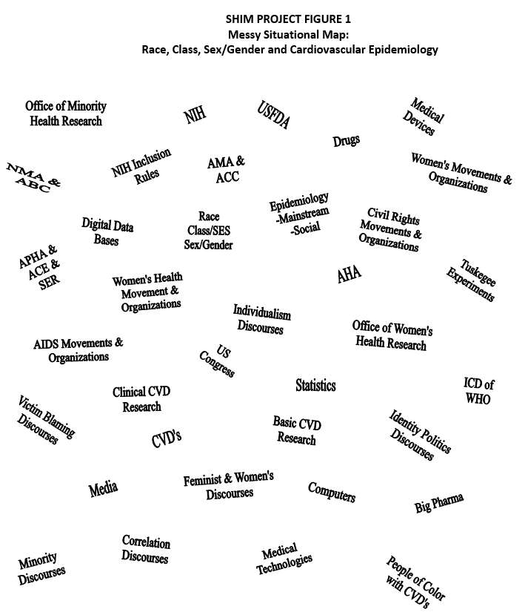

Shim Project Figure 1: Messy Situational Map: Race, Class, Sex/Gender, and Cardiovascular Epidemiology
Looking at the messy situational map of Shim’s project (see Shim Project Figure 1), first note that many institutional/collective actors are in this situation. Professional expertise is central to Shim’s project, and federal research funding fuels the whole arena. Recently, the U.S. National Institutes of Health (NIH) implemented revised “inclusion rules” whereby federally funded research using human subjects must include women and people of color or satisfactorily explain why they cannot be included. The long tradition of white males as the “standard medical research subjects” whose outcomes could supposedly be generalized to all others has begun to collapse (Epstein, 2004). At the NIH in 1990, both an Office of Research on Minority Health and an Office of Research on Women’s Health were founded. They both remain politically controversial and highly vulnerable. All of these developments, deeply charged with “identity politics,” have emerged in response to various social movements active over the past 50-plus years: civil rights/antiracism, women’s health, AIDS, queer (lesbian, gay, bi- and transsexual), and others. Today in the United States, ongoing movement organizations with complex agendas actively monitor federally funded research vis-à-vis these inclusion rules and other identity-based criteria.
For the epidemiologists, the most important nonhuman elements in this situational map are likely the computers and software programs that perform highly complex statistical manipulations on data from giant population samples and the International Classification of Diseases of the World Health Organization, the major means of globally systematizing distributional statistics.
Shim Project Figure 2 is the “Ordered Situational Map: Race, Class, Sex/Gender, and Cardiovascular Epidemiology.” Note that some elements appear multiple times—under different headings—as their salience can be quite differently inflected and all sites of their appearance deserve consideration. For example, “individualism” appears under Discursive Constructions of Nonhuman Actants, Political/Economic Elements, Sociocultural Symbolic Elements, National Historical Frame, and Major Issues/Debates. This signals that individualism needs to be understood in multiple ways in this project. Individualism here is the notion that phenomena related to disease and illness—ranging from causes, progression, manifestations and symptoms, outcomes, treatment, and amelioration—can be appropriately and adequately understood at the level of the individual. Thus, it is assumed by most epidemiologists that epidemiologic research into the etiology of CVDs can be conducted with the individual as the basic unit of analysis, potential factors and determinants can validly be conceptualized and measured at the individual level, and treatment and prevention efforts can be predicated on individual change and aimed at individual actors. It is this form of individualism that social epidemiology as a professional segment challenges.
Shim Project Figure 2: Ordered Situational Map:
Race, Class, Sex/Gender, and Cardiovascular Epidemiology
Individual Human Elements/Actors | Nonhuman Elements/Actants
Participants in Shim’s research: | Computers (hardware, software, and databases for epidemiology); reports: prior clinical trials/studies (e.g., Framingham community studies); CVD procedures, drugs, devices, and tests; data collection instruments; key epidemiological concepts (see below)
1. People of color with CVDs
2. Key social epidemiologists: Krieger, Cassel, Syme, Susser, Berkman, Kawachi, Diez-Roux
Collective Human Elements/Actors | Implicated/Silent Actors/Actants
U.S. Congress; U.S. FDA; U.S. NIH and its Offices of Minority and Women’s Health Research; ICD of the WHO; epidemiology as discipline: mainstream and social segments; professional organizations: APHA, ACE, NMA, ABC, AMA, ACC, AHA, SER; patient care institutions: local hospitals, ERs, HMOs, clinics, private physicians’ offices; big pharma; big biomedicine; civil rights, women’s health, and HIV/AIDS movements | People of color with CVDs
 | Key Events in Situation
 | NIH Office of Research on Women’s Health (1990)
 | NIH Office of Minority Health and Research (1990)
Discursive Constructions Individual and/or Collective Human Actors | Discursive Constructions of Nonhuman Actants
Racial and ethnic stereotypes; sex/gender stereotypes; class/SES stereotypes; stereotypes of patient care; individualism | Concepts of race/ethnicity; class/socioeconomic status; sex/gender; sameness/difference(s); statistical significance; correlation; correlation is not causation; multifactoral causation; measureability; standardization; environment; curing; individualism
Political/Economic Elements | Sociocultural/Symbolic Elements
U.S. health care politics; Medicare and Medicaid policies; health insurance politics; concepts of citizenship; concepts of individualism | Symbolisms of health and illness, esp. of CVDs; curing; individualism
Temporal Elements: U.S. National Historical Frame | Spatial Elements
Histories of race, sex, and class and (bio)medicine; Tuskegee research abuses; histories of routine exclusion of women and minorities from health research; histories of scapegoating and individualism | Local and regional variations, esp. re: race/ethnicity and health care
Major Issues/Debates (Usually Contested) | Related Discourses (Historical, Narrative, and/or Visual)
Focus on meanings and consequences of race/ethnicity, class/SES, and sex/gender vis-à-vis CVDs and CVD epidemiology; individualism | Public service health education; media coverage of health; marvels of modern medicine; identity politics discourses; “minority” discourses; women as reproductive bodies; victim-blaming discourses; illness and duty to be healthy discourses; individualism discourses

In Shim’s analysis here, individualism first needs to be explicated as an idea/concept salient in the conduct of mainstream epidemiology and as a focal point for commentaries and critiques about epidemiologists’ practices. Then, its historical importance vis-à-vis causal theories in health generally and cardiovascular risk specifically need to be laid out. Third, individualism constitutes a central and distinctively American public discourse, structuring the ways Americans are encouraged to think about many things, including bodies and multiple health-related phenomena and the origin, location, and amelioration of illnesses. For Shim, analytic considerations might therefore include the following: How do people diagnosed with CVDs engage or not with individualistic rhetorics about disease causes, risks, and cures? How do epidemiologists so engage or not? How do they discuss—give language to—these issues in their work and their lives?
Questions for Shim’s situational maps include the following: Who and what things matter in the broad situation of attending to racial, class, and sex/gender differences in CVDs? Who and what things are involved in producing knowledge about such differences? What discourses, ideas, scientific criteria, and concepts shape how epidemiologic experts and laypeople think about, conceive, and define the nature of racial, socioeconomic/class, and sex/gender differences? What economic, regulatory, political, and cultural conditions affect how research into such differences gets conducted? What professional and social values are taken for granted and by whom, and what, if any, cultural ideologies underwrite these? What are the consequences of varying kinds of conceptions of “difference” for how researchers conduct epidemiologic studies of differences and for how people “manage” their CVDs? These questions both helped produce the map and were produced by it.

Doing Relational Analyses With Situational Maps
Relational maps diagram particularly interesting relations by circling (and boxing, triangling, etc.) certain elements and connecting them. Then, the analyst asks about the nature of the relationship between the two elements. The same element can, of course, be “related” to multiple others. Relational maps help the analyst decide which stories—which relations—to pursue. At early stages of analysis, memos can and usually should be partial and tentative, full of questions to be asked and answered about the nature and range of particular sets of social relations, rather than being answers, in and of themselves.
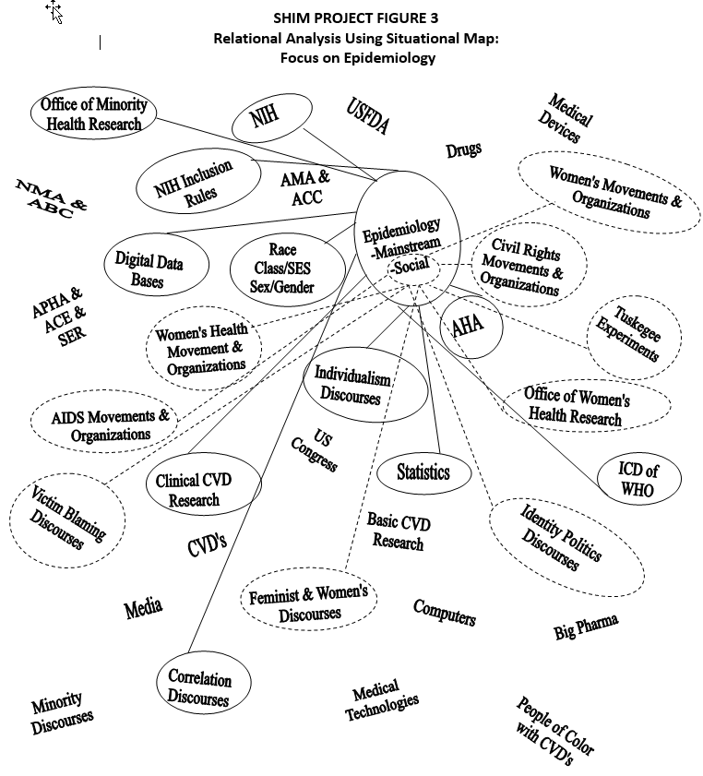Shim Project Figure 3: Relational Analysis: Focus on Epidemiology
While Shim’s research is quite complex, Figure 3 focuses on the two main actors in the relational analyses offered here. But there are many other analytic drawings possible. The focus is on epidemiology (see solid-line relations), but Shim also slightly/gently deconstructs that to analyze the relations of social epidemiology (see dotted-line relations) that seem to extend beyond those of mainstream epi. The map shows that Shim’s decision (discussed later) that mainstream and social epi were both part of epi (rather than separate social worlds) works well here in terms of the analysis showing how social epi is bringing new relations to bear on mainstream epi. Social epi extends the overall web of epi to new relational sites, even if the ties seem weaker. But those ties may seem strong indeed to the social epidemiologists who have worked for decades to build them (e.g., Granoveter, 1983).
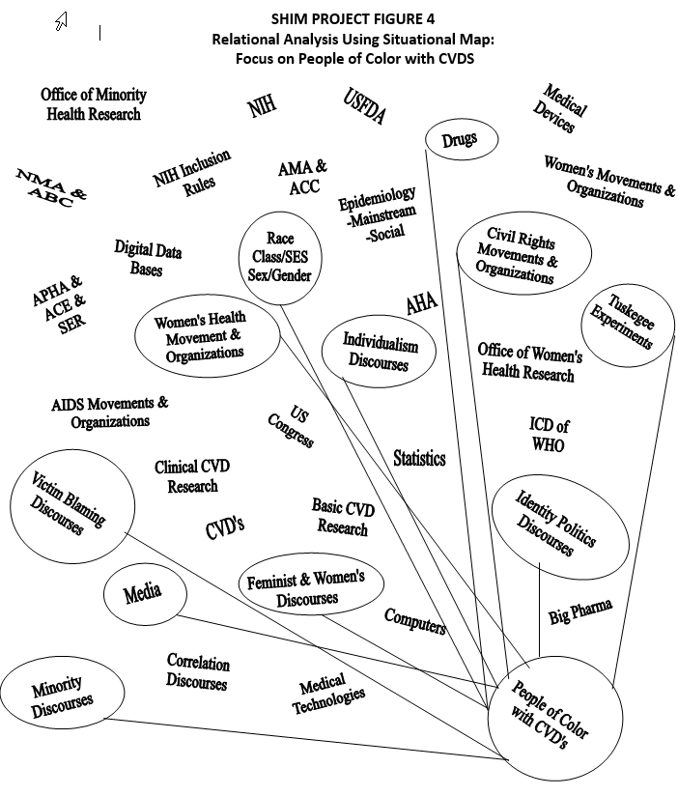Shim Project Figure 4: Relational Analysis: Focus on People of Color With CVDs
Looking at Shim Project Figure 4, we again see a smaller and weaker web of relations, much less formally organized and especially concerned with media and various historical discourses of injustice. Here, for example, a line connecting the historical and symbolic event “The Tuskegee Experiment” with the people/patients of color Shim interviewed would be an important relation to memo. The Tuskegee Experiment allowed “Negro” men suffering from advanced syphilis to go untreated for decades after antibiotic treatment was available and would likely have dramatically improved the quality and length of their lives. The U.S. government sponsored the withholding of appropriate treatment as an “experiment” to see what would happen to their bodies (especially their brains at autopsy). Dramatically uncovered in the 1970s (Jones, 1981/1993; Reverby, 2000), this case of experimental human subjects abuse explains and symbolizes aspects of the deep lack of trust of many African Americans in the U.S. medical system today. Intense and often insensitive research on the effects of radiation was also done among survivors of the nuclear bombings of Japan by the United States after World War II (e.g., Lindee, 1997). Did any of the people/patients mention these? Did any of the epidemiologists mention it? Given her study, Shim certainly needs at least a memo on such events and on any mentions of such events by study participants.
In doing her relational analyses, Shim also runs smack into an absence. Although her project is concerned with the meanings of race, class/SES, and sex/gender, no discourse about social class or SES is evident in the situational map. There is also no social movement explicitly organized around class or class-related issues. There is silence on class. How American! What are the implications of these absences for the ways in which Shim’s epidemiologists and people/patients make meaning about class/SES? Does it affect their meaning making around race? Sex/gender? Could the concept of race be doing double duty as a proxy for class in American culture? In epidemiology? This certainly deserves a memo!

Social Worlds/Arenas Map of Shim’s Project
Shim Project Figure 5 situates expert cardiovascular epidemiologies and people/patients diagnosed with CVDs in the United States today in a broad arena focused around CVD, itself within a much broader domain of health care that includes multiple other arenas. Inside that CVD arena (but often extending beyond it as well into other arenas in the broader health care domain) are a number of quite large and complicated social worlds that have key segments or subworlds pertinent to her project.
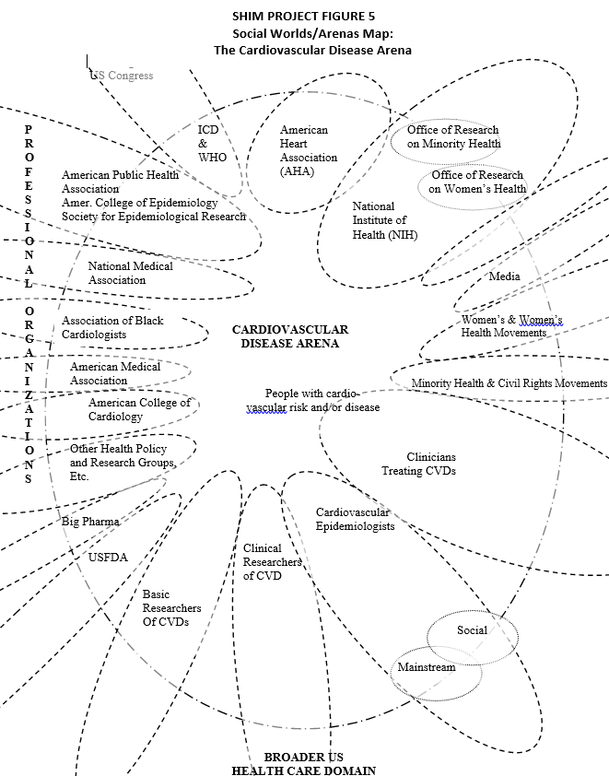

Shim Project Figure 5: Social Worlds/Arenas Map: The Cardiovascular Disease Arena

Shim’s project centers on U.S. research largely sponsored by the federal government, so the first major worlds are composed of those related agencies and organizations: the U.S. Congress, the NIH, and the Offices of Research on Minority and Women’s Health in the NIH. By virtue of their gate keeping and control over access to funding resources, these entities retain considerable bureaucratic and regulatory power to shape the agendas, methods, and conduct of epidemiologic work. Also in this arena is a huge private nonprofit nongovernmental organization (NGO)—the American Heart Association (AHA)—a social world unto itself with local, national, and international suborganizations. By positioning the AHA as a large and similarly significant world to the NIH vis-à-vis CVDs, this map signals that this nonprofit organization is continuous/coconstitutive with governmental organizations in highly significant ways. The map thus constructs what might be considered a “cardiovascular disease enterprise,” parallel to what Estes (1979) called “the aging enterprise”—a broad network of major players who have tremendous powers and influence over most aspects of the CVD arena—including but far from limited to the world(s) of cardiovascular epidemiological research. Such enterprises typically have long and consequential histories.
The next major social world in this map is that of epidemiologists and their professional associations. When considering the concept of individualism discussed earlier, it quickly became clear to Janet Shim that the discipline of epidemiology seems in actual practice to be divided into (at least) two subgroupings or segments: mainstream epidemiology and social epidemiology. Mainstream/conventional epidemiologists tend to focus on cardiovascular risk factors as individual phenomena while social epidemiologists tend to conceptualize sex/gender, race, and class as more complicated social/cultural processes. After some months of research and a lot of thought and analysis, Shim decided that these were segments of a single social world rather than separate worlds, for several reasons.
Both groupings still identify professionally as epidemiologists and are in the same professional organizations. Both use many of the same methods and share many other disciplinary trappings. While the research agendas and questions raised by social epidemiologists differ from those of mainstream epidemiologists, this is more in degree than in kind, and mainstream epidemiology itself is characterized by divergent agendas as well. Social epidemiologists are definitely critical of many mainstream research assumptions. Yet given their as yet still somewhat marginalized status within the discipline, vis-à-vis funding organizations, and so on and the many possible contestations over their research agendas, Shim sees them as relatively modest in their critiques. She finds that social epidemiologists are arguing now that epidemiology merely needs to expand its lens, to pursue research at multiple different levels, including the social. This is not arguing for a totally different kind of epidemiology. Thus, we can view the social epidemiologists as constituting a “reform movement” inside the social world of epidemiology (e.g., Bucher, 1962). Shim has further noted that this segment is having some successes as more social epidemiologists are being hired into major U.S. departments and are chairing more such departments. The professional associations of epidemiologists are also on the social worlds/arenas map (e.g., the American Public Health Association, the American College of Epidemiology, and the Society for Epidemiological Research).
The nonmonolithic nature of this social world highlighted, for Shim, an important theoretical sampling issue: In interviewing epidemiologists, she should attend scrupulously to their categorization of their own work as conventional or social epidemiology. She could get even more specific by asking herself—and asking her informants and data—questions such as, Why are there seemingly two groups of epidemiologists? Where did they come from? Are there other debates between them? What perspectives on data collection, conceptual models, and measurability do they share or disagree about? What are their relationships to funders and regulatory agencies? Are there other groups?
In the cardiovascular arena, there are, in addition, several loosely bounded social worlds of the clinicians of various kinds who treat CVDs. These range from MD epidemiologists (who are both clinicians and clinical researchers) to general practitioners, internists, hospitalists, nurse practitioners, and other health professionals. Another loosely bounded world is composed of basic and medical scientists who do basic scientific research on CVDs and their underlying biological processes, usually using animal models or computer models rather than human subjects. The professional associations of clinicians are also on the social worlds/arenas map. These include the American Medical Association, the American College of Cardiology, and the National Medical Association (a predominantly African American organization founded in 1895, when “Negroes” were not allowed to join the AMA) and its Association of Black Cardiologists.
In sharp contrast, any set of people diagnosed with particular conditions and patients in general are not collective actors, the special focus of social worlds/arenas analyses. This absence of collective identity and commitment to act together among patients has been a key aspect of understanding many medical practices historically, especially how patients are situated differently from medical professionals (e.g., Alford, 1972).
Yet people (who are, some of the time, also patients) often have their own understandings, thoughts, and beliefs—“lay” knowledges—about their health conditions. Such “knowledges” are rarely recognized by medical professionals and, even then, are usually marginalized, in contrast to the centrality of “official” knowledge production regarding cardiovascular health and disease. Lay actors in medical arenas are rarely given active voice and participation in the production of authoritative knowledge. As such, they are more often “implicated actors.” However, under certain conditions, people diagnosed/patients can become collective and agentic actors in health care arenas—when they organize themselves into social movements concerned with health issues generally (such as the women’s health movement) or into “patients’ movements” around particular conditions/diseases (AIDS, Alzheimer’s movements). Such groups are becoming increasingly common and, today, are changing the dynamics in many arenas in the health care domain quite powerfully in the United States and elsewhere.¹²
Unsurprisingly, then, another major set of social worlds in Shim’s social worlds/arenas map are social movements of various kinds. Those diagrammed here include civil rights/antiracism movements, women’s movements, women’s health movements, and AIDS movements. Not only did Shim find that these social movements were extremely consequential in structuring what “differences” epidemiologists should attend to and who should be included in their research, but they also raised larger concerns about the public credibility and social status of U.S. health research in general and about epidemiology as a field of professional expertise in particular.
Yet another social world in Shim’s analysis is the media, who increasingly consider it their responsibility to translate new scientific findings to the public to implement the claims of epidemiologic science regarding cardiovascular risk and disease prevention. Health and illness are “news,” and coverage of medical topics by the media has expanded dramatically, as well as extensive direct-to-consumer advertising of pharmaceuticals. Big Pharma, the current term for the vast international network of major pharmaceutical companies, is also quite present as a social world. The CVD arena is particularly important to them, as many people diagnosed with such diseases, especially in the first world, take daily medications for them—the backbone of pharmaceutical profit making. Yet another world or set of worlds present in the cardiovascular arena are health policy, public health, academic health, and other groups that attend to developments in this arena, including Shim and myself as researchers!
Looking at this social worlds/arenas map, Shim can ask, What is possible in the world of cardiovascular epidemiology now? Given the situation(s) in which they are located, where do researchers think the discipline should go, and how do they think they can get there, given possible path options? How do these research directions relate to the conceptions of race, class, and sex/gender held by epidemiologists? And by people of color diagnosed with CVDs?
Shim pursued the perceptions and interpretations of people in one social world—epidemiologists—and those of people who are not collectively organized—patients/people of color diagnosed with CVDs. These people are themselves varyingly aware of and involved with the social worlds and arenas in which their CVDs are studied, but those worlds are highly consequential for them. They are, then, implicated actors in those worlds. By and large, epidemiology seems unaware of and unconcerned about the perspectives of the people/patients with CVDs.
Shim’s study thus works beautifully for her explicit comparative purposes. She can compare and contrast the meanings of race, class, and gender constructed by epidemiologists (who constitute a highly focused, if highly segmented, professional social world and who frequently communicate with one another across multiple venues) with the meanings held by people of color diagnosed as having the disease (who are not in communication with one another nor with the epidemiologists). Here, as is often the case, there are considerable differences within particular groups, as well as across “different” groups. Such studies help us deconstruct difference as essential.

Positional Maps of Shim’s Project
We developed several positional maps for Shim’s project to include in the first edition of Situational Analysis. In Shim Project Figure 6, “Positional Map A: Race in Expert Cardiovascular Epidemiology,” we see three major positions held down. Working from the top right, the first position holds that race is very significant epidemiologically and that race is a collective/social phenomenon. Specifically, racial formations and racial stratification, as manifest in the division of labor, institutional and geographic segregation (e.g., from housing to region in the United States), and so on, are all consequential for cardiovascular health. The second position is that race is an epidemiologically important cultural phenomenon and manifest in lifestyle practices that are consequential for cardiovascular health. This, Shim finds, is a more middle-of-the-road position on race in contemporary epidemiology, especially insofar as it constructs race as more than an individual, biological, and perhaps genetic attribute. The third position holds that race is an epidemiologically significant individual/biological phenomenon. (I should also carefully note that the concepts “biological” and “race” are handled quite complexly both within epidemiology and in Shim’s work in ways I am not detailing here.)
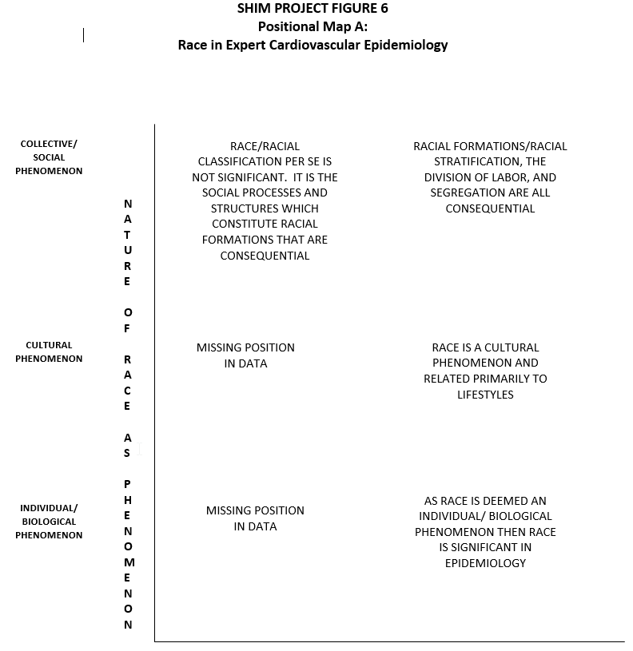
Shim Project Figure 6: Positional Map A: Race in Expert Cardiovascular Epidemiology
All but one position predicated on race not being epidemiologically significant was missing from Shim’s data. This is not to say they do not exist within epidemiology but that after years of research, they did not appear in her data. The one position that did appear, on the top left, is very nuanced. Here, it is argued that it is not race, in and of itself, that is consequential (read it is not race biologically that is important). Rather, it is the social processes and structures that constitute racial formations that produce racism. The position is that racism in its many guises impacts people of color and has negative consequences for their cardiovascular health.
In sum, in Shim’s study, race seems to be a significant variable to most, if not all, cardiovascular epidemiologists but for different, if sometimes overlapping, reasons. The most nuanced position disarticulates race per se as a property of individuals from the practices of racism. While I will not offer the positional map on class/socioeconomic status for Shim’s project, the patterns were essentially the same as for race. Historically, much of epidemiology has been the study of the consequences of the effects of poverty on health, today captured in the new language of “social disparities in health” and “population health.”
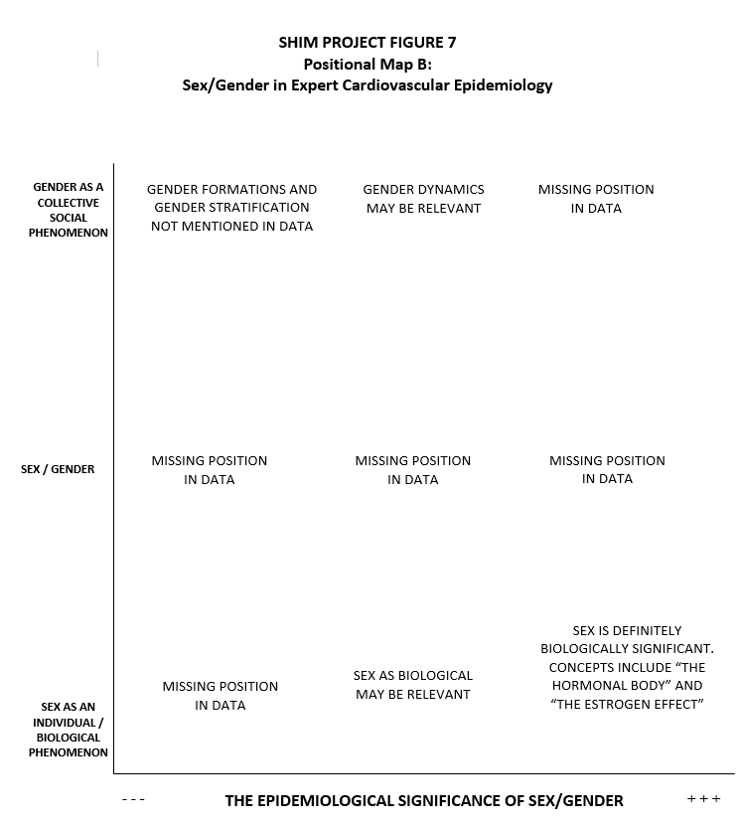
Shim Project Figure 7: Positional Map B: Sex/Gender in Expert Cardiovascular Epidemiology
Shim Project Figure 7: “Positional Map B: Sex/Gender in Expert Cardiovascular Epidemiology” is another positional map of Shim’s work, focused this time on sex/gender in expert cardiovascular epidemiology. The left axis on the nature of sex/gender as a variable makes the classic, if still problematic, social science distinction between sex as a biological category and gender as a performative social category on which various kinds of stratifications systems are built. These include paid employment, work undertaken in families, and other kinds of segregations and stratifications. In between is “sex/gender” as a hybrid nonfungible social category—the elements of which cannot meaningfully be separated. Neither Shim’s epidemiologists nor the individuals of color she studied took up this category. It is present in this positional map because it is present theoretically in the social constructionist social sciences today, where the assumption that biology is, after all, “really” “underneath it all” is refused. Instead, the relations between what we usually deem “social” and “biological” are viewed as inseparable, coproduced, and coconstitutive. In this instance, then, the researcher has clearly stepped into the analysis in terms of constructing the possible categories on the positional map. This position was added because it is available to epidemiologists as a conceptual resource in related social science research. This position on sex/gender is also close to the nuanced position on racism articulated earlier. The fact that the epidemiologists did not take any related positions is quite interesting. This is another way of helping the data speak to silences.
Sexism and its consequences are not understood similarly to racism, even among social epidemiologists. Shim’s data were actually quite bifurcated here. Most epidemiologists, social and mainstream alike, would support the position that sex as a biological category is fundamentally central to the study of CVD. There is very little doubt in their minds that hormonal and other physiological differences between the categories of persons deemed women and men are significantly responsible for differences in CVD incidence. However, a few epidemiologists question whether gender—that is, power relations and social processes predicated on socially constructed assumptions of difference and hierarchy—might not also have effects on cardiovascular risk, the position represented at the top middle site on the positional map. Also, the upper right position, that gender formations and discrimination are consequential, is actually missing in epidemiologists’ accounts and, hence, missing here. Shim carefully noted, however, that this last position was common in the narratives of the people/patients of color diagnosed with CVD whom she interviewed.
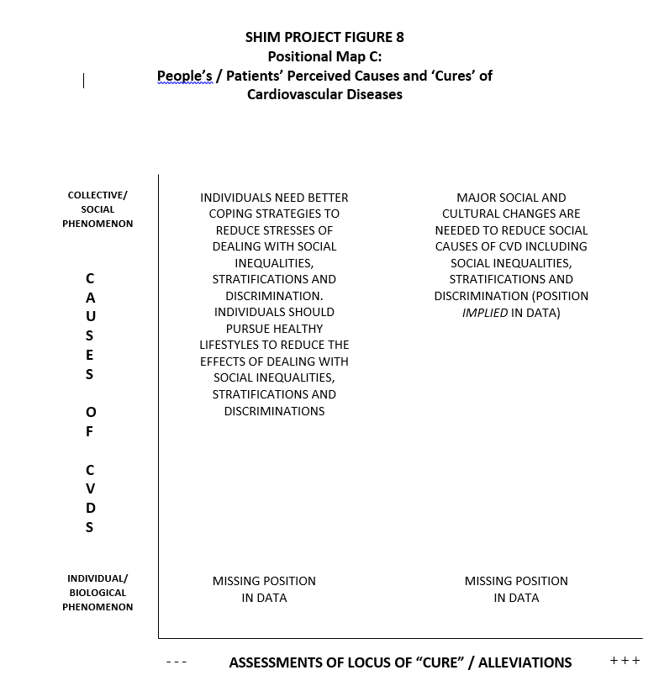
Shim Project Figure 8: Positional Map C: People/Patients on Causes and “Cures” of CVDs
Shim Project Figure 8: “Positional Map C: People/Patients on Causes and “Cures” of CVDs” is a different positional map of Shim’s work than the last two and needs some introduction. In examining constructions of “difference” across the “expert”/“lay” divide, Shim found some general differences. The people of color she interviewed, when providing causal/etiological accounts of their CVDs, implicated complex and interlocking structural social processes. These included the racial and sex/gender divisions of paid and unpaid labor they confronted in their lives, the educational and employment opportunities they did and did not have, and the institutional and personal discrimination they observed and personally experienced. Thus, lay epidemiology tended to be very social in its level of conceptualization. That is, for these people/patients, the causes of their CVDs were understood to lie in the highly racially stratified and discriminatory ways in which daily life and broader opportunities to make one’s way in life are routinely organized unequally. To them, the concrete and deeply stratifying practices of racism and sexism were highly consequential for their health.
Looking at Shim Project Figure 8, we see first that this map is part of the analysis of the discourse of individualism in Shim’s project. It is based on Shim’s ironic finding that at the same time some of her participants—the people/patients of color diagnosed with CVDs—viewed the causes of their cardiovascular conditions and diseases as social, they also viewed themselves and their own individual actions as the sole source of improvement or “cure.” That is, they articulated a position that individuals need better coping strategies to reduce the effects of stress on themselves from dealing with social inequalities, stratification, and discrimination. In that upper left position, there was, in fact, an intense discourse among participants regarding health promotion, healthy lifestyle, educate yourself, and self-awareness—all to be taken up on the individual level to counter social inequalities, stratification, and discrimination. On the upper right, the need for major social changes to reduce the social causes of CVD was only implied in the data, present but really only hinted at, according to Shim. The other two possible positions were missing from the data.
In contrast, Shim found that the “expert” epidemiologists tend to define “difference” in largely individualistic terms—race as cultural difference and sex/gender as a biological distinction—and to most often conceptualize social class in terms of individualized measures of socioeconomic status (occupation, income, and educational attainment). Historically, such conceptions have been widely routinized in epidemiologic research. Shim found that there is a fair amount of controversy and acknowledgment that these interpretations are methodologically and conceptually inadequate in many ways, articulated especially by social epidemiologists. However, despite these controversies, a multitude of other conditions in the broader epidemiological research situation support and facilitate the continued standardization of race, class/SES, and sex in those historic ways in epidemiologic work today. These conditions include regulatory requirements regarding racial and gender representation that emerged from the complex influence of identity politics on late-20th-century U.S. health research; economic and research sponsorship constraints that structure what kinds of theoretical models and raw data—the tools of epidemiologists—are available; funding concerns; and criteria for scientific credibility that circumscribe possibilities of interdisciplinary work. In Shim’s project, this story thus links many of the elements of the social worlds/arenas and positional maps together.
Again, we can see in the positional map exemplars the advantages of disarticulating positions from persons and institutions (individually and collectively) in terms of representation of the full range of variation—of differences both within and across groups of actors.

SHIM’S PUBLICATIONS FROM THIS PROJECT:
The following publications are all based on Janet Shim’s research project on the racial and other politics of risk, inequality, and heart disease.
Shim, J. K. (2000). Biopower and racial, class, and gender formation in biomedical knowledge production. In J. J. Kronenfield (Ed.), Research in the sociology of health care (Vol. 17, pp. 173–195). Stamford, CT: JAI Press.
Shim, J. K. (2002a). The embodiment and governance of “difference”: What epidemiological experts and street intellectuals say about race, class, gender, and cardiovascular risk. PhD diss., University of California, San Francisco.
Shim, J. K. (2002b). Understanding the routinised inclusion of race, socio­economic status and sex in epidemiology: The utility of concepts from technoscience studies. Sociology of Health and Illness, 24, 129–150.
Shim, J. K. (2005). Constructing “race” across the science–lay divide: Racial formation in the epidemiology and experience of cardiovascular disease. Social Studies of Science, 35(3), 405–436. Reprinted in R. Grzanka (Ed.), Intersectionality: A foundations and frontiers reader. Boulder, CO: Westview Press.
Shim, J. K. (2014). Heart-sick: The politics of risk, inequality, heart disease. New York: New York University Press. Finalist (one of six selected from 63 nominated books) for the 2014 C. Wright Mills Award, Society for the Study of Social Problems.
Shim, J. K., & Thomson, L. K. (2010). The end of the epidemiology wars? Epidemiological “ethics” and the challenge of translation. BioSocieties, 5(2), 159–179.

. Janet Shim’s dissertation committee was chaired by Professor Howard Pinderhughes, faculty in the Doctoral Program in Sociology. She received her PhD in sociology with distinction from UC, San Francisco in 2002.
. Shim had one caveat here. She did not explicitly ask nor did participants volunteer ideas on how to alleviate CVDs. Thus, the upper right position is only implied in their accounts of what they think the causes of their CVDs were and her asking about race, class, and gender and analytically arguing for a connection. She also carefully notes that sometimes the participants did not make connections between these dynamics and their health. The individual as the site of “cure”/alleviation is so intensely present because the participants all talked about how they managed their risks (or did not) when she asked them about what they thought their risk factors were.

