Exercise 1: Discussion of the video clip “Tickets”

Watch the video clip titled “Tickets”. Here is the transcription of this clip, with visible behaviors represented via transcriber comments (as shown in the book chapter):

1a Tickets – Transcriber Comments
((Al is sitting at the desk, working. Bob is standing a few feet away, picking up papers to bring to his office))

01 Al: [I tried yesterday: the who:le day, (.)
[((A turns to look at B; B looks at A))
02 to get tickets for the Van[Gogh]
03 Bob: [heh ]heh
04 .h[heh
05 Al: [º(exhibition)º
06 [(0.8)
[((A turns back towards his desk))

Compare this transcript with the one that uses Goodwin’s conventions for representing eye gaze:

1b Tickets – Goodwin’s conventions

02 Al: ______________________________________
to get tickets for the Van[Gogh.]
Bob: ______________________________________
03 [heh ] heh

.h[heh

04 A: [º(exhibition)º (- -)
A: _____,,,,
B: _____________

05 A:
I am getting cra:zy.
B: ___________________

06 (----------+---------+---------+--------)
A:
B: _,, .X_,

What seem to be the advantages of this representation? What is obscured in this transcript that was obvious in the first one? How might these transcripts be improved?

Now examine the same piece of data as it is represented with Rossano’s conventions:

1c Tickets – Rossano’s conventions

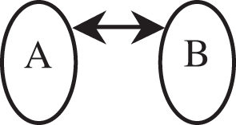
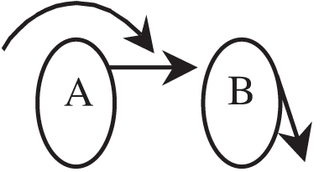

01 A: I tried yesterday: the who:le day, (.)

02 to get tickets for the Van[Gogh]
03 B: [heh ] heh
.h[heh
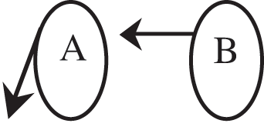

04 A: [º(exhibition)º (- -)

05 A: I am getting cra:zy.

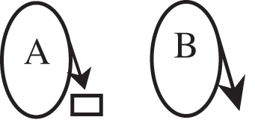
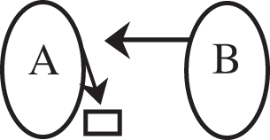

06 (---------x---------x--------x--------)
(3.8)

Compare the transcript that uses Goodwin’s conventions with the one that uses Rossano’s conventions. What are the strengths and weaknesses of the two representations? How do they compare to 1a?

