Exercise 3: Transcribing “Pizza Money”

Watch the video clip “Pizza Money.” Prior to this clip, the participants ordered pizza and located the money to pay for it. Now Danny is getting the phone call that the pizza is being delivered.

Here is the transcript of the vocal conduct:
- Danny: This [might be] the pizza.
- Amalia: [Pizzah? ]
- (1.8) ((Danny answers the phone))
- Kyung-Mi: Ur::lgh=
- Hector: =ºPi:zzah. ººPiz[zah.
- Danny: [Hello? ((on the phone))
- (1.2)
- Danny: Hi:,
- (0.5)
- Danny: Izzis::
- (2.2)
- Kyung-Mi: ºTaco:s.
- Amalia: º↑Huh ↑↑hnhº
- Hector: [ºI’m sort’veº ººhungry now.ºº
- Danny: [Okay,
- Hector: ººI’[m glad we did this.ºº
- Danny: [So a’you g-(.) gonna be outside?
- (4.8)
- Danny: Okay. ((on the phone))
- (.)
- Danny: Thank you. ((on the phone))
- (.)
- Danny: I’ll be out. ((on the phone))
Our attention will be on what happens during the silence in line 18. Watch the clip several times and write down a narrative description of what you see happen during this gap.

Answer key:
Pizza delivery on the phone, while: Danny stands up and taps his pant pocket. Amalia looks around for the money. Amalia taps Danny on the arm. Danny turns to look at Amalia. Amalia extends her hand with money toward Danny. Danny turns takes the money and nods.
[end answer key]

Consider several other possible ways of representing what happens during this gap. Discuss advantages and disadvantages of different representations.

One way to capture the visible actions is through a series of frame grabs, like this:
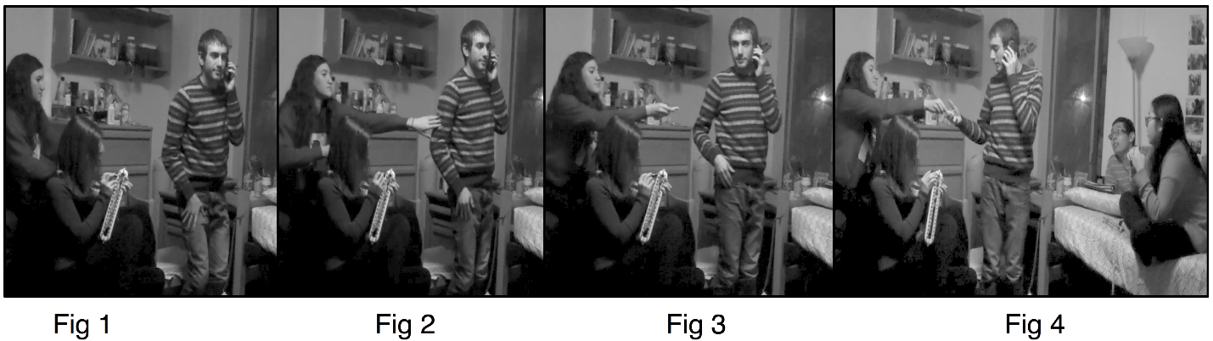

What is missing in this representation? How can we improve on this representation?

Answer key:
A simple series of frame grabs contains little information about the temporal unfolding of the actions. To add this information to the transcript, we may want to unpack the 4.8 gap in line 18 in this way:

18 (1.2)#(0.9)# (.) #(1.0) #(1.6)
#fig1 #fig2 #fig3 #fig4

or, alternatively like this, to capture the temporal relationships visually:

18 ----------+--|--------+-|-|--------+--|--------+--------
|fig1 |fig2 |fig4
|fig3
In the above, following Goodwin’s conventions, each dash stands for a tenth of a second silence and each plus sign marks a second boundary.

The resulting transcript will look like this:

- Danny: This [might be] the pizza.
- Amalia: [Pizzah? ]
- (1.8) ((Danny answers the phone))
- Kyung-Mi: Ur::lgh=
- Hector: =ºPi:zzah. ººPiz[zah.
- Danny: [Hello? ((on the phone))
- (1.2)
- Danny: Hi:,
- (0.5)
- Danny: Izzis::
- (2.2)
- Kyung-Mi: ºTaco:s.
- Amalia: º↑Huh ↑↑hnhº
- Hector: [ºI’m sort’veº ººhungry now.ºº
- Danny: [Okay,
- Hector: ººI’[m glad we did this.ºº
- Danny: [So a’you g-(.) gonna be outside?

18 ----------+--|--------+-|-|--------+--|--------+--------
|fig1 |fig2 |fig4
|fig3

19 Danny: Okay. ((on the phone))
20 (.)
21 Danny: Thank you. ((on the phone))
22 (.)
23 Danny: I’ll be out. ((on the phone))

Discuss pluses and minuses of this representation.
[end of answer key]

