Exercise 5: Transcribing gesture in “Melatonin”

Watch the video clip titled “Melatonin” in which three housemates, Helen, Sybil, and Glen are having a morning coffee. Here is the transcript:

Melatonin (Tiwa1 2:00)

01 Hel: I took a mela↓tonin so I can: reset my schedule.=right,
02 so I [can ]go to sle[ep early:?
03 Syb: [º(ah)º] [
04 Glen: [bha-
05 (h)hah-=
06 Hel: =an’ wake up early¿
07 Glen: Bad time to take melat[onin.
08 Hel: [Yeah, I know.=I’m like
09 ylUgH[H!
10 Glen: [Way too early.

Focusing on Helen (on the right), produce a representation of the gestures she uses during line 1. First use Streeck’s conventions and then Kendon’s conventions. How do the two representations differ? What are their limitations? How could these representations be improved?

Answer key:
Helen uses a quotation gesture in line 1.
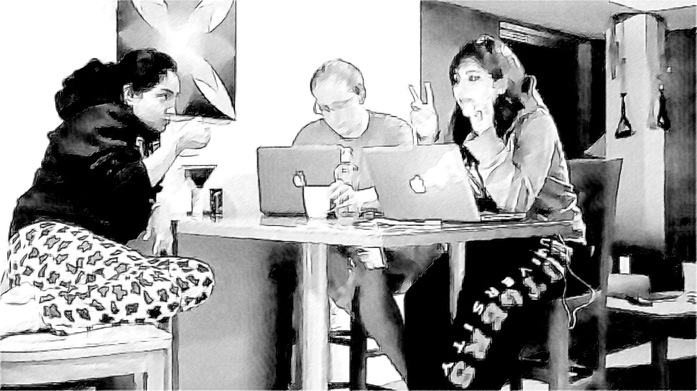

Using Streeck’s conventions, it could be represented in this way:

_quote__º__º__º_________
| |
01 Hel: I took a mela↓tonin so I can: reset my schedule.=right,

Kendon’s representation would look like this:

01 Hel: I took a mela↓tonin so I can: reset my schedule.=right,
|~*******/**/*-./.-.-.-.-.|

Note that Kendon’s conventions allow you to represent the gradual withdrawal of the gesture and the return to the home position.

Both representations could be supplemented by a representation of the speaker and the recipients’ gaze.

[end answer key]

