Instructions for Creating Figure 12.2: Column Chart on an iPad
- Create a single series column chart. Organize the data as shown. Months charted are in column A, performance values are in column B.
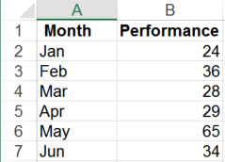
- Select cells A1:B7. From the INSERT tab, select the 2-D Clustered Column chart.
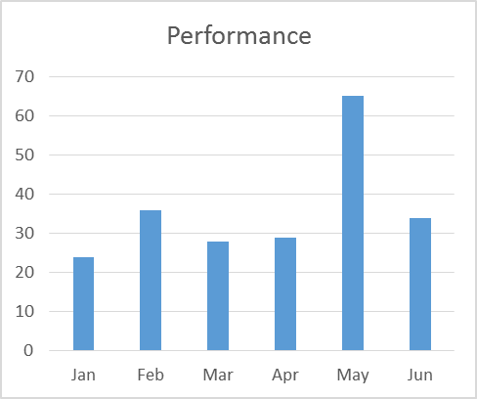
- Delete the y-axis labels, the gridlines, and the chart title.
- Add data labels to the columns.
- From the Format Data Series task pane > SERIES OPTIONS, adjust the Gap Width to 100%.
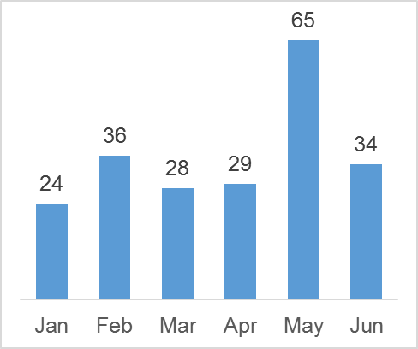
- Place the chart on the image of an iPad (or iPhone, computer monitor, etc.).

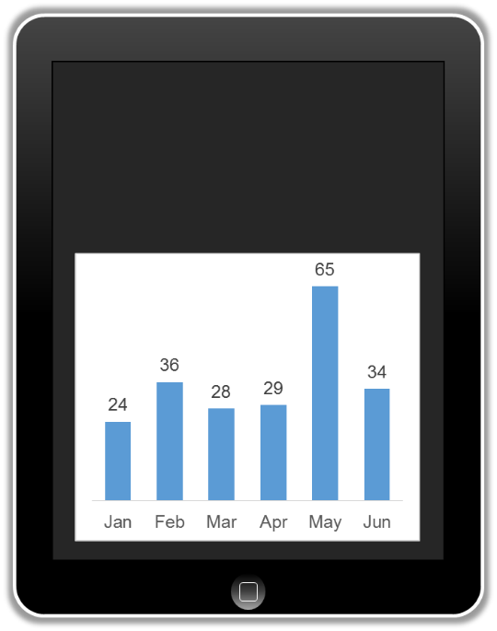
- Select the Chart Area. From the Format Chart Area task pane, select No fill.
- Select the columns. Change the column fill color to white.
- Select the data labels, change the text color to white.
- Select the x-axis labels, change the text color to white.
- Add a text box containing a chart title to the top of the iPad image.

