Instructions for Creating Figure 12.3: Thermometer Chart
- Create a single series column chart with one data value. Organize the data as shown.
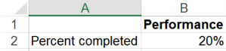
- Select cells A1:B2. From the INSERT tab, choose the 2-D Clustered Column chart.
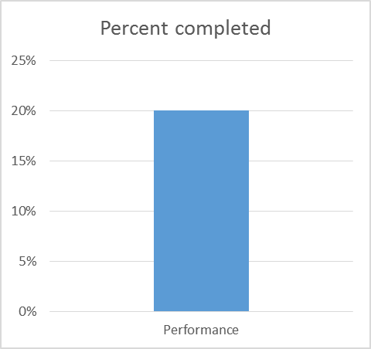
- Format the y-axis. From the Format Axis task pane, expand AXIS OPTIONS. Set the Minimum Bound to 0.0, and the Maximum Bound to 1.
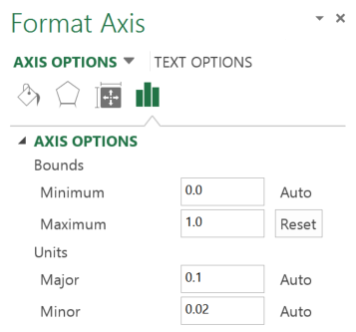
- Delete the gridlines, chart title and x-axis label.
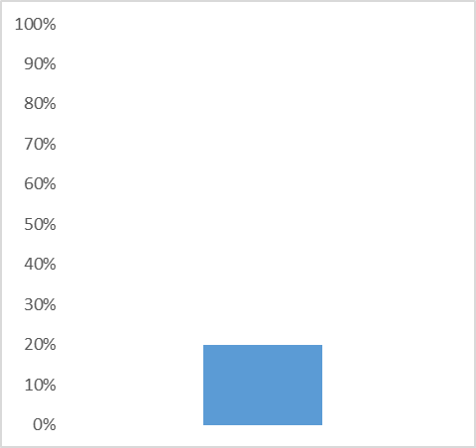
- From the FORMAT DATA SERIES task pane, change the Gap Width to 0%.

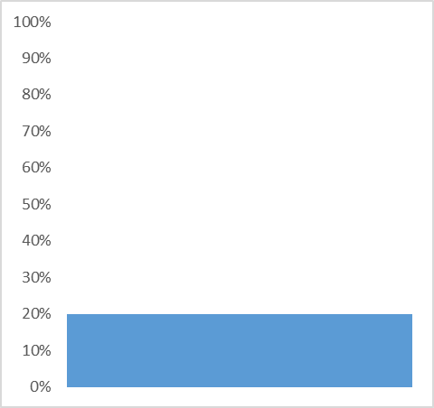

- Adjust the chart so that it is narrower. From the Format Data Series task pane, expand the column FILL menu. Select Solid fill and choose red. Expand the BORDER menu and choose Solid line, choose red.
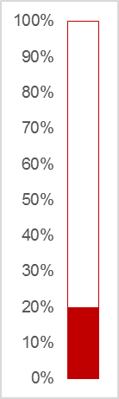
- Delete the chart border and ensure that the chart fill is set to “No fill.” Place the chart on an image of a thermometer. You may need to nudge the chart and/or the image of the thermometer so that the y-axis labels sits to the left of the image while the red column indicating progress remains centered within the image.

