Instructions for Creating Figure 12.4: Pizza Pie Chart
- Organize the data as you would for a standard pie chart. Cell B1, the target, represents the entire pie chart. Cell B2 is the current progress toward the target. Cell B3 is the difference between the Progress and Target, computed using the formula: =B1-B2.
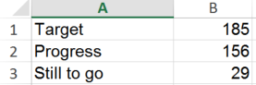
- Select A2:B3 and to create the pie chart. The resulting chart will look like this:
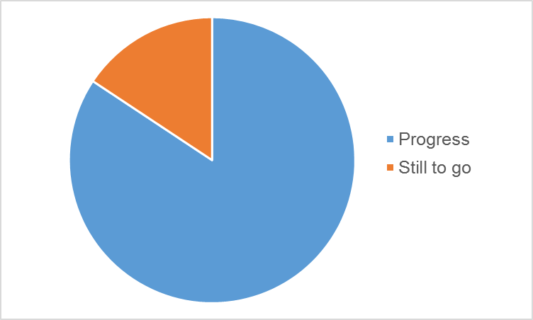
- Remove the colored fills from the chart. From the Format Data Series task pane, select FILL > No Fill. We’ve kept the borders for illustration purposes, they will be deleted later.
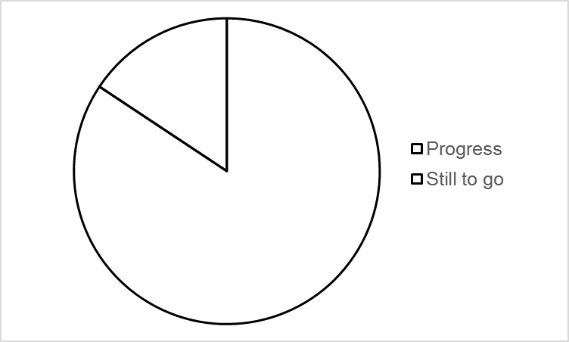

- Select the plot area. From the Format Chart Area task pane, select Picture or texture fill. Click Insert picture from > File. Navigate to the location of the picture, click Insert.
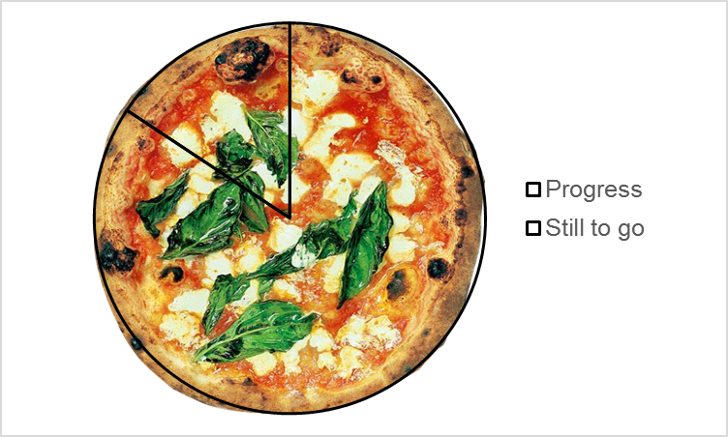
- Click on the “Still to go” section. From the Format Data Point task pane, select Solid fill and choose white (or any color that matches the background).
- Remove the borders. From the Format Chart Area task pane, expand the Border menu. Select No Line.
- Delete the legend. Add a text box with the data label and percentage still to go.
