SOLUTIONS

# CHAPTER 11: BIVARIATE CORRELATION AND ORDINARY LEAST SQUARES REGRESSION

1. You have data on two variables:

a. Self-restraint measured at age 10: Those who score high on this measure have a lot of self-

restraint and think about things before doing them. It is a continuous variable. It is measured in the following way: A plate of cookies was placed before each kid by an experimenter who told the kid not to take a cookie until “he or she really wanted it.” The experimenter then left the room and the score for each kid is the number of minutes that passed before a kid grabbed a cookie—those who took less time have less self-restraint.

b. Number of delinquent acts committed between the ages of 10 and 17.

Here are your data:

|  |  |
| --- | --- |
| Self-Restraint | Number of Delinquent Acts |
| 22 | 1 |
| 20 | 3 |
| 3 | 8 |
| 5 | 4 |
| 2 | 5 |
| 8 | 8 |
| 7 | 3 |
| 5 | 4 |
| 4 | 10 |
| 13 | 3 |
| 9 | 6 |
| 2 | 8 |
| 11 | 7 |
| 1 | 9 |
| 4 | 7 |
| 5 | 6 |
| 2 | 7 |
| 12 | 3 |
| 10 | 1 |
| 13 | 2 |
| 2 | 8 |
| 3 | 7 |
| 1 | 9 |
| 25 | 3 |
| 20 | 0 |

1. Graph the two variables with the correct independent variable on the *x* axis and dependent variable on *y* axis. Does it look like there’s a relationship? Does it look at least approximately linear?

**Below is the scattergram. Looks like there is a relationship, and it looks negative and linear.**

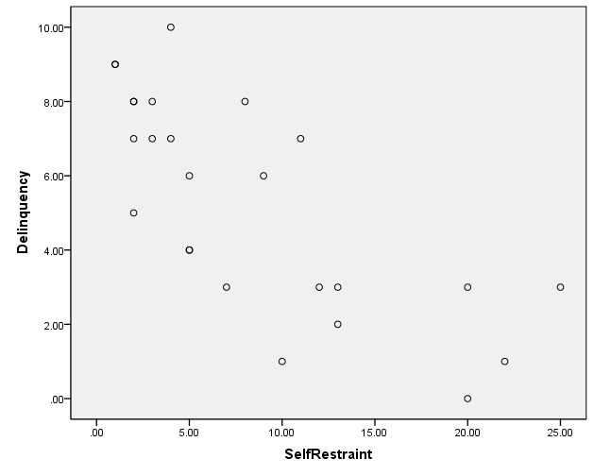

b. Calculate and interpret the correlation coefficient.

| **Correlations** | | | |
| --- | --- | --- | --- |
|  | | NumDelActs | Self-Restraint |
| NumDelActs | Pearson Correlation | 1 | -.745** |
| Sig. (2-tailed) |  | .000 |
| N | 25 | 25 |
| Self-Restraint | Pearson Correlation | -.745** | 1 |
| Sig. (2-tailed) | .000 |  |
| N | 25 | 25 |
| ** Correlation is significant at the 0.01 level (2-tailed). | | | |

**Correlation of -.745**

**Here are the calculations:**

|  |  |  |
| --- | --- | --- |
| ***x*2** | ***y*2** | ***xy*** |
| **484** | **1** | **22** |
| **400** | **9** | **60** |
| **9** | **64** | **24** |
| **25** | **16** | **20** |
| **4** | **25** | **10** |
| **64** | **64** | **64** |
| **49** | **9** | **21** |
| **25** | **16** | **20** |
| **16** | **100** | **40** |
| **169** | **9** | **39** |
| **81** | **36** | **54** |
| **4** | **64** | **16** |
| **121** | **49** | **77** |
| **1** | **81** | **9** |
| **16** | **49** | **28** |
| **25** | **36** | **30** |
| **4** | **49** | **14** |
| **144** | **9** | **36** |
| **100** | **1** | **10** |
| **169** | **4** | **26** |
| **4** | **64** | **16** |
| **9** | **49** | **21** |
| **1** | **81** | **9** |
| **625** | **9** | **75** |
| **400** | **0** | **0** |



c. Calculate and interpret the value of R2.

***R*2 = .56 or 56% of the variance in delinquent acts is explained by differences in self-restraint.**

d. Estimate and interpret the regression coefficients.

**Regression Coefficients:**



**First, solve for the slope *(b)***

**A*****b*****of -.302 means**

**that each 1 unit increase**

**in self-restraint**

**(each one minute delay in grabbing**

**the cookie) reduces the**

**number of subsequent delinquent**

**acts by .302.**

*The equation becomes* ***y = a* -.302*(x)***

**Now, substitute for the mean of *y* and the mean of *x* and solve for the intercept (*a*).**

**Mean of *y* = 5.28**

**Mean of *x* = 8.36**

**5.28= *a* -.302(8.36)**

**5.28= *a* – 2.52**

**5.28 + 2.52 = *a***

**7.80 = *a***

**So the *y* intercept (the point where the regression line crosses the *y* axis and the predicted value for *y* when *x* = 0) is 7.80.**

**The full regression equation is:**

***y* = 7.80 – (.302)*x***

e. What is the predicted number of delinquent acts for a kid who has a self-restraint score of 5, 10, 15, and 20?

**Predicted number of delinquent acts for someone who waited only 5 minutes to grab a cookie.**



**Predicted number for one who waited 10 minutes is**

**4.78**

**Predicted number for one who waited 15 minutes is**

**3.27**

**Predicted number for one who waited 20 minutes is**

**1.76**