DISCUSSION GROUP ANSWERS

CHAPTER 11: BIVARIATE CORRELATION AND ORDINARY LEAST-SQUARES REGRESSION

1. The following data is about the relationship (if any) between the number of sworn police officers in a county and the property crime rate (per 100,000) in the county.

a. Make a scatterplot of the raw data above. What does this graph reveal to you about the relationship between the number of sworn officers in a county and the property crime rate in that county?

It looks like there might be a weak negative relationship between the two variables.

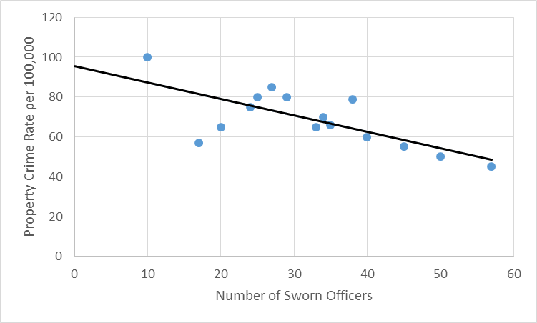

b. Using the raw data, calculate the value of the slope coefficient, then the intercept, and write out your full regression equation:

y = 95.4 – .824x

The y intercept is 95.4.
The slope is -.824.

The y intercept means that when there are 0 sworn officers, the property crime rate will be 95.4 per 100,000 population.

The slope means that for each sworn officer added to the force, the property crime rate will decline by .824 per 100,000 population.

c. Given this regression equation, predict the property crime rate for a county with 37 sworn police officers? Put your final answer in the box.

d. Calculate the r, interpret this r, and calculate and interpret the r².

r = -.711. The linear relationship between the number of sworn police officers and the property crime rate is strong and negative. The more sworn officers the lower the property crime rate.

r ² = .51 or about 51% of the variance in property crime rates is explained by variation in the number of sworn police officers.

e. Based upon these data, would you suggest to the county commissioner that hiring more police officers could reduce crime in the county? Explain.

Yes, hiring new police officers does lower the crime rate, therefore, I would argue for hiring new police officers. Plus the reduction in crime is nontrivial.

2. You want to study the relationship between age of convicted drug offenders (in years) and monthly income (in dollars) earned in illegal drug markets. Your hypothesis is that older offenders earn more money. A scatter plot is provided for data examining this relationship in a sample of 10 youthful offenders.

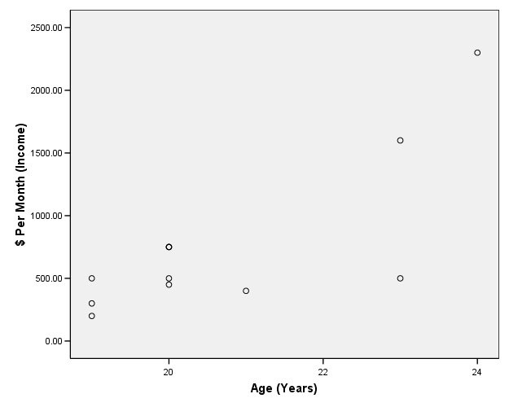

a. In fifteen words or less, why is this example appropriate for analysis using ordinary least-squares regression?

Because both the independent and dependent variables are measured at the ratio level continuously

b. Draw a regression line on the scatter plot in approximately the appropriate location.

(Make sure the line doesn’t go straight up through the top points . . .)
Assume you have conducted a bivariate regression analysis and found that your regression equation (y = α + βx) is as follows, where y is dollars earned and x is age.

y = -4,875 + 275x

c. Is y your independent or dependent variable?
Dependent variable

d. In 15 words or less, what does an α of -4,875 mean?
It is the y intercept. When x is 0 (at age 0), a drug dealer will make negative $4875 . . . This intercept cannot be meaningfully interpreted.

e. In 15 words or less, what does a β of 275 mean?
For each additional year of age, a drug dealer will make an extra $275.

f. Using the regression equation above, predict how much a 25-year-old drug dealer will make. Also predict how much a 30-year-old drug dealer will make.
25-year-old: $2,000
30-year-old: $3,375

