DISCUSSION GROUP PROBLEMS

CHAPTER 11: BIVARIATE CORRELATION AND ORDINARY LEAST-SQUARES REGRESSION

1. The following data is about the relationship (if any) between the number of sworn police officers in a county and the property crime rate (per 100,000) in the county.

Number Sworn Officers | Property Crime Rate
34.0 | 70.0
24.0 | 75.0
33.0 | 65.0
17.0 | 57.0
25.0 | 80.0
27.0 | 85.0
57.0 | 45.0
35.0 | 66.0
38.0 | 79.0
45.0 | 55.0
29.0 | 80.0
40.0 | 60.0
20.0 | 65.0
10.0 | 100.0
50.0 | 50.0

- Make a scatterplot of the raw data above. What does this graph reveal to you about the relationship between the number of sworn officers in a county and the property crime rate in that county?
- Using the raw data, calculate the value of the slope coefficient, then the intercept, and write out your full regression equation:
- Given this regression equation, predict the property crime rate for a county with 37 sworn police officers?
- Calculate the r, interpret this r, and calculate and interpret the r².
- Based upon these data, would you suggest to the county commissioner that hiring more police officers could reduce crime in the county? Explain.

2. You want to study the relationship between age of convicted drug offenders (in years) and monthly income (in dollars) earned in illegal drug markets. Your hypothesis is that older offenders earn more money. A scatter plot is provided for data examining this relationship in a sample of 10 youthful offenders.

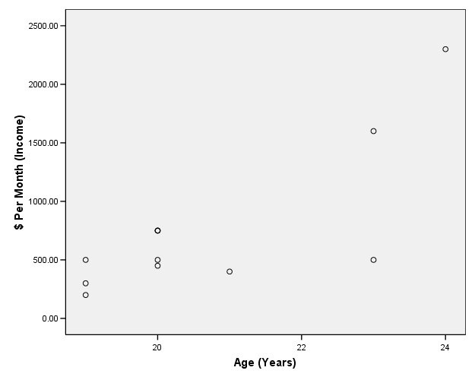

- In fifteen words or less, why is this example appropriate for analysis using ordinary least-squares regression?
- Draw a regression line on the scatter plot in approximately the appropriate location.
(Make sure the line doesn’t go straight up through the top points . . .)
Assume you have conducted a bivariate regression analysis and found that your regression equation (y = α + βx) is as follows, where y is dollars earned and x is age.
- Is y your independent or dependent variable?
- In 15 words or less, what does an α of -4,875 mean?
- In 15 words or less, what does a β of 275 mean?
- Using the regression equation above, predict how much a 25-year-old drug dealer will make. Also predict how much a 30-year-old drug dealer will make.

