Style Sheet Template for ________________ Project
[Directions: Fill in the blank spaces with your related decisions, edit any text as needed, and delete anything in brackets.]
This document outlines the branding and style choices that will guide any externally-distributed work on _________________ project.
Fonts
For this project, use these fonts consistently. Changes in font can be interpreted as sloppiness, so stick with these choices for all project-related documents.
[Highlight the examples below and change the font to what you have selected for your project. Adjust the size and RGB color codes, too, if needed.]
Printed materials:
Title – Rockwell Bold, size 28
Headings - Rockwell, size 16
Subheadings - Rockwell, size 14
Narrative text - Georgia, size 11
Slideshows:
Rockwell, at least size 28
Color Palette
[Right-click on squares and select the fill color option to change the colors to those you have chosen. Adjust the associated color codes.]
These are our two primary colors. Any externally-distributed documents should contain at least one of these. [from Adobe Kuler]
Dark Blue
R29 G97 B125
Teal
R67 G162 B202
These are our two accent colors, which complement and can be used in combination with our two primary colors.
Brown
R125 G75 B17
Tan
R202 G139 B67

For sequential coloring, such as in some data visualizations, use this color scheme, with a ¼ pt gray R51 G51 B51 border around outside edges, if needed for contrast against background. [from colorbrewer2.org]
Teal
R67 G162 B202
Light Green
R186 G228 B188
White
R240 G249 B232
Medium Blue
R8 G104 B172
Aquamarine
R123 G204 B196

For printed materials, use basic black (R0 G0 B0) on all narrative text that appears on a white background. Our primary dark blue should be used on the title and subheadings. Use our primary teal or one of our accent colors for call out boxes or sidebars. Use our white when printing narrative text on a nonwhite background.
For slideshows, use our dark blue and white for background and text (either color can be background or text).
Imagery
Use something from our repository (contact ________ for help) or follow these guidelines when searching for new images.
Images that fit with the theme for this project should be photos of real participants, or models who look like real participants [this one comes from AV4TAr via Flickr & TinEye Labs MulticolorEngine], looking at the camera, cropped at the shoulders and top of head.
Layout
In slideshows, the image should partially bleed, in that at least three sides of the image touch the sides of the slide. We use a rule of thirds layout, in which the photo can take up one, two, or all of the thirds. These are examples, not templates.
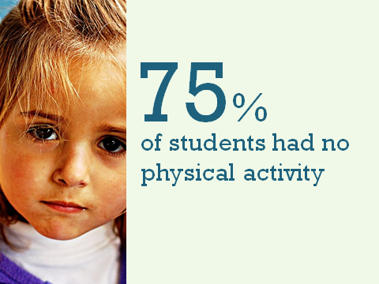
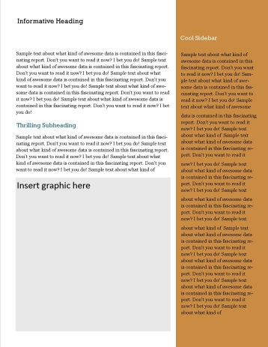
Printed materials should also be guided by a Rule of Thirds, with a graphic on the front page and 1-2 graphics (including sidebars) on interior pages. Examples, not templates, shown below.

Logo Policy
Our logo must appear on at least the first and last pages or slides, at least 1” in height, of any product delivered to an external audience. Contact __________ for the logo files.

