Nine Additional Case Studies
Case study title | Keywords
Denny’s Millennial Strategy | Denny’s, Tumblr, Twitter, Instagram, rebranding, millennials, content marketing
Snap, Inc.: Pushing the Limits of Social Media Communities | Snapchat, Facebook, brand community, brand content, paid content, Audi
The Role of Digital Influencers in Social Media | Digital influencers, social media, Instagram, endorsement
The Rise and Fall of a Fake Psychologist as an Instagram Celebrity | Influence impressions, source credibility, fake, Instagram celebrity
AcademLink – Information before Socialization | Research community, online social networks, localization, discussion, networking, collaboration, communication, informative portal.
Social Media Marketing in the Wedding Planning Industry | Word of mouth, customer reviews, social community, social media strategy
Authentic and Fake Consumers? Accepting the use of Native Advertisements in Social Media | Catphishing, influence, social media posts, fake product reviews, regulation
Nebraska State Historical Society Foundation: The Nebraska Marker Project Launch | Social media campaign, social media zones, types of media outreach
Combining Qualitative Marketing Research with Advanced Social Media Intelligence for Positioning | Leveraging social media data, market research

Denny’s Millennial Strategy
Kristen Smirnov
Assistant Professor of Marketing, Whittier College

Case
Denny’s is a traditional American diner chain with more than 1,600 locations nationwide, and additional overseas operations in more than a dozen countries. They’re well known for their bottomless cups of coffee, Grand Slam breakfasts, and other staples of the greasy spoon. However, in recent years, Denny's identified a positioning problem facing the company: lack of appeal among millennial consumers. Though Denny's has strong national brand awareness, it was associated with visits of convenience or habit: the driver on a road trip, the long-time customer powered by inertia, or someone whose 3 a.m. hunger had them on the lookout for any open restaurant.
The boomer customer base they did have was aging, leading to a decline in sales, and they were not attracting new consumers to their booths to compensate (Usitalo, 2015). Fortunately for Denny's, this was about to change. In late 2014, John Dillon became the new Chief Marketing Officer of the company, taking over from a predecessor who had already begun to correct the company's course. Under Dillon's leadership, a new social media strategy was launched to attract younger consumers.
Two major platforms served as a launchpad for a millennial-friendly social media rebranding: Twitter (twitter.com/dennysdiner) and Tumblr (dennys.tumblr.com). Twitter was an obvious choice for this effort. It is one of the largest social media platforms, but attracts a younger and less formal audience for its short, of-the-moment posts than can be found on Facebook. Tumblr was a less expected decision. Though Tumblr has a young and wealthy user base, its quirky, flexible posting structure has proven challenging for most marketers to master (Sloane, 2014). Its users also tend to be hostile to traditional promotional efforts, even compared to other millennials.
However, it was on Tumblr that Denny's millennial rebranding effort truly first clicked. Through the use of surrealistic, almost Dadaist posts, Denny's Tumblr became a content marketing hotspot on the platform. Following the Tumblr account doesn't put traditional advertisements on someone's dashboard. Instead, followers see a steady feed of bizarre question-and-answer sessions with the company representative, where they suggest that only a chicken can make a “perfect egg,” or humorously edited gifs and photographs, where a man might juggle three burgers above an animation of a smiling pancake face.
Denny's had become a strange, intriguing, and enjoyable destination for millennials on social media, and their Twitter soon began garnering similar amounts of attention. In the first months of 2017, it was rare for any post (whether on Twitter or Tumblr) to earn below one thousand direct interactions. More commonly, each new piece of content had several thousand interactions, and a few viral posts earned tens of thousands of likes, reblogs, or retweets.
Denny's had become a destination visit online, but did this translate to increases in sales? Yes. Their end-of-year financial results for 2016 reported 6.7% domestic two-year growth (Denny’s, 2017). Their deliberate outreach to millennials was timed to coincide with improvements in product quality, which had been building since 2010, and improvements in service related to reinvigorated franchisee relations (Giammona, 2015). Before reaching out to the millennial segment, Denny’s upgraded the product offerings to satisfy them when they did have their initial experience with the company. Once this improvement occurred, the use of social media brought in new consumers who have demonstrated consistent year-over-year sales growth for the formerly stagnant company.
Their Instagram account (instagram.com/Denny diner) has since become equally surreal, and with equally strong engagement numbers. Visiting the Denny's homepage lists Instagram second in their social media lineup, ahead of Twitter. Denny's is one of the very few major corporations to list their Tumblr account first, and in fact uses it as their official company blog on their main corporate domain (as blog.dennys.com displays the Tumblr account's content).
Through unique, unexpected, and unpredictable content marketing, Denny's successfully changed brand preferences among a notoriously resistant consumer segment. By being one of the few marketers to successfully focus on the Tumblr platform, they also essentially enjoyed a first-mover advantage among an attractive user base that was not already overloaded on corporate posts. Accordingly, they are often pointed to as a true success story on the platform.

Discussion Questions
1. Why might content marketing like this appeal to consumers who dislike traditional promotional strategies?
2. Why were Tumblr, Twitter, and Instagram good platforms to use for Denny's surreal and absurd content marketing? Would you recommend any others?
3. As noted, relatively few companies have a real marketing presence on Tumblr. Why do you think that might be? What is one company that you feel could benefit from an expanded presence on the platform, and why?
4. Denny's stood out by producing unique content. After the broad success they've seen, imitators of their style would be obvious. With that in mind, what can other marketers hope to learn and reproduce from their strategy?

References
“Denny's Corporation Releases Preliminary Financial Results for Fourth Quarter and Fiscal Year 2016.” Dennys.com. Last modified January 9, 2017. http://investor.dennys.com/investor-relations/press-releases/press-release-details/2017/Dennys-Corporation-Releases-Preliminary-Financial-Results-for-Fourth-Quarter-and-Fiscal-Year-2016/default.aspx.
Giammona, Craig. “Denny's Revival Provides Blueprint for McDonald's Turnaround.” Bloomberg.com. Last modified June 3, 2015. https://www.bloomberg.com/news/articles/2015-06-03/denny-s-revival-provides-blueprint-for-mcdonald-s-turnaround.
Sloane, Garett. “Tumblr’s Top Draw as a Marketing Platform Is Its Wealthier User Base.” Adweek. Last modified September 14, 2014. http://www.adweek.com/digital/tumblr-s-top-draw-marketing-platform-its-wealthier-user-base-160103/.
Usitalo, Olivia. “Denny's: Always Open, Always Successful.” Ohio University Strategic Social Media. Last modified February 9, 2015. http://oustrategicsocialmedia.com/2015/02/09/dennys-always-open-always-successful/.

SNAP Inc.: Pushing the Limits of Social Media Communities and Advertising through Innovation – Audi Super Bowl Campaign
Samir Sarofim

Learning Objectives
After analyzing the case, students should be able to:
1. apply Roger’s Diffusion of Innovation theory to evaluate the rate of adoption of social media communities and platforms.
2. determine the characteristics of Brand Fans?
3. analyze consumer-brand engagement on social media platforms.
4. identify the effects of real-time marketing on brand relationships on social media
5. integrate paid digital media strategy (e.g., Snapchat Sponsored Lenses and Sponsored Geofilters) with earned digital media to create brand social relationships
6. utilize social media communities to achieve competitive advantage via differentiation strategy.

Case
A young, almost 23 years old, entrepreneur, rejecting a 3 billion dollars acquisition offer, made the news taglines in late 2013. Who rejects such an offer, particularly when it’s made twice (the first offer was for 1 billion dollars)? More interestingly, who does so when the offering company is Facebook? According to Wall Street Journal (WSJ), Snapchat’s (currently Snap Inc.) co-founder and CEO, Evan Spiegel turned down the $3 billion Facebook’s acquisition offer. Seemingly, what had been an arguable decision in 2013 became more justifiable in early 2017.
In February 2017, Snap Inc. made a successful Initial Public Offering (IPO). Operating less than six years, Snap Inc., according to some financial evaluations, is worth more than $40 billion dollars, after the IPO. This makes Snap Inc. possess a market value that surpasses that of major corporations, such as e-Bay, Target, or Marriott. It’s worth mentioning that the stock price of Snap Inc. increased by more than 40% after just one day of trading.
A vital question is how such an uprising social media platform created an advertising avenue as well as an opportunity to build brand communities. The Snapchat app re-vitalized social media interactions by propagating the concept of short-lived posts and messages that lack a permanent footprint. Pictures, short videos, and messages survive for 24 hours before they are automatically deleted. With such short-term visibility of content, marketer seem to be puzzled by how to create a community of brand fans and foster consumer-brand engagement. Yet, the popularity of the Snapchat app among consumers, particularly Millennials, encouraged marketers in major corporations to investigate creative techniques to increase brand engagement, despite the short-live nature of content posted on Snapchat.
For instance, highly regarded brands such as BMW, McDonalds, Under Armour, Gatorade, and Coca Cola utilized Snapchat as a social media avenue to communicate with consumers. Snapchat offers multiple ways to interact with brand followers. Brands can create user accounts that consumers can follow and receive notifications for brand posts. Further, brands can utilize paid media via partnering with Snapchat to create Sponsored Lenses and Sponsored Geofilters. Sponsored Lenses allow brands to create interactive filters that consumers can trigger and play with to edit and add action to their photos. Sponsored Geofilters allow marketers to associate a tiny stamp that represents their brand to events, retail chains, or even shared public space. When consumers take their pictures in the associated avenues, the pre-designed brand stamp will appear as an option to add to the picture. This way brands can spread among the social network.
In addition to interacting with consumers through free posts or paid Sponsored Lenses and Sponsored Geofilters on Snapchat, brands have the opportunity to create up to 10-seconds Snap Ads. Shooting vertical ads for the Snap Ads platform comes with logistical challenges since it changes the norms of the landscape dimension employed in creating video ads and hence requires additional resources. However, brands seem to be willing to accommodate this logistical changes, especially that Snapchat encouraged advertised by claiming that, when compared to horizontal ads, vertical ads achieve better viewing rates on mobile devices.
Apparently, with the opportunities and challenges that Snapchat brings to marketers and advertisers, many brands are taking serious steps to communicate with their fans via the several options available on this innovative social media avenue. Audi, the high-end auto manufacturer, decided to early adopt Snapchat in its integrated marketing communication strategy to create an engaging social media experience to the brand fans. In 2011, Audi was the first brand to establish a hashtag in a Super Bowl commercial. With Audi’s history of pioneering social media campaigns during the Super Bowl, in 2014, they decided to go big by creating the first real-time campaign on Snapchat during the Super Bowl Sunday. Building on marketing research with Huge (business consulting company), Audi examined the results of the second-screen viewing habits during the 2013 Super Bowl to find out that 59% of the Super Bowl TV viewers used mobile devices as they were watching the game. In partnership with The Onion (digital media company), Audi created a serious of humorous snaps that are related to the game and sent those snaps to brand followers. The Snapchat campaign was to promote Audi A3 model, which is an enter-price vehicle to the luxury brand. With futuristic mindset, Millennial Snapchat users seemed to be a justifiable target market for the A3 model.
According to the Mobile Marketing Association video that was posted on Vimeo, Audi believes that the campaign exceeded their expectations. Loren Angelo, director of marketing, at Audi of America said: “We realize the Super Bowl is no longer just a one-day event...It’s a month-long conversation.”
How to measure the actual success of Audi’s Super Bowl Snapchat campaign, its sustainability in creating a brand community, and its effect on generating brand fans are questions that deserve Audi’s marketing executives attention. If you were in the position to provide marketing consultancy to Audi, would you advice Loren Angelo to continue to use Snapchat posts to communicate with Millennials? Should Audi use paid Snap Ads, Sponsored Lenses, and Sponsored Geofilters? Would other sport events represent opportunities for Audi for future Real-Time Marketing (RTM) campaigns? And, how could Audi expand its social brand community?

Discussion Questions
1. Does Snap Inc. represent a successful example for diffusion of innovation in social media? Evaluate Snapchat in the light of the four criteria of Roger’s diffusion of innovations theory.
2. How could brands use Snapchat to increase brand-consumer engagement? How could marketers utilize the short-lived nature of Snapchat’s content (posts, pictures, messages) to create a long-lived brand engagement?
3. Discuss the sustainability of brand communities developed via Snapchat. Are there possible ways to create social brand communities on Snapchat?
4. Do brand followers on Snapchat possess the characteristic of brand fans?
5. Do you expect the 2014 Audi Snapchat campaign to affect Audi’s brand community on other social media platforms? How could Audi create a synergetic rather than a segregated social media strategy?
6. How did Audi implement RTM? And, what are the effects on the brand community and brand fans after the RTM Snapchat campaign?
7. What did Audi’s Snapchat campaign affect earned media? What are the downstream consequences on Audi’s Brand Community?

The Role of Digital Influencers in Social Media
Ricardo Limongi França Coelho and Marcos Inácio Severo de Almeida
Federal University of Goias, Brazil

Case
The traditional communication process has undergone a transformation, evolving from a one-to-many structure to many-to-many. This evolution was made possible by the emergence of the Internet as a medium, which changed the way companies connect with their consumers (Hoffman & Novak, 1996), and opening space for new behaviors based on interactions and experiences (Lamberton & Stephen, 2016). This change has even generated a questioning about the future of traditional advertising (Kumar & Gupta, 2016; Schultz, 2016) since companies must deal with an increasingly dispersed and organized target audience in micro-communities in social media. The practical implication of this situation is a phenomenon in which people distribute themselves in community networks that provide information, a sense of belonging, and build connections with others they may not know personally but share the same interests (Wellman, 2001). Individuals recognized as opinion makers can form such networks by bringing together their set of followers and serving as vehicles for brands that wish to advertise products or services, as the endorsement of such individuals transfers the endorser’s recognition, trust, and respect to the announced product (Kumar & Gupta, 2016).
Endorsement represents a marketing technique in which a person endowed with public recognition lends this advantage to a product or service. The practice of endorsement can represent the psychological process of social influence and deals with every component of human behavior not determined by biology, in which individuals influence the opinions and behaviors of others. In general, the agencies and the companies themselves state that celebrity endorsement has a positive effect on the attitude towards the endorsed object, although it does not affect the behavioral intentions of consumers, and has as a positive aspect to achieve the dissemination of their product or service in a segmented and which tends to generate better performance. Many companies rely on an endorsement of virtual social networks as a means of attracting attention to their products or services, due to the decrease in consumer attention in traditional forms of advertising. In general the effects of this tactic on online environments is still in its early stages but has already been used as a marketing strategy for small and large companies.
The most traditional virtual tool for disseminating content to followers in a particular network is the blog. It is a regular publication, organized chronologically in postings combining images and texts (Castro & Santos Júnior, 2015). However, bloggers have gradually migrated to more modern virtual platforms with broader, deeper and agiler broadcasting properties (Zhang & Peng, 2015), such as virtual social networks. Specifically, in Brazil, Instagram is the space where opinion makers play the role of digital influencers by bringing together followers around an individual profile, from where they advertise products and services. The phenomenon seems to have begun in the fashion segment, where model profiles or personalities bring together up to 4.7 million followers (Fernandez, 2016), but has spread to other areas. Market data consolidated by a Brazilian digital agency reveal two young people, a comedian and an actress, who gather five and eight million subscribers, respectively in their private channels in a social network of videos (IInterativa, 2016). On the one hand, this strong dynamic of advertising activity in social media like Instagram seems to be peculiar to Brazil. Digital influencers, apparently unknown to the general public, but known to a particular group, also receive offers from companies to produce sponsored posts that are viewed by followers located in the “network” of these influencers. On the other hand, celebrity like the American Selena Gomez charged almost $2 million for a post, a price justified by the audience of the singer who has more than 100 million followers on Instagram, and also by the digital influence of celebrities such as the singer, which can generate up to three times more engagement on Instagram, and five times more than other media in corporate profiles (Socialbakers, 2016). In spite of the constant use of celebrities to promote products and services by companies, digital influencers with a lower number of followers have attracted the attention of companies that are looking for alternative ways of disseminating their messages, mainly due to the authenticity of their posts (Suhrawardi, 2016).
According to data from a virtual social media management platform, 92% of consumers rely more on ads made by influencers than through traditional media or celebrity use (Weinswig, 2016). This trust is justified by the ability of influencers to create authentic and personalized posts, which creates a sense of credibility (Boyd, 2016). Therefore, the influencers have characteristics that are related to the context in which it is inserted, position in the virtual social network and the connection with other members. A representation of this perceived credibility is the case of YouTubers who are users who promote videos about various topics through the YouTube online video tool and can establish strong relationships with the users of their network (Google, 2016). According to Google, the videos promoted by YouTubers receive more engagement compared to celebrity videos, promoting three times more views, twice as many actions and twelve times more comments in the posts.
Measuring the real level of influence of these new opinion makers is still a challenge for marketers (Terra, 2012; Uzunoglu; Kip, 2014). In an advertising survey in which influencers in social networks Facebook and Twitter are analyzed influencers can be identified by a number of followers in a number of pages on the web, as well as their index in the PageRank (form that Google represents the importance of a page), if it has more than one profile on social media, and also, through the Klout index (tool that measures the influence of the user in a social network). In this way, the challenge for agencies and companies is in identifying the influencer for their target audience and a campaign alignment so that the endorsement of the brand or product can be positive.

Discussion Questions
1. What strategy could marketers follow to identify influencers in virtual social networks aligned with their product or brand?
2. How can companies evaluate the performance of actions with digital influencers?
3. What indicators could the company use to assess the remuneration of digital influencers?

References
Boyd, Sarah. How Instagram micro-influencers are changing your mind one sponsored post at a time. Forbes, 28 June 2016. http://www.forbes.com/sites/sboyd/2016/06/28/how-instagram-micro-influencers-are-changing-your-mind-one-sponsored-post-at-a-time/#6132e69543c1. Accessed 18 November 2016.
Castro, I. V., & Santos Júnior, C. D. (2015). “O que gerencio e de quem dependo?”: Determinantes da ação de blogueiros. Revista de Administração Contemporânea, 19(4), 486-507.
Fernandez, C. (2016, August 22). 10 of biggest influencers to follow on Instagram. http://fashionista.com/2016/08/best-brazillian-instagrams-to-follow
Google (2016, February). The new influencers: How fans interact with celebrity video online. https://www.thinkwithgoogle.com/infographics/youtube-stars-influence.html. Accessed 28 November 2016.
Hoffman, D. L., & Novak, T. P. (1996). Marketing in hypermedia computer-mediated environments: Conceptual foundations. Journal of Marketing, 60(3), 50-68.
IInterativa (2016, June 21). Infográfico – Por que investor em influenciadores digitais? http://www.iinterativa.com.br/infografico-por-investir-em-influenciadores-digitais/
Kumar, V., & Gupta, S. (2016). Conceptualizing the evolution and future of advertising. Journal of Advertising, 45(3), 302-317.
Schultz, D. (2016). The future of advertising or whatever we’re going to call it. Journal of Advertising, 45(3), 276-285.
Lamberton, C., & Stephen, A. T. (2016). A thematic exploration of digital social media, and mobile marketing: Research evolution from 2000 to 2015 and an agenda for future inquiry. Journal of Marketing, 80(6), 146-172.
Social Bakers (2016). Instagram marketing review top industries. https://www.socialbakers.com/resources/studies/datadriven-social-marketing-on-instagram. Accessed 16 October 2016.
Suhrawardi, Rebecca. Digital marketing strategy and the rise of the micro-influencer. Forbes, 2016. http://www.forbes.com/sites/rebeccasuhrawardi/2016/08/30/digital-marketing-strategy-and-the-rise-of-the-micro-influencer/#4b3e532642e5. Accessed 25 September 2016.
Terra, Carolina Frazon. Relacionamentos nas mídias sociais (ou relações públicas digitais): estamos falando da midiatização das relações públicas?. Revista Organicom, v. 12, n. 22, 2015.
Uzunoğlu, Ebru; KIP, Sema Misci. Brand communication through digital influencers: Leveraging blogger engagement. International Journal of Information Management, v. 34, n. 5, p. 592-602, 2014.
Wellman, B. (2001). Computer networks as social networks. Science, 293, 2031-2034.
Weinswig, Deborah. Influencers are the new brands. Forbes, 5 August 2016. Disponível em: <http://www.forbes.com/sites/deborahweinswig/2016/10/05/influencers-are-the-new-brands/#692512c77fc5>. Acessado em 18 de novembro de 2016.
Zhang, L., & Peng, T. (2015). Breadth, depth, and speed: diffusion of advertising messages on microblogging sites. Internet Research, 25(3), 453-4.

The Rise and Fall of a Fake Psychologist as an Instagram Celebrity
Selcen Ozturkcan
Bahcesehir University, Faculty of Communication, Istanbul, Turkey

Learning Objectives
After analyzing this case study, the student should be able to do the following:
1. analyze the sources of credibility in forming “influence impressions”
2. identify possible ethical conflicts resulting from misinformation on social media
3. discuss the impact of social media on individuals and families

Case
What if the popular child development psychologist turns out to be only an Instagram celebrity without any credentials or formal training? Had it been not her engagement in expensive therapy sessions giving treatments to many real patients, or numerous consultancy contracts with multinational infant food companies and frequent participation in TV shows on parenting, perhaps the case would have been just regarded as another Internet scam. However, the unique community features of social media have made it possible for Instagrammer Cagla Duvenci Sonmez (aka. Socialmomm) to experience a sharp increase in her popularity (and perhaps earnings), followed with instantaneous loss of credibility.
Mrs. Sonmez preferred to describe herself as psychologist – sociologist in her short bio in Instagram where she managed to amass some 190 thousand followers (Gokce 2016). She chose to inform her prospects online about the fees involved for her services, too. Accordingly, face-to-face treatment sessions were priced at $65+VAT while online consultation was $30+VAT per hour (Filoloji 2016). Her services covered a wide array of topics ranging from mother-baby communication to the role of father during pregnancy seminars to keynote speeches at university hospitals on child development and education (MedyaFaresi 2016, KıbrısSonDakika 2016, YakındDoguUniversitesi 2015). In addition, she also enjoyed the perks of being a social media celebrity via product endorsement agreements with companies targeting kids, babies, and parents. However, it took only couple of suspicious followers to launch an investigative tracking of her claimed degrees. By December 2016, it was revealed by Istanbul Bilgi University’s Registrar’s Office that Mrs. Sonmez only had a BA in Sociology degree issued on January 27, 2010 (Instamomsavar 2017). Once information on her formal degree was presented and her opinion was asked, Mrs. Sonmez refused to answer calls (TurkiyeGazetesi 2016). Simultaneously, Mrs. Sonmez made an announcement on Instagram, which read, “I wonder why mentally healthy individuals that did not receive any psychological counseling would question the counselor’s diploma? Until today, my consulting company has billed my consultants and I paid my due tax. I have been focusing on blogging for the last two years, and I have not been counseling during this time. I’m a blogger. If anyone wonders whether I have a company or any unpaid taxes, they can search via the chamber of commerce. The rest is nobody’s business. There is nothing for me to prove.” At the same time the short-bio on her Instagram account was edited, “psychologist – sociologist” phrase was changed to “blogger mom.” Moreover, all videos of her seminars has been removed from her web site and social media accounts (Yazıyor 2016).
On the other hand, some has reached to Turkish Psychologists Association’s ethics committee, with regards consulting on legislative action. Committee has announced that serious problems are involved in uneducated individuals provision of unprofessional “services” particularly in sensitive topics involving child psychology. Moreover, even if it were positioned as a counseling service fee, both the invoice itself and any received payments would involve criminal activity.
Despite the ongoing jurisdiction, even after 3 months into the revealed information, Mrs. Sonmez still continues her blogging activities.

Discussion Questions
1. Explain possible factors that could have been involved in Mrs. Sonmez’s social media popularity.
2. Discuss the ethical concerns that could be involved.
3. In groups of 3–4 students, discuss which key factors (average follower number, average comment number, average like number, popularity on f2f channels, etc.) contribute to associating credibility to social media personas.

References
Filoloji. 2016. “Socialmomm Çağla Düvenci Sönmez’in Diploması Sahte Çıktı!”. filoloji.com, Last Modified 21 December 2016 Accessed 28 March 2017. http://filoji.com/unlu-blogger-socialmommin-psikolog-olmadigi-iddiasi/.
Gokce, Dincer. 2016. “Sosyal medya 'sahte psikolog' iddiası ile çalkalanıyor.” Hurriyet, 20 December 2016. http://www.hurriyet.com.tr/sosyal-medyada-sahte-psikolog-iddiasi-ile-calkalaniyor-40312616.
Instamomsavar. 2017. “Title.” 27 January 2017. https://instamomsavar.wordpress.com.
KıbrısSonDakika. 2016. “Türkiye’nin Konuştuğu Çağla Düvenci’nin KKTC Bağı!”. Kıbrıs Son Dakika, Last Modified 25 December 2016 Accessed 28 March 2017. http://kibrissondakika.com/turkiyenin-konustugu-cagla-duvencinin-kktc-bagi/.
MedyaFaresi. 2016. “Çağla Düvenci Sönmez kimdir?”. Medya Faresi, Last Modified 21 December 2016 Accessed 28 March 2017. http://www.medyafaresi.com/foto-galeri/unlu-psikolog-sahte-cikti/800465.
TurkiyeGazetesi. 2016. “'Psikoloğum' diyen Çağla Düvenci Sönmez herkesi kandırmış.” Turkiye Gazetesi, Last Modified 23 December 2016 Accessed 28 March 2017. http://www.turkiyegazetesi.com.tr/yasam/431596.aspx.
YakındDoguUniversitesi. 2015. “Yakın Doğu Üniversite Hastanesi Toplumu Bilinçlendirici Seminerler Düzenlemeye Devam Ediyor.” http://www.neu.edu.tr, Last Modified 20 October 2015 Accessed 28 March 2017. https://neu.edu.tr/yakin-dogu-universite-hastanesi-toplumu-bilinclendirici-seminerler-duzenlemeye-devam-ediyor/?lang=tr.
Yazıyor. 2016. “Meğer sahte psikologmuş!”. Yaziyor.tv, Last Modified 23 December 2016 Accessed 28 March 2017. http://www.yaziyor.tv/meger-sahte-psikologmus/.

AcademLink – Information before Socialization
Jelena Filipović
Faculty of Economics, University of Belgrade

Case
Science has always required international collaboration and it appears as the social media provided a long-awaited answer to the research community. It started modestly with blogs and forums, followed by profiles and discussions on social networks, but slowly, researchers realized they needed something bigger – their own online social networks! And here they came to global arena in 2008. However, was this segmentation criterion (scientists vs. world) enough? Not according to AcademLink. The keyword was localization and in 2012, Ivana, entrepreneur running a language center, and Yelena, university lecturer in marketing, started a social network aimed at researchers of the Southeast Europe (hereinafter: SEE). Years after – local business, global dilemmas: Do scientists really need their own social network or some other media would do a job? Can social media help “irreconcilable differences” to reconcile after the (political) divorce? Founders of AcademLink needed to answer these questions and revisit the applied strategy for consumer segmentation urgently in order to keep their business in the market.
In the previous decade, several social networks for researchers have been established, such as ResearchGate, Academia.edu and Mendeley. They gather millions of researchers worldwide and offer diverse sets of tools to facilitate their work and cooperation. Even though these networks vary greatly in terms of services they provide, the identical feature they all possess is that they are primarily provided in English. This way, researchers who are not sufficiently competent in English are limited in their possibilities to network with international colleagues or to present their work and therefore contribute to their scientific field to a greater extent. AcademLink noticed this gap and tried to address that unfulfilled need in the SEE market.
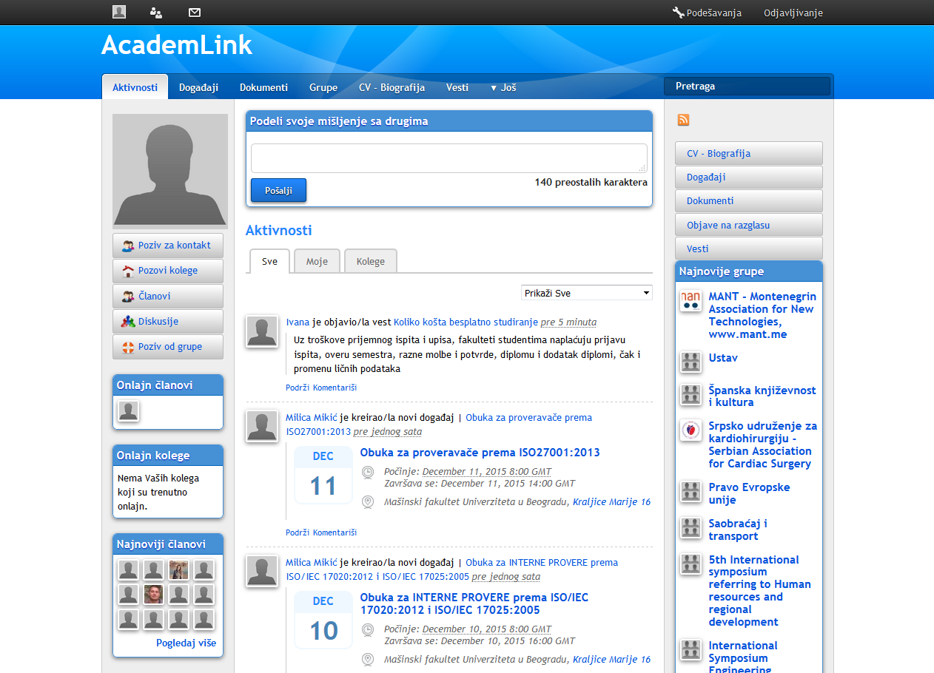
Figure 1: Profile page of an AcademLink member
AcademLink (www.AcademLink.com) is a social network for researchers, university lecturers and post-graduates from SEE (encompassing: Serbia, Croatia, Bosnia and Herzegovina, Montenegro, Slovenia and FYR Macedonia). During the period of four years, AcademLink community has gathered more than 4,000 members, which counted for about 12% of the whole scientific population in the region. AcademLink’s social network utilities include news on higher education and research sectors, discussion boards, inmail messages, CV database, database of scientific papers written mostly in local language and information on scientific events (e.g. conferences, seminars, etc. held in SEE). All members can freely add any of the listed content and participate in all of the activities. The profile page appearance is provided in the Figure 1.
Vast majority of the region population speaks different dialects of the local language (Bosnian/Croatian/Montenegrin/Serbian), while smaller part speaks Macedonian and Slovenian. All regional languages are highly understandable to all nations from the SEE territory. Therefore, AcademLink website and a great part of the content are provided in local languages, while only some of the news are offered in English.
Besides services typical for a social network, AcademLink publishes weekly newsletter “Scientific news of Southeastern Europe,” distributed by email to about 15,000 researchers, decision-makers, university librarians, scientific journal boards and science enthusiasts. AcademLink’s newsletter has been so far the only medium targeting this significant consumer group, providing its members with specific regional information. It covers seven most relevant updates and news on scientific breakthroughs, legal issues in the higher education sector (e.g. plagiarism, corruption, mobbing, new regulations on innovation practices, etc.) and so forth, posted on AcademLink network by its members in the previous week. A special section is dedicated to the announcements of the open calls for funds, scholarships, prizes and fellowships for SEE researchers.
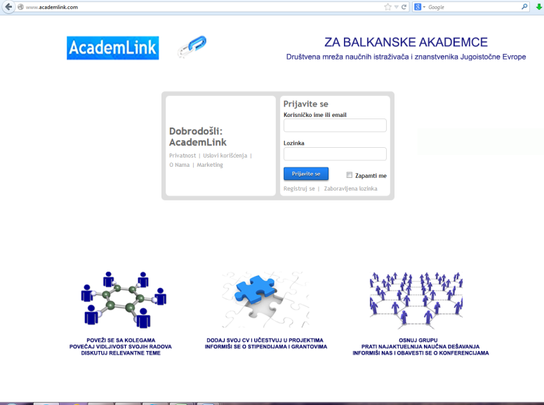
Figure 2. AcademLink login page
Ivana, one of the founders, stated that: “From the very start, AcademLink faced various difficulties. Firstly, internet penetration in the region in question is lower than average in Europe, amounting to approximately 50% of households. Secondly, average age of university staff in SEE is quite high, implying lower level of innovation acceptance and use of information-communication technologies. Furthermore, from the marketing communications point of view, there is a problem in reaching SEE research community, bearing in mind that no medium addresses them specifically. Finally, political and social burden from the recent past (civil war in Yugoslavia in the 1990s of the 20th century) caused the unwillingness of neighboring countries in the region to collaborate, e.g. some of the newsletter subscribers kept sending us emails complaining about us using some words in certain dialect and not in another; why the sequence of news in the newsletter is as it is – why news from some countries are positioned lower than others; or why researchers from some countries seem to have more space in our newsletter and more network posts than others.”
Given the above-stated, there has been a visible lack of cooperation and information flow among SEE researchers. AcademLink founders wanted to address these particular challenges by providing a platform completely available in native languages of the regional researchers, a platform for discussion, networking and collaboration on joint projects. Strong orientation toward communication is also visible from the AcademLink’s login page presented in Figure 2.
“From the beginning and throughout the whole period of AcademLink’s operation, researchers demonstrated the willingness to become members of the social network and to read the content regularly, but not to post anything apart from the events, nor to participate in discussions or groups,” as Maria, editor of the AcademLink’s newsletter and the network member, noticed. Actually, Ivana points out that all features distinctively typical for social networks (and socialization) proved to be underused, while information services have been very much appreciated by the community. Bearing in mind all this, Ivana and Yelena have considered to switch from a social network to an informative portal.

Discussion Questions
1. Why does the science ask for cooperation in the international arena?
2. What are the special utilities of social networks required by scientists compared to other public groups?
3. What other social media, besides social networks for researchers, are especially useful for scientists? For what purposes?
4. What socio-political challenges AcademLink faced with in the international context?
5. List the advantages and flaws of AcademLink and explain how those reflect on its business success.
6. What are the business models behind academic social networks? How do they finance their operations?
7. Advise AcademLink’s management team what to do in the future. Should they change their strategic approach from social to informative media? How can they increase their revenues? What consumer group they need to target?

Additional Readings
Collins, Kimberley, David Shiffman, and Jenny Rock. “How Are Scientists Using Social Media in the Workplace?” PloS One 11, no. 10 (2016): e0162680.
Harseim, Tina and Goodey, Gregory (2016), How do researchers use social media and scholarly collaboration networks (SCNs)?, http://blogs.nature.com/ofschemesandmemes /2017/06/15/how-do-researchers-use-social-media-and-scholarly-collaboration-networks-scns
Kintisch, Eli (2014), Is ResearchGate Facebook for science?, http://www.sciencemag.org/careers/2014/08/researchgate-facebook-science
Matthews, David (2016), Do academic social networks share academics’ interests?, https://www.timeshighereducation.com/features/do-academic-social-networks-share-academics-interests#survey-answer
Natural Sciences Sector UNESCO (2017) International scientific collaboration has become a must, says report, http://www.unesco.org/new/en/natural-sciences/science-technology/single-view-sc-policy/news/international_scientific_collaboration_has_become_a_must_sa/
Natural Sciences Sector UNESCO (2017), Table S10: Scientific publications in international collaboration, 2008-2014, https://en.unesco.org/sites/default/files/tab_usr15_s10_publications _collaboration_en.pdf
Rikken, Maarten (2016), Insights into international research collaboration, https://www.researchgate.net/blog/post/insights-into-international-research-collaboration
Russian reality (2017) “Vkontakte” set a record in Ukraine by number of users per day, https://rusreality.com/2017/05/17/vkontakte-set-a-record-in-ukraine-by-number-of-users-per-day/
Van Noorden, Richard (2014) Online collaboration: Scientists and the social network, http://www.nature.com/news/online-collaboration-scientists-and-the-social-network-1.15711

Social Media Marketing in the Wedding Planning Industry
Sharon Justice
East Carolina University

Case
In 2015 Andi Workman started a small Etsy Shop at her kitchen table in her tiny apartment, hand making a few Christmas ornaments to share with friends. She had always had a creative spirit and loved to share her handcrafted items. When she became engaged, she couldn't find exactly what she was looking for in the wedding industry: simplicity, beauty, and affordability. She quickly dove into the world of wedding stationery, signs, and decor – having no idea that she would discover something that would bring her so much joy as well as a future business venture. Her wedding was beautiful and a few of her friends wanted her help in designing and creating items for their weddings. It was in those moments of creating custom pieces for her wedding and other brides that Workman Creative Co. was born. WCC now offers a complete line of hand designed custom stationery items for every wedding need, hand lettered signs and other custom décor.
Andi is the creative director and the driving force of the business but she is well supported by her husband and her own family of entrepreneurs that are the behind the scenes “workmen.” Over the past year Workman Creative has focused on building a strong, positive following through their Etsy shop. Reviews, favorite shop status, and sales are the measure of an Etsy retailer. While still small, WCC is striving to move to an integrated storefront through their website and targeted, social media interaction. Etsy will remain a vehicle to promote the business, but the website and social media events will become the primary focus of promoting and marketing the business.
Through research, they have learned that the key to growing their business in the competitive wedding market is through word of mouth, positive reviews and personal referrals. As Miller and Washington noted in the retail marketing handbook, “Social media networks are becoming prime vehicles for the wedding industry to market products and services to brides.” In the AM 2014 publication researching the influence on social media and the wedding industry, it was noted how brides of today see themselves as brand managers, seeking that unique personalized experience and sharing it widely on their own social media platforms. It is in this environment that WCC is seeking to promote their unique customized products to couples planning their perfect day.
WCC has done several things over the past 6 months to grow their business:
- Launched a new website with stylized photographs, personal stories and wedding focused products and services.
- Participated in 2 bridal showcase events to build brand awareness and expose a local, target market of couples with wedding dates in the next 24 months to WCC and their beautiful, affordable, customized options
- Joined a regional wedding association that shares social media posts, contests and other interactive strategies to couples planning their wedding, referring them to the exclusive members of the association.
- Created Instagram and Facebook pages for WCC. Launched 1 giveaway and participated in a week long posting challenge hosted by another creative entrepreneur.
- Researched, followed, posted and liked other creatives that compliment WCC products and services without being direct competitors.
- Invested in technology and equipment to support the graphic design and printing requirements to deliver a one stop source for wedding stationery designs.
WCC is now facing several challenges with the business.
How can WCC effectively grow exposure to their business? Andi is a gifted writer and has blogged a little, but she also is a teacher, a wife, and volunteers as a middle school girl leader. How can she keep the blogs, Instagram posts, FB feeds fresh, yet interactive and not an overwhelming daily task that takes away from her creative time?
How can WCC move among the Zones? WCC has strong social publishing through workmancreativeco.com, with content, products, reviews, and ecommerce options. What do they need to do next?
What strategies should WCC utilize to develop a social community filled with brides sharing stories, offering advice and recommending WCC to their own community?
Social commerce is the ultimate goal of this business; growing the business so that it can sustain Andi and her husband, allowing them to move into this work on a dedicated basis, rather than part time on nights and weekends. How would you advise WCC in the development of their social media strategy to achieve this long term objective?
The challenge for WCC: how to keep the content on these sites fresh, interactive and focused on building followers, while also encouraging social interaction from other creatives, current brides and the dreamers, those hoping to plan their perfect day soon. What advice can you offer? What platforms or apps would you recommend to manage this part of the business?

Authentic and Fake Consumers? Accepting the Use of Native Advertisements in Social Media
Sarah Fischbach
California Lutheran University
Jennifer Zarzosa
Henderson State University

Case
(InFeed) Twitter Post:
Hello. My name is Robert Hunt. I am a recovering addict and have been sober for more than 9 years. I live in Los Angeles, California. My troubles with addiction have led me to become a coach, mentor, and friend who enjoys sharing sobriety success stories from around the around. You can follow me on my blog at XLDrugRehabBlog.com as I share stories to help you recover too. You can follow me on Twitter @RecoveryRobert
(https://twitter.com/RecoveryRobert)
Robert is not a recovery addict, he does not live in Los Angeles, California and he does not go by Robert Hunt. Marketing organizations are exploring the use of paying consumers to review products and to be advocates for the brands. One of these strategies is the development of false profiles online through Facebook and Twitter in order to build relationships with a customer and feed information to this specific target market group. Similar to catphishing, the phenomenon of Internet predators that fabricate online identities and entire social circles to trick people into emotional (romantic) relationships, this same approach can be found successful for businesses. Just like the rehabilitation companies using phony online profiles displaying a recovering drug addict. Catphishing is not a new scam, just a new label on a new platform for duping customers and it is important to develop awareness to reduce the vulnerability of consumers.
Social media platforms such as Facebook, Twitter, LinkedIn, YouTube and Instagram are a few companies that come top of mind for both consumers and business professionals. The main purpose of social media is to create a new platform for online social relationships among friends and family. For example, Facebook enables you to post pictures for your friends and family that live across the country or the world, building close relationships over long distances.
Technology makes it easier for us to build these relationships without physical contact. The uniqueness of social media is the incorporation of user-generated content. Users, i.e. the individuals, are providing their thoughts, opinions, beliefs, desires and behaviors to people all over the world. Of course businesses want to be a part of this conversation allowing them to gain access to the content consumers so readily provide online. For example, businesses understand the power of friends and family product suggestions. When a friend or family member suggests/testifies that a product is a great purchase, consumers are more likely to favor this comment relationship more than if it came from a business promotion such as a television advertisement. Companies creating catphishing profiles, posing as a friend of the company or cause has potential powerful influence over the consumer.
The Twitter post by Robert Hunt is a perfect example of native advertising referred to as in-feed ads. Native advertising has become one of the most talked about and controversial marketing topics in advertising. According to the Federal Trade Commission (FTC), native advertising is considered digital media that comes in the form of news, entertainment, featured articles, or product reviews. The twitter post by Robert Hunt discussing topics related to drug rehabilitation can be considered a way to engage consumers through featured articles and news in an informal setting such as social media posts, similar to the in-feed post by Robert Hunt.
The IAB refers to native advertising as a means to bring brand partners together on the digital platform. In-feed advertisements are included on the social media platform such as Twitter that looks similar to a post from a friend or family member however is actually a paid advertisements from an organization (See Figure 1: @RecoveryRobert).
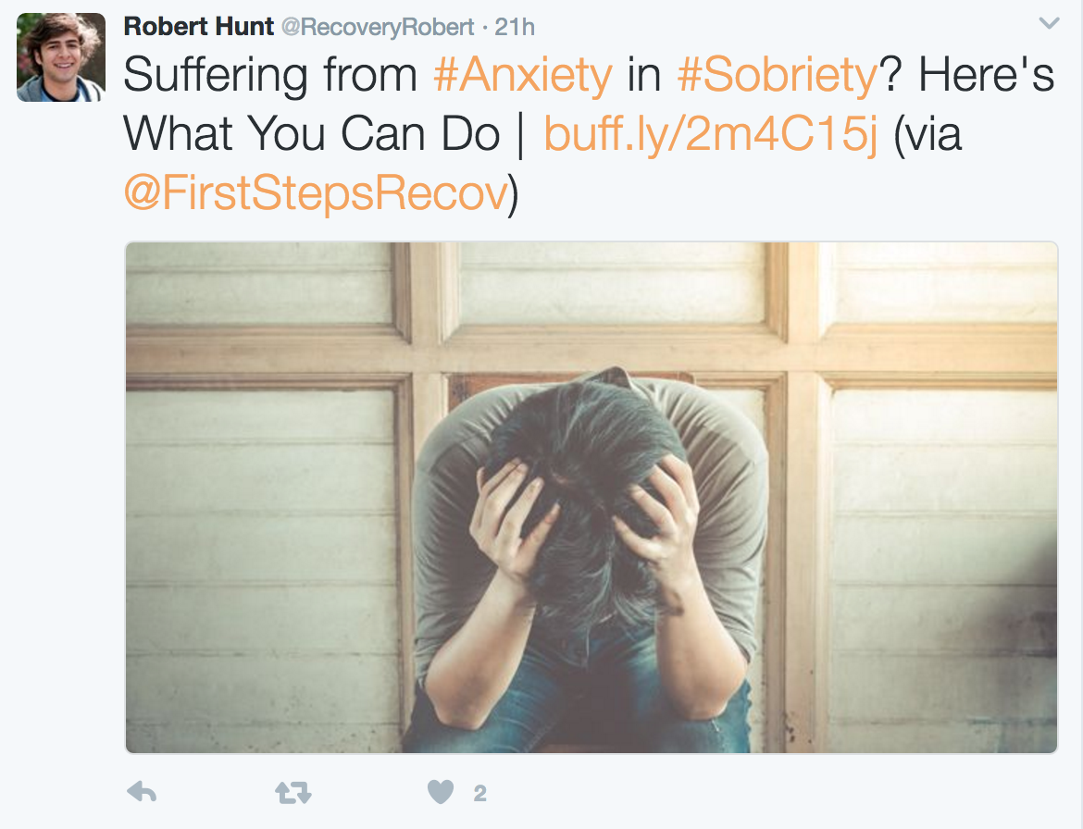
Figure 1: In-feed Twitter post
The use of native advertisements and the regulation around the development of the digital content (such as in-feed posts) is not considered illegal, however is it ethical? Accountability for who is posting content on social media has not been clearly defined within the United States. Although regulation is not clearly defined, organizations have begun to self-regulate their own consumer comments (including in-feed content). For example, Amazon has “verified purchase reviews” requiring that anyone who reviews the product must verify that they have purchased the product through Amazon.com. Amazon has gone further to build trust with their customers including posting articles to help consumers spot fake product reviews. This extra step may build enough assurance for potential consumers by building confidence in their purchases with Amazon.com. Many organizations are countering the effects of deception in native advertisements and it is an exciting time to be a part of this discussion.

Discussion Questions
In small groups of 3–5 students discuss the following questions:
1. Examine in-feed native advertisements. What effects does the use of in-feed ads have on your willingness to click on the content? Have you seen other tactics used by companies to get you to open content on an in-feed post?
2. Search online for more examples of in-feed native advertisements using the Sharethrough website https://www.sharethrough.com/resources/in-feed-ads/ How has your perception of online advertisements affected your trust in the advertiser?
3. Do you believe it is ethical for companies to use “catphishing” techniques to gain customers attention?
4. Debate how your perspective of the organization may change after you found out that the profile is not authentic. Would the use of phony (fake) profiles change your perspective of the organization? Discuss in small groups

Nebraska State Historical Society Foundation: The Nebraska Marker Project Launch
Julia Cronin-Gilmore and Randa Zalman
Bellevue University

Learning Objectives
1. Define the four zones of social media. (Level 1 Blooms: Knowledge)
2. Describe earned, shared, owned, and paid media. (Level 2 Blooms: Comprehension)
3. Apply knowledge of social media zones to the case. (Level 3 Blooms: Application)
4. Analyze strategic tactics pursued. (Level 4 Blooms: Analysis)
5. Develop tactics given the information provided in the case. (Level 5 Blooms: Synthesis)
6. Assess the plan’s success and make recommendations for the future. (Level 6 Blooms: Evaluation)

Case
Like many states, Nebraska has erected permanent informational markers at historically significant locations. Over time, many of these markers have fallen into disrepair. In preparation for the state’s 150th anniversary, the Nebraska State Historical Society Foundation created the Nebraska Marker Project with goals to repair or replace about 100 of the markers, increase awareness of its activities, and raise about $80,000. A project team was formed, made up of the Foundation’s Executive Director and volunteers from the local chapter of the Public Relations Society of America. Together, they created a strategy that utilized each of the four types of media outreach: Earned, Shared, Owned, and Paid. Earned media is “free,” and gained through editorial and feature coverage by media outlets. Shared media results from brand-focused interaction between the marketer and the public through social media platforms. Owned media refers to communication channels that are totally within control of the marketer, such as websites. Paid media consists of messages that are purchased. Tactics for each channel follow:
Earned tactics: Media outreach
Communication goals: Awareness, increase web traffic
Prioritized analytics: Number and quality of interviews, advertising, and PR equivalencies
A news release announcing the project was distributed statewide to media outlets. To help the Foundation prepare for media inquiries, a media training session was held where stakeholders were briefed on media expectations, interview techniques, and gained experience through a mock interview by an actual reporter. This experience was crucial since the press release generated more than 20 interview requests. The story was picked up by the Associated Press, the Washington Times, and many local television outlets. Particularly “high-impact coverage,” such as that from the Times, was also shared over Facebook, along with a “thank you” and an invitation to donate. In the end, the announcement release generated about $2 million in earned media value.
Shared tactics: Social media
Communication goals: Awareness, drive web traffic, donations
Prioritized analytics: Number of posts, number of shares, engagement actions
At the project’s start, the Foundation’s Facebook page had approximately 100 likes comprised of mostly men at 65%. In the 65+ age category, it was 55%. To ensure success, the audience had to be expanded. A project team identified a diverse group of Nebraska thought-leaders who met several criteria: well-versed in aspects of Nebraska history, large community or social media following, and a camera-ready presence. These individuals were filmed making a fundraising appeal near markers targeted for repair. Through a mix of provided talking points and spontaneous ad libs, each of these three-minute videos provided both an informational and a human connection to the roadside landmarks. The influencers featured in each video were also “tagged” in the post to help spread awareness among their circles of influence and beyond. The tagging was an organic reach resulting in not having to pay for promoting the videos. In addition to the influencer videos, the team also created a Facebook fundraiser page, released in 2016. It allowed users to create a page to solicit donations, generate engagement, and provide a trackable link that could be shared in other channels.
Owned tactics: Videos, webinars, newsletters, direct mail
Communication goals: Awareness, identify new audiences, donations
Prioritized analytics: Number of new audiences, library of content, audience reach
The team created a variety of owned elements for the Project. Even though some were non-digital, all were formatted with Facebook sharing in mind. This allowed for “cross-pollination” between traditional and digital channels. Two of the most successful elements were a Historical Society newsletter article announcing the project, and a direct mail appeal to attendees of the state’s annual cancer fundraiser, the Cattlemen’s Ball. In addition to its placement in the organization’s newsletter, the announcement article was also attached to social media posts along with a call to donate via the Facebook fundraiser page. For the Cattlemen’s Ball, the team sponsored a booth at the event and followed with a direct mail appeal to attendees with information on the Marker Project and a call to donate. This single letter generated about $7,000 for the campaign.
Paid tactics: Facebook paid placement
Communication goals: Awareness, identify new audiences
Prioritized analytics: Reach, views, engagement actions
The Marker Project utilized a variety of paid media channels. The launch announcement was broadcast over Facebook Live and promoted to history enthusiasts across the state. An unexpected challenge experienced with Facebook paid advertising involved the platform not allowing promoted posts with images made up of more than 20% text. Unfortunately, the historical markers being promoted featured all text. Often, ads were rejected because of a marker photo, so two workarounds were devised. The first involved featuring a video instead of a photo. Facebook does not scan video for text. The second involved finding angles for marker photos that minimized or obscured the text.
Through the team’s efforts in Earned, Shared, Owned and Paid media, within four months, enough funds were raised to start repairing markers. A check-presentation ceremony for the repair was shared on social media to acknowledge the efforts of donors, reinforce the goals of the project, and encourage further support to continue the work. Metrics also tell the story of the launch’s success. Facebook followers increased from 103 to more than 1,500. These additional followers provide exponential impact as they can be remarketed to, and they gain exposure as they share content. The campaign raised more than $37,000, close to half of the established goal. It received donations from 19 states and two foreign countries, and from other state and county historical societies, a first for the organization. The campaign also generated more than 20,000 video views, received more than $4 million in earned media value, created more than seven million impressions, tripled web traffic compared to same time frame the year prior, and diversified the organization’s Facebook population: June 2016: 65% male, 35% female; 55% 65+, 20% 55-64; followers were concentrated in two cities. By October 2016: 53% male, 46% female; 13% 55-64, 11% 65+, 8% 45-54, 7% 35-44, 5% 25-34; new followers were gained from across the state and country, and from some foreign countries, as well.

Discussion Questions
1. Describe the initial targeted segments. What other segments could have been targeted and what social media channels could have been used?
2. What social media zones were used? What others could be used going forward, and in what ways?
3. When is it a good idea to combine traditional (direct mail, etc.) and digital channels to increase traffic?
4. When Facebook became a challenge due to the “no more than 20 percent text” rule, was it legal and ethical to work around it? In addition to Facebook, what other social media channels could have been pursued, and by what means?
5. What specific tactics would you propose to raise additional funds?
Target segments would help spread awareness and raise additional capital.
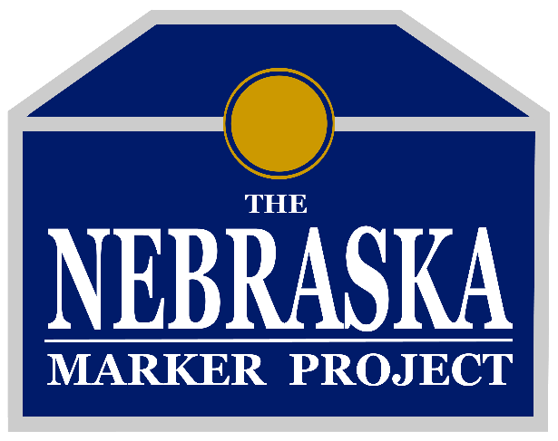

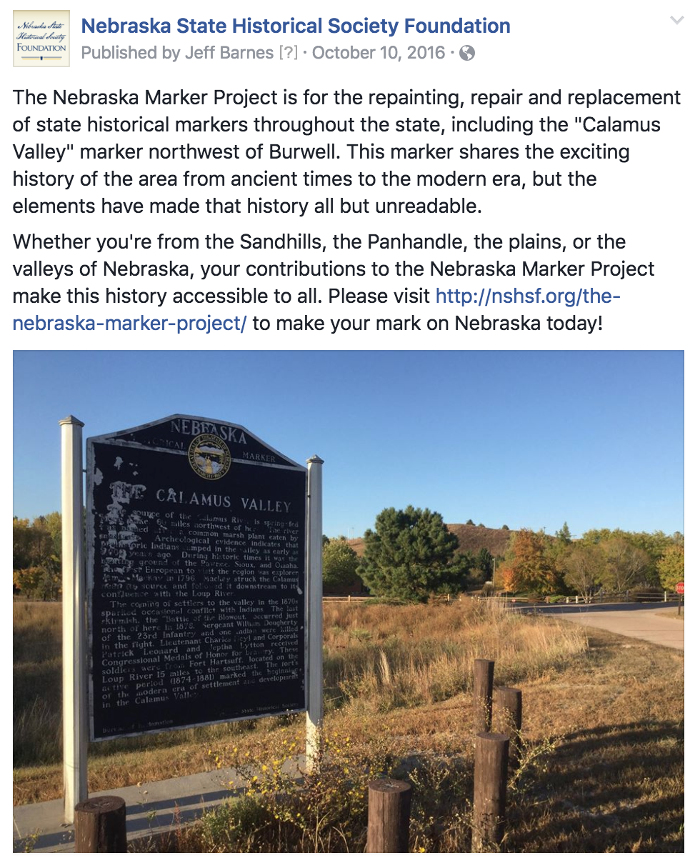

References
The Nebraska State Historical Society website: http://nshsf.org/
The Marker Project website: http://nshsf.org/the-nebraska-marker-project/
Facebook: https://www.facebook.com/NebraskaStateHistoricalSocietyFoundation/
News video: https://www.youtube.com/watch?v=t9RCd_Cp97s
Images: The Nebraska State Historical Society logo, The Marker Project logo, and Burwell marker.

Combining Qualitative Marketing Research with Advanced Social Media Intelligence for Positioning
Rania A. Pilidou
Business Consultant, Greece
Case
Social media are increasingly used to inform decision makers both for insights and forecasts. An increasing number of marketers employ listening platforms that collect comments posted across social media of interest to their company in order to measure the outcome of their own social media strategy, as well as to utilize insights from social media in their marketing research process.
This case study illustrates how typical marketing research methods were combined with advanced social media intelligence in the case of deploying the brand strategy of a popular singer in Greece. The main research objective was to evaluate the extent to which the singer’s intended positioning (how she believes people perceive her) matched the realized positioning (how do people actually perceive her), in order to be able to structure a brand strategy that could support her future ventures.
As a first step, in order to delineate intended positioning of the performer a series of in-depth personal interviews (qualitative marketing research) were conducted, with the singer herself as well as her manager and two other close associates of hers. The main outcome of the personal interviews was the self concept of the singer (intended positioning: how she believes people perceive her) summarized in the following four axes and related descriptors:
1st axis – ORIGINALITY
● non meretricious
● honest
● non-compromising
● daring
● alternative
● authentic
2nd axis – AFFABILITY
● well-intentioned
● giving
● kind
● “one of us”
3rd axis – DEVOTION
● disciplined
● professional
● hard-working
● persistent
● organized
4th axis – FLEXIBILITY
● receptive
● open-minded
● pliable
● adaptable
● transformable
Having delineated the intended positioning of the singer, the next step was to evaluate the realized positioning (how do people actually perceive her). The typical approach would be to proceed with collecting primary data through focus groups (qualitative research) and/ or a survey (quantitative research), but given the ample amount of information in the on line world, social media insights could not be omitted before proceeding.
For analyzing the online image of the of the singer (realized positioning: online) a leading on line listening platform (Qualia, http://qualia.ai/) that provides business intelligence through monitoring and recording of online content was used. Qualia conducted a retrospective search in the period 1 November 2015–1 November 2016 in online sources, i.e. web news, blogs and social media (Twitter, Instagram, YouTube, fora) and collected the body of texts that contained a reference to the singer. In parallel, the content of the official Facebook page of the singer, as well as her fan club Facebook page (that is also administered by the singer) for the period 1 September 2016–15 November 2016, was also collected. A considerable online buzz for the singer was detected, since the aggregate number of identified mentions for analysis (after removing all the “noise” from the data) summed to:
3.279 articles in web news
440 blog posts
29.993 posts in social media (Twitter, Instagram, YouTube, fora)
2.628 posts and comments on Facebook (official page and fan page)
First, the material was manually processed by a team of analysts at Qualia in order to identify categories of themes and emotions. Overall comments were coded for opinion, such as each comment was identified as positive, negative, or neutral (Figures 1 and 2). The online image of the singer was found to be largely positive, since negative mentions were very limited in all three types of sources.
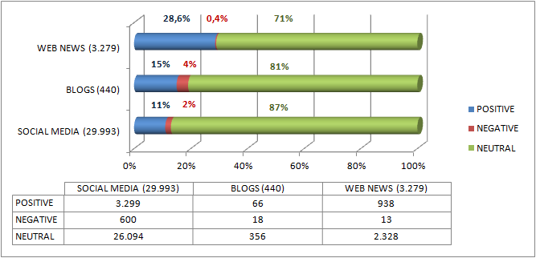
Figure 1. Opinion Analysis
Further, the data collected from the two Facebook pages were processed with the sentiment analysis software of Qualia. Sentiment analysis is intended to identify words that are considered as mood indicators, i.e. words that describe feelings and emotional states, words including intimacy, loud expressive words and words that refer to good and bad. The categorization of the words is done through rules and analysis of language and ends on the following basic emotion categories:
- Pleasure (love, excitement, satisfaction, fun, liking, sympathy)
- Displeasure (disappointment, disapproval, disgust, resentment)
- Anxiety (fear, agitation, anxiety, pessimism)
- Anger (frustration, anger)
- Calmness (composure, calmness, relief)
- Anticipation (anticipation, expectation, optimism)
- Surprise (surprise, query)
The outcome of the sentiment analysis is presented in Figure 2. Overall the emotions that users expressed on both pages through the comments and publications were positive with the majority of users expressing their love towards the singer.
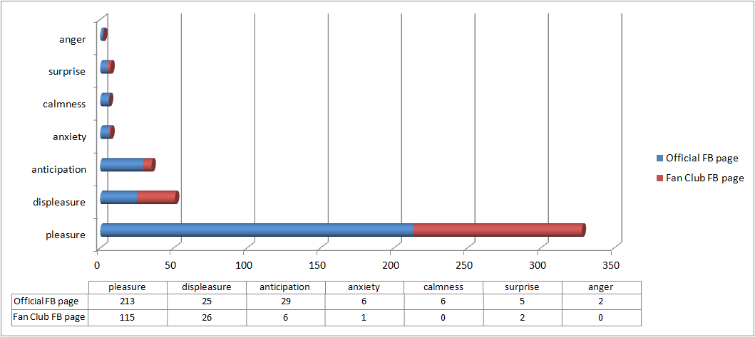
Figure 2. Sentiment analysis
The social media data analysis showed that the realized positioning of the singer as expressed by people’s comments in the online environment is compiled by attributes that only partly match the intended positioning (self concept) of the singer. People that had expressed an opinion in the online environment perceived the singer mainly as subversive, provocative, hot-blooded, unique (“one of a kind”), intense and daring
In addition to the aforementioned analyses, a number of algorithms processed the data automatically in order to produce additional metadata (i.e. new data from the primary data collected) that aid comprehension of different aspects of the information gathered. In particular, all the posts were processed in order to identify some issues/themes that had created high online buzz (i.e. many shares in a limited time frame). The total time each issue/theme remained active online with relatively high intensity, as well as the maximum speed of this period were measured. An indicative number of issues analyzed, along with their evaluation with respect to the singer’s positioning are presented in Figure 3.

Figure 3
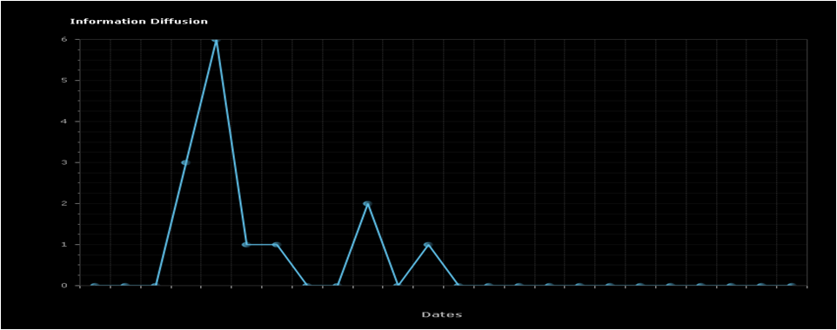
Issue #1: Commercial on the opening of the series concerts
Total number of mentions: 187
Duration: 2 days
Maximum speed (mentions per 4 hours): 6
Evaluation: The commercial is just an announcement that is not related to any attributes of the singer’s positioning. It fails to create a buzz, the issue extinguishes within a day
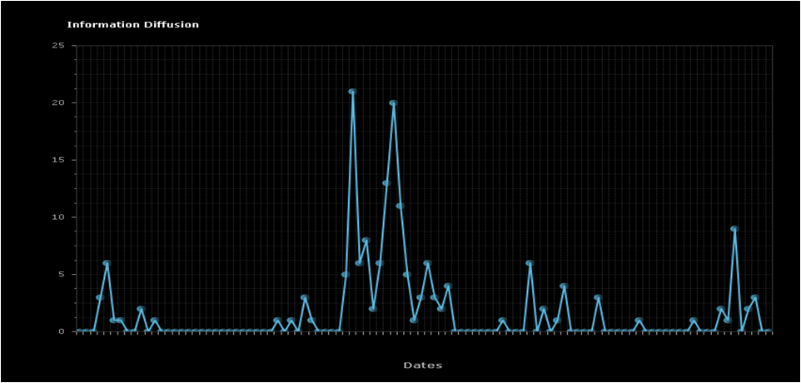
Issue #2: Incident on stage at the opening of the series of winter concerts
Total number of mentions: 198
Duration: 13 days
Maximum speed (mentions per 4 hours): 21
Evaluation: The incident was emphasizing the non-compromising and daring intended positioning attributes of the singer
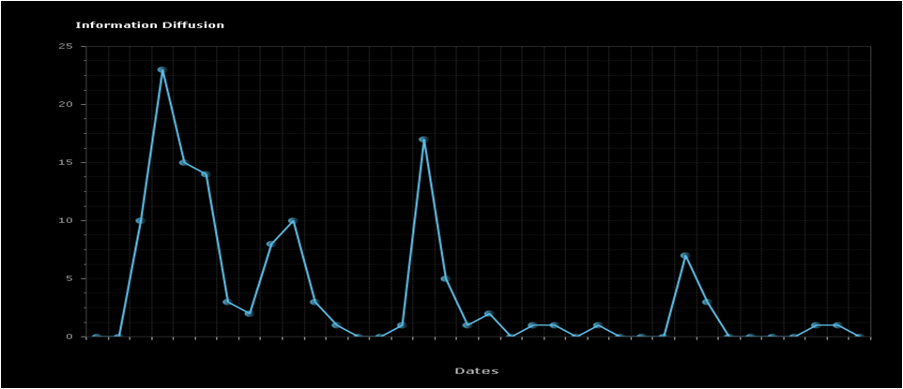
Issue #3: Dressing up on stage as a legendary pop singer
Total number of mentions: 130
Duration: 6 days
Maximum speed (mentions per 4 hours): 23
Evaluation: The issue emphasized the non-compromising, daring and transformable intended positioning attributes of the singer
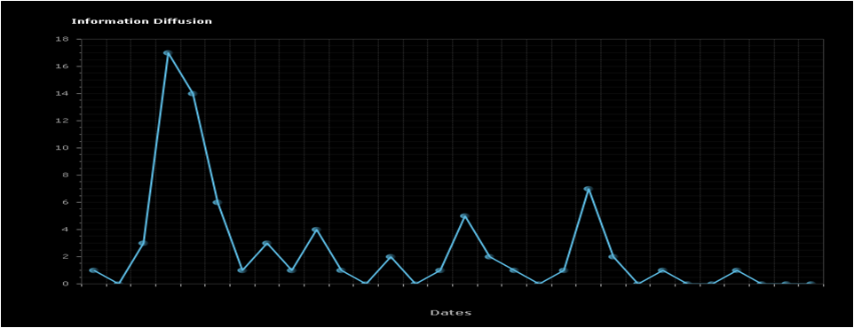Issue #4: Newspaper Interview
Total number of mentions: 74
Duration: 5 days
Maximum speed (mentions per 4 hours): 17
Evaluation: The issue emphasized the authentic intended positioning attributes, combined with the hot-blooded attribute of the realized positioning of the singer
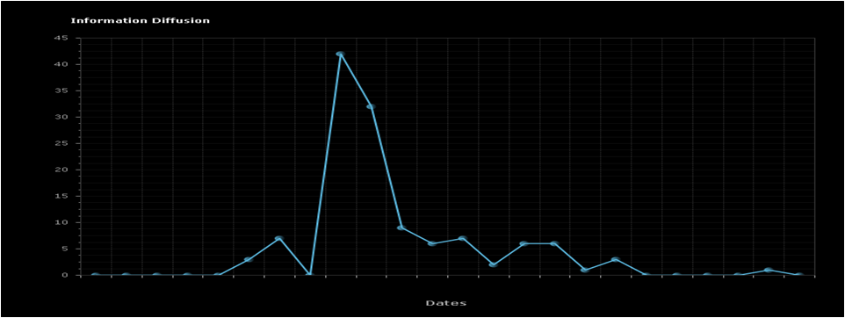
Issue #5: Photo she uploaded on Instagram
Total number of mentions: 125
Duration: 4 days
Maximum Speed (mentions per 4 hours): 42
Evaluation: The issue emphasized the non-meretricious intended positioning attribute combined with the provoking and subversive attributes of the realized positioning of the singer
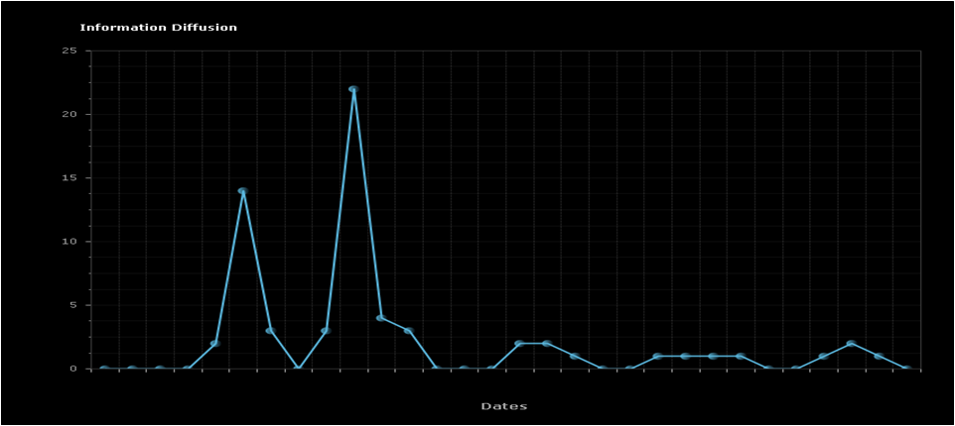
Issue #6: Summer open concert
Total number of mentions: 64
Duration: 5 days
Maximum speed (mentions per 4 hours): 22
Evaluation: The issue emphasized the intense attribute of the realized positioning of the singer
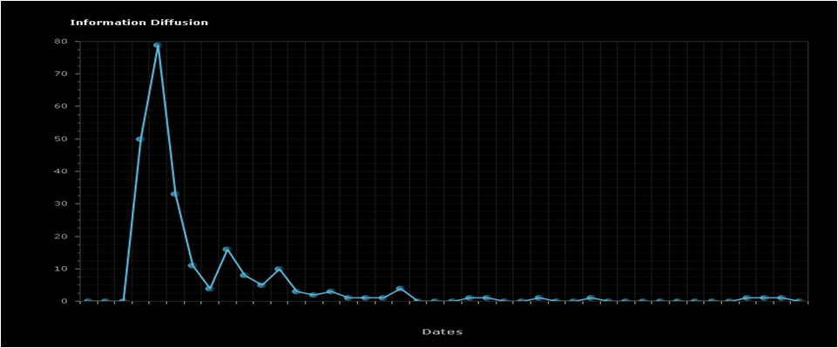
Issue #7: Incidence on Stage
Total number of mentions: 238
Duration: 7 days
Maximum speed (mentions per 4 hours): 79
Evaluation: The issue emphasized the non-meretricious, “one of us” and honest intended positioning attributes of the singer
The outcome of the above analyses were the main input for the development of a well-informed focus groups discussion guide, that is based on both the singers self concept (derived by the in-depth personal interviews) as well as on how people actually talk online about the singer (derived by the advanced social media intelligence).

Evelyn Rusli and Douglas MacMillan, “Snapchat Spurned $3 Billion Acquisition Offer from Facebook,” The Wall Street Journal, November 13, 2013, accessed April 2, 2017, http://blogs.wsj.com/digits/2013/11/13/snapchat-spurned-3-billion-acquisition-offer-from-facebook/.
Paul R. La Monica, “Snapchat is worth more than Delta, Target and CBS,” CNN Money, March 3, 2017, accessed April 2, 2017, http://money.cnn.com/2017/03/03/investing/snapchat-market-value/
Jamie O’Brien, “How 6 Big Brands are Advertising on Snapchat Discover,” Sprinklr, October 12, 2012, accessed April 2, 2017, https://www.sprinklr.com/the-way/big-brands-advertising-on-snapchat-discover/
Alexandra Bruell, “Some Advertisers Struggle to Create Snapchat Ads,” The Wall Street Journal, November 1, 2016, accessed April 2, 2017, https://www.wsj.com/articles/some-advertisers-struggle-to-create-snapchat-ads-1477994401.
Garett Sloane, “Snapchat Persuades Brands to Go Vertical With Their Video,” Adweek, April 26, 2015, accessed April 2, 2017, http://www.adweek.com/digital/snapchat-persuades-brands-go-vertical-their-video-164305/.
Todd Wasserman, “Audi Super Bowl Ad Claims First Use of Twitter Hashtag,” Mashable, February 2, 2011, accessed April 2, 2017, http://mashable.com/2011/02/02/audi-super-bowl-twitter-hashtag/#CGnelz70muqn.
Jack Simpson, “Five seriously creative Snapchat campaigns and their results,” Econsultancy, August 27, 2015, accessed April 2, 2017, https://econsultancy.com/blog/66867-five-seriously-creative-snapchat-campaigns-and-their-results/.
“Audi Takes Snapchat By Storm On Super Bowl Sunday,” Mobile Markeitn Association, accessed April 2, 2017, https://vimeo.com/107336661.
Christopher Heine, “Audi and The Onion’s Snapchat Super Bowl Goes for Quick Laughs,” Adweek, January 31, 2014, accessed April 2, 2017, http://www.adweek.com/digital/audi-and-onions-snapchat-super-bowl-goes-quick-laughs-155433/.
Acknowledgement: I would like to thank Top Class for sharing their business information and thoughts relevant for the creation of this case study. All impressions, advice and conclusions regarding discussion questions provided by the case study participants will be appreciated and received with gratitude on akademci@academlink.com.
Acknowledgements: Alan, Garrett, Collin, and Anna Gilmore, Leslie Fattig, Jeff Barnes, and Jim Svoboda

