ATLAS.ti Resources
Resources for those using Atlas.ti 9 in association with Bazeley, P. (2021). Qualitative Data Analysis: Practical Strategies. London: Sage.
Provided by Dr Steve Wright, independent consultant (www. caqdas.co.uk) and Senior Teaching Fellow/Learning Technologist at Lancaster University
July 2020

Introduction
Pat Bazeley's book considers and explores a broad and diverse range of approaches that researchers can use to comprehensively and meaningfully analyse qualitative data. These are illustrated with approaches to implementing the ideas using paper-and-pen, conventional office software applications such as word processors and spreadsheets and examples from two of the leading, fully featured Qualitative Data Analysis Software (QDAS) packages: NVivo and MAXQDA. A third leading package is ATLAS.ti.
Each package provides tools that will support you in analysis. The following resources supplement those in the book to explore and suggest ways in which ATLAS.ti can be used to support the different approaches and engage with the nuances and differences between the varied approaches to analysis considered in the main text. Chapter references are to the chapters in Bazeley (2021).
With all QDAS packages there are multiple ways to achieve each of the approaches demonstrated in the text and here. Each package includes comprehensive manuals and help guides as well as online learning resources. The illustrations in the book and here in these web resources are therefore not intended as a software guide or manual for any of the QDAS packages used, but instead provide illustrations and suggestions of ways of translating strategies in the book into the components of the software.

About the author of these resources
Dr. Steve Wright is a certified NVivo Trainer, Certified Senior ATLAS.ti Trainer and QUIRKOS certified trainer. Steve works part-time at Lancaster University – a top 10 research intensive University in the UK – as a senior teaching fellow for postgraduate research. He provides training and support in qualitative data analysis software for students and research teams, and support as a Learning Technologist for the Faculty of Health and Medicine. He also runs an independent QDA software consultancy www.caqdas.co.uk providing consultancy, training and support to corporate, governmental and educational groups and individuals on site or online.

Key features of ATLAS.ti
ATLAS.ti offers the core QDAS functions of coding, memoing, linking and searching qualitative data, including support for analysing text, images, audio, video, and importing from social media platforms.
Unlike other packages, ATLAS.ti does not require data to be coded in order to engage in analysis. Rather than being primarily driven by codes ATLAS.ti is built around selecting and connecting data segments, called quotations. These quotations can then be linked to the other project elements. This design integrates processes of coding, linking, annotating and memoing through creating connections to data segments:
- Quotations can be annotated through writing quotation comments.
- Quotations can be linked directly to other quotations to show conceptual relationships between data segments (e.g., disagreement, justification, contradiction, replying, etc.).
- Quotations can have multiple codes linked to them to represent conceptual categories.
  - Codes can be linked to one or more other codes to create queryable, multiple, and non-exclusive relational networks or hierarchies.
  - Unlike other QDAS packages quotations do not have to be coded and extensive analysis can be undertaken with coding playing only a secondary or supporting role.
- Quotations and other project elements can also have memos linked to them. Memos provide a space for extended writing and conceptual development and can be linked to multiple quotations, codes, and other memos.
- These elements and the connections between them can then be visualised and also created and edited through networks.
- Exporting Reports allows you to export the content of one or more elements together with any comments and any linked items.
  - For example, you could output a memo that synthesises your considerations of a conceptual domain along with all the quotations and their comments that it is linked to e.g., selected segments of images and passages of text together with your annotations about these as well the codes and code descriptions.
This infrastructure opens up creative possibilities for implementing the diverse range of analysis approaches outlined in the book. The following resources are designed to present examples to complement the illustrations from MAXQDA and NVivo in the printed text, for those using ATLAS.ti.

Import the Researchers files into ATLAS.ti
You are strongly advised to try applying the suggestions that follow in your own data, but should you wish to explore using the Researchers data, you can create a copy of the project, limited primarily to sources with their coding, using the Researchers 2020 .qdpx exchange project.
As the exchange format project originated from NVivo and there are differences between packages and their implementations of QDAS elements, there will be some differences from the original version. In particular, links from NVivo in a QDPX exchange file aren't converted between packages as each package implements linking very differently – the linked annotations and memos will appear as unattached memos. Additionally, it is likely that sources will be listed without their folder structure, and that there will be a series of empty codes that were auto-created in NVivo from Twitter data (and possibly some others) that will need to be cleaned out.

CH5: Annotating text in ATLAS.ti
ATLAS.ti makes annotating text a core activity. With quotations driving analysis, your annotations in quotation comments are always linked to the data they were written about as well as the ways you categorise that data (through linking codes), and relationally link that data (through linking quotations).
Annotations are made through quotation comments. Double-clicking the coloured bar in the margin area opens a quotation comment for editing (Figure 1).
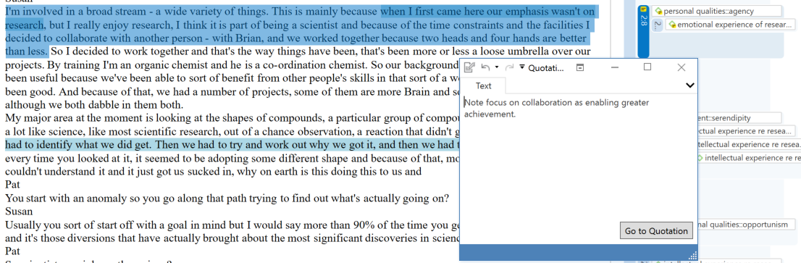

Figure 1 Quotation comment added to Researchers project in interview with Susan

CH5: Keeping a research journal memo in ATLAS.ti
You can create multiple memos. One of the most important is usually an ongoing research or project journal memo.
In ATLAS.ti memos are textual documents that can be linked to other elements – this could be to several key codes (as a code or theme memo) and/or to quotations (as a place for extended writing about one or more segments of data). Memos provide a space to consider and synthesise your ideas and connect them to evidence.
Linking memos and exporting memo reports with their linked data enables memos to be used to supplement and develop the work of coding. However, you cannot directly code segments of a memo. This creates two options:
- Option 1 – copy and paste sections of an extended memo as stand-alone memos and then link them to the relevant quotations and/or codes.
OR
- Option 2 – convert the memo to a document in order to code it like any other text document in your project.

CH6/7: Quotations and codes in ATLAS.ti
As noted in the introduction, ATLAS.ti is ‘driven’ by data segments – quotations – which can be given titles. The title of a quotation can be edited, enabling naming to form one way of categorising quotations – an approach that can be used to help list quotations together.
Likewise, codes have a name and an extended comment area for describing them.
Codes can be linked to multiple quotations to categorise and collect together both the contents of the quotation and any annotations about that data, written in the quotation comments.

Elements of codes in ATLAS.ti and their uses
These features, used carefully and purposefully, will build a useful, meaningful, efficient, and well-structured code system.
- Codes, like all other element in ATLAS.ti, include a name and a comment field.
- The comment field for a code is of unlimited length. It enables extended text with formatting. This makes code comments the most efficient place to write definitions for codes and analytic text about the development and use of a specific code.
- ATLAS.ti works with a flat coding structure where order is added primarily through the careful naming of codes.
- There are additional methods to create and visualise relationships between codes.
- A memo can be created and linked to one or more codes to record the connections between those codes and the data they are applied to. This makes them efficient to use for writing about the development of higher-level categories and concepts that connect or link several codes. These are invaluable for documenting the emerging structure that will be implemented through effective naming, and (potentially) creating code-code links to formalise taxonomies of codes (explored further in notes on CH7).
- Exported reports of memos can include all these linked elements (i.e., the memos, codes and descriptive comments plus data and associated comments)
- Each code includes two numbers:
  - Its groundedness indicates how many times that code has been used (i.e., how many quotations it has been linked to).
  - Its density which shows how many other codes it has been formally linked to by the coder/researcher/analyst. NOTE: this is not the codes it co-occurs with but indicates formal and queryable relationships between codes that are created by the researcher.
Good practice when defining codes in ATLAS.ti:
- Take advantage of the extended comment space to write a brief summary definition but also supplement this with a more extended consideration of the code.
- Make use of the timestamp feature to record when definitions are applied and how / when they change and what prompted that change.
- If you want to explore and write about a code as a higher-level theme, consider using a memo and linking that to the code (and potentially to key quotations that exemplify it).
- When naming the codes use the name structure to order the code list (Theme – Aspect: Detail e.g., Environment – institutional: working conditions)

CH7: Coding in ATLAS.ti
Select a segment of text and right-click to code the segment. This creates a new quotation and opens the new coding dialogue box.
Alternatively, if you select a previously created quotation in the margin, the new coding dialogue box opens with the full list of available codes displayed (Figure 2). You can then select one or more codes from this list. The code comment (which should be a clear definition and description of use) is displayed for a selected code below the list, to help with your selection.
If there is no code with the terms added in the text box you can create a new code by clicking the + symbol. If you type a few letters in the entry field, this filters the code list based on the letters or words. This makes coding with existing codes much easier and you can use this to search and filter codes before creating new ones.
When creating new codes, it is very important that you add a comment with a working definition of the new code as soon as you've started to use it. To do this: double click the code in the margin and edit the comment.
Applied codes for a quotation are shown in the margin. Select ‘Applied Codes’ in the new coding dialogue box to see a list that allows for deletion, should you change your mind.
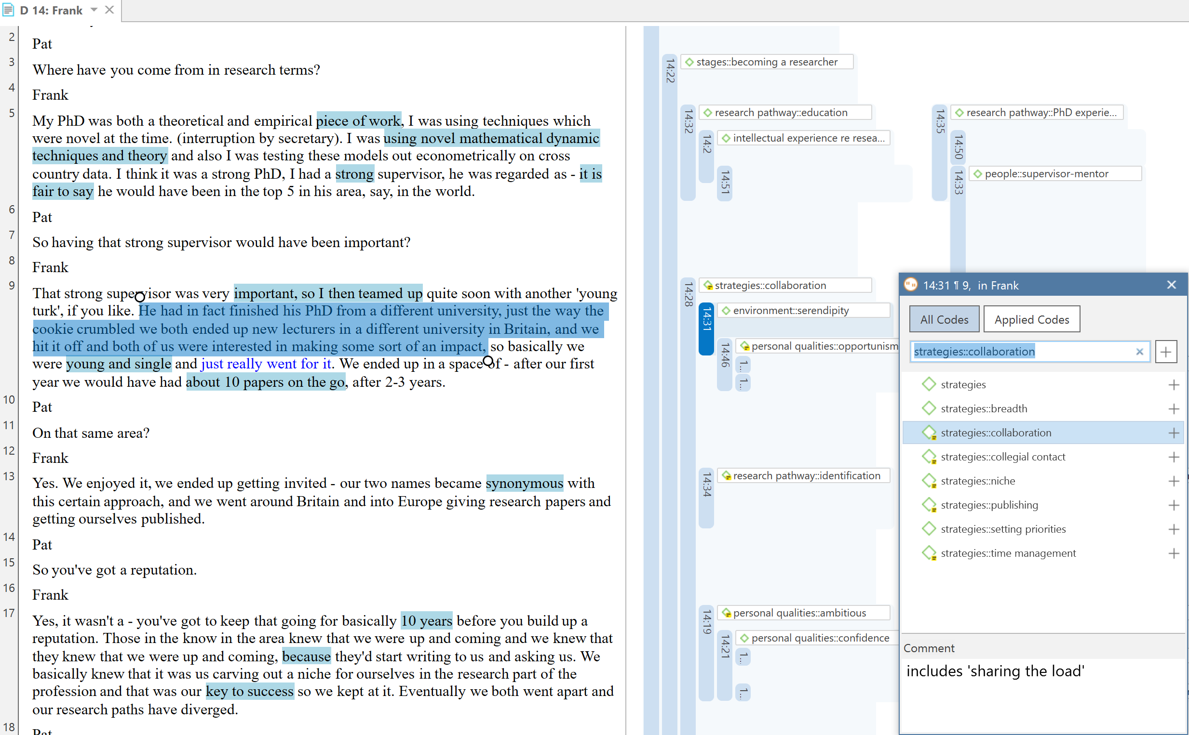
Figure 2 The coding dialogue box

CH7: Organising codes through naming
Use the title to name codes clearly so they are organised and ordered together in the code list.
The Researchers project shows this with a hierarchy of codes, as follows:
emotional experience of research
emotional experience of research::negative affect
emotional experience of research::negative affect::feeling low
In ATLAS.ti the hierarchical name is included as part of the code name. Using naming like this creates a clear code list that orders alphabetically to help show conceptual levels.

Using prefixes to group and organise codes
Prefixes help group codes together. For example:
- Prefix codes with a? If you don't know where to put them in your emerging structure – this way they group together.
- Use other symbols to prefix other types of codes:
  - € or ¢ for Case codes
  - * for particularly frequently used ‘star’ codes e.g., ‘*good quote’ when reviewing your coding for writing up
  - ^ or ~ for ‘reflexive’ codes such as ‘^interesting’ etc.
- Use colons, hyphens, and spaces to show hierarchical relationships and maintain code ordering (e.g., in the Researchers project codes above, :: has been inserted between code name levels).
- It is a good idea to avoid @ symbols as prefixes as these have a special function in the focus group coding tool (and also in twitter data).

Creating higher-level codes in ATLAS.ti
ATLAS.ti enables several ways to create code structures and higher-level codes. The primary process is through applying a clearly structured naming system to your codes, as detailed above.
Adding capitalised CATEGORY CODES helps to keep code lists clearly organised – these capitalised code names are not applied directly to the data but serve to organise a code list rather like category titles in a book index.
While naming like this serves to create a well-ordered list of codes that can be sorted by name and is functional for the purposes of coding data, it does not create formal relationships between the codes that can be directly queried or used directly to aggregate sub-topics to a higher-level code.
There are two main ways of creating that sort of aggregation: using queries and saving them as smart codes, or through creating formal links between codes.
- Add multiple codes to a query using OR operators to pick up quotations coded at any of those codes.
  - If this proves useful, save the results of the query as a ‘smart code’.
- Alternatively, to view the codes as a hierarchical set of relationships (via the code forest and code tree tools) or through a network, create formal relationships between codes:
  - Add links from sub-codes to a higher-level code by selecting then dragging and dropping a code in the list.
  - Having created code structures like this, use operators in the query tool to select a higher-level code and include the logically connected ‘child’ codes.
Linked hierarchies can then be seen within the explorer (Figure 3), as well as in the code forest viewer.
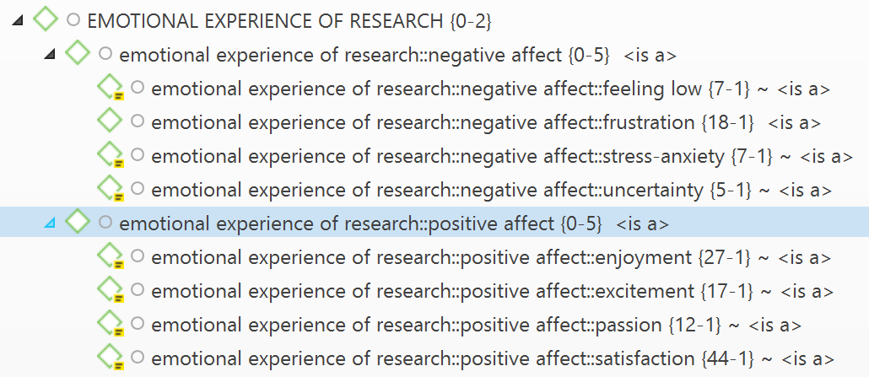
Figure 3 Code hierarchies in the explorer
Furthermore, these relationships between codes can be visualised in network structures (Figure 4). When querying these codes, you can then use the child operators to pick up all codes linked below, above, or as siblings to a code.
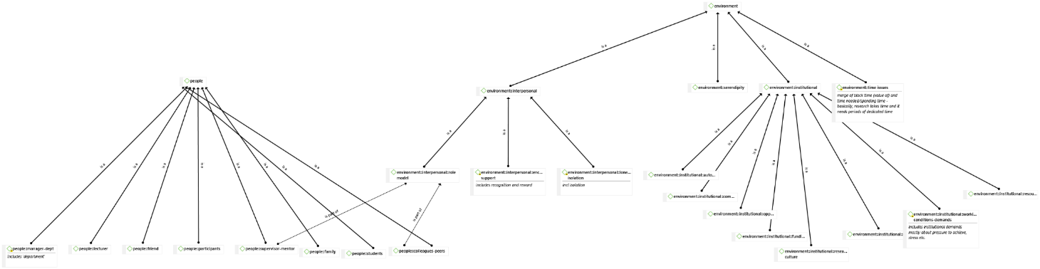
Figure 4 Hierarchical code relationships shown in network view

CH7: Merging and splitting codes

Merging and splitting codes
A code merge tool is available to merge codes that duplicate meaning or application, and the tool to find redundant codes helps identify if identical segments of data have had the same codes attached (note: be cautious of spurious matches with image data!)
If you realise one of your codes is a ‘compound code’, coding two distinct and separate concepts that need to be separated out, ATLAS.ti includes a useful code splitter tool. Choose to create new codes to split the old code into and then review and allocate its coded quotations to the new codes.
For example: In Figures 5–7, the code for ‘institutional working conditions-demands’ is being split and re-allocated to either ‘working conditions’ OR ‘demands’ to refine and differentiate these two aspects of a previously combined / compound concept.
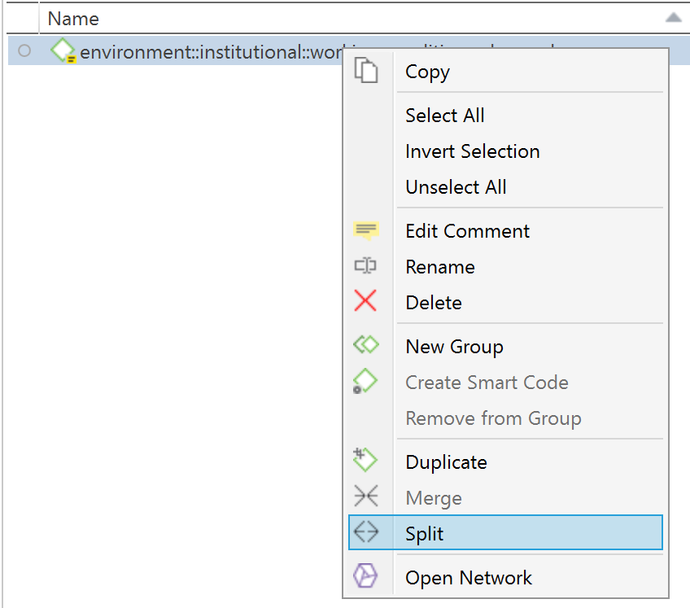
Figure 5 Choosing to split a code

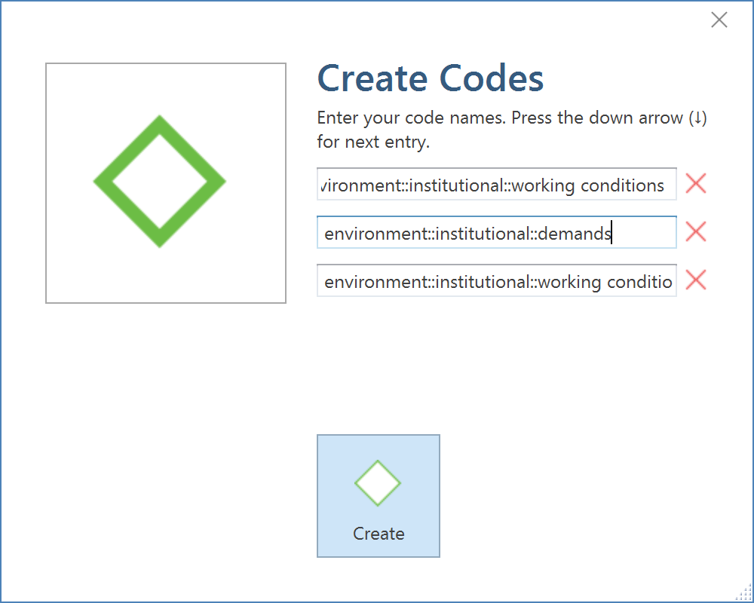
Figure 6 Creating new code names for split codes

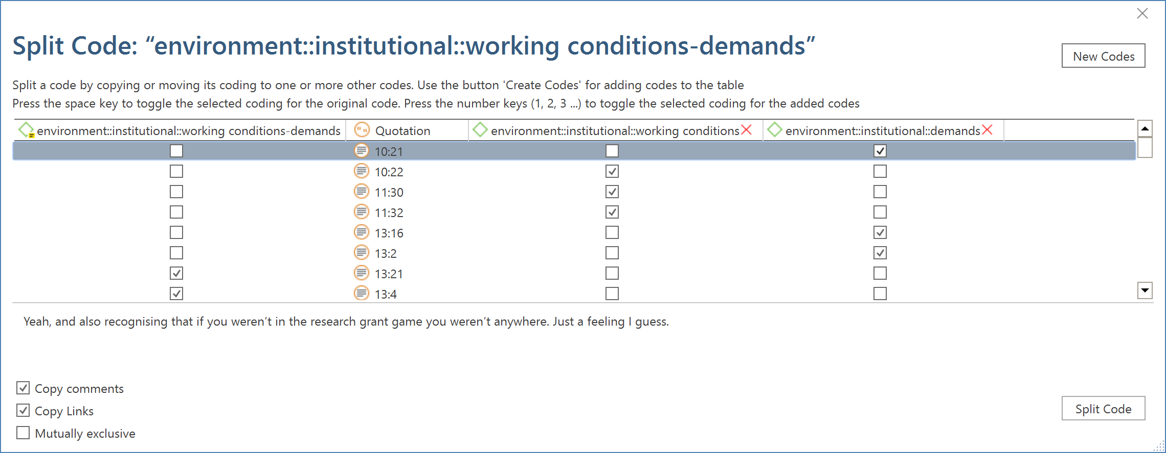
Figure 7 Assigning coded segments to the new codes

CH7: Visual Coding in ATLAS.ti
ATLAS.ti's network visualisation tool provides alternative, flexible opportunities for creatively exploring, visualising, and coding your data.
You can drag and drop quotations from one or many documents onto the network view and then move them around to arrange them into meaningful clusters.
If you turn on the view options to see ‘preview’ and ‘comments’ you will see the content of each quotation together with any annotations you have written about it (Figure 8)
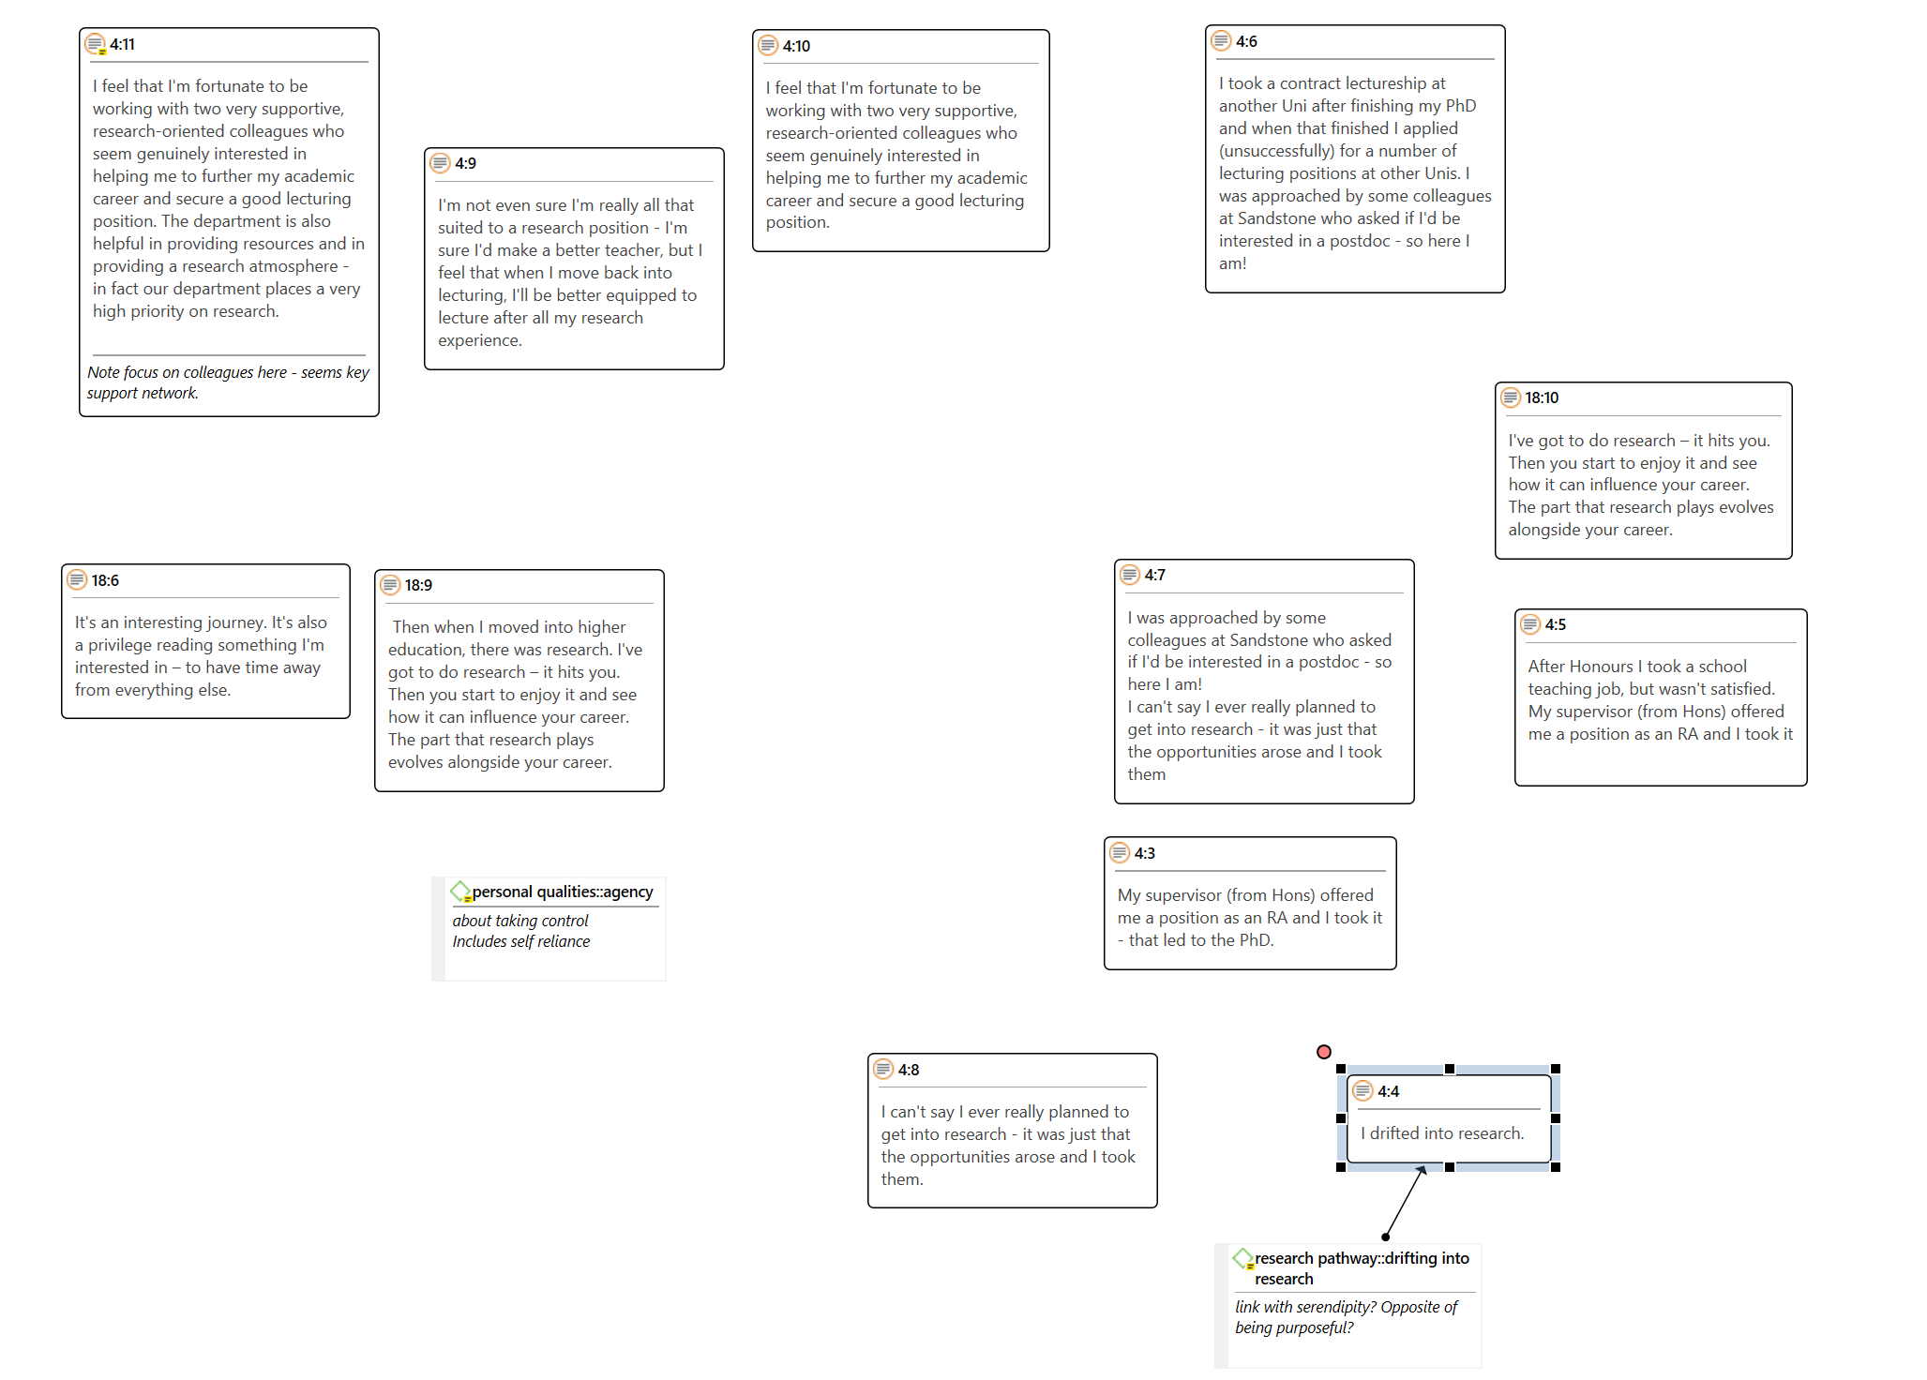
Figure 8 Quotations organised in a network view
You can then work with the quotations to:
- connect concepts by creating labelled hyperlink connections between quotations;
- visually arrange the quotations – manually or by using the different layout pre-sets;
- double click the quotations to view them in context;
- click the new code button or add existing codes via drag-and-drop from the explorer and link them to quotations to code visually.

CH7: Advanced Content Analysis Options with Natural language Processing in ATLAS.ti
Content analysis can be significantly extended and also translated into coding through the Search & Code tab.
ATLAS.ti offers four ways of searching for relevant information in your data that can then be automatically coded:
- Text Search
- Expert Search
- Named Entity Recognition (NER)
- Sentiment Analysis
These are not fully automated but involve you as researcher in the selection and application of codes to data through reviewing the results, making modifications, and choosing what (and what not) to code.
Named Entity Recognition (NER) introduces features for the automatic coding of text to identify words or phrases that that can be categorised as indicating a person, organisation, location, or ‘miscellaneous’ named entities (such as works of art, languages, political parties, events, title of books, etc.).
Sentiment analysis similarly supports the interpretation and classification of emotions (positive, negative, and neutral) within text data using text analysis techniques.
After the search is completed, ATLAS.ti shows you what it found. You can review all categories, or select only one category (Figure 9). This makes it easier to select what you are interested in. It is also possible to change the category identified.
The identified and selected elements can be automatically coded and the codes added into code groups, and/or you can review each of the results in context and code all or selected results with the suggested codes (Figure 10).
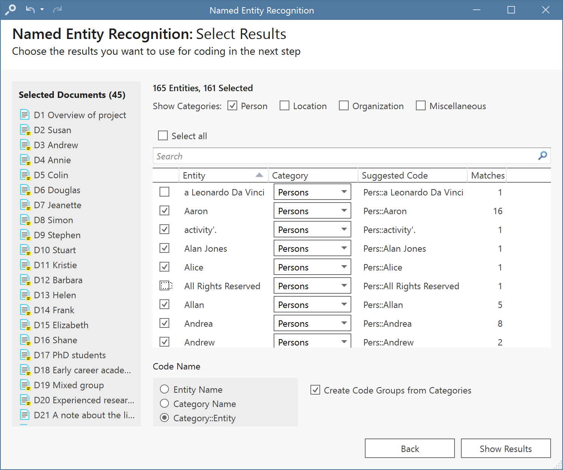
Figure 9 Initial selection of NER search results for persons across the Researchers project
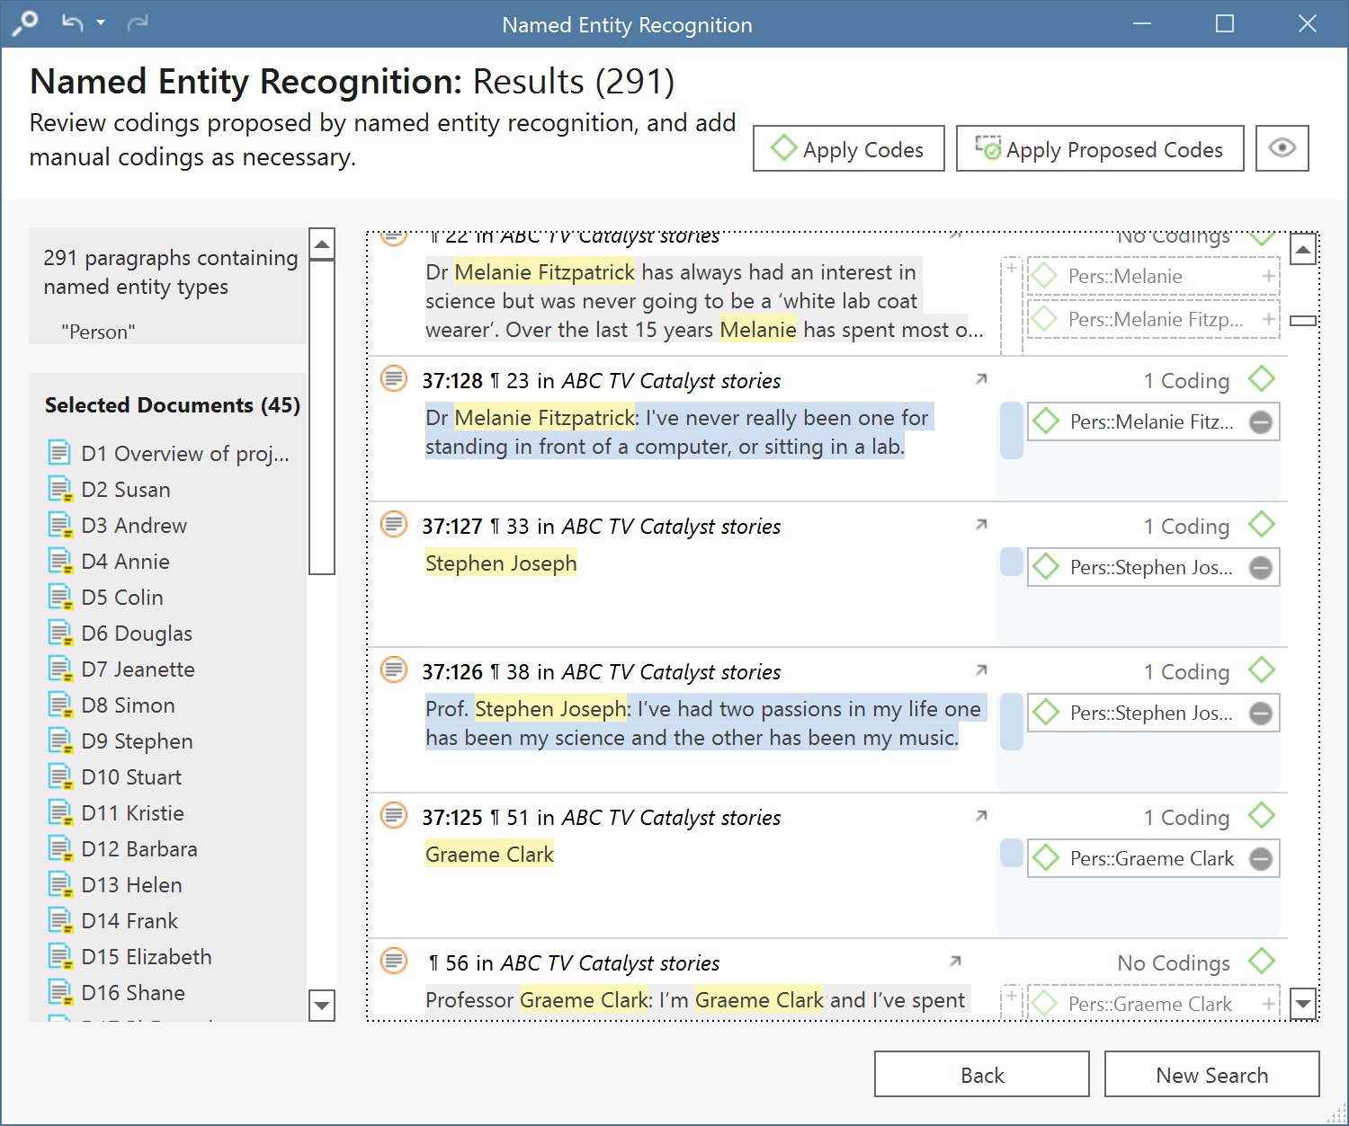
Figure 10 Final selection of search results and coding

CH8: Creating focused (second-level) codes in ATLAS.ti

Using code groups (aka Sets in other QDAS)
Code groups can be created by right-clicking selected codes and providing a name.
- Code groups can also be used – especially for data where there are multiple cases in each document (e.g., in focus groups or fieldnotes) – to create groups for case attributes such as gender, age, etc.

Using formal relationships between codes
Earlier (see CH7: Creating higher-level codes) an implementation approach was outlined for creating code-code links (using OR queries and smart codes, or through creating formal links) to formalise hierarchical relationships between codes. These same processes can be used also to represent, visualise, and query other patterned relationships you find between your codes (i.e., to create metacodes or pattern codes). The intellectual work is in the process of reviewing code comments and their use via the quotation viewer to inform the naming and grouping or linking of codes, and documenting the insights from these through memos. This enables the creation of additional, parallel, and more free-form conceptual linking to be added to your coding structure, visualised in networks and explored in queries (see also CH13).
A detailed and extended consideration of how these can be used is described in Wright, S. (2016). Exploring actor-network theory and CAQDAS: provisional principles and practices for coding, connecting and describing data using ATLAS. ti. Institutional Repository of Technische Universität Berlin, 31.DOI: 10.14279/depositonce-5079. https://depositonce.tu-berlin.de/handle/11303/5485

CH9: Visually comparing cases in ATLAS.ti
Any of the core elements in a project (quotations, codes, documents, memos) can be right-clicked and a network view opened.
Comparing case coding between two or across several cases by visualising in a network view requires comparing documents as a proxy for cases. Select documents – either from the explorer or the document manager – then right-click to open a network based on co-occurring codes for those selected documents.
The resulting comparison, shown in Figure 11 for Susan, Andrew, and Annie, shows greater similarity between Andrew and Susan (perhaps because they are both scientists), than between Annie and Susan.
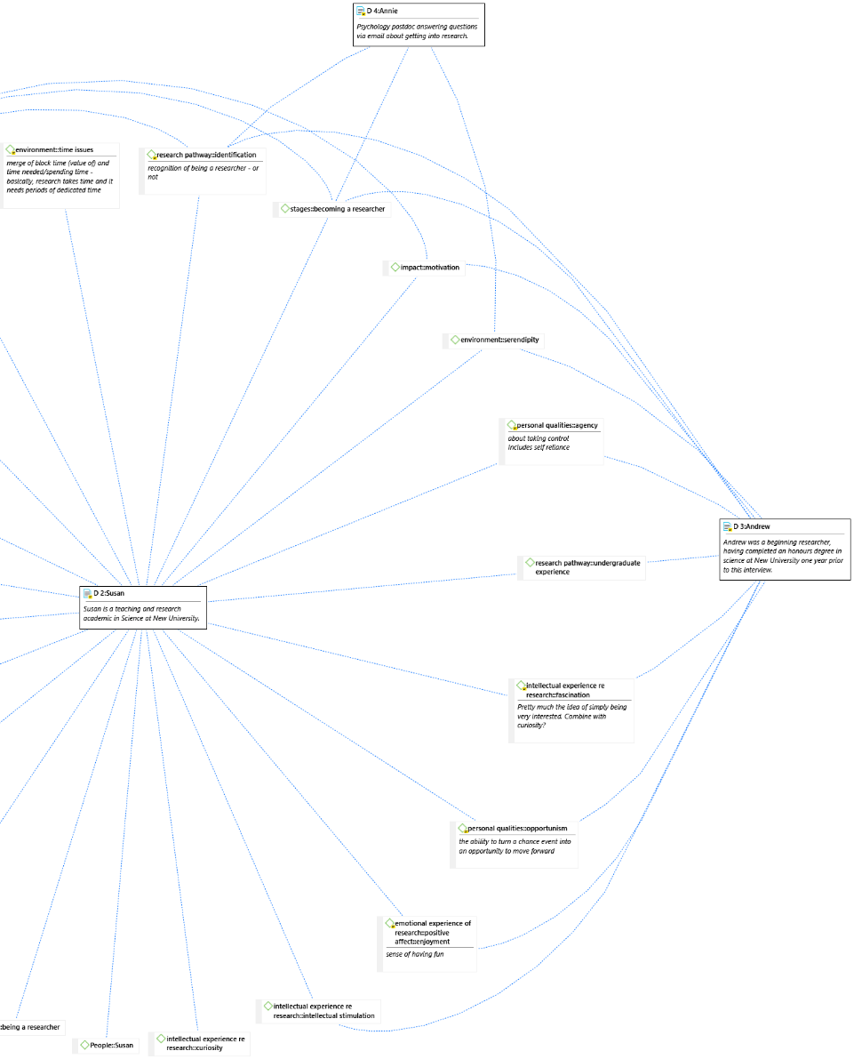
Figure 11 Susan compared to Andrew and Annie (partial network map, with View comments on)

CH10: Tracing narrative structures with ATLAS.ti
The network tool in ATLAS.ti can be applied to arrange and group quotations that trace or map narrative structures within and across data sources. By dragging selected quotations onto a network diagram and previewing both their content and comments you can arrange these into a grid or flow diagram with named links between elements. Neighbouring codes can be added, their descriptions displayed, and links created also between codes. Add linked quotations or further coding if useful, and document it all in a memo. If transitive links are created between codes in this sort of mapping activity, then the code relationships can be queried as well as visualised.
If you need to add additional key concepts to the map to explain and describe narrative elements that are not captured in codes or links between quotations, then you can create a set of short label memos and add these to a network with their content previewed – name them carefully!

CH10: Working with talk and text in ATLAS.ti
ATLAS.ti’s tools include the option to synchronise transcripts with audio or video through to hundredths of a second, making them particularly appropriate for the detailed work of conversation and discursive analysis (CA and DA respectively). See Paulus, T. M., & Lester, J. N. (2016). ATLAS.ti for conversation and discourse analysis studies. International Journal of Social Research Methodology, 19(4), 405–428 for essential guidance on using these approaches in ATLAS.ti (this is useful for those working with other QDAS as well).

Example: Working with Synchronised Transcripts in ATLAS.ti
In Figure 12, a video recording (left) showing writing on a form (recorded using a digital LiveScribe pen) is synchronised with a detailed Jeffersonian transcript of the talk that occurred as the form was being filled out. This enabled detailed analysis of the co-ordination occurring between talk and writing, and of how categorisation and judgement were achieved, recorded and moderated through conversation. This approach – while used here to explore beer judging – has application for considering how standardised tests or surveys are completed in practice (Wright, 2014).
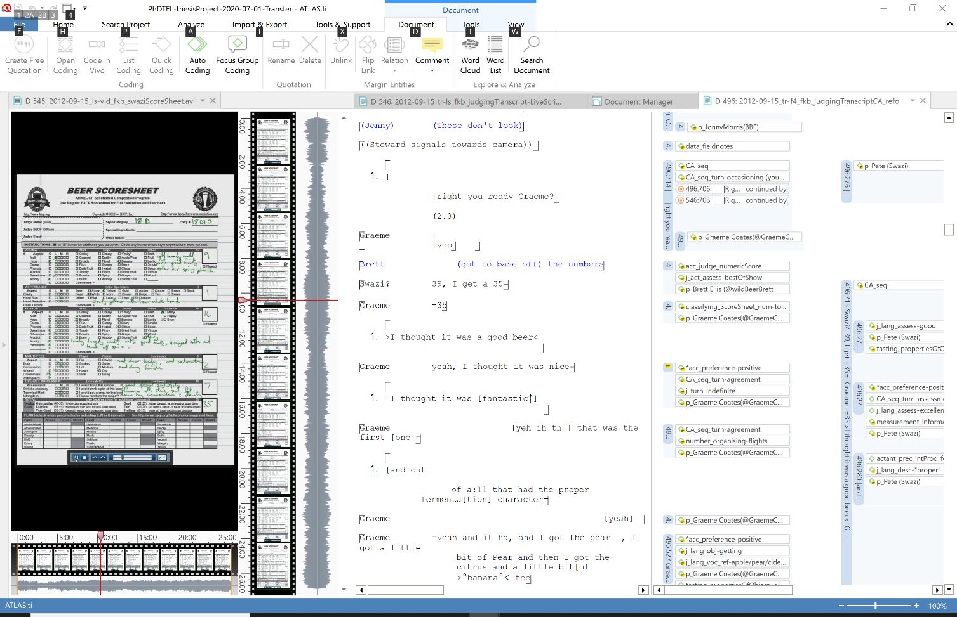
Figure 12 Video with synchronised coded transcript

Example: Working with multiple video sources in ATLAS.ti:
In Figure 13, the screen has been arranged with four tab groups. The two left tabs display two different video feeds: the top one is a video recording of the people judging showing their actions and interaction, below it is the LiveScribe video capturing the writing on a form by one of the two beer judges. At the bottom right is the detailed Jeffersonian transcript, which is sequenced with the LiveScribe video.
These three data sources have had a quotation created for each which matches in duration, start, and finish. These have been linked via a new custom hyperlink for ‘sync link’. The transcript segment has been coded with the code CA_seq, identifying it as a ‘Conversation Analysis Sequence of interest’. Within it, each utterance is coded for speaker and function, and the quotations have been annotated with quotation comments. (It is possible for the transcript to also be edited to include information about actions in the video sources.)
The top right panel is probably the most important: it is a memo used to log the prompt for this focus, the setup of the screen, emerging insights, and also to note the development of coding and queries. This memo will then be linked to the relevant quotations.
See: Wright, S. (2014). Accounting for taste: Conversation, categorisation and certification in the sensory assessment of craft brewing (Doctoral dissertation, Lancaster University). https://eprints.lancs.ac.uk/id/eprint/71741/
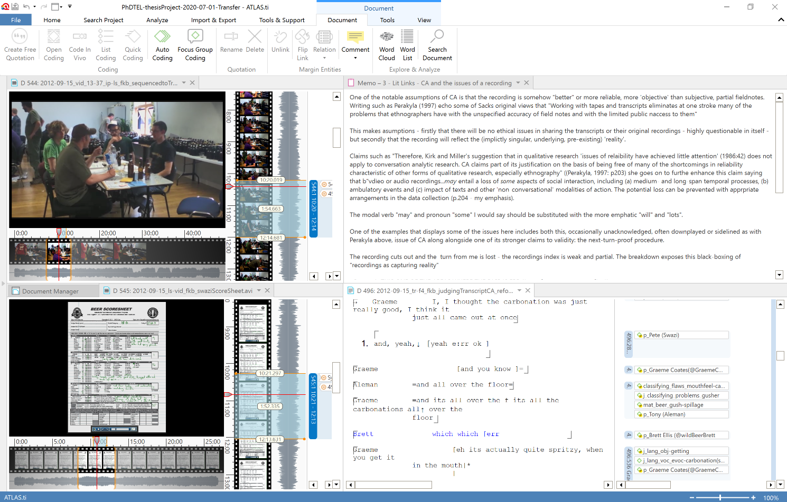
Figure 13 Screen setup for multiple video display with transcript and notes

CH11: Coding images and video in ATLAS.ti
ATLAS.ti offers flexible tools for selecting segments of images or media and adding annotations and codes. Image segments can be included directly in reports, which is especially useful for writing up.
Video frames can be captured and are directly added to the project as an image file. This creates the potential to capture video frame sequences and present them as illustrations. For example, the ‘disgust’ reaction shown in Figure 14 was captured using frame capture in ATLAS.ti to show a sequence of images. A segment with the same dimensions and location was selected and coded from each captured frame and coded with a specific code for writing up: ‘writing-ch6-images:disgust sequence’. These coded segments were exported from ATLAS.ti through a coding report and then assembled in a table in the thesis to show the embodied response of disgust at drinking a beer doctored with lactic acid as part of a tasting certification exam (from Wright, 2014).
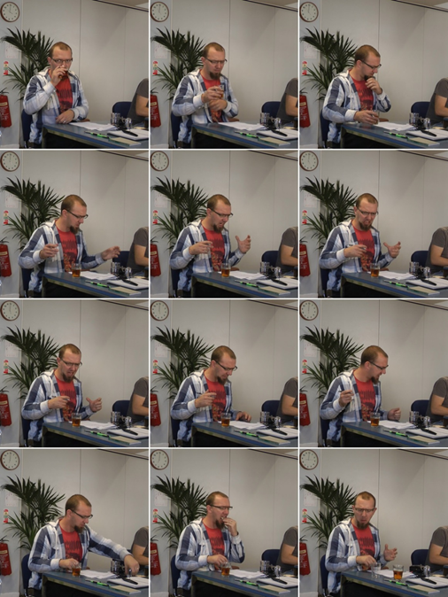
Figure 14 Sequence of video images captured using frame capture in ATLAS.ti

CH13: Mapping and Interrogating your coding system in ATLAS.ti

The code co-occurrence explorer
The code co-occurrence explorer lets you look at and select from your list of codes or documents to see a list of co-occurring codes and then view the code comments and access the quotations.
Open the explorer and select a code; click its arrow to view co-occurring codes. Click their arrows to open each of these to show the quotations as a list. The quotation reader allows you to preview these and make notes on specific quotations. View the content of these quotations to see any informative and/or unexpected relationships; add additional coding if you wish. For example, Figure 15 illustrates a potential relationship showing institutional funding as prompting both negative (frustration) and positive (enjoyment) emotional effects.
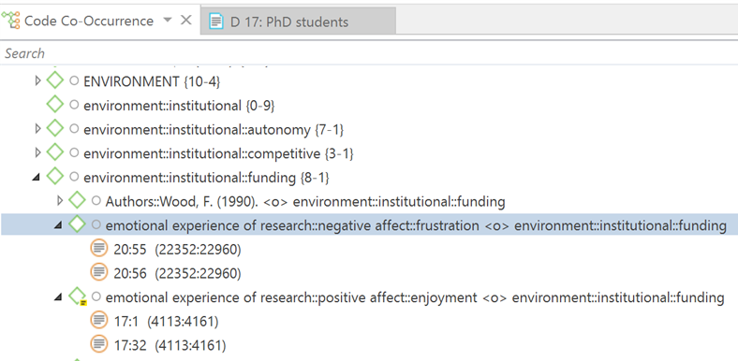
Figure 15 The code co-occurrence explorer

Mapping using the network tool
As considered in previous sections, there are flexible ways to explore and map your coding using the network tool – through dragging codes in and adding neighbours or co-occurring codes, displaying their coded quotations, and iteratively adding other elements to the visualisation. You can also use this display to create new relationships between codes and apply the codes to quotations. This makes the network tool a particularly powerful one for not only visualisation but also extension, review, and refinement of your coding.
Suggestions for working with the network tool:
- Start specific – right-click an interesting segment and open the network view from there, iteratively add other neighbouring elements.
- Make use of switching on and off the different view options – previews and comments are particularly useful.
- Create spin-off networks to focus in on particular elements and explore them in greater depth.
- Creating transitive links between codes will enable you to query the resulting relationships.

CH13: Data Visualisation and Exploration in ATLAS.ti using Sankey diagrams*
Data visualisation is a great way to simplify the complexity of understanding relationships among data. Sankey diagrams give rich interactive visualisation of a complex process, focusing on a single aspect or resource that you want to highlight. They result in attractive graphics for information materials and effective visual data exploration practices.
- Sankey diagrams (e.g., Figure 16) make dominant factors stand out, and they help you to see the relative magnitudes and/or areas with the largest contributions to the selected entity (code or document).
- They offer the added benefit of supporting multiple viewing levels. Viewers can get a high-level view, see specific details, or generate interactive views.
- In ATLAS.ti, the Sankey diagram complements the Code Document Table. As soon as you create a table, a Sankey diagram visualising the data will be shown below the table.
The row and column entities of the table are represented in the Sankey model as nodes and edges, showing the flow between each pair of nodes. In the Code Document table, the connecting pairs are codes or code groups and documents or document groups. In the Code Co-occurrence table, the connecting pairs are codes for both rows and columns. The key to reading and interpreting Sankey diagrams is remembering that the width of a link is proportional to the quantity of co-occurrences represented.
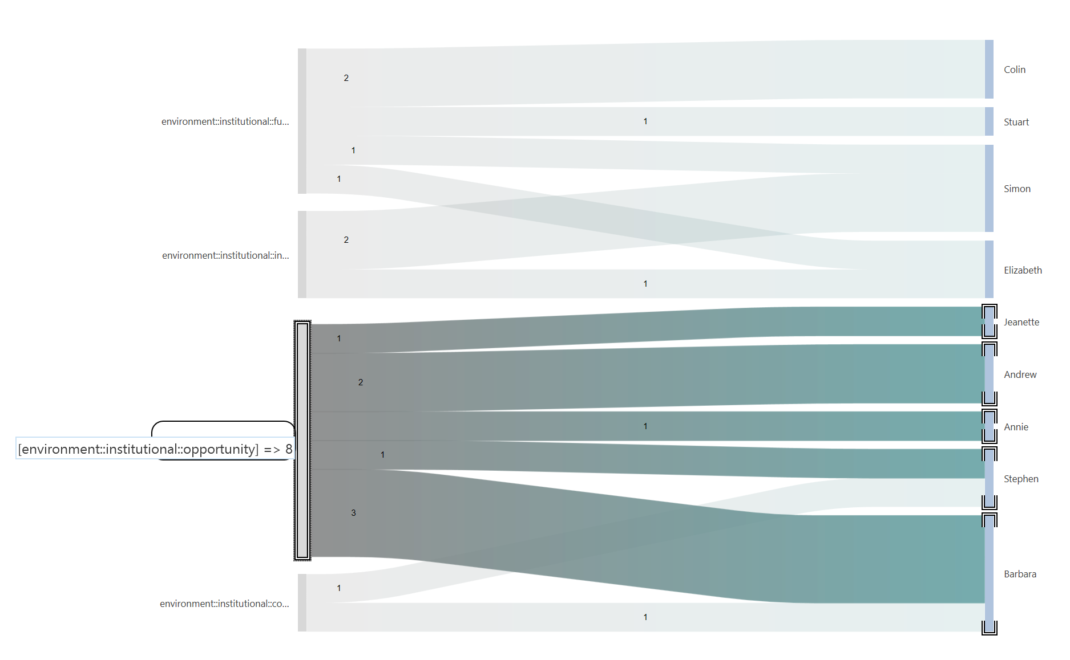
Figure 16 Sankey diagram representing the relationship between codes and documents in the Researchers project – here four different environment codes and individual interviewees.
*With acknowledgement to Susan Friese

CH15: Writing up
One useful option with ATLAS.ti (and other QDAS) is to use memos to track your thinking, the development of an idea and its translation into analytic steps working with the programme elements. As your insight develops rather than copying and pasting text into the memo, you can link the memo directly to key quotations and informative codes. You can then export a memo report including linked quotations (and their annotations/quotation comments) as well as codes and their descriptions. You can further link the memo to other memos that explore aspects of the concept.
This is a great way to create draft chapter sections – with the report output as a word document that includes not only your thinking and draft writing but also the relevant data (including image segments from quotations), notes and the development and operationalisation of conceptual codes.
Useful guidelines (recommended reading!) on reporting when you have used QDAS are provided by Paulus, T., Woods, M., Atkins, D. P., & Macklin, R. (2017). The discourse of QDAS: Reporting practices of ATLAS.ti and NVivo users with implications for best practices. International Journal of Social Research Methodology, 20(1), 35–47.

