Figure 30.1: Paradigmatic penchants in core IR courses

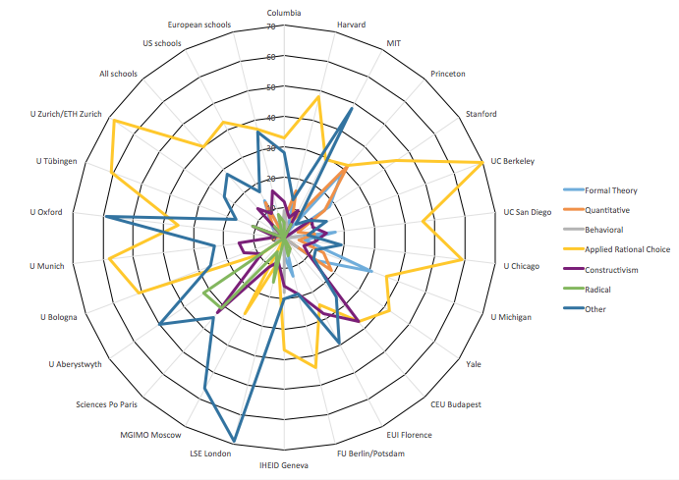

Figure 30.2: Paradigmatic pluralism and parochialism in IR classrooms

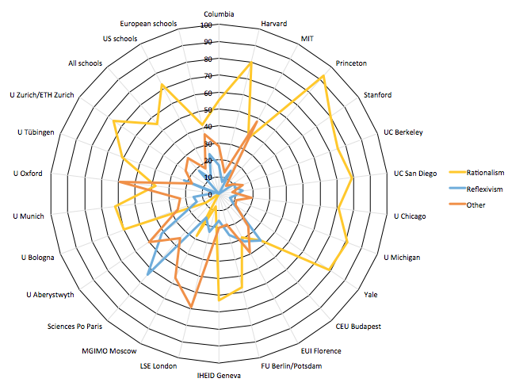

Figure 30.3: Sources of international knowledge

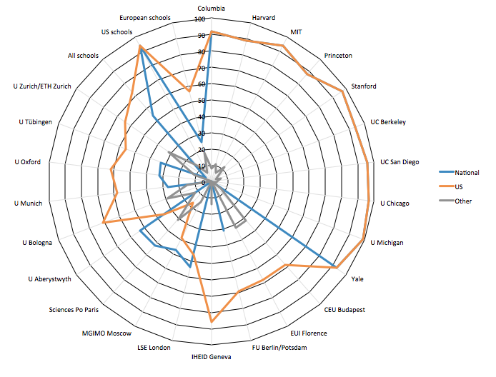

Figure 30.4: Gender of authors and age of assigned readings

