Statement of Work
An Evaluation of the Blended Onboarding Program
Month, Year

1. Introduction
This Statement of Work (SOW) provides an overall understanding of the scope of work, timeline, deliverables, resources, assumptions, and risk factors for evaluating the Blended Onboarding Program at Sawtooth, Inc. The evaluation was requested by the Manager of the Training Department (the Client) and will be provided by the evaluation team of the Performance Improvement and Learning Solutions Department (the Service Provider). The following are the points of contact:
- The client: Ms. Bobbie Allison, Training Manager, Training Department, Sawtooth Inc., 208-426-000X, BobbieAllison@SawtoothMan.com
- The service provider: Ms. Pennie Scully, Evaluation Team Lead, Performance Improvement and Learning Solutions (PILS) Department, Sawtooth Inc., 208-426-000X, EvaluationTeam@SawtoothMan.com

2. Background
The organization: Sawtooth Inc., a manufacturing company in Boise, Idaho, was founded in 2010. Due to the fast growth of business, the company experienced an increasing number of new hires, which resulted in the implementation of a two-day onboarding program in 2012.
The program and stakeholders: The program was initially a face-to-face, instructor-led training program. After a few of years of operating the onboarding program, the company realized that the two-day onboarding program was not sufficient in helping new employees get up to speed. In August 2017, the training department of the company redesigned the program using both in-class and online formats. After operating the blended onboarding program for one and a half years, the training department wanted to have the program evaluated. The evaluation team responded to the request from the Manager of the Training Department (the Client) to conduct an evaluation of the blended onboarding program. The current onboarding program is a three-day blended training program delivered online as well as in the classroom. The overall three-day training schedule is presented in Table 1.

Table 1. Blended On-Boarding Program Schedule
Training day/time | Day 1 | Day 2 | Day 3
Morning (3 hours) | Instructor-led, in classroom | Instructor-led, in classroom | Instructor-led, in classroom
Break (2 hours) | Lunch &  Breakout socialization | Lunch &  Breakout socialization | Lunch &  Breakout socialization
Afternoon (3 hours) | Instructor-led, in classroom | Self-paced, online, in office | Self-paced, online, in office
Although the online curriculum is self-paced, the trainer is still available via e-mail for any questions that new employees may have. The overall goal of the blended onboarding program is to help new employees be able to start performing their job tasks without assistance 90% of the time.
Currently 10 to 20 new employees are hired each month. The blended onboarding program is offered twice a month. The training department, staffed with two instructional designers and a trainer, is open to revising the program content to improve its quality and to help achieve the program goal.
The evaluation purpose and type: Based on the discussion with the training manager, the trainer, and a supervisor of new employees who recently completed the program, the evaluation team discovered that the evaluation findings would be used by (1) the training department staff, including the instructional designers and trainer, to revise and improve the program content; and (2) the new employees’ supervisors to provide adequate support to new employees to help them get up to speed as quickly as possible. Because the staff and supervisors intend to use the evaluation findings to recognize areas for improvement, it was determined to conduct a formative goal-based evaluation to find out how well the blended onboarding program is designed and supported to achieve the program goal and what needs to be changed. The evaluation team will also incorporate a goal-free evaluation approach to find out if there have been any unexpected results from the recent change to a blended program.

3. Objectives and Deliverables
The evaluation will be conducted through two phases: planning and implementation. The primary objectives of the evaluation planning phase are to accomplish the following tasks:
1. Identify or develop a program logic model.
2. Determine evaluation dimensions and evaluation questions.
3. Determine data collection methods.
At the end of the planning phase, the evaluation team will deliver to the client an evaluation proposal, which will include descriptions of the program to be evaluated, specific evaluation methodology to be used, and the team’s assessment of project feasibility and risk factors to be managed during the implementation phase. The proposal will enable an estimation of the evaluation team’s responsibilities and the stakeholders’ involvement during the implementation phase. Upon approval of the evaluation proposal, the evaluation team will proceed with the implementation phase. However, if the project feasibility and risks assessments show a significant lack of the organization’s readiness for implementing the proposed evaluation plan, the evaluation team and the client may decide to delay or forgo the evaluation project.
The primary objectives of the evaluation implementation phase are to accomplish the following tasks:
1. Develop data collection instruments.
2. Collect data.
3. Analyze data with rubrics.
4. Draw conclusions.
Upon completion of the evaluation, the evaluation team will deliver to the client an evaluation final report, summarizing the findings and evidence-based conclusions. The two deliverables are summarized in Table 2.
Table 2. Two Deliverables: Evaluation Proposal and Final Report
Evaluation proposal | Evaluation final report
1. Background  2. Program and stakeholders  3. Evaluation methodology  4. Feasibility and risk factors | 1. Background  2. Program and stakeholders  3. Evaluation methodology  4. Feasibility and risk factors  5. Evaluation results  6. Conclusions  7. Limitations  8. Reporting
References
Appendices

4. Scope of Work and Timeline
The scope of work, stakeholders to be involved, and tentative duration for each task are described in Table 3. Figure 1 is a Gantt chart illustrating the overall timeline. Any necessary changes will be determined through discussion with the client.
Table 3. Scope of Work and Timeline
Task | Participating stakeholders | Start date (duration)
1. Identify or develop a program logic model for the program.  - The evaluation team will offer a one-hour kick-off workshop to the stakeholders to draft out a program logic model.  - The evaluation team will follow up with stakeholders via telephone and/or e-mail as well as in-person meetings to finalize the model. | Training manager  Instructional designer  Trainer  Supervisor | February 4, 2019 (15 days)
2. Determine three to five evaluation dimensions, specific evaluation questions to be investigated, and relative degrees of importance weighting among dimensions.  - A one-hour meeting with stakeholders should be scheduled. | Training manager  Instructional designer  Trainer  Supervisor | February 11, 2019 (15 days)
3. Determine specific data collection methods to be used for each dimension.  - The information can be communicated via e-mail and telephone, as well as in person. | Training manager  Supervisor | February 18, 2019 (10 days)
4. Prepare an evaluation proposal and submit it to the stakeholders to obtain approval.  - The stakeholders will provide feedback to make necessary changes, help finalize the evaluation implementation plan, and approve the plan.  - A significant lack of the organization’s readiness for implementing the proposed evaluation plan may cause a decision to delay or forgo the project. | Training manager | February 25, 2019 (7 days)
5. Develop data collection instruments and obtain approval.  - The evaluation team will develop all required materials to be used to collect data and submit them to the stakeholders for approval. | Training manager | March 4, 2019 (20 days)
6. Collect data.  - With the stakeholders’ support (e.g., granting access to employees and extant data, encouraging employees to participate in the study), the evaluation team will collect data. | Training manager  Instructional designers  Trainer  Trainees  Supervisors | March 18, 2019 (20 days)
7. Analyze data with rubrics.  - The evaluation team will work with the stakeholders to develop rubrics and analyze collected data against the rubrics. | Training manager | April 1, 2019 (20 days)
8. Draw conclusions.  - The evaluation team will combine dimensional results, draw evidence-based conclusions, and develop recommendations. | Training manager  External reviewers | April 15, 2019 (10 days)
9. Prepare an evaluation final report and submit it to the stakeholders.  - The evaluation team will write an evaluation final report and submit it to the stakeholders via e-mail, and arrange a meeting with the stakeholders for a presentation and Q&As.  Note: While completing the tasks listed in this table, the evaluation team will conduct internal and external meta-evaluations to ensure credibility of the methods used and conclusions drawn from the collected data. | Training manager | April 15, 2019 (15 days)

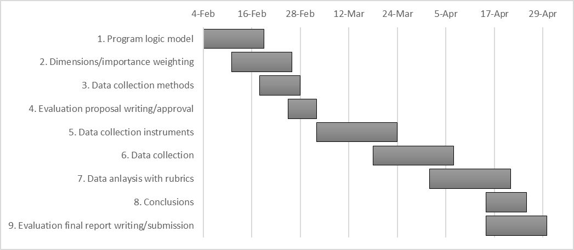
Figure 1. The project Gantt chart.

5. Resources
To successfully complete the evaluation, the following resources are needed:
- Personnel:
- The evaluation team’s expertise
- The evaluation client’s commitment
- Time:
- The evaluation team’s time (approximately 100 hours collectively)
- The evaluation client’s time for communication (6–8 hours)
- Other stakeholders’ time to participate in evaluation activities (1–2 hours/each person)
- Facility and tools:
- The face-to-face meetings will be held in the training department conference room, equipped with a whiteboard, a computer projector, and a flipchart.
- Other formal and informal face-to-face discussions may occur in the stakeholders’ offices.
- Other tools that are needed during discussions will be supplied by the evaluation team.
- Communication:
- In addition to the face-to-face meetings with stakeholders, telephone, e-mail, and/or videoconference meetings will be held to gather information from stakeholders necessary to complete the evaluation.

6. Assumptions and Risk Factors
To successfully complete the project, it is critical to have the client’s support and stakeholders’ active participation. Thus, the following assumptions are made:
- The client provides full support for the project until it is completed, and the evaluation team is committed to completing the project.
- The stakeholders are allowed to participate in in-person meetings and engage in telephone and online communications during their work hours.
- When communicating with stakeholders via e-mail and phone, all messages are returned within two working days.
The currently known risk factors are presented in Table 4. The evaluation team and the client will continue to monitor the risk factors and find ways to minimize the negative impact. Failing to do so may jeopardize successfully completing the evaluation project, and result in rescheduling or canceling the project.
Table 4. A Risk Assessment Matrix
Damage to  project  Likelihood | Minor | Moderate | Substantial | Detrimental
Unlikely | – | Schedule slips | – | Changes in leadership and support for evaluation
Maybe | Employee turnover (changes in program stakeholders) | – | Lack of stakeholders’ participation resulting in missing data from surveys | –
Likely | – | Slow communication between evaluation team and stakeholders | – | –

7. Acceptance Signatures

The Client  Ms. Bobbie Allison, Training Manager  Sawtooth, Inc.  Signature  Date | The Partner  Ms. Pennie Scully, Evaluation Team, PILS  Sawtooth, Inc.  Signature  Date

