Supplementary Digital Content

Practice Exercises

Chapter 2
Chapter 3
Chapter 4
Chapter 5
Chapter 6
Chapter 9

Chapter 2 Practice Exercises
We developed the following exercises to help readers understand some of the concepts illustrated in Chapter 2. The exercises are presented in four sections and suggested answers are provided at the end. We used real studies and evaluations for inspiration when developing these exercises; however, they have been modified for pedagogical purposes and may not accurately reflect the actual goals or findings of the cited analyses.
1. Generating configural questions.
For each research question below, determine whether it is a configural question. If yes, explain why. If no, explain why and modify the question so that it is configural.
- The VERB™ campaign was a national social marketing campaign to encourage US youth aged 9 to 13 to be physically active (Centers for Disease Control and Prevention, 2007). The campaign’s activities included advertising, public relations, promotions, national and community outreach, and web activities.

Research Question: Did the VERB™ campaign result increase physical activity among US youth?
- A management science researcher seeks to understand the relationship between individual personality characteristics and entrepreneurship, particularly among women (Begley & Boyd, 1987).

Research Question: What patterns of personality characteristics (specifically related to risk taking, locus of control, and tolerance of ambiguity) are found among successful female entrepreneurs?
c. Instructional design refers the approach a school uses to provide curricula to its students and different approaches to instruction can be included as part of instructional design (Slavin, Lake, & Groff, 2009).
Research Question: Which combination of instructional design features for high school mathematics education are found in schools with high student achievement among low socioeconomic or vulnerable student populations?
d. Minimum wage is considered by some as a tool for the redistribution of earnings; the impact of minimum wage increases or decreases can have far reaching consequences across an economy (Freeman, 1996).
Research question: What is the impact of a minimum wage increase on the wages and unemployment rate of families below the federal poverty level?
2. Identifying set-theoretic relationships in verbal statements
Identify the following verbal statements as statements of necessity, sufficiency, or both. Draw Venn diagrams to demonstrate the set relationship.
a. All patients with acquired immunodeficiency syndrome (AIDS) have HIV (human immunodeficiency virus) infection.

b. In a nationally representative sample of 56 school districts, all districts that offered student access to mentors increased high school graduation rates by 10% among low income, vulnerable populations.
c. Among 20 interventions to improve customer service by retail clerks within large department stores, an “audit and feedback” component was present among all effective interventions. Further, all interventions using an audit and feedback component resulted in improved customer service.
d. In a study of incarcerated men in the southeastern United States, access to opportunities for higher education reduces recidivism.
e. Health-care associated infections are infections resulting from unsafe or unnecessary health care interventions. Nursing homes with high rates of health-care associated infections employ a high proportion of temporary staff.
3. Identifying set-theoretic relationships from 2X2 Tables
Poor medication adherence can lead to negative consequences for persons with chronic health conditions. A systematic review recently synthesized the effectiveness of interventions to improve medication adherence in this population(Viswanathan et al., 2012). This review included 60 clinical trials; within each included trial a treatment group received an intervention comprised of one or more behavioral-change techniques, and a control group received usual care. Some of the behavioral change techniques included in these interventions were techniques to increase patient knowledge, increase patient action-control, or improve patient self-efficacy. In this review, 34 of the 60 included trials showed a favorable effect of the intervention on medication adherence. Study authors used QCA to identify the combinations of behavior change techniques used among effective interventions (Kahwati, Jacobs, et al., 2016; Kahwati, Viswanathan, et al., 2016).
The following output depicts two-by-two contingency tables generated using data from this example. A “0” indicates that the condition (e.g., various behavioral change techniques) is absent as a component of the overall behavioral intervention and a “1” indicates that it is present. A “0” for the outcome indicates that the overall intervention was not effective at improving medication adherence. A “1” indicates the overall intervention was effective.
For each table:
- Indicate which cells would be used to determine whether the behavioral change technique is necessary for the outcome.
- Indicate which cells would be used to determine whether the behavioral change technique is sufficient for the outcome
- Draw Venn diagram representations of the set relationship between the presence of the condition and the presence of the outcome. For additional challenge, draw a Venn diagram depicting the entire two-by-two table.
Note: the 2X2 tables may be oriented differently in each example below, and may be oriented differently than how they were presented in Chapter 2. We have purposely done this to avoid a mechanistic approach to these concepts. Because no standard approach to creating 2X2 tables exists, it is important to be able to deduce information from them, regardless of their orientation.
a. Assessment of techniques to increase patient KNOWLEDGE as a necessary or sufficient condition for effective interventions.
 |  | Knowledge
 |  | 0 | 1 | Total
Outcome | 0 | 4 (a) | 22 (b) | 26
 | 1 | 0 (c) | 34 (d) | 34
 | Total | 4 | 56 | 60

- Assessment of techniques to increase ACTION CONTROL as a necessary or sufficient condition for effective interventions.
 |  | Outcome
 |  | 0 | 1 | Total
Action Control | 0 | 21 (a) | 29 (b) | 50
 | 1 | 5 (c) | 5 (d) | 10
 | Total | 26 | 34 | 60

- Assessment of techniques to increase SELF EFFICACY as a necessary or sufficient condition for effective interventions.
 |  | Self-efficacy
 |  | 0 | 1 | Total
Outcome | 1 | 14 (a) | 20 (b) | 34
 | 0 | 26 (c) | 0 (d) | 26
 | Total | 40 | 20 | 60

4. Interpreting set notation
a. Select the symbolic notation that represents the following verbal expression of sufficiency:
The combination of a low teacher-to-student ratio combined with use of school-wide positive behavior intervention support and either evidence-based instructional strategies or not using a problem-based learning curriculum is found among schools that reduced the achievement gap by 20% or more between minority and majority populations in 3rd grade.
R= low teacher-to-student ratio
P= use of school-wide positive behavior intervention support
E= use of evidence-based instructional strategies
C=use of problem-based learning curriculum
Y= Reduction in achievement gap of 20% or more

- R+P+(E*~C)Y
- R*P+(E*C)Y
- R*P*(E+C)Y
- R*P*(E+~C)Y

- Select the statement that represents the following symbolic expression of sufficiency:
A*~D(B+C)X
  - The combination of condition A and D combined with the combination of B and C is sufficient for the outcome X.
  - The combination of condition A and not D combined with condition B or condition C is sufficient for the outcome X.
  - The combination of condition A and not D combined with the combination of B and C is sufficient for the outcome X.
  - The combination of condition A or not D combined with condition B and C is sufficient for the outcome X.

Answers
- Generating configural questions
1a. No, this is not a configural research question.
The purpose of this question is to determine whether the VERB™ campaign is effective at getting youth to be more physically active. The type of research designs that could be used to address this question could include qualitative or quantitative, and findings derived from this ultimately could be expressed as “yes”, “no”, “somewhat”, or “yes, for certain populations”. Rewriting this question as a configural question, such as the one illustrated below, would refocus the purpose away from the original research question’s purpose, though may offer complementary insights about the campaign’s effectiveness.
Which combination of VERB™ campaign components result in a large increase (which could be defined in absolute or relative terms) in youth physical activity?
1b. Yes, this is a configural research question.
This question is formulated to look at patterns of characteristics found among a set of individuals defined as being successful; this question takes a configural form.
1c. Yes, this is a configural research question.
This question seeks to elucidate the combination of instructional design features that are found among schools with high student achievement in mathematics among their vulnerable populations. This question takes a configural form.
1d. No, this is not a configural question.
This question is designed to estimate the magnitude and direction of effect on wages and unemployment from a policy intervention that increases the minimum wage. This question could be rewritten configurally as below, but in doing so will change the purpose and focus of the question.
What combinations of economic policies result in a decrease in wages for families just below the federal poverty level?
- Identifying set-theoretic relationships in verbal statements
2a. The relationship between AIDS and HIV infection is one of necessity; persons with AIDS are a subset of all persons with HIV. Infection with HIV is a necessary condition for having AIDS. Persons can’t have AIDS without being infected with HIV. HIV infection is not sufficient for having AIDS since with current medical treatment many persons live with chronic HIV infection and never develop AIDS. Other conditions must be present for persons with HIV infection to develop AIDS, such as poor access to medical care, nonadherence to medication, or other illnesses that cause suppression of the immune system.
All Persons
Persons with HIV Infection
Persons with AIDS

2b. The relationship between students having access to mentors and increased graduation rates is one of sufficiency. Increased graduation rates were present in districts where vulnerable students have access to mentors. School districts providing access to mentors are a subset of all the school districts that experienced increased graduation rates. From the information provided, we cannot discern whether access to mentors is a necessary condition. If this sample also included districts that increased graduation rates without providing students access to mentors, then we can conclude that that access to mentors is not a necessary condition.
56 Nationally-representative school districts
School districts with increased graduation rates
School districts offering access to mentors
2c. Audit and feedback is both a necessary and sufficient component of effective interventions in this example. All interventions using audit and feedback were effective (sufficiency); and all effective interventions used an audit and feedback component (necessity). Depicting this relationship using a Venn diagram involves completely overlapping sets. All cases are members of both sets.
20 interventions to improve customer service
Effective Interventions
Interventions that use Audit and Feedback

2d. This example demonstrates a relationship of sufficiency. Reduced recidivism is found among men who had access to opportunities for higher education. Members of the set of men who had access to opportunities for higher education are a subset of members of the set of men that did not return to prison.
Men with history of incarceration
Reduced recidivism
Access to higher education opportunities

2e. The relationship between high use of temporary staff and high rates of health-care associated infection is one of necessity. In this example, we see that the set comprised of cases that frequently use temporary staff are a superset of the set of cases with high infection rates. All cases with high infection rates use temporary staff, however using temporary staff doesn’t guarantee high infection rates, thus, this condition is not sufficient.
Nursing homes
High proportion of temporary staff
High infection rate

 |  | Knowledge
 |  | 0 | 1 | Total
Outcome | 0 | 4 (a) | 22 (b) | 26
 | 1 | 0 (c) | 34 (d) | 34
 | Total | 4 | 56 | 60
3a. Assessment of techniques to increase patient KNOWLEDGE as a necessary or sufficient condition for effective interventions.

Necessity: consider cells “c” and “d” only.
Consistency of necessity= d/c+d
34/(0+34)=1
Sufficiency: consider cells “b” and “d” only.
Consistency of sufficiency: d/b+d
34/(22+34)=0.57
Venn Diagram for relationship between presence of condition and presence of outcome:
Included a knowledge component(N=56)
Effective interventions (N=34)

Venn Diagram depicting the entire table:
Ineffective interventions (N=26)
Included a knowledge component(N=56)
Effective interventions (N=34)
Did not include a knowledge component (N=4)

Interpretation: Effective interventions are a subset of interventions that use knowledge so techniques to increase knowledge is a necessary component of effective interventions. However, only about half of interventions that use techniques to increase patient knowledge are effective. Many interventions (22 to be precise) that use techniques to increase knowledge are not effective. Thus, we conclude that techniques to increase knowledge are not sufficient for effective interventions. Note in the second Venn diagram that interventions without a knowledge component are a subset of the set of ineffective interventions; the absence of techniques to increase knowledge is sufficient for ineffective interventions. This is logically equivalent to saying that the presence of techniques to increase knowledge is a necessary component for effective interventions.

 |  | Outcome
 |  | 0 | 1 | Total
Action Control | 0 | 21 (a) | 29 (b) | 50
 | 1 | 5 (c) | 5 (d) | 10
 | Total | 26 | 34 | 60
3b. Assessment of techniques to increase ACTION CONTROL as a necessary or sufficient condition for effective interventions.

Necessity: consider cells “b” and “d” only.
Consistency of necessity= d/b+d
5/(29+5)=0.15
Sufficiency: consider cells “c” and “d” only.
Included Action Control component
(N=10 total)
Effective Interventions (N=34)
n=5
n=5
Consistency of sufficiency: d/c+d
5/(5+5)=0.50
Venn Diagram for relationship between presence of condition and presence of outcome:

Venn diagram depicting the entire table:
Ineffective interventions (N=26)
Effective interventions (N=34)
Did not include an action control component (N=50)
Included an action control component (N=10)

Interpretation: Only half of interventions that use techniques to increase action control are effective so we would likely conclude that techniques to increase action control are not sufficient for effective interventions. Similarly, only a few (15%) of effective interventions use action control techniques, so we would also conclude that action control is not necessary for effective interventions.

 |  | Self-efficacy
 |  | 0 | 1 | Total
Outcome | 1 | 14 (a) | 20 (b) | 34
 | 0 | 26 (c) | 0 (d) | 26
 | Total | 40 | 20 | 60
3c. Assessment of techniques to increase SELF EFFICACY as a necessary or sufficient condition for effective interventions.

Necessity: consider cells “a” and “b” only.
Consistency of necessity= b/a+b
20/(14+20)=0.59
Sufficiency: consider cells “b” and “d” only.
Consistency of sufficiency: b/b+d
Effective Interventions (N=34)
Included a self-efficacy component
(N=20)
20/(20+0)=1.0
Venn diagram for relationship between presence of condition and presence of outcome:

Venn diagram depicting the entire table:
Ineffective interventions (N=26)
Effective interventions (N=34)
Included a self-efficacy component (N=20)
Did not include a self-efficacy component (N=40)

Interpretation: Interventions with a self-efficacy component are a subset of effective interventions so we would conclude that self-efficacy is a sufficient technique for effective interventions. However, not all effective interventions include self-efficacy as a component, thus techniques to increase self-efficacy are not necessary for effective interventions.

4a. Choice 4 is the correct symbolic representation of the verbal expression.
4b. Choice 2 is the correct verbal expression of the symbolic notation.

Chapter 3 Practice Exercises
1. Use Table 3-4 (reproduced below) to answer questions about your own research.
Consideration | Questions to Consider
Theoretical | - What is your configural question?  - What theory or conceptual framework in your field will you use?  - What constructs comprise that theory or conceptual framework  - What are accepted types of cases in your field?  - Are the cases relevant to the outcome?  - How are the constructs related to the outcome(s) in the theory?
Empirical | - Are the cases comparable, but different on some characteristics (i.e., will the cases have variation on conditions or on outcomes)?  - How many cases do you have?  - Do you have too many conditions (especially relative to the number of cases)? If so, how can the number be reduced?  - Could the number of conditions be quite small compared to the number of cases (e.g., 3 conditions for 100 cases)? If so, are you failing to capture a condition that may be salient or essential to the analysis?  - Is there variation on the condition and outcome? (Or, is it likely that cases may vary on the conditions and outcome?)
Practical | - Are the data available, or can they be collected (e.g., any institutional review board restrictions, feasibility of obtaining information)?  - Will the data that are available accurately reflect the constructs you are trying to assess?  - How much time, resources, staff, etc. to collect and analyze the data? Are those resources adequate?

2. Use Table 3-4 (reproduced above) to guide your reading of the study listed below.
Although most journal articles will not provide all the details and explicitly address all the questions in Table 3-4 (because journals have space limitations), one can glean some information on case, condition, and outcome selection in methods sections. Review the “Methods” and “Measures” sections of Kane et al. 2017. Identify: a.) what theory and/or conceptual model guided condition selection, b.) how the authors selected the cases and outcome
Kane, Heather; Hinnant, Laurie; Day, Kristine; Council, Mary; Tzeng, Janice; Soler, Robin; Chambard, Megan; Roussel, Amy PhD; Heirendt, Wendy. (2017). Pathways to program success: A qualitative comparative analysis (QCA) of Communities Putting Prevention to Work case study programs. Journal of Public Health Management & Practice. 23(2):104-111, March/April 2017
Full Text Available at: https://stacks.cdc.gov/view/cdc/43983

Chapter 4 Practice Exercises
- Calibrating Continuous Fuzzy Sets
The practice data set provided at the book’s companion website contains raw student test scores on an end of year standardized exam. The range of possible scores for this exam is 0 to 200. The following thresholds for interpretation of scores have been established:
- Less than or equal to 60: not proficient
- 61-99: provisionally proficient
- 100-139: proficient
- 140 or more: superior proficiency

- Using the data set of raw test scores, calibrate using direct calibration with the default logistic function available in most software packages. Plot the raw data scores against the calibrated data scores.
- Now calibrate the same dataset using different settings for the logistic function (set inclusion threshold to 0.01 and 0.99). Plot the results and compare to the plot created using the default logistic function.
- Now calibrate the same dataset using the estimated cumulative density function (ECDF). Plot the results and compare to the plot created using the logistic functions in #1 and #2 above.
- Using the second data set of raw test scores provided at the book’s companion website, calibrate using indirect calibration with the binomial regression function. Plot the raw data scores against the calibrated data scores. Note, in the dataset provided, we have done the initial fixed-value fuzzy set calibration.

- Calibrating Sets-In Depth Review of Existing Studies
The following two studies provide examples of set calibration. Questions for discussion and/or reflection are provided for each study.
Basurto, X., & Speer, J. (2012). Structuring the calibration of qualitative data as sets for qualitative comparative analysis (QCA). Field Methods, 24(2), 155-174. doi:10.1177/1525822x11433998
- What data sources were used for set calibration?
- How did the researchers ensure that data needed for QCA were collected as part of the data collection effort?
- What type of set calibration was used and describe the iterative process used by the researchers to develop the calibration scheme?
Sebastian, J., Allensworth, E., & Stevens, D. (2014). The influence of school leadership on classroom participation: Examining configurations of organizational supports. Teachers College Record, 116(8), 1-36.
- What data sources were used for set calibration?
- What type of set calibration was used in this analysis?
- Describe the approach to calibrating the condition and outcome sets in this analysis? How did the authors manage the lack of an external standard to guide calibration thresholds?

Answers
- Calibrating Continuous Fuzzy Sets
The following table provides the calibrated values generated for the provided data set using the R QCA package version 2.6. The cases are sorted from low to high based on raw score. The thresholds used to directly calibrate the data is as follows:
Fully Out: 60 or less
Cross Over Threshold: 100
Fully In: 140 or more
CaseID | Raw Score | Direct Calibration  Logistic Function (0.05/0.95) (a) | Direct Calibration  Logistic Function (0.01/0.99) (b) | Direct Calibration  ECDF (c) | Indirect Calibration
6 | 33 | 0.007 | 0.000 | 0.000 | 0.028
27 | 43 | 0.015 | 0.001 | 0.000 | 0.046
13 | 45 | 0.017 | 0.002 | 0.000 | 0.051
16 | 45 | 0.017 | 0.002 | 0.000 | 0.051
26 | 49 | 0.023 | 0.003 | 0.000 | 0.062
12 | 50 | 0.025 | 0.003 | 0.000 | 0.065
25 | 58 | 0.043 | 0.008 | 0.000 | 0.095
17 | 63 | 0.062 | 0.014 | 0.033 | 0.121
11 | 65 | 0.071 | 0.018 | 0.067 | 0.132
29 | 67 | 0.081 | 0.022 | 0.100 | 0.145
22 | 69 | 0.093 | 0.028 | 0.133 | 0.158
5 | 72 | 0.113 | 0.039 | 0.200 | 0.180
19 | 72 | 0.113 | 0.039 | 0.200 | 0.180
24 | 76 | 0.146 | 0.060 | 0.233 | 0.213
18 | 85 | 0.249 | 0.151 | 0.300 | 0.302
30 | 85 | 0.249 | 0.151 | 0.300 | 0.302
10 | 87 | 0.277 | 0.183 | 0.333 | 0.325
3 | 90 | 0.324 | 0.241 | 0.367 | 0.360
20 | 91 | 0.340 | 0.262 | 0.400 | 0.372
8 | 93 | 0.374 | 0.309 | 0.433 | 0.397
7 | 99 | 0.482 | 0.471 | 0.500 | 0.474
21 | 99 | 0.482 | 0.471 | 0.500 | 0.474
1 | 113 | 0.723 | 0.817 | 0.667 | 0.652
9 | 115 | 0.751 | 0.849 | 0.833 | 0.675
14 | 136 | 0.934 | 0.984 | 1.000 | 0.862
4 | 152 | 0.979 | 0.997 | 1.000 | 0.935
2 | 171 | 0.995 | 1.000 | 1.000 | 0.975
23 | 184 | 0.998 | 1.000 | 1.000 | 0.987
28 | 190 | 0.999 | 1.000 | 1.000 | 0.991
15 | 191 | 0.999 | 1.000 | 1.000 | 0.991

A plot of raw scores versus calibrated values follows for each approach.
4a.
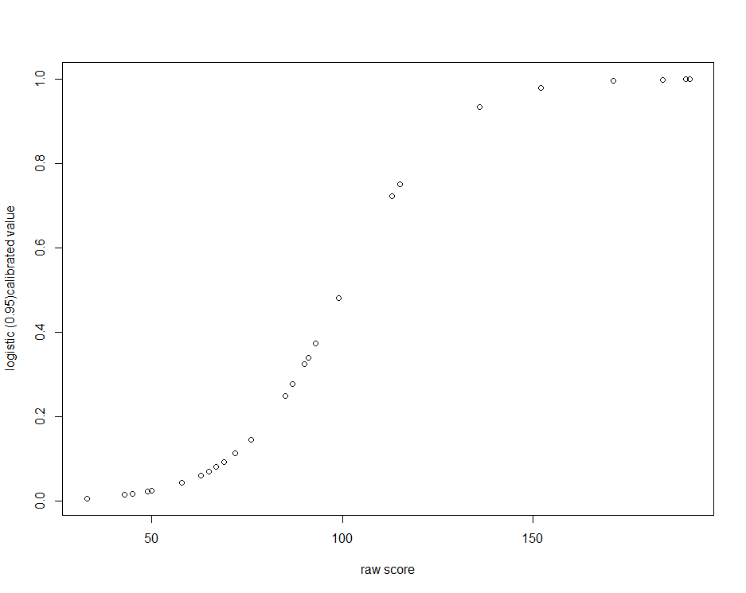

4b.
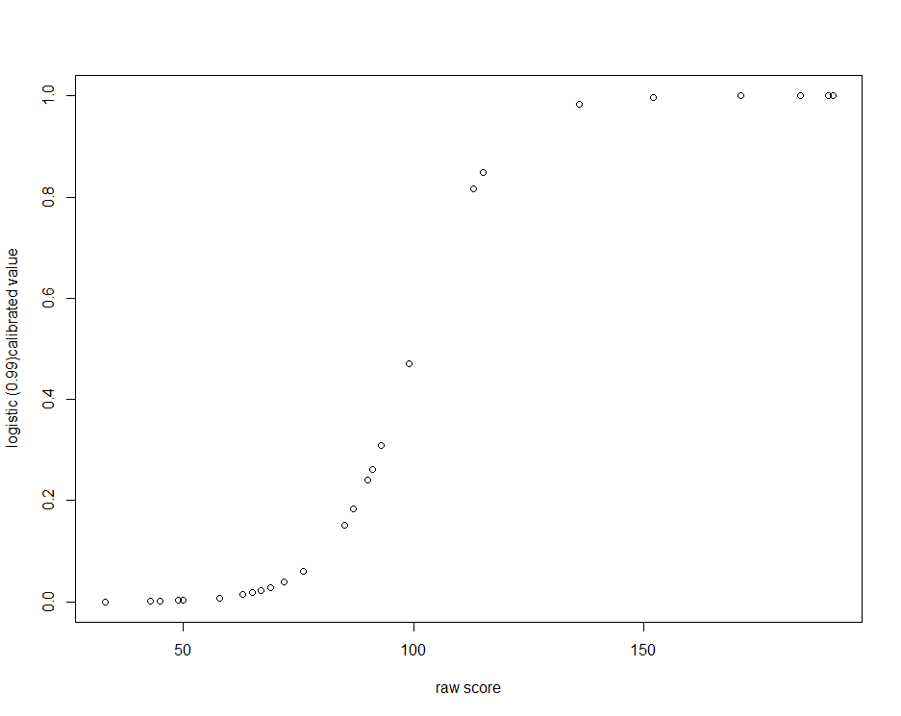
4c.
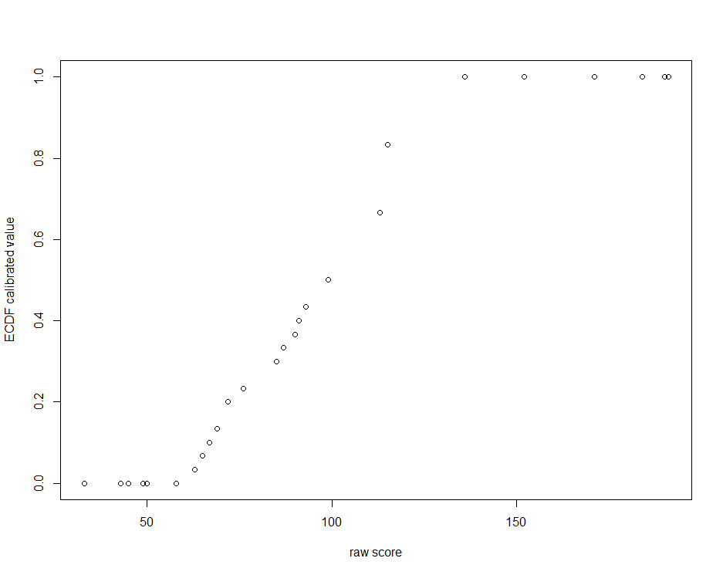
4d.
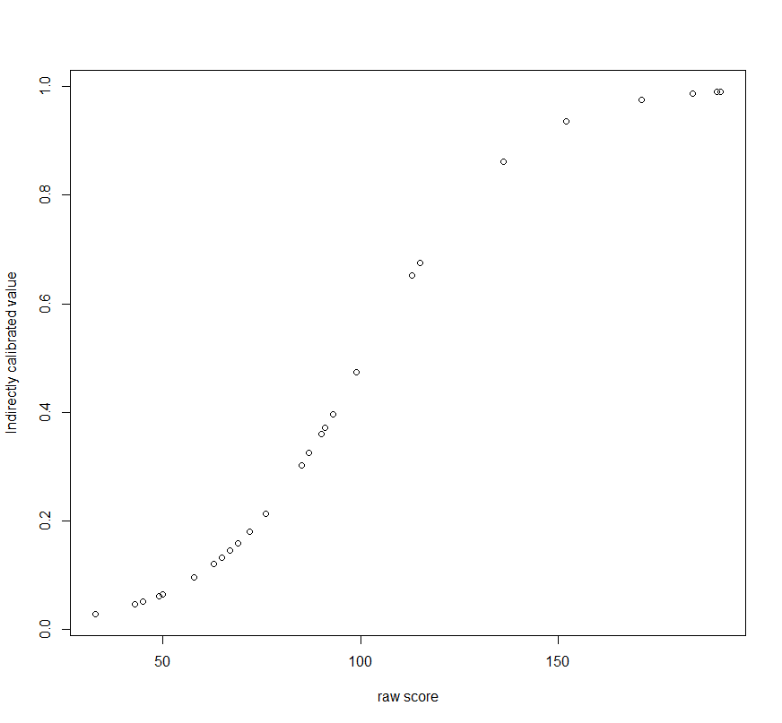

- Calibrating Sets -In Depth Review of Existing Studies
Basurto, X., & Speer, J. (2012). Structuring the calibration of qualitative data as sets for qualitative comparative analysis (QCA). Field Methods, 24(2), 155-174. doi:10.1177/1525822x11433998
- What data sources were used for set calibration?
The study authors used qualitative data collected through semistructured interviews with stakeholders and experts to calibrate some sets for this analysis. In addition to data derived from interviews, the study authors used existing data including meeting minutes, budgets, and other economic, political, or social information about the local government.

- How did the researchers ensure that data needed for QCA were collected as part of the data collection effort?
The interview guides were explicitly developed a priori with the specific conditions selected and the specific qualitative thresholds for set calibration (referred to as “anchor points” in the article) in mind. Subquestions on the interview guide to obtain more detailed responses needed for fuzzy set calibration were specified when initial eliciting questions did not provide enough detail.
- What type of set calibration was used and describe the iterative process used by the researchers to develop the calibration scheme?
Study authors used a fixed value fuzzy set approach. This included thresholds for full in, fully out, more in than out, more out than in, and the cross-over threshold. Although the study authors refer to their scheme as a four-value fuzzy set; they did not count the cross-over threshold (which results in a five-value set).

Sebastian, J., Allensworth, E., & Stevens, D. (2014). The influence of school leadership on classroom participation: Examining configurations of organizational supports. Teachers College Record, 116(8), 1-36.
- What data sources were used for set calibration?
The study authors used administrative data and student test data from a large, U.S., public school district. In addition, the study authors used data from a teacher survey also conducted within the same school district.
- What type of set calibration was used in this analysis?
The study authors used continuous fuzzy set calibration for the outcome set and condition sets. Although not explicitly mentioned in the article, the use of fsQCA to conduct the analysis suggest that direct calibration using a logistic function was used (note: this was confirmed by the study author in a follow-up communication from July 2017). One condition set (“high incoming achievement”) was alternately calibrated using crisp sets in addition to a fuzzy set approach.
- Describe the approach to calibrating the condition and outcome sets in this analysis? How did the authors manage the lack of an external standard to guide calibration thresholds?
For the outcome measure of “student classroom participation”, an initial outcome of student participation, and a second outcome of “very high” student participation were calibrated. For each outcome set, a composite measure derived from the teacher survey was used. A threshold on this composite measure was defined for full set membership (above 75% on initial outcome set), full set non-membership (below 25% on initial outcome set), and the cross-over threshold was defined as 50% for the initial outcome set. For the outcome set of “very high participation”, 50%, 75%, and 90% were used as the raw data thresholds for fully out, cross-over, and fully-in, respectively. The authors demonstrate data to suggest high reliability of teacher survey data, and reasonable correlation between original survey response categories and the transformation of survey for use in calibration.
A similar approach was used to calibrate condition sets related to school leadership and school organizational processes as these sets were also calibrated on the basis of teacher survey data. Condition sets related to school contextual variables were calibrated using continuous fuzzy sets based on administrative data and student test data; fully in, fully out, and the cross-over thresholds are provided, along with the rationale for the thresholds selected. The authors provide a detailed rationale for selection of calibration thresholds, avoiding sample-
driven thresholds in general, and selecting benchmarks informed by known context or that corresponded to prior studies or that would allow comparison across similar studies.

Chapter 5 Practice Exercises

- Drawing Venn Diagrams
Using the solutions in Figures 5-6 to Figure 5-8, draw a Venn diagram for a solution term of your choosing and show the set relations among the conservative, parsimonious, and intermediate solutions.

- Crisp Set Analysis
Use software to transform the crisp data matrix provided at the Book’s companion website into a truth table. Use the checklist in Box 5-6 to guide your analysis. This hypothetical data is for organizations (CASE) that are implementing an initiative to improve job satisfaction among their employees (OUT). The conditions are having leadership support for the initiative (LEAD), having financial resources to support the initiative (FIN), having experience with implementing similar initiatives (EXP), and having dedicated staff to implement the initiative (STAFF).

  - Inspect the truth table:
      - Which truth table rows are contradictory?
      - Which rows are logical remainders?
  - Assess whether there are necessary conditions. Are there any? If so, what are they?
  - Minimize the truth table and obtain the conservative, parsimonious, and intermediate solutions. Set the consistency threshold to 0.8. For the intermediate solution, set your directional expectations to 1 for each of the conditions.
  - Compare the 3 solutions. What do you observe?

- Fuzzy Set Analysis
Use software to transform the fuzzy data matrix provided at the Book’s companion website into a truth table. Use the checklist in Box 5-6 to guide your analysis. This is an analysis of conditions that are necessary or sufficient for delaying first sexual contact for teen-aged girls (OUT). The conditions in the model are having a sense of self-efficacy (SELF), having knowledge about sexually transmitted infections (KNOW), and having religious beliefs that favor abstinence (RELIG).

  - Inspect the truth table:
    - Which truth table rows are contradictory?
    - Which rows are logical remainders?
  - Assess whether there are necessary conditions. Are there any? If so, what are they?
  - Minimize the truth table and obtain the solution. For this solution, why don’t you need to run all three solutions?

- Crips Set Analysis
Use software to transform the crisp set data matrix provided at the Book’s companion website into a truth table. Use the checklist in Box 5-6 to guide your analysis. This is an analysis of state law characteristics that are necessary or sufficient for a reduction in rates of prescribing high doses of opioids (OUT). The characteristics of the state laws are having strong penalties (PEN), having strong enforcement (ENFOR), having few exemptions from the law (EXEMPT), and having a broad/comprehensive definition of the types of opioids the law covers (DEF).

  - Inspect the truth table:
    - Which truth table rows are contradictory?
    - Which rows are logical remainders?
  - Assess whether there are necessary conditions. Are there any? If so, what are they?
  - Minimize the truth table and obtain the conservative, parsimonious, and intermediate solutions. Set the consistency threshold to .8. For the intermediate solution, set your directional expectations to 1 for each of the conditions.
    - Compare the 3 solutions. What do you observe?

Answers
2. Crisp set analysis
- Inspect the truth table:
  - Which truth table rows are contradictory? 10 and 16
  - Which rows are logical remainders? 1, 5, 7, 9, 11, and15
TRUTH TABLE (R OUTPUT)
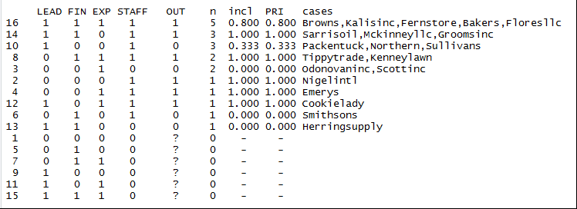

- Assess whether there are necessary conditions. Are there any? If so, what are they? There are no necessary conditions. Although STAFF has a 1.00 consistency of necessity; it has a low relevance of necessity and should not be considered a necessary condition. Recall that there are four tests of necessity, for each combination of the condition and its complement with the outcome and its complement.
Condition and Outcome

inclN RoN covN
-----------------------------
1 LEAD 0.692 0.636 0.692
2 FIN 0.692 0.727 0.750
3 EXP 0.615 0.750 0.727
4 STAFF 1.000 0.429 0.765
-----------------------------

Condition complement and Outcome
inclN RoN covN
------------------------------
1 ~LEAD 0.308 0.812 0.571
2 ~FIN 0.308 0.750 0.500
3 ~EXP 0.385 0.733 0.556
4 ~STAFF 0.000 0.850 0.000
------------------------------

Condition complement and outcome complement

inclN RoN covN
------------------------------
1 ~LEAD 0.429 0.765 0.429
2 ~FIN 0.571 0.750 0.500
3 ~EXP 0.571 0.688 0.444
4 ~STAFF 0.429 1.000 1.000
------------------------------

Condition and outcome complement

inclN RoN covN
-----------------------------
1 LEAD 0.571 0.438 0.308
2 FIN 0.429 0.471 0.250
3 EXP 0.429 0.529 0.273
4 STAFF 0.571 0.188 0.235
-----------------------------

- Minimize the truth table and obtain the conservative, parsimonious, and intermediate solutions.
CONSERVATIVE SOLUTION

PARSIMONIOUS SOLUTION

INTERMEDIATE SOLUTION

- Compare the 3 solutions. What do you observe?
All of the solutions were identical; this means that none of the logical remainder rows were used as simplifying assumptions to reduce the truth table.

3. Fuzzy Set Analysis
- Inspect the truth table:
  - Which truth table rows are contradictory? 1, 2, 3, 4
  - Which rows are logical remainders? None of them.
TRUTH TABLE
- Assess whether there are necessary conditions. Are there any? If so, what are they? There are no necessary conditions.
Condition and outcome

inclN RoN covN
-----------------------------
1 SELF 0.741 1.000 1.000
2 KNOW 0.603 0.769 0.700
3 RELIG 0.707 0.864 0.837
-----------------------------

Condition complement and outcome

inclN RoN covN
------------------------------
1 ~SELF 0.483 0.597 0.491
2 ~KNOW 0.586 0.758 0.680
3 ~RELIG 0.534 0.710 0.608
------------------------------

Condition complement and outcome complement

inclN RoN covN
------------------------------
1 ~SELF 1.000 0.741 0.737
2 ~KNOW 0.643 0.685 0.540
3 ~RELIG 0.810 0.742 0.667
------------------------------

Condition and outcome complement

inclN RoN covN
-----------------------------
1 SELF 0.310 0.655 0.302
2 KNOW 0.619 0.676 0.520
3 RELIG 0.524 0.654 0.449
-----------------------------
- Minimize the truth table and obtain the solution. For this solution, why don’t you need to run all three solutions? There are no logical remainder rows in your truth table, so all three solutions will be the same.
SOLUTION

4. Crisp Set Analysis
- Inspect the truth table:
  - Which truth table rows are contradictory? 4,10, 12, 13, and 14
  - Which rows are logical remainders? 6, 7 and 15

TRUTH TABLE
- Assess whether there are necessary conditions. Are there any? If so, what are they? There are no necessary conditions.
Condition and outcome
inclN RoN covN
------------------------------
1 PEN 0.800 0.654 0.727
2 ENFOR 0.600 0.844 0.783
3 EXEMPT 0.667 0.867 0.833
4 DEF 0.800 0.692 0.750
------------------------------

Condition complement and outcome

inclN RoN covN
-------------------------------
1 ~PEN 0.200 0.750 0.353
2 ~ENFOR 0.400 0.605 0.444
3 ~EXEMPT 0.333 0.600 0.385
4 ~DEF 0.200 0.727 0.333
-------------------------------

Condition complement and outcome complement
inclN RoN covN
-------------------------------
1 ~PEN 0.550 0.846 0.647
2 ~ENFOR 0.750 0.657 0.556
3 ~EXEMPT 0.800 0.706 0.615
4 ~DEF 0.600 0.842 0.667
-------------------------------

Condition and outcome complement
inclN RoN covN
------------------------------
1 PEN 0.450 0.415 0.273
2 ENFOR 0.250 0.600 0.217
3 EXEMPT 0.200 0.565 0.167
4 DEF 0.400 0.429 0.250
------------------------------

- Minimize the truth table and obtain the conservative, parsimonious, and intermediate solutions.
  - Compare the 3 solutions. All three solutions have the same consistency and coverage parameters. The conservative solution is a subset of the intermediate solution, which is a subset of the parsimonious solution.
CONSERVATIVE SOLUTION
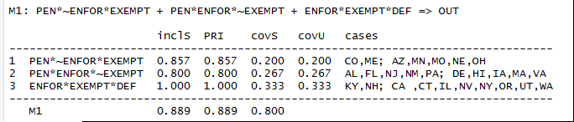
INTERMEDIATE SOLUTION
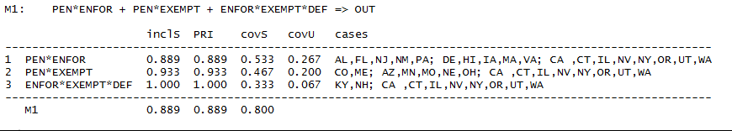
PARSIMONIOUS SOLUTION
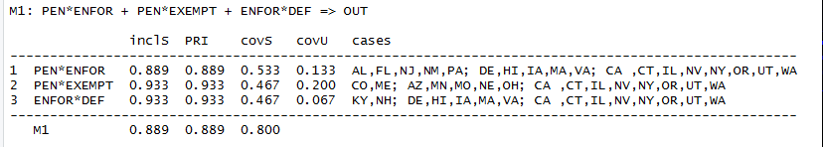

Chapter 6 Practice Exercises

- Use the checklist in Box 6-2 to conduct model analytics on the analysis from Question 4 of Chapter 5 Practice exercises.

Note: some steps may be difficult to perform as a practice exercise without the underlying raw case data.
  - Review the parameters of fit (solution consistency and coverage) for each solution. Consider whether case selection or condition or outcome selection and calibration should be respecified.
- Evaluate the simplifying assumptions made on logical remainders for the parsimonious and intermediate solutions to determine if the software made any implausible or incoherent assumptions.
- Assess whether model ambiguity is present.
- Conduct robustness tests
- Add or exclude cases.
- Change calibration points.
- Change row consistency threshold used for minimization (check 0.75 and 0.9)

Answers
Use the checklist in Box 6-2 to conduct model analytics on the analysis from Question 4 of Chapter 5 Practice exercises. Note: some steps may be difficult to perform as a practice exercise without the underlying raw case data.
  - Review the parameters of fit (solution consistency and coverage) for each solution. Consider whether case selection or condition or outcome selection and calibration should be respecified.
The solution consistency is 0.89, which would be considered a moderately strong relationship of sufficiency. The solution coverage is 0.80, which suggest moderately high empirical relevance; in other words most (80%) of cases with the outcome are covered by this solution. One might consider evaluating the cases in the contradictory truth table rows as they all have a row consistency close or at the consistency threshold. Alternatively, one could reevaluate the calibration points used for one or more conditions.

  - Evaluate the simplifying assumptions made on logical remainders for the parsimonious and intermediate solutions to determine if the software made any implausible or incoherent assumptions.
The software used row 6 and 15 as simplifying assumptions.
PEN ENFOR EXEMPT DEF
6 0 1 0 1
        - 1 1 1 0

The configurations represented by these rows appear plausible based on what we know about this area of research, thus no implausible assumptions were used. We did not identify any necessary conditions, so these assumptions don’t contradict any earlier findings of necessity (because there were none). Lastly, we generated the conservative, parsimonious, and intermediate solutions for the outcome complement.
CONSERVATIVE SOLUTION (OUTCOME COMPLEMENT)
M1: ~PEN*~ENFOR*~EXEMPT + ~PEN*~ENFOR*~DEF + ~PEN*~EXEMPT*~DEF + ~ENFOR*~EXEMPT*~DEF => ~OUT

inclS PRI covS covU cases
-------------------------------------------------------------------------
1 ~PEN*~ENFOR*~EXEMPT 1.000 1.000 0.250 0.150 AK,KS; GA,MT,SC
2 ~PEN*~ENFOR*~DEF 1.000 1.000 0.150 0.050 AK,KS; TN
3 ~PEN*~EXEMPT*~DEF 1.000 1.000 0.250 0.150 AK,KS; AR,SD,WV
4 ~ENFOR*~EXEMPT*~DEF 1.000 1.000 0.350 0.250 AK,KS; IN,NC,ND,OK,WI
-------------------------------------------------------------------------
M1 1.000 1.000 0.700

INTERMEDIATE SOLUTION (OUTCOME COMPLEMENT)
M1: ~PEN*~EXEMPT + ~PEN*~DEF + ~ENFOR*~EXEMPT*~DEF => ~OUT

inclS PRI covS covU cases
-----------------------------------------------------------------------------
1 ~PEN*~EXEMPT 1.000 1.000 0.400 0.150 AK,KS; GA,MT,SC; AR,SD,WV
2 ~PEN*~DEF 1.000 1.000 0.300 0.050 AK,KS; TN; AR,SD,WV
3 ~ENFOR*~EXEMPT*~DEF 1.000 1.000 0.350 0.250 AK,KS; IN,NC,ND,OK,WI
-----------------------------------------------------------------------------
M1 1.000 1.000 0.700

PARSIMONIOUS SOLUTION (OUTCOME COMPLEMENT)
M1: ~PEN*~EXEMPT + ~PEN*~DEF + ~ENFOR*~EXEMPT*~DEF => ~OUT

inclS PRI covS covU cases
-----------------------------------------------------------------------------
1 ~PEN*~EXEMPT 1.000 1.000 0.400 0.150 AK,KS; GA,MT,SC; AR,SD,WV
2 ~PEN*~DEF 1.000 1.000 0.300 0.050 AK,KS; TN; AR,SD,WV
3 ~ENFOR*~EXEMPT*~DEF 1.000 1.000 0.350 0.250 AK,KS; IN,NC,ND,OK,WI
-----------------------------------------------------------------------------
M1 1.000 1.000 0.700

In the analysis of the outcome complement, rows 6 and 7 were used as simplifying assumptions.
PEN ENFOR EXEMPT DEF
6 0 1 0 1
7 0 1 1 0

Row 6 is an incoherent assumption because it was used in the minimization of the outcome and of the outcome complement. However, the rules of logic dictate that this row can’t be sufficient for both the outcome and for the outcome complement. Thus, we must choose the analysis in which it should be used. There are several ways to do this within the software; we refer readers to the guide by Eva Thomann, Ioana-Elena Oana, and Stefan Wittwer called ‘Guide Performing fuzzy- and crisp set QCA with R: A user-oriented beginner’s guide.” Version March 7, 2018. http://www.evathomann.com/links/qca-r-manual

  - Assess whether model ambiguity is present.
There is no model ambiguity present. Model ambiguity is identified in slightly different ways depending on the software used. In R, model ambiguity is present if more than an “M1” model is generated. In fsQCA, model ambiguity is present if the researcher is presented with a prime implicant selection chart during the minimization process.

  - Conduct robustness tests
- Add or exclude cases.
There is no ‘right’ answer to this question. Try adding or excluding an additional case to the original data matrix and compare/contrast the results with the original results.
- Change calibration points.
There is no ‘right’ answer to this question. Without raw case data, it would be hard to change the calibration point. For practice, adjust the SMVs of one condition for a handful of cases and rerun the analysis to compare results with the original analysis.
- Change row consistency threshold used for minimization (check 0.75 and 0.9)
Row consistency threshold = 0.75
The solution terms, coverage and consistency are the same as the original analysis for all solutions. This was predictable since no truth table rows had a consistency between 0.75 and 0.8.
TRUTH TABLE
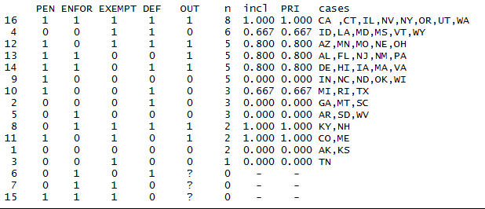

CONSERVATIVE SOLUTION
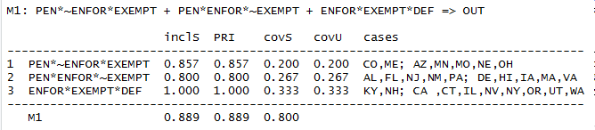
INTERMEDIATE SOLUTION
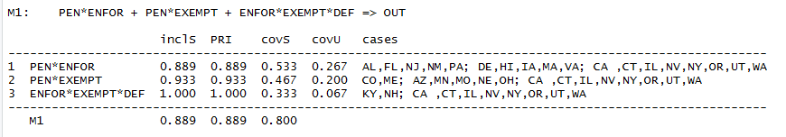

PARSIMONIOUS SOLUTION
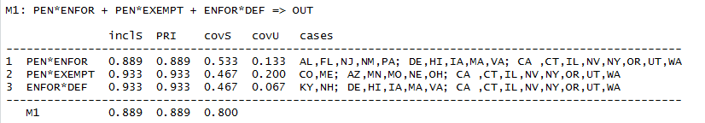

Row consistency threshold = 0.9
The solution terms, coverage and consistency are different from the original analysis for all solutions. This was predictable since several truth table rows (row 12, 13, and 14) had a consistency of 0.8, and thus, would not be used in the logical minimization process if a row consistency threshold of 0.9 is used. Note, the solution terms are in a subset relationship to the terms in the original analysis. Predictably, the solution consistency increases (a higher row consistency threshold means fewer contradictory cases) and the solution coverage decreases (cases with the outcome that are in contradictory rows below the threshold will not be covered by the solution).

TRUTH TABLE
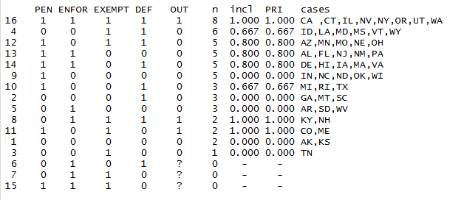

CONSERVATIVE SOLUTION
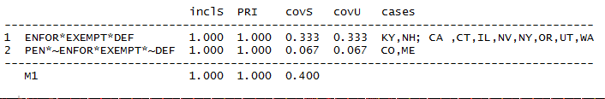

INTERMEDIATE SOLUTION
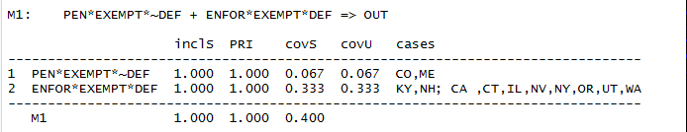

PARSIMONIOUS SOLUTION
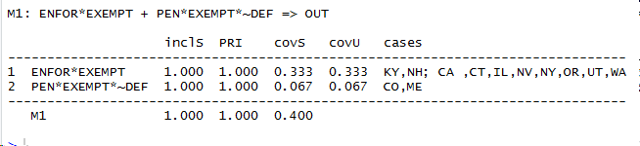

Chapter 9 Practice Exercises

Below we provide citations to several published examples of studies from across different disciplines that include a QCA. Using the checklist from Chapter 6 (Box 6-2, reprinted below) and the critical appraisal signaling questions listed below, assess how well the study authors conducted and reported findings according to standards of good practice. Although one may not be familiar with the content of studies outside of one’s own discipline, readers can still critically appraise whether studies followed standards of good practice and reported their methods findings in enough detail to assess validity and certainty of findings.

Checklist For Conducting Analysis—Initial Analysis and Model Analytics (Box 6-2)
- Create your truth table from the data matrix.
  - Create a truth table shell
  - Assign cases from data matrix to truth table row
  - Assign an outcome value to each truth table row
- Inspect your truth table.
  - Examine where the cases fall (e.g., do all or most fall into just a few rows?)
  - Examine the consistency values of each row
  - Assign an outcome value to each row
  - Try to resolve contradictory truth table rows
  - Check for coding errors if cases appear in implausible truth table rows
- Test for individual necessary conditions (and combinations of necessary conditions if applicable)
  - Examine for necessity of both the condition and its complement with the outcome and its complement (i.e., 4 tests of necessity)
  - Declare conditions necessary only when they surpass a consistency value of 0.9 and relevance of necessary conditions (RON) of at least 0.8.
- Minimize the truth table to generate the conservative, parsimonious, and intermediate solutions.
- Review parameters of fit to assess whether case selection or condition and outcome selection and calibration should be reconsidered.
- Evaluate the simplifying assumptions made on logical remainders for the parsimonious and intermediate solutions to determine if implausible assumptions were made.
- Generate the conservative, parsimonious, and intermediate solutions for the outcome complement.
- Evaluate whether any of the same simplifying assumptions were made in the truth table minimization for the outcome and the outcome complement. If so, resolve the assumptions and generate new solutions for the outcome and its complement.
- Assess whether model ambiguity is present. If present, determine which model best reflects theory or substantive knowledge. If too much model ambiguity is present, reconsider case selection or condition and outcome selection and calibration.
- Conduct robustness tests.
  - Add or exclude cases.
  - Change calibration threshold or calibration function (fuzzy sets only).
  - Change consistency threshold.

Critical appraisal questions
- Were criteria for selection of cases, conditions, and outcomes described?
  - Are criteria appropriate?
- Was the calibration approach and processes to calibrate described?
- Were the analytic steps conducted by study authors described in enough detail to be replicable?
- Were standards of good practice for conducting analyses used (See Checklist at end of Chapter 6)
- Were the substantive findings from the QCA summarized and put into a context for interpretation?

Suggested Citations for Critical Appraisal:
- Straatmann, T., Rothenhöfer, L. M., Meier, A., & Mueller, K. (2018). A Configurational Perspective on the Theory of Planned Behaviour to Understand Employees' Change‐Supportive Intentions. Applied Psychology, 67(1), 91-135.
- Bernal‐Jurado, E., Mozas‐Moral, A., Fernández‐Uclés, D., & Medina‐Viruel, M. J. (2017). Explanatory factors for efficiency in the use of social networking sites—The case of organic food products. Psychology & Marketing, 34(12), 1119-1126.
- Poorkavoos, M., Duan, Y., Edwards, J. S., & Ramanathan, R. (2016). Identifying the configurational paths to innovation in SMEs: A fuzzy-set qualitative comparative analysis. Journal of Business Research, 69(12), 5843-5854.
- Marcus Thygeson, N., Solberg, L. I., Asche, S. E., Fontaine, P., Gregory Pawlson, L., & Scholle, S. H. (2012). Using fuzzy set qualitative comparative analysis (fs/QCA) to explore the relationship between medical “homeness” and quality. Health services research, 47(1pt1), 22-45.
- Svevo-Cianci, K. A., Hart, S. N., & Rubinson, C. (2010). Protecting children from violence and maltreatment: A qualitative comparative analysis assessing the implementation of UN CRC Article 19. Child Abuse & Neglect, 34(1), 45-56.
- Candy, B., King, M., Jones, L., & Oliver, S. (2013). Using qualitative evidence on patients’ views to help understand variation in effectiveness of complex interventions: a qualitative comparative analysis. Trials, 14(1), 179.

