**Templates for Research Practice Innovations**

Throughout the book, I have referred to providing templates of some of the figures in Appendix B. These versions of the templates have been made available for the website so that you can download them and work with them directly.

Chapter 4. Template for Creating Mixed Methods Study Complexity Profile

|  |  |  |  |  |  |  |
| --- | --- | --- | --- | --- | --- | --- |
| **Dimension of complexity** | **Dimension**  **characteristics** | | **Level of complexity** | | | **Rationale/description** |
| **Low** | **Moderate** | **High** |  |
| Intentions of research problems | Stability of background influences | |  |  |  |  |
| Clarity of mixing purpose | |  |  |  |  |
| Certainty of study outcomes | |  |  |  |  |
| Systems of research contexts | Dynamics of environmental influences | |  |  |  |  |
| Range of geographical dispersion | |  |  |  |  |
| Diversity of participants | |  |  |  |  |
| Designs of research integrations | Predictability of feasibility influences | |  |  |  |  |
| Nature of design approach | |  |  |  |  |
| Definition of timeframes and resources | |  |  |  |  |
| Capacities of research interactions | Diversity of social influences | |  |  |  |  |
| Extent of role definition | |  |  |  |  |
| Nature of interpersonal outcomes | |  |  |  |  |
| Evidence of research outcomes | Familiarity of practical influences | |  |  |  |  |
| Transparency of integration strategy | |  |  |  |  |
| Nature of study impacts | |  |  |  |  |
| Overall study complexity rating | | |  | | | |
| Rationale for study’s complexity rating | |  | | | | |

Chapter 5. Template for Visual Mapping Informing Framing a Complex Mixed Methods Research Problem

**Figure%205.3%20Exploratory%20diagram_August%2015.pdf**

Chapter 5. Template for Flow Diagram for Documenting Literature Search for a Complex Mixed Methods Research Problem

**Search%20Documentation%20diagram_August%2015.pdf**

Chapter 6. Template for Conveying Interrelated societal, interpersonal, personal systems Defining the Complex Mixed Methods Research Contexts

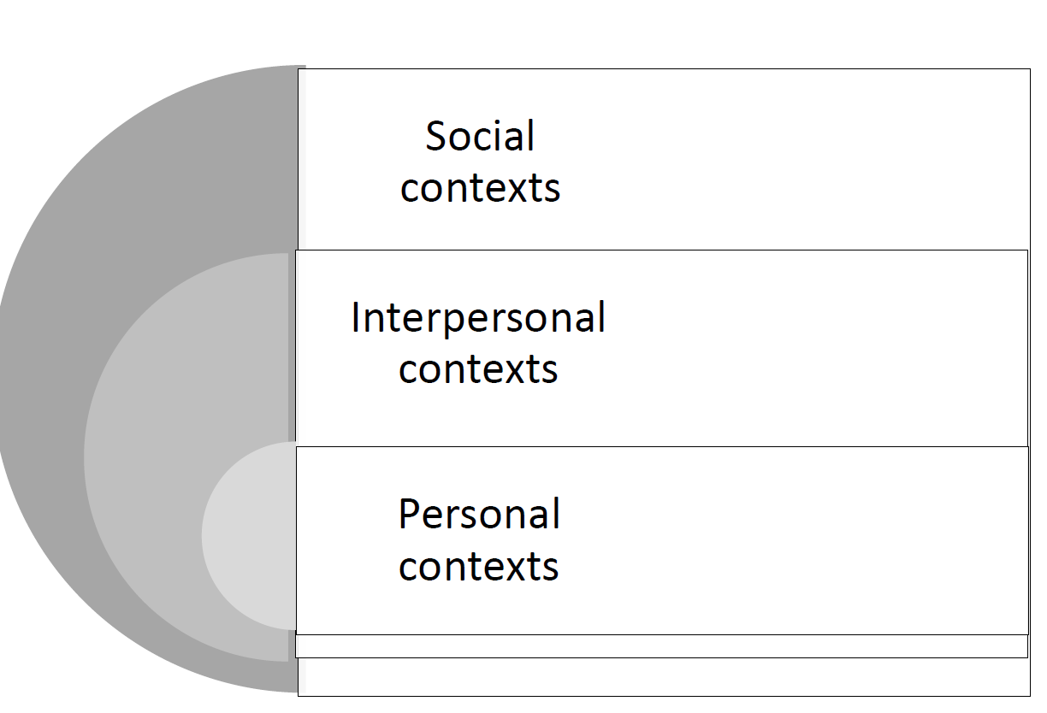

Chapter 7. Template for Conveying Initial Understandings for Guiding Descriptive Design Approach

|  |  |  |  |
| --- | --- | --- | --- |
| **Tasks** | **Considerations** | **Initial Understandings** | **Evolutions** |
| Articulate framing Sensitivities Guiding Study Foundations | Guiding Theoretical Framework |  |  |
| Study’s need for Integration |  |  |
| Intensity of Mixing  (research stage) |  |  |
| Examine Logic Features guiding data integrations | Timing of Data Strands |  |  |
| Weighting of data Strands |  |  |
| Mixed Sampling Strategies |  |  |
| Generating Data Strategies |  |  |
| Mixing Strands Strategies |  |  |
| Attend to Ethics Concerns Guiding research procedures | Respect for Persons |  |  |
| Concern for Welfare |  |  |
| Justice |  |  |
| Assimilate Procedural Adaptations guiding researcher responses | Design Typology (if appropriate) |  |  |
| Potential Procedural Adaptations |  |  |
| Other? |  |  |  |
|  |  |  |  |
|  |  |  |  |

Chapter 8. Template for Conveying Unique and Common Backgrounds and Expertise of Research Members

