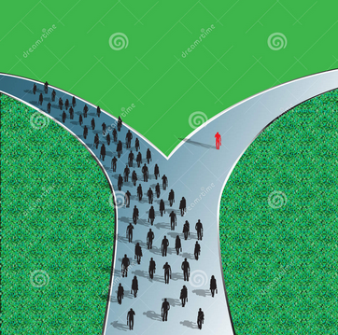

What is life like now, with X?

What makes you turn off the main road and get into X?

What is life like now, before X?