Qualitative E-Interview Research

Worksheet for Reviewing the Research Design Using the E-Interview Research Framework
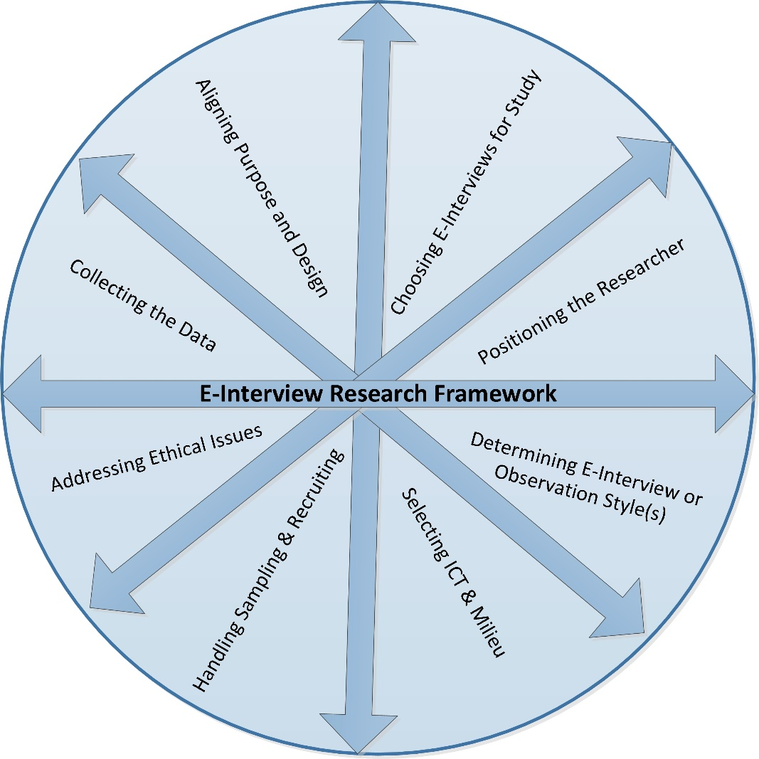

The E-Interview Research Framework invites researchers to generate ideas and questions about key features of online interview research and relationships between those features. It is displayed as a circle to convey the sense that one angle alone will not provide the systems-level view we need to really understand the interrelated mechanisms of online interview research. Use the eight categories of models and key questions to think about your own research design, or as an analytic framework to dissect others' research.

Framework | Questions or Issues to Address in Your Study
I. Aligning Purpose  and Design | - Are research purpose, theories and epistemologies, methodologies and methods clearly aligned?  - How will the data collected from e-interviews relate to theories? Do you want to explore, prove or generate theory?  - Do you offer a compelling rationale for using e-interviews to achieve the research purpose?  What steps will improve your study design?
II. Choosing E-Interviews and related E-Observations for the Study | - Do you provide a compelling reason for using data collected from online interviews? Do you identify any related observations or use of posted data? Is the rationale aligned with methodologies, research purpose and questions?  - Did you choose online data collection approaches in order to investigate real-world phenomena? Or to investigate online phenomena? Is it clear to the reader why you made these choices?  What explanations are needed or what needs to be strengthened in this rationale for the study’s data collection approach?
III. Handling Sampling  & Recruiting | - What sampling approaches are appropriate given the purpose of the study and e-interview approach?  - How will you assess whether the target population has access to the technology you intend to use, and the capability and willingness to use it as a research participant?  - How will you locate credible research participants? How will you verify the identity and age (or other relevant criteria) of research participants recruited online?  - How will online recruitment be carried out?  Have you thought through all of the steps and articulated them clearly?
IV. Taking a Position as a Researcher | - Is your position in relation to the study as an insider, as one of the actors in the case? Or is your position looking at emic issues, revealed by actors in the case (Stake, 1995)?  - Is your position in relation to the study as an outsider who brings questions in from outside the case, looking at etic issues, (Stake, 1995)?  - Can your role be described as Miner, Traveler (Kvale, 2007; Kvale & Brinkman, 2009) or Gardener (Salmons, 2010)?  Are your position, relationship to participants in the study—and the implications of your position—clearly explained?
V. Determining  E-Interview and any  E-Observational Style(s) | - Do you plan to use structured, semi-structured or unstructured or a combination of styles for the interviews?  - Have you defined what kinds of observations you plan to conduct, and what data you plan to collect?  - Have you made sure to align ICT functions, features and/or limitations with the selected e-interview style(s)?  Have you decided what styles of interviews (and if used, observations) you plan to use to collect data? Can you support your decisions?
VI. Selecting ICT  & Milieu | - Will the interview use text-based, audio and/or visual communication options?  - Where will the interaction fall on the Time-Response Continuum?  - Will the interview setting be in a public or private online milieu?  - Is the choice of ICT aligned with research purpose, interview style and access/preference of the research participants?  If using visually-oriented ICTs:  - If the interview technology has capacity for visual exchange, have you acknowledged visual nature of interview in the research design and planned for collection and analysis of visual data?  - Have permissions for use of visual data been discussed with participants and included in the consent agreement?  Have you decided what technology to use for communication with participants, and for any research setting that may be used? Have you done background inquiries to make sure that these choices will work with the sample population? Have you addressed any special issues in the consent agreement?
VII. Conducting the Interview and any Observations | - Do you have a plan for conducting the interview-- either prepared questions or an interview guide?  - Do you have a plan for the 4 interview stages: Opening, Questioning and Guiding, Closing and Following Up? Have you practiced carrying out these stages using the selected ICT?  - Do you have contingency plan in case there are technical difficulties?  - Do you have a guide or outline spelling out what you want to observe and what posts or documents you plan to access?  Are you adequately prepared to conduct the interviews and if used, observations?
VIII. Key Questions: Addressing Ethical Issues | - Have you taken appropriate steps to protect human subjects, and where appropriate, their avatars or online representations?  - Have you fully explained all aspects of the study, data and its use, and obtained proper informed consent?  - Do you have a plan for protecting the data and the participants’ identities?  Have you anticipated any ethical risks and planned to prevent ethical lapses?

