Qualitative E-Interview Research

Worksheet: Mapping Interrelated Facets of a Research Design
An underlying principle for the approaches described in Qualitative Online Interviews and Cases in Online Interviews is the need for alignment of research purpose, theories, methods and methodologies in the effort to create new knowledge. Such alignment is not unique to online interview research, however, a clear depiction of the design can strengthen the rationale for using online methods.

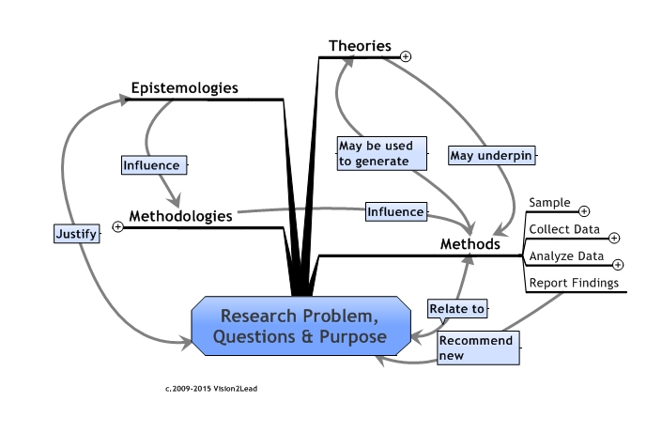
This visual map shows relationships of these components in a research design.
Four inter-related facets of research are defined for our purposes as:
Epistemology refers to the study of the nature of knowledge, beliefs about knowledge, or the study of how knowledge is justified;
Theory refers to an explanation that is internally consistent, supportive of other theories, and gives new insights. Qualitative studies may be structured using theoretical frameworks, used to explore and build on existing theories, or to develop theory.
Methodology refers to the study of, and justification for the methods used to conduct the research.
Method refers to the practical steps used to conduct the study. Interviews or observations are data collection methods.
Map your own study design! Use the Knowledge Map worksheet and visually describe key elements of your study.
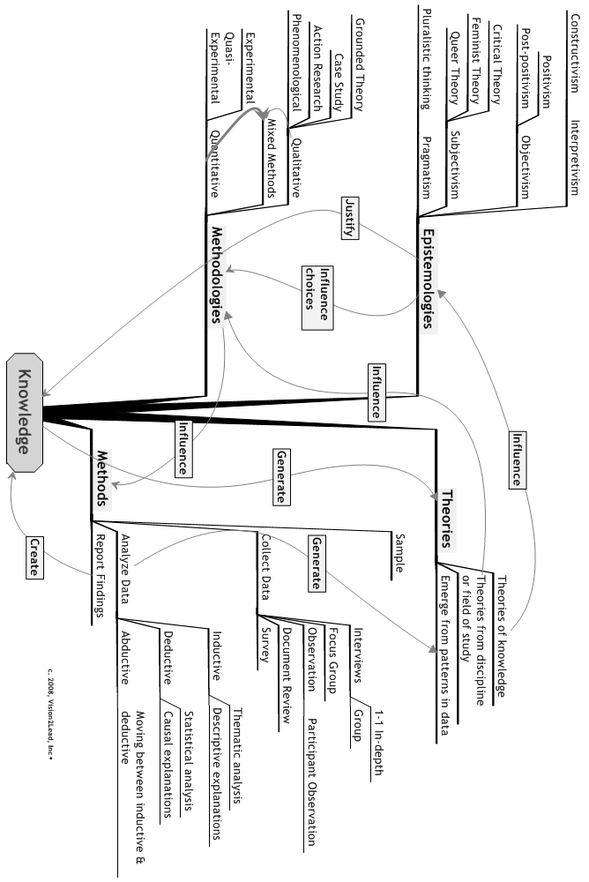
Epistemology
Methods
Methodology
Theories
Research question or problem?

