Activity sheet

Activity: Plutchik’s emotion wheel (Adapted from Castle and Buckler, 2021: 148)

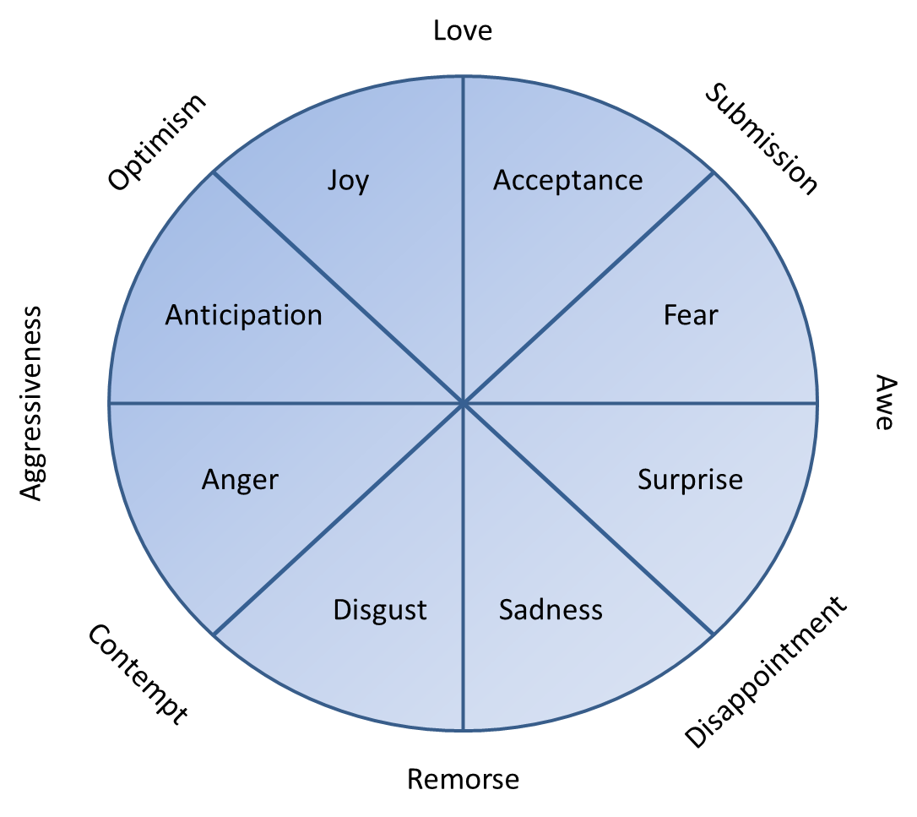
• Convert Plutchik’s emotional wheel into a record sheet so that you can record instances where you observe a particular emotion.
• As the opportunity arises during a normal school day or lesson if you prefer, record any examples of emotions that appear on your record sheet.
• If you feel that you are able to do the same for emotional blends then do the same as above.
• A word of warning: you may need to establish what each emotion looks like before you start, in terms of the observable characteristics. If you cannot ‘see’ it you cannot record it.
An example:
Emotion or emotional blend | Defining characteristics | Learner/ Student | Observation notes
Example: joy | Example: smiling, enthused, and so on. | Example: Learner A | Example: what were the antecedents, behaviour, consequence?  (Skill/challenge balance was appropriate, learner engaged well with success, learner was enthused, learner took pride in their work.

