Activity sheet

Activity: Synthesis of perspectives (Adapted from Castle and Buckler, 2021: 247)
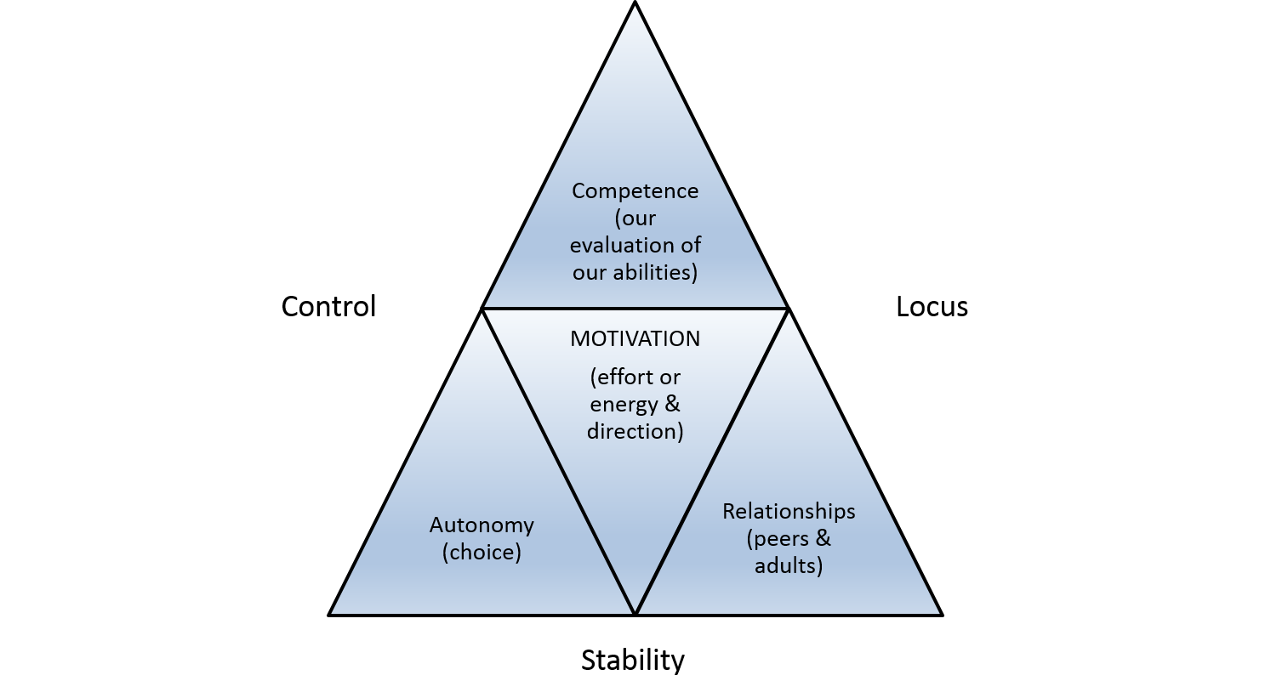
(Buckler and Castle, 2021: 247, Figure 11.1)

Please read the extract from p.245‒248 to understand the diagram.
The following example lesson integrates all of the components from the diagram. Can you identify where and how the various components are located?
• The lesson is to make a newspaper bridge.
• Students can test their ideas and contribute them to a discussion, perhaps using a range of relevant resources to investigate bridges, for example, the internet, books, and so forth.
• Students can contribute to a group discussion about how best to proceed with the available resources of newspaper: whether each sheet is folded or rolled.
• Students can decide on the design of the bridge to maximise structural integrity and test this through weight.
• In some way, the bridge is recorded. This could be through drawings, photographs, written instructions, or through some other way.
• At a later stage, they are encouraged to make a second bridge that is stronger than their first bridge.
As an extension activity, design a lesson of your own that integrates the components you have identified.

