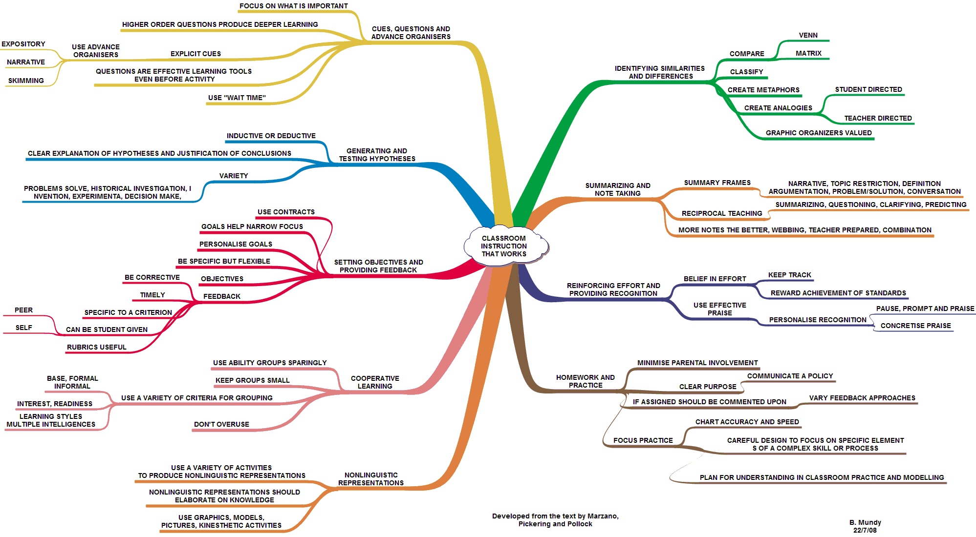

AITSL Standards development/reflection checklist | Occurrence
 | 1 | 2 | 3
- Know students and how they learn
1.1 Demonstrate knowledge and understanding of physical, social and intellectual development and characteristics of students and how these may affect learning.
1.2 Demonstrate knowledge and understanding of research into how students learn and the implications for teaching.
1.3 Demonstrate knowledge of teaching strategies that are responsive to the learning strengths and needs of students from diverse linguistic, cultural, religious and socioeconomic backgrounds.
1.4 Demonstrate broad knowledge and understanding of the impact of culture, cultural identity and linguistic background on the education of students from Aboriginal and Torres Strait Islander backgrounds.
1.5 Demonstrate knowledge and understanding of strategies for differentiating teaching to meet the specific learning needs of students across the full range of abilities.
1.6 Demonstrate broad knowledge and understanding of legislative requirements and teaching strategies that support participation and learning of students with disability.
- Know the content and how to teach it
2.1 Demonstrate knowledge and understanding of the concepts, substance and structure of the content and teaching strategies of the teaching area
2.2 Organise content into an effective learning and teaching sequence.
2.3 Use curriculum, assessment and reporting knowledge to design learning sequences and lesson plans.
2.4 Demonstrate broad knowledge of, understanding of and respect for Aboriginal and Torres Strait Islander histories, cultures and languages.
2.5 Know and understand literacy and numeracy teaching strategies and their application in teaching areas.
2.6 Implement teaching strategies for using ICT to expand curriculum learning opportunities for students.
- Plan and implement effective teaching and learning
3.1 Set learning goals that provide achievable challenges for students of varying abilities and characteristics.
3.2 Plan lesson sequences using knowledge of student learning, content and effective teaching strategies
3.3 Include a range of teaching strategies
3.4 Demonstrate knowledge of a range of resources, including ICT, that engage students in their learning
3.5 Demonstrate a range of verbal and non-verbal communication strategies to support student engagement.
3.6 Demonstrate broad knowledge of strategies that can be used to evaluate teaching programs to improve student learning.
3.7 Describe a broad range of strategies for involving parents/carers in the educative process.
- Create and maintain supporting and safe learning environments
4.1 Identify strategies to support inclusive student participation and engagement in classroom activities.
4.2 Demonstrate the capacity to organise classroom activities and provide clear directions.
4.3 Demonstrate knowledge of practical approaches to manage challenging behaviour.
4.4 Describe strategies that support students’ wellbeing and safety working within school and/or system, curriculum and legislative requirements.
4.5 Demonstrate an understanding of the relevant issues and the strategies available to support the safe, responsible and ethical use of ICT in learning and teaching.
- Assess, provide feedback and report on student learning
5.1 Demonstrate understanding of assessment strategies, including informal and formal, diagnostic, formative and summative approaches to assess student learning.
5.2 Demonstrate an understanding of the purpose of providing timely and appropriate feedback to students about their learning.
5.3 Demonstrate understanding of assessment moderation and its application to support consistent and comparable judgements of student learning.
5.4 Demonstrate the capacity to interpret student assessment data to evaluate student learning and modify teaching practice.
5.5 Demonstrate understanding of a range of strategies for reporting to students and parents/carers and the purpose of keeping accurate and reliable records of student achievement.
- Engage in professional learning
6.1 Demonstrate an understanding of the role of the Australian Professional Standards for Teachers in identifying professional learning needs.
6.2 Understand the relevant and appropriate sources of professional learning for teachers.
6.3 Seek and apply constructive feedback from supervisors and teachers to improve teaching practices.
6.4 Demonstrate an understanding of the rationale for continued professional learning and the implications for improved student learning.
- Engage professionally with colleagues, parents/carers and the community
7.1 Understand and apply the key principles described in codes of ethics and conduct for the teaching profession.
7.2 Understand the relevant legislative, administrative and organisational policies and processes required for teachers according to school stage.
7.3 Understand strategies for working effectively, sensitively and confidentially with parents/carers.
7.4 Understand the role of external professionals and community representatives in broadening teachers’ professional knowledge and practice.

Evaluating your lesson/unit using the High Impact Teaching Strategies (HITS)
HITS | Using  Yes/No | Current strategies that reflect the use of this HITS | Future strategies that reflect or improve the use of this HITS
- Setting goals

- Structuring lessons
- Explicit teaching
- Worked examples
- Collaborative learning
- Multiple exposures
- Questioning
- Feedback
- Metacognitive strategies
- Differentiated instructions

Evaluating your pedagogy using the Victorian Practice Principles

Practice Principles | Use  Yes/no | Current activities within my class or unit that reflect this pedagogy | Future activities within my class or unit that reflect this pedagogy
Principle 1: High expectations for every student promote intellectual engagement and self-awareness
Principle 2: A supportive and productive learning environment promotes inclusion and collaboration
Principle 3: Student voice, agency and leadership empower students and build school pride
Principle 4: Curriculum planning and implementation engages and challenges all students
Principle 5: Deep learning challenges students to construct and apply new knowledge
Principle 6: Rigorous assessment practices and feedback inform teaching and learning
Principle 7: Evidence-based strategies drive professional practice improvement
Principle 8: Global citizenship is fostered through real world contexts for learning
Principle 9: Partnerships with parents and carers enhance student learning

Evaluating your lesson/unit using the Elements of the NSW Quality Teaching Framework
Dimensions | Elements | Using  Yes/No | Current strategies that reflect the use of this elements | Future strategies that reflect or improve the use of the elements
Intellectual quality | Deep knowledge
 | Deep understanding
 | Problematic knowledge
 | Higher-order thinking
 | Metalanguage
 | Substantive conversation
Quality learning environment | Explicit quality criteria
 | Engagement
 | High expectations
 | Social support
 | Students’ self-regulation
 | Student direction
Significance | Background knowledge
 | Cultural knowledge
 | Knowledge integration
 | Inclusivity
 | Connectedness
 | Narrative

Source: https://theelements.schools.nsw.gov.au/introduction-to-the-elements/policy-reforms-and-focus-areas/quality-teaching-framework.html

Unit/Topic/Excursion/Activity: Year level:
Positives  What worked well?  What did you like? | Minuses  What did not work well?  What did you not like? | Improvements/interesting  How could this be improved?  What was interesting?

Strengths  What I am doing well? | Weaknesses  What I am not doing well?
Opportunities  How can I improve?  What supports are here for me? | Threats  What stops me improving or doing well?  What can I do about them?

