Activity: Synthesis of perspectives (Adapted from Castle and Buckler, 2018: 250)

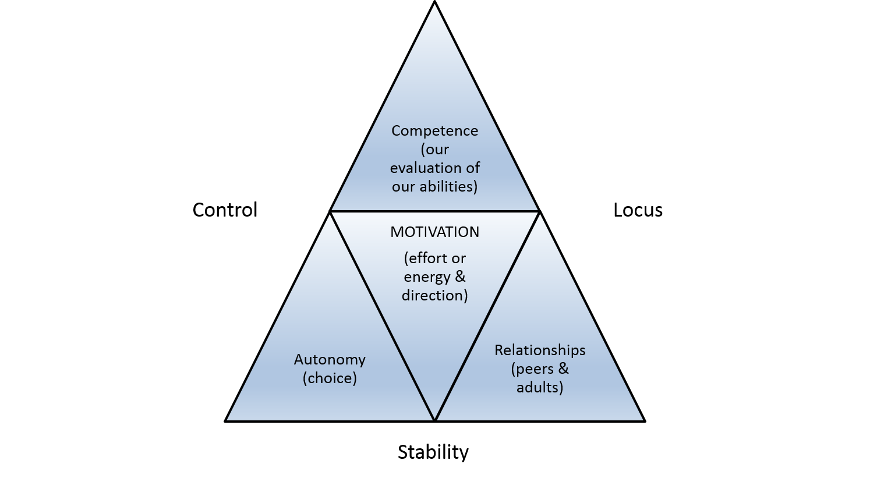
(Buckler and Castle, 2014: 242, Figure 11.1)

Please read the extract from p.241-242 to understand the diagram.
The following example lesson integrates all of the components from the diagram. Can you identify where and how the various components are located?
- The lesson is to make a newspaper bridge.
- Students can test their ideas and contribute them to a discussion, perhaps using a range of relevant resources to investigate bridges, for example, the internet, books, and so forth.
- Students can contribute to a group discussion about how best to proceed with the available resources of newspaper: whether each sheet is folded or rolled.
- Students can decide on the design of the bridge to maximise structural integrity and test this through weight.
- In some way, the bridge is recorded. This could be through drawings, photographs, written instructions, or through some other way.
- At a later stage, they are encouraged to make a second bridge that is stronger than their first bridge.

As an extension activity, design a lesson of your own which integrates the components you have identified.

