Activity: Parallel distributed processing model (From Castle and Buckler, 2018: 133-134)

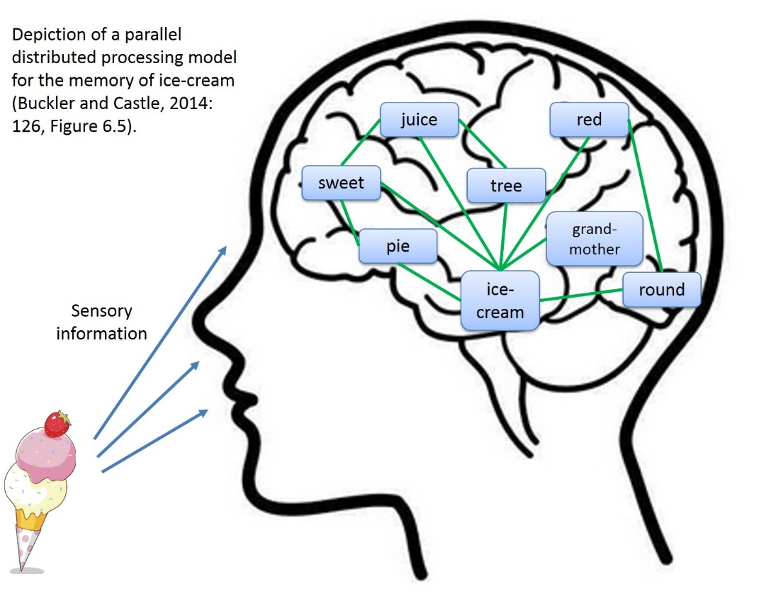

- Consider the parallel distributed processing model for the memory of ice-cream.
- In the space below, draw your own network of memories for an object of your choice (e.g. chocolate, the beach, and so on). The object should stimulate more memories if it is multi-sensory in nature.

