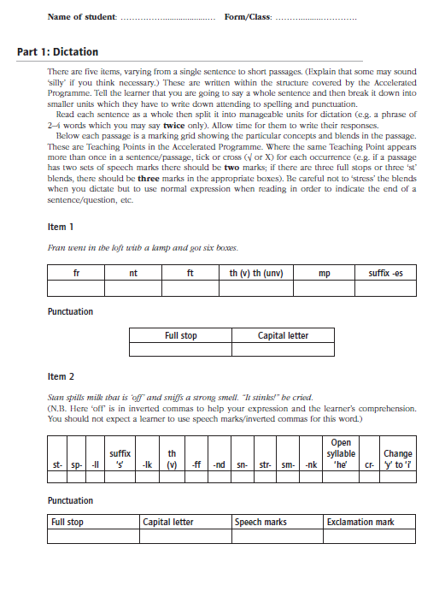
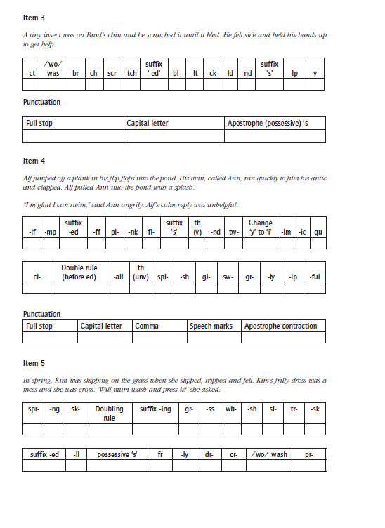
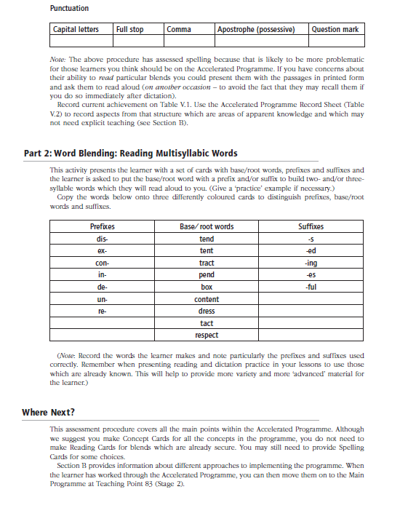

Downloadable: Teaching Literacy to Learners with Dyslexia 4e © Kathleen Kelly and Sylvia Phillips, 2025 (SAGE)

