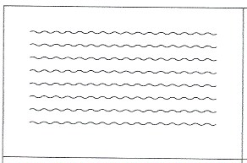 | /sp/
w | w  +
m | It is it’s
V  V | ˘  ˘  sit
Figure VI.3 Concept Cards 9–16 Front Downloadable: Teaching Literacy to Learners with Dyslexia 4e © Kathleen Kelly and Sylvia Phillips, 2025 (SAGE)

