Key Note

Chapter 10: Visual and auditory localisation

Key note 10B: Angular declination hypothesis – why height in the visual field may sometimes be a useful cue to distance
The aim of this note is to illustrate a suggestion for how ‘height in the visual field’ might be converted to perceived distance by the visual system, and to note a potential problem. You can gauge the value of this depth cue by plotting object distance against angular declination, as outlined below.
In the book, a study is reported which found that, for objects below the horizon, height in the visual field is a cue to their distance, so that higher objects are perceived as further away. But how could height in the field be used to compute distance? Figure 1 illustrates the angular declination hypothesis: the angle between eye level and the line of sight to the further object on the ground is smaller than that for the nearer object. The figure also illustrates a hypothesis suggesting how distance could be computed from height in the visual field, namely by dividing eye height by the tangent of the angle between eye level and the line of sight to the object. Ooi et al. (2001) tested the theory by having their observers view the scene through base-up prisms, so increasing the apparent angle, and reducing apparent distance. When asked to walk while blindfolded to the apparent location of the distant object, participants traversed smaller distances after viewing through prisms than when viewing without, as the angular declination hypothesis suggests. If the hypothesis is correct, height in the field would provide metrical depth information.
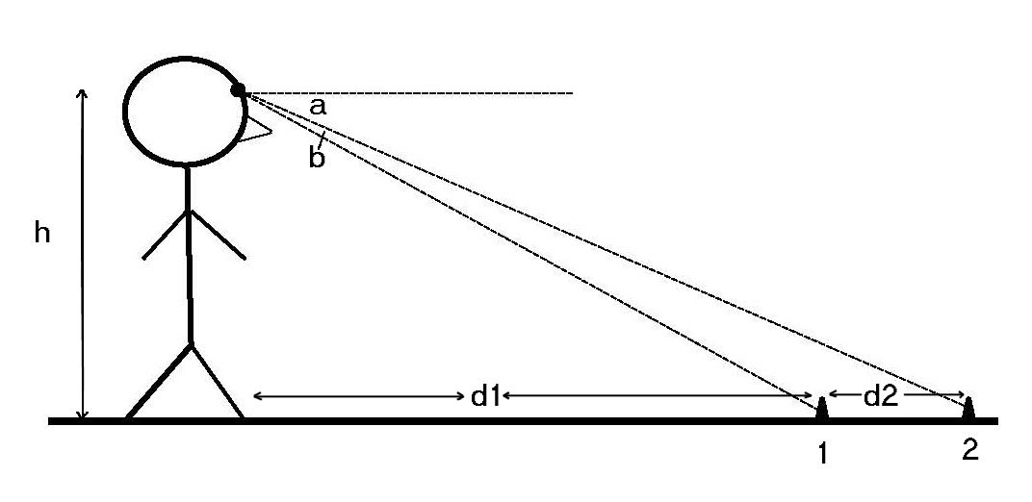
Figure 1 Angular declination hypothesis. The observer, whose eyes are at height h, calculates the distance (d1, d1 + d2) of two objects (1, 2) on the ground from the angle between eye level and the line of sight to each object. Distance to Object 1 is : d1 = h/tan a, and to Object 2, d1 + d2 = h/tan (a + b). Redrawn from Ooi et al. (2001).
Assuming an eye height of 150 cm, plot a graph (using say Microsoft Excel, in which case include the RADIANS function in your formula) of angular declination (from say 5 to 85 degrees) against object distance. You should see that the graph declines quite sharply for large angular declinations (short distances), but becomes quite shallow for distances over about 5–6 m. On this view, height in the visual field would be quite a sensitive cue for near objects, but a much coarser cue for more distant objects. Thus a change in declination from 85 to 80 degrees corresponds to a change of distance of less than 1 m, whereas a change from 10 to 5 degrees corresponds to a change of around 1 km.
The computation of angular declination would work perfectly if the surface of the earth was as flat and smooth as a pool table. But what would happen when the ground undulates markedly, so that an object might be positioned on a hillock? Without further rules, the visual system would perceive the object as further away than it really was.
Ooi TL, Wu B, He ZJ (2001) Distance determined by the angular declination below the horizon. Nature 414: 197–200.

