Key Note

Chapter 11: Perception and action

Key note 11A: Paul Fitts and the efficiency of human movement
In his 1954 paper, Fitts aimed to quantify the information transmitted by the human motor system, using the ideas in the currently fashionable Information Theory. Figure 1 shows in schematic form the apparatus in one of his experiments. The task was to move a stylus repeatedly from one central black bar to the other, as quickly as possible, but avoiding errors. Fitts varied two things – the width of the black bars, and their separation (and so the required amplitude of the repetitive movements). He also varied the weight of the stylus (either 1 oz or 1 lb) but the result from the two styli were very similar.
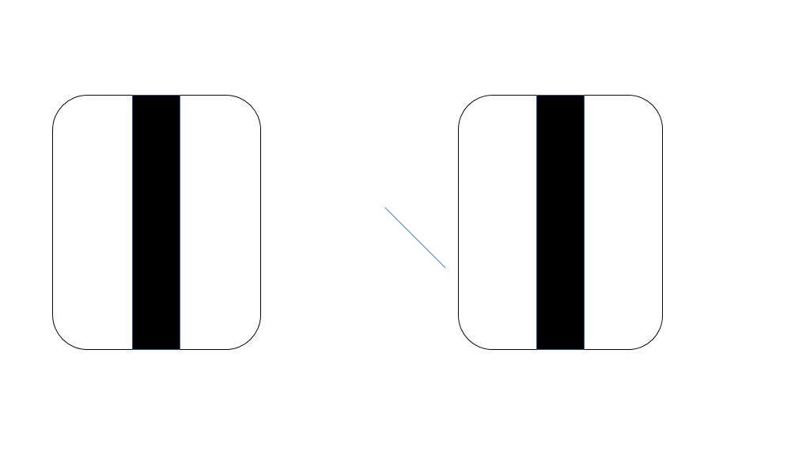
Figure 1 Schematic representation of the apparatus used to measure performance of repetitive tapping
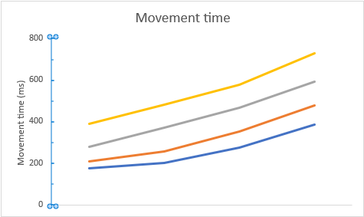
2 4 8 16
Movement amplitude (inches)
Figure 2 Results of repetitive tapping task with the 1 oz stylus. Key to target widths (in inches): Yellow 0.25; Gray 0.5; Orange 1.0; Blue 2.0

The average movement times for the different conditions are shown in Figure 2. Movement time rose with required movement amplitude, and also rose as target width was reduced. This seems intuitively reasonable: as target width is reduced more care is required to hit the target rather than the surround.
Clearly, performance differs across conditions, if movement time is taken as the criterion. However, Fitts went on to show that performance was almost constant across conditions in Information Theory terms. He produced an Index of Performance (I_{p}) which relates Target Width (W) and Movement Amplitude (A) to Movement Time (t):
For all but one of the Movement Times shown in Figure 2, I_{p} ranged from 9.43 to 11.54, suggesting that the Index of Performance indeed captured some constant in the task. (The exception was what appears to be the easiest condition, in which both movement amplitude and target width were 2 inches, when I_{p} was 5.56).
Fitts also tested performance on other tasks, such as transferring washers from one set of pins to another, or transferring pins from one set of holes to another, with similar results. He pointed out that his information measure is likely to vary for very different tasks, and others have suggested alternative measures of performance, but his seminal work has been very influential in studies of sensorimotor performance.

Fitts PM (1954) The information capacity of the human motor system in controlling the amplitude of movement. Journal of Experimental Psychology 47(6): 381–391.

