Key Note

Chapter 15: Changes in perception through the life-span

Key note 15C: A longitudinal study of the effects of ageing on hearing
Most studies of the effects of ageing on perception are cross-sectional: two or more groups with different mean ages are tested at the same time. In this note, we describe a (much rarer) longitudinal study in which the same individuals are tested at different times (separated by many years).
The data in Figure 15.11 in the book are taken from a study by Brant and Fozard (1990), but similar losses of sensitivity have been reported by others. An unusual feature of the Brant and Fozard study is that, as well as the cross-sectional data in Figure 15.11, they gathered longitudinal data by measuring sensitivity in the same individuals twice, with a gap of 15 years between the measurements. Figure 1 below shows the same sensitivity data for the 20-year-olds as in Figure 15.11, and also measurements made on the same individuals when they were 35 years of age. The same pattern of loss is apparent as in the 30-year-old group in Figure 15. 11. It is reassuring to see that, in this context, a longitudinal study gives a similar pattern of results to a cross-sectional study, since at least part of an effect in the latter may result from sampling error (choosing individuals by chance who are atypical of their age group).
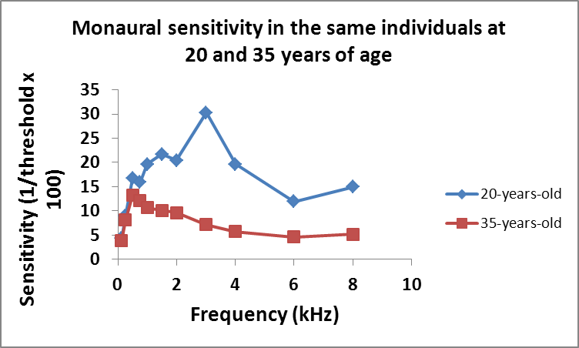
Figure 1 Data are from the same individuals from measurements made 15 years apart, when the participants were aged 20 and 35.
Brant LJ, Fozard JL (1990) Age changes in pure-tone hearing thresholds in a longitudinal study of normal human aging. Journal of the Acoustical Society of America 88(2): 813–820.

