Key Note

Chapter 16: Pathologies of perception

Key note 16A: Perception of complex motion in ASD
There has been general agreement that aspects of motion perception are impaired in ASD. The aim of this note is to assess ways in which the impairments might impact on different uses of visual information about motion.
The impairments in motion perception found in ASD have implications for several aspects of behaviour. Gepner et al. (1995) reported that the posture of children with ASD was less influenced by patterns of optic flow than was that of typically developing (TD) children, a finding which they attributed to an impairment of motion perception in ASD. Although other interpretations, such as an impairment of motor control, are possible, subsequent work has supported the original conclusion, suggesting that the visual control of some actions may be abnormal in ASD. Spencer et al. (2000) found, with the type of display shown in Figure 1, that motion coherence thresholds (the proportion of coherently moving dots needed to reliably detect the strip containing oscillation in the opposite direction to that in the surrounding areas) were higher in ASD children than in age-matched TD children. They suggested that the cause of this impairment was a deficiency of some kind in the dorsal visual stream (see Chapter 3) in ASD.
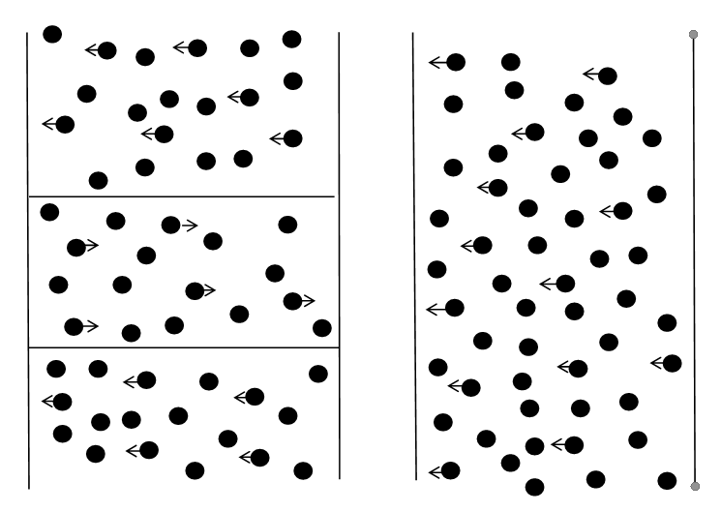
Figure 1 Schematic representation of the motion coherence display used by Spencer et al. (2000). Most of the dots moved in random directions, but a proportion (indicated by arrows) oscillated together from side to side. The task was to locate the side of the display on which the dots in a central strip oscillated in the opposite direction to the other oscillating dots.
Another type of motion perception which requires the integration of dots in local motion is that of biological motion, introduced in Chapter 5. As we saw in Chapter 13, one can accurately perceive the emotions expressed in such stimuli, so that any impairment in their perception in ASD may be relevant to an impairment of social skills. Blake et al. (2003) presented a series of short movies depicting biological motion randomly interspersed with versions of the same movies in which the positions of the individual dots had been jittered, so removing the appearance of biological motion. Recognition scores were significantly worse in an ASD than in a TD group. In contrast, performance of the two groups on the form coherence task of detecting the polygon in images like that shown in Figure 16.2 in the book was very similar. As noted in Chapter 16, local mechanisms may be able to perform the form coherence task, even though Blake et al. supposed that more global processes were required. Nevertheless, ASD performance on the coherence task suggests that their attention and motivation was as good as in the TD group. A more convincing demonstration of impairment in ASD would be to compare performance on different types of motion stimuli. Annaz et al. (2010) measured the ability to recognise biological motion, and compared thresholds for biological motion with those for motion coherence. Recognition scores and thresholds for biological motion were higher in the ASD than in the TD group, and, unlike in the TD group, did not improve with chronological age or with verbal or non-verbal mental ages. Coherence thresholds were higher in ASD (as noted in Chapter 16 for other studies). Unlike in the TD group, coherence thresholds did not improve in ASD with chronological or mental ages. When performance on the two types of motion stimuli was compared, the authors found that performance on the biological motion tasks was worse impaired in ASD than on the motion coherence task. This clearly suggests that there is a particular deficit in the perception of biological motion in ASD, and it is tempting to conclude that this may be important in understanding impoverished social skills.
One reason to be cautious in drawing this conclusion is that the perception of biological motion (unlike social skills) may not be impaired in adults with ASD, since Aygin et al. (2010) found no differences between ASD and TD groups. An important difference between the studies may be the difference in mean age (Annaz et al.: <9 years; Aygin et al.: >33 years). One might speculate that impaired perception of emotions and intentions from biological motion led to the development of poor social skills during some critical period, so that normalised biological motion perception later in life was not adequate to correct them.
Herrington et al. (2007) measured brain activity with fMRI as adult participants looked at a biological motion stimulus (someone walking on the spot), as well as a version of the stimulus in which dot position had been randomised (and so cues to biological motion were degraded), and a fixation-only condition. When the motion stimuli were presented, the behavioural task was to signal whether the walker as walking towards the left or right. Participants were TD (mean age 25.6 years) or diagnosed with Asperger syndrome, a condition on the autistic spectrum (mean age 27.6 years). Although the ASD group was similar to the TD group in discriminating direction of walking, there was significantly less activity in several brain regions, including MT+/V5 (see Figure 2), superior regions of the temporal lobe (known to be involved in the perception of biological motion – Puce and Perrett, 2003) and the fusiform gyrus (known to be involved in the perception of faces and emotional expressions – see Chapter 13). In a similar study with younger participants (ASD mean age 17.5 years (SD 3.5 years, and so including some quite young participants)), Freitag et al. (2008) found broadly similar fMRI effects, and their ASD participants were slower to detect biological motion than were the TD controls.

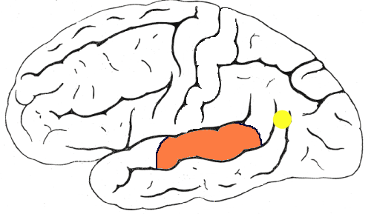
Figure 2 Lateral view of the brain showing approximate location of MT+/V5 (yellow), and superior temporal regions (brown) activated by biological motion in the study of Herrington et al. (2007).
Taken together, these studies reveal impairments in the perception of complex patterns of motion in ASD. The results suggest that the control of posture and of locomotion, on the one hand, and the perception of emotion and intentions, on the other, may be less efficient in ASD than in typically developing individuals.
Annaz D, Remington A, Milne E, Coleman M, Campbell R, Thomas MSC, Swettenham J (2010) Development of motion processing in children with autism. Developmental Science 13(6): 826–838.
Aygin AP, Cook J, Blakemore S-J (2010) Unaffected perceptual thresholds for biological and non-biological form-from-motion perception in autism spectrum conditions. PLoS ONE 5(10): e13491. doi:10.1371/journalpone.0013491
Blake R, Turner LM, Smoski MJ, Pozdol SL, Stone WL (2003) Visual recognition of biological motion is impaired in children with autism. Psychological Science 14(2): 151–157.
Freitag CM, Konrad C, Haeberlen M, Kleser C, von Gontard A, Reith W, Troje NF, Krick C (2008) Perception of biological motion in autism spectrum disorders. Neuropsychologia 46: 1480–1494.
Gepner B, Mestre D, Masson G, Deschonen S (1995) Postural effects of motion vision in young autistic children. Neuroreport 6(8): 1211–1214.
Herrington JD, Baron-Cohen S, Wheelwright SJ, Singh KD, Bullmore ET, Brammer M, Williams SCR (2007) The role of MT+/V5 during biological motion perception in Asperger Syndrome: an fMRI study. Research in Autism Spectrum Disorders 1: 14–27.
Puce A, Perrett D (2003) Electrophysiology and brain imaging of biological motion. Philosophical Transactions of the Royal Society of London Series B: Biological Sciences: 358: 435–445.
Spencer J, O’Brien J, Riggs K, Braddick O, Atkinson J, Wattam-Bell J (2000) Motion processing in autism: evidence for a dorsal stream deficiency. Neuroreport 11(12): 2765–2767

