Key Note

Chapter 16: Pathologies of perception

Key note 16B: Further approaches to studying neglect
This note describes two studies in which a range of measures of neglect was made and related to the sites of brain lesions. Unfortunately, the correspondence between the findings from different studies is not perfect, and possible reasons for this are discussed.
An informative approach to identifying the neural bases of different types of neglect was taken by Verdon et al. (2010), who administered a battery of tests to a group of 80 patients, namely line bisection, copying a landscape, cancelling bells amongst non-bell distractors, text reading, reading compound words and cancelling circles with a gap amongst complete circles. In the penultimate test, errors could be of omissions of words on the (usually) left side of the page, or of the left part of the word when placed anywhere on the page. In the last test, errors could refer to position on the page, or side of the circle which contained the gap. Thus the errors on these two tests could be space-based (page position) or object-based (part of compound word or gap position). In a factor analysis of all the data, the first three factors accounted for 82% of the variance. The first factor was related to omissions in reading text and left sided omissions when reading words, and deviations on line bisection (the authors referred to this as a ‘perceptive visuo-spatial component’ (PVS)). The second factor reflected object-based neglect (OB – changes or omissions on the left side of compound words of gaps on the left side of circles). The third factor was related to the number of misses in left space on the cancellations tasks (an ‘exploratory visuo-spatial’ component – EVS).
When Verdon et al. tested for the anatomical correlates of each factor, they found that PVS significantly involved the right inferior parietal lobe, near the supramarginal gyrus (see Figure 1), and the adjacent white matter. EVS, on the other hand, involved frontal regions, including right inferior frontal gyrus, anterior dorsolateral prefrontal cortex and the posterior part of the middle frontal gyrus, as well as parts of the underlying white matter. Finally, OB was associated with lesions to the temporal lobe, particularly near the parahippocampal gyrus, but extending through the white matter of the temporal lobe to the middle temporal gyrus on the lateral surface.
Sometimes terminology in this area can be confusing. For example, Committeri et al. (2007) compared personal with extrapersonal neglect. Personal neglect was assessed by the patient’s use of spectacles, a razor or face powder, and a comb in left and right space, whereas extrapersonal neglect was tested with line cancellation, letter cancellation, sentence reading and a visual illusion (Wundt-Jastrow) in which the lower of two identical curved shapes appears larger. Notice that these tests of extrapersonal neglect actually take place in peripersonal or near space, not what others have referred to as extrapersonal or far space. Personal neglect (of the left side of the head) was found to be associated with right parietal lesions, especially of the post-central and supra-marginal gyri. Brain regions involved in extrapersonal neglect included ventral premotor cortex (in the inferior precentral gyrus), and dorsolateral prefrontal cortex, as well as parts of the temporal lobe (middle and anterior superior temporal gyrus, superior temporal sulcus and their underlying white matter).
All Verdon et al.’s tests were performed in near space, as were those of Committeri et al., and one can ask, when the tests are the same in both studies, to what extent the underlying lesions are similar. Verdon et al. identified factors common to a range of tests, one of which (EVS) was associated with cancellation errors, and another (OB) with omissions on the left of words. Two of Committeri et al.’s four tests of extrapersonal neglect involved cancellation, and another omissions on the left of sentences. One might expect then that Committeri et al. would report lesions in areas identified by Verdon et al. as associated with both EVS and OB, and to some extent this is true. For example, frontal regions such as dorsolateral prefrontal cortex, and temporal regions in and around the superior temporal sulcus, are reported as related to neglect in near space in both studies. However, there are regions which are significantly associated with neglect in one study which are not mentioned in the other.
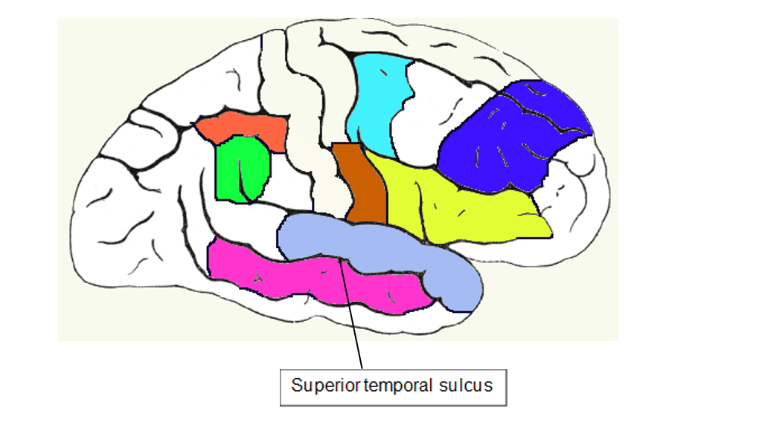
Figure 1 Cortical areas in which lesions were associated with neglect in the studies of Verdon et al. (2010) and Commotteri et al. (2007). Areas in common were the anterior dorsolateral prefrontal cortex (blue) and regions in and around the superior temporal sulcus (superior and middle temporal gyri). Other regions were identified in only one of the studies: inferior parietal lobe (red), supramarginal gyrus (green), inferior pre-central gyrus (brown), posterior middle frontal gyrus (turquoise) and right inferior frontal gyrus (yellow). See text for more details.

The differences between the anatomical sites underlying what are apparently the same functions in these studies might reflect subtle differences in the tests (e.g. single words vs sentences). Another possibility is that some functions are carried out by a network of brain regions, damage to any one of which could produce the observed deficits. Future refinements of testing and/or measurement of lesions may throw light on these issues.
Committeri G, Ptzalis S, Galati G, Patria F, Pelle G, Sabatini U, Castriota-Scanderbeg A, Piccardi L, Guariglia C, Pizzamiglio L (2007) Neural bases of personal and extrapersonal neglect in humans. Brain 130: 431–441.
Verdun V, Schwartz S, Lovblad K-O, Hauert C-A, Vuilleumier P (2010) Neuroanatomy of hemispatial neglect and its functional components: a study using voxel-based lesion-symptom mapping. Brain 133: 880–894.

