Key Note

Chapter 3: Mechanisms of early and middle visual processing

Key note 3A: Retino-geniculo-striate visual pathway
This note describes, in more detail than given in Chapter 3, the main visual pathway from the retina to the brain, and some of the consequences of its arrangement.
The pathway to the cortex projects from the retina to the two lateral geniculate nuclei which lie either side of, and form part of, the thalamus, and from there to visual cortex. However, different routes are taken by fibres sending signals from the left and right regions of the retina, and this has important clinical and scientific consequences. A bird’s eye view of a schematic representation of the pathways is shown in Figure 1.
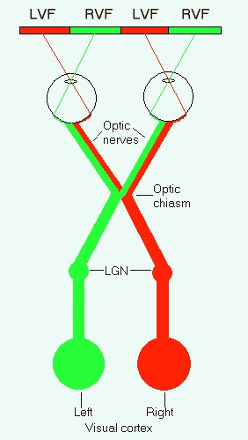
Figure 1 Retino-geniculo-striate visual pathway.

Subjectively, for most of us, the visual field appears as a homogeneous whole. However, in terms of the anatomy of the early stages of vision, the visual field of each eye is divided into two around its vertical midline, so that information from the left and right regions of the visual field is initially processed in different hemispheres. Because the visual field is left-right reversed on the retina by the optics of the eye, information from the left visual field falls on the right regions of both retinas, and that from the right visual field on the left regions. Fibres from all regions of the retina of the left eye form the left optic nerve, and those from the right retina the right optic nerve. The two optic nerves meet at a structure called the optic chiasm (or chiasma – the Greek word for ‘crossing’). The fibres from the temporal region of each retina (the side nearest to the temple) continue on the same side of the head. However, those from the nasal regions of each retina (the sides nearest the nose) cross at the chiasm to the other side of the head. Thus the temporal fibres of the left eye and the nasal fibres from the right eye form the left optic tract, and the temporal fibres of the right eye and nasal fibres of the left eye form the right optic tract. Each optic tract terminates in the lateral geniculate nucleus (LGN) on its side of the thalamus. From each LGN, fibres project as the optic radiations to the primary visual cortex (V1) on its side of the brain.
You can trace the flow of information in the pathway by following the colour codes (green for right visual field – RVF, and red for left visual field – LVF). They show that information from the left visual field is initially processed in right V1, and that from the right visual field in left V1. This means that visual information presented away from the midline is processed, at least initially, by only one hemisphere. Many studies have made use of this fact to try to tease out aspects of specialisation of the hemispheres. For example, in Chapter 13, a study is described in which pictures of human faces were presented briefly to either the left or right hemispheres of participants who were asked to rate their attractiveness. It turned out that judgements of faces in the left visual field (right hemisphere) were based on their sexual attractiveness, and of those in the right visual field (left hemisphere) by their ‘non-sexual’ attractiveness (e.g. as a possible lab partner).
The organisation of the visual pathways also has important clinical consequences, when a neurologist is trying to identify the site of brain damage. Thus, if the left optic nerve is cut, the patient will be blind in the left eye but sight in the right eye will be unimpaired. If the left optic tract is cut, the patient will be blind in the right visual field, whether viewing with the left or right eye.

