Key Note

Chapter 3: Mechanisms of early and middle visual processing

Key note 3B: Changes in flicker sensitivity with dark adaptation
We noted in the text that, in the dark-adapted eye, the inhibitory surrounds of ganglion cell receptive field become weaker or disappear, which affects spatial vision for fine details. It turns out that there are effects of dark adaptation on vision for temporal changes also. Figure 1 shows a family of temporal contrast sensitivity functions, plots of sensitivity to flicker of a range of frequencies from low (1 Hz) to high (32 Hz).
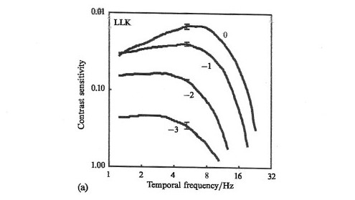
Figure 1 Temporal contrast sensitivity functions measured by Anstis et al. (1999). Note that the numbers on the vertical axis of the graph are threshold contrasts. It would be better to replace them with sensitivities (1/threshold contrast), i.e. 1, 10, 100.

The upper graph plots contrast sensitivity in the light adapted eye, showing that it peaks at a medium frequency (about 8 Hz) then declines at lower and higher frequencies. The lower three curves show the effects of viewing through neutral density filters of 1, 2 or 3 log units, so dimming the display by 10, 100 or 1,000 times. This reduces the sensitivity to medium frequencies, and progressively decreases the contrast at which sensitivity to higher frequencies starts to decline (from about 6 Hz with the 1 log unit ND filter to about 3 Hz with the 3 log unit filter).
Although the measurements were made for temporal frequency, a similar family of curves would be obtained for spatial frequency, which peaks for the light-adapted eye at around 5 c deg⁻¹ (see Figure 5.4). However, as with temporal frequency, as dark adaptation proceeds, peak sensitivity shifts towards lower frequencies and sensitivity to high frequencies is lost.
Why should this happen? As luminance reduces, the number of photons reaching the retina reduces. The retina changes its properties to capture as many photons as possible by removing inhibitory surrounds, so increasing spatial summation, and increasing the time over which ganglion cells add up photons to produce neural activity. This increases sensitivity but sacrifices the ability to detect tiny spatial and temporal changes. If you like, it is better to see something, however imperfectly, than nothing.
How did Anstis et al. make their measurements of temporal frequency sensitivity?
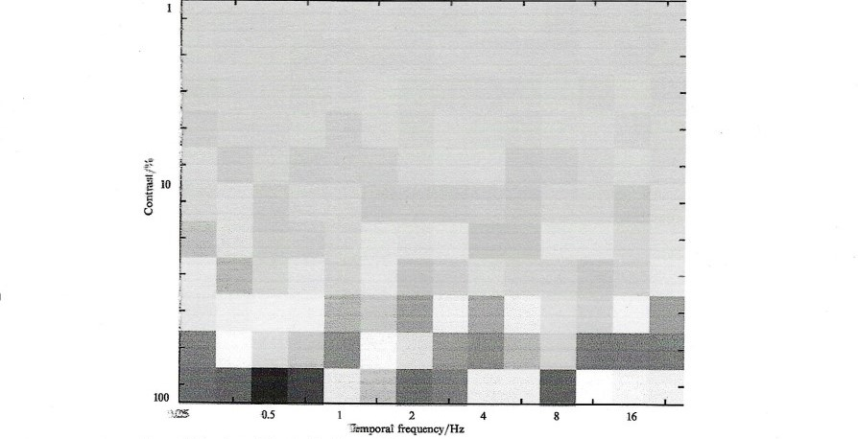
Figure 2 Snapshot of the computer display used by Anstis et al. to measure temporal contrast sensitivity.

Figure 2 shows a still picture of their flickering display, which is divided up into tiny squares, which can flicker independently. As one moves to the right along the display, flicker frequency increases. As one moves up the display, contrast (the difference between the bright and dark parts of the flicker) reduces. At some point on the screen, flicker at each frequency becomes invisible. The curves in Figure 1 were obtained by fixing a clear plastic sheet to the screen and tracing with a pen the points where flicker became invisible.

Anstis S, Kontsevich L, Tyler C (1999) Demonstrating the temporal modulation transfer function. Perception 28: 623–626.

