Key Note

Chapter 5: Seeing pattern and motion

Key note 5A: Adjusting the gain of spatial channels – contrast constancy
As indicated in Chapter 3 of the book, spatial information is encoded in human vision by a small number of channels tuned to different spatial frequencies. This note discusses how the arrangement can provide benefits in later stages of image processing.
An advantage of a system in which spatial information is encoded by a number of separate channels tuned for different spatial frequencies is that individual channels can be adjusted to compensate for losses of information. Figure 1 shows that contrast sensitivity for a grating of 20 c deg⁻¹ is about 1 log units (a factor of 10) less than that for one of 5 c deg⁻¹. But is this difference in the ability of the underlying channels to transmit spatial information maintained for contrasts above threshold? This question was investigated in a study by Georgeson and Sullivan (1975) in which they presented a grating of 5 c deg⁻¹ (the standard) at various contrasts, and had their observers vary the apparent contrast of gratings of other spatial frequencies until they appeared to match it. A subset of their data is shown in Figure 1, in which it is clear that, at threshold (upper graph), the observer needs progressively more contrast to detect the gratings as spatial frequency is increased or decreased from 5 c deg⁻¹. But as the contrast of the standard 5 c deg⁻¹ grating is progressively raised, so the physical contrast needed to match it at higher and lower spatial frequencies becomes more like that of the standard. When the contrast of the standard reaches 0.3 (30%), the matching curves are horizontal, so that at match all spatial frequencies have the same contrast. The authors suggested that this effect, which they termed ‘contrast constancy’, reflected the operation of a mechanism which ‘de-blurred’ an image attenuated by optical and neural factors in early vision. This might be done by progressively increasing the gain or amount of amplification ofspatial frequency channels as their deviation from 5 c deg⁻¹ increased. So, for example, the firing rate of neurons responding to low and high spatial frequencies would rise more rapidly with contrast, once their threshold had been reached, than would that of neurons responding medium spatial frequencies. This idea was confirmed and extended by Snowden (1994), using selective adaptation. He argued that high and low spatial frequency channels should be more adaptable than medium spatial frequency channels, if indeed their gain was higher at low contrasts.
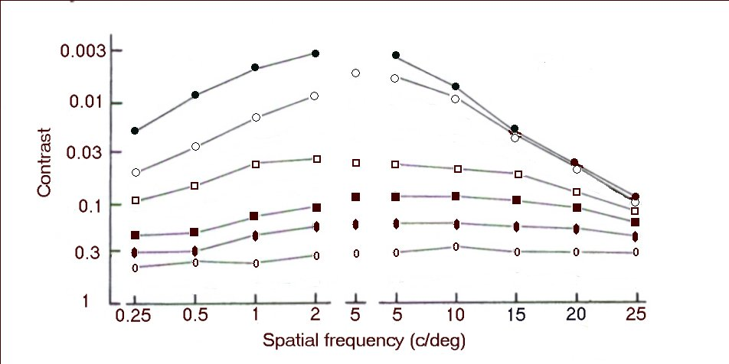

Figure 1 Contrasts of gratings measured by Georgeson and Sullivan (1975). The upper curve (filled circles) shows threshold contrasts. The central column of isolated symbols shows the contrasts of the 5 c deg⁻¹ grating to which matches were made. The corresponding joined symbols show the contrasts of other spatial frequencies at match. Data taken and redrawn from Georgeson and Sullivan (1975).

Some of his data are shown in Figure 2, which illustrates how threshold elevation (the rise in contrast threshold, compared with threshold after adaptation to a blank screen) rose with adapting contrast. The threshold contrasts for the three spatial frequencies were: 3 c deg⁻¹ : 0.25%; 15 c deg⁻¹ : 1.6%; 45 c deg⁻¹ : 10%. Thus, the higher the threshold contrast (and so the more insensitive the underlying mechanisms), the steeper the slope of the graph of threshold elevation against adapting contrast (and so the higher the gain of the channel at lower contrasts). Snowden also found that he could make the slope steeper by increasing the frequency at which a 15 c deg⁻¹ grating was flickering, or by viewing it with peripheral vision, both manipulations which increased its threshold contrast.
One way to view these findings is that the visual system has been shaped in such a way that the contrast signalled by channels in which it has been attenuated by optical or neural imperfections at an early stage of vision can be restored at later stage of visual processing. The auditory system appears to be similarly organised. Figure 6.10 in the book shows that the large differences between the thresholds for different frequencies are much reduced for louder sounds.

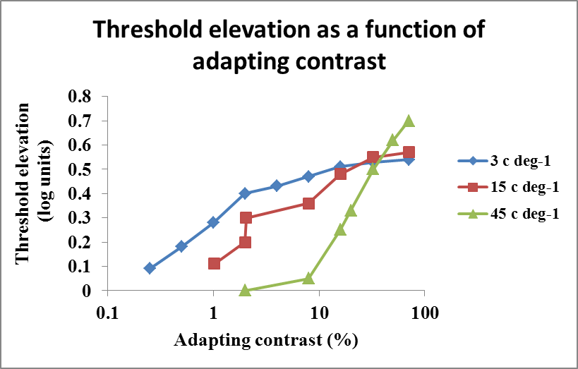
Figure 2 Threshold elevation as a function of adapting contrast for three spatial frequencies. Redrawn from Snowden (1994).

Georgeson MA, Sullivan GD (1975) Contrast constancy: deblurring in human vision by spatial frequency channels. Journal of Physiology 252: 627–656.
Snowden RJ (1994) Adaptability of the visual system is inversely related to its sensitivity. Journal of the Optical Society of America A 11(1): 25–32.

