Key Note

Chapter 5: Seeing pattern and motion

Key note 5C: Finding the effect of a stimulus on visual receptive fields – convolution
The aim of this section is use Microsoft Excel to calculate the response of a visual receptive field to an edge in the retinal image. One example is given, and a second is suggested.
How is an edge located in the retinal image? As pointed out in the text, the neural signal of a sharp edge is actually blurred by the optics of the eye and by spatial summation in the retina – if plotted on a graph it would form an S-shaped curve. It has been suggested that edge location might be done by computing spatial derivatives, to find a point in the retinal image which corresponds to the mid-point of the S-shaped curve, which in turn corresponds to the sharp edge out there in the world. The aim of this Key Note is to show you how the first spatial derivative (defined in the book) might be computed by a cortical neuron.
Two types of receptive field, known as odd-symmetric (A) and even-symmetric (B) are shown in Figure 1. The even-symmetric RF is like that in Figure 2.7.
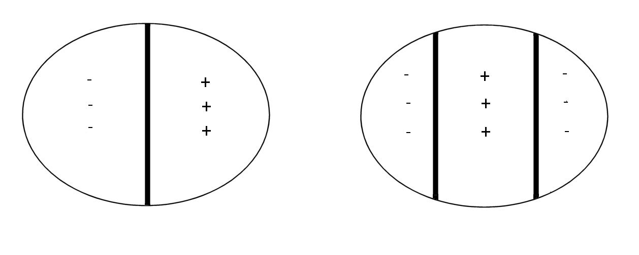
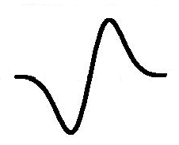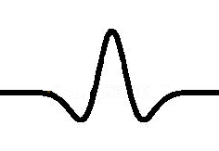
A B
Figure 1 Schematic representations of odd- and even-symmetric receptive fields. Upper pair of figures show approximate plan view of sensitivities, lower pair cross-sectional view, so that the lower graphs rise in regions marked with a + in the upper panels, and fall in regions marked with a −. A: odd-symmetric; B: even-symmetric.

The mathematical operation by which a receptive field can compute a spatial derivative is known as convolution. It can be thought of as sliding the receptive field over the image, at each point finding its sensitivity to that region of the image. An example of how to do this is given in Table 1 below. Row 2 (cells K1–V1) shows sensitivity at different points in a section through an odd-symmetric receptive field (the graph in Figure 1A). As one moves from the left, sensitivity declines from zero to −15, then rises again to a peak of 15, to decline again to zero. Row 3 (cells A2–W2) shows the intensity at different points on a blurred edge, rising from a plateau of 1 on the left to another plateau of 12 on the right. Row 3 (cells A3–W3) shows the convolution of the data in Rows 2 and 3. This is done by moving the receptive field over the luminance profile of the edge, multiplying the sensitivity at each point with the intensity of the stimulus at that point, and adding together the products. In Microsoft Excel, this can be done with the SUMPRODUCT() formula. Thus cell A3 = SUMPRODUCT(K1:V1, A2:L2), cell B3 = SUMPRODUCT(K1:V1, B2:M2) and so on. Before trying it, increase the number of columns on the right of the table, to extend the row of numbers representing the high-intensity plateau.

Table 1 Illustrating convolution.
A | B | C | D | E | F | G | H | I | J | K | L | M | N | O | P | Q | R | S | T | U | V | W
 |  |  |  |  |  |  |  |  |  | 0 | −3 | −6 | −15 | −6 | −3 | 3 | 6 | 15 | 6 | 3 | 0
1 | 1 | 1 | 1 | 1 | 1 | 1 | 1 | 1 | 1 | 1 | 2 | 3 | 4 | 5 | 6 | 7 | 8 | 9 | 10 | 11 | 12 | 12
0 | 3 | 12 | 36 | 66 | 99 | 129 | 153 | 162 | 165 | 165 | 165 | 162 | 153 | 129 | 99 | 66 | 36 | 12 | 3 | 0 | 0 | 0

Figure 2 Graph of response of odd-symmetric receptive field to a dark-light edge.

The result of the convolution (Row 3 in Table 1) is plotted in Figure 2. One problem with this arrangement is that the peak of the graph (Position 11 in Figure 2, and Column K in Table 1) does not correspond to the mid-point of the luminance ramp representing the edge (between Positions P and Q in Table 1), but is offset to the left. One can calculate the response of an even-symmetric receptive field (Figure 1B) to an edge, but repeating the convolution after changing the values in cells K1–V1 in Table 1 to reflect points on the sensitivity profile shown in Figure 1B. The output is a mirror image of the second derivative shown in Figure 5.10C of the book. However, the zero crossing is shifted to the left, rather than aligned with the midpoint of the blurred edge. Some additional computation would be needed to give accurate localisation of an edge, if indeed this is given by the first or second spatial derivatives as produced by odd- or even-symmetric receptive fields.
This example has illustrated the simple case where the image varies in one dimension (is a single black/white edge). Most images vary in two dimensions, but the same sum of products at each point can be used to calculate the receptive field’s response. Note also that the numbers in Row 2 of Table 1 (the sensitivities to, or weights given to, stimulus features falling in that part of the receptive field, sum to zero). This means that the cell is insensitive to a display of uniform luminance.

