Key Note

Chapter 6: Hearing

Key note 6A: Application: Cochlear implants
As noted by Lau et al. (2017), experimental studies suggesting that place-based information can be sufficient to generate complex pitch perception has important implications for the design of cochlear or brainstem implants intended to restore hearing. Cochlear implants comprise an array of very small electrodes, which are surgically inserted into the turns of the cochlea (Figure 6.1). The implants directly stimulate neurons in the auditory nerve using electrical pulses, with the aim of bypassing damaged or missing sensory hair cells in the cochlea. Stimuli reflecting different parts of the audio frequency spectrum delivered to the different electrodes along the length of the array excite different subpopulations of spiral ganglion neurons and consequently produce an approximation to the tonotopic mapping of frequencies that occurs in the normal cochlea. Despite the array comprising only 12–24 electrodes (replacing the functioning of some 3,500 inner hair cells), cochlear implants are highly successful in transmitting speech information to users with profound hearing loss. But, at present, pitch is only weakly conveyed by cochlear implants, and users often have trouble with speech reception in noise and music perception.
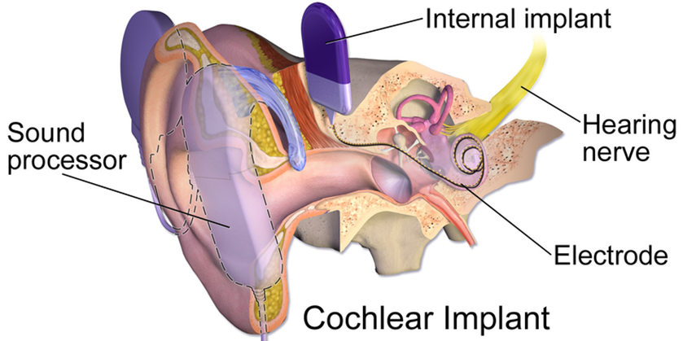
Figure 1 Diagram showing elements of a cochlear implant. The sound processor captures sound, converts it to digital signals and sends these to the internal implant whereby they are decoded and transformed into electric energy and sent to an electrode array inside the cochlea. The electrodes stimulate the auditory nerve, bypassing missing or damaged hair cells, enabling sound to be perceived. Image taken from WikiCommons; https://commons.wikimedia.org/wiki/File:Cochlear_Implant.png

Impaired processing of pitch in cochlear implant users relates in part to poor spectral resolution, a result of the limited number of array electrodes, interference or crosstalk between electrodes, non-uniform neural survival along the length of the cochlea, and that implants do not reach the most apical portions of the cochlea (where lowest frequencies most critical to pitch perception are processed; Oxenham, 2018). To the extent that place coding can by itself elicit complex pitch perception, then accurate pitch discrimination in implant users could potentially be restored based on location of stimulation, if sufficient resolution can be achieved. While current cochlear implants fail in this regard, various novel interventions are beginning to show promise. For example, neurotrophic treatment in guinea pigs can stimulate regeneration of spiral ganglion neurons in close proximity with the cochlear implant electrodes and improve implant performance (Pinyon et al., 2014). Another study showed that compared with cochlear-implant stimulation direct auditory, nerve stimulation with a multielectrode array in animals yielded lower neural excitation thresholds and more selective excitation of low-frequency fibres from the cochlear apex and markedly reduced interference between electrodes when simultaneously stimulated (Middlebrooks and Snyder, 2007, 2008).

Lau BK, Mehta AH, Oxenham AJ (2017) Superoptimal perceptual integration suggests a place-based representation of pitch at high frequencies. Journal of Neuroscience 37: 9013–9021
Pinyon JL, Tadros SF, Froud KE, Y Wong AC, Tompson IT, Crawford EN, Ko M, Morris R, Klugmann M, Housley GD (2014) Close-field electroporation gene delivery using the cochlear implant electrode array enhances the bionic ear. Science Translational Medicine 6: 233ra54.
Middlebrooks JC, Snyder RL (2007) Auditory prosthesis with a penetrating nerve array. Journal of the Association for Research in Otolaryngology 8: 258–279.
Middlebrooks JC, Snyder RL (2008) Intraneural stimulation for auditory prosthesis: modiolar trunk and intracranial stimulation sites. Hearing Research 242: 52–63.
Oxenham AJ (2018) How we hear: The perception and neural coding of sound. Annual Review of Psychology 69: 27–50.

