Mental Map Familiarization Exercises

Using the mental map to help you engage with your chosen frontline text

About these exercises

The set of Mental Map Familiarization Exercises is lengthy because it develops your learning in relation to six chapters of the book Critical Reading and Writing for Postgraduates (5th edition) by Mike Wallace and Alison Wray, published by Sage in 2026.
The set contains six exercises, reflecting the five components of the Mental Map listed in the box below, plus a final short reflection exercise on them.

- Tools for thinking: how the authors conceptualize key aspects of their topic
- Ways of thinking about the social world: what the authors assume about the nature of the social world, how we can know about it, and how it should be
- Reasons for studying and trying to make an impact: why the authors are doing their research and who they wish to inform about their findings
- Claims to knowledge: what, in summary, the authors claim to have found out from their investigation
- Claim characteristics – degree of certainty and generalization: how sure the authors are about what they’ve found out and how widely they think it applies beyond the settings they studied

The exercises are designed to help you practise looking for these components in the academic papers you read, so you can assess how they shape the claims that the authors make. For these exercises we focus on research report articles: academic journal articles that report the authors’ own, original, empirical research findings.
For example, suppose an author states: we can be certain that this result represents a major breakthrough in our understanding of this issue. A critical reader needs to be asking:
- How do you view the new knowledge you have gained, such that it’s appropriate to call your finding a ‘major breakthrough’? (4: Claims to knowledge)
- What makes you so certain? (5: Claim characteristics)
- How are you perceiving the purpose of research you do, such that a ‘major breakthrough’ is relevant and worthwhile? (3: Reasons for studying and trying to make an impact)
- How are you perceiving the social world, such that a ‘major breakthrough’ is possible and/or likely? (2: Ways of thinking about the social world)
- How are you conceptually framing the (inevitably complex) area you investigate, so that you are confident you have cut through the complexity to get to a ‘major breakthrough’? (1: Tools for thinking).

In time, asking this sort of question can become second nature to you, but at first it’s quite difficult. You have to step back from looking at the things the author is trying to make you concentrate on, and identify the underlying beliefs, assumptions and priorities that the author has (and might not always be aware of).

It is very important, first, to read the relevant chapters in the book which explain the components and give examples. Either you could read through the six chapters (8–13) and then work through all the exercises, or you could read Chapters 8, 9 and 10 and work through exercises A and B, and then return to the book to read Chapters 11 and 12 (for exercises C and D) and Chapter 13 (for exercise E).
If you choose to space the exercises out over time, it’s fine to choose different research report articles for the different exercises, so you are always working on an article that you need to read anyway for your studies. Alternatively, choose one research report article that is central to your studies, and use it throughout.
All of the exercises will help sharpen up your thinking. Specifically, they aim to make you much more aware of why some academic articles are more convincing than others, which is a vital step in your critical reading. However, it’s also okay to skip exercises if you feel from reading the chapter that you understand the ideas and know how to identify and work with that component.
If you’re not sure about whether to do these exercises and want to pick just one to try, we recommend you jump straight to exercise E (read Chapter 13 first). In line with the example above, the claim characteristics can be a good starting point for asking questions about how the author felt able to make the claim. So, having done exercise E, you may have helpful insight into which of the other exercises might also be of benefit to you.

What to read first

The mental map and its five components are introduced in Part Two of the book.

Chapter 8 introduces the mental map and its five components. The next five chapters outline each of the components in detail:
- tools for thinking (Chapter 9)
- ways of thinking (Chapter 10)
- reasons for conducting the research (Chapter 11)
- knowledge claims (Chapter 12)
- key characteristics of knowledge claims (Chapter 13)

What the exercises entail

The exercises invite you to identify within your chosen article how a given component might be affecting the authors’ argument, and what you could look for when evaluating how convincing their claims are about what they have found out.
There is a grid to prompt you to write down what you find, and then there are critical checks which invite you to reflect on how your findings might impact on your evaluation of the claims in the article.

What you need

- Have available a copy of the Critical Reading and Writing for Postgraduates textbook (5th edition) to refer to as you go along, for descriptions and explanations of the different components you’ll be working with in this exercise.
- Choose an academic journal article you are interested in analysing that reports the authors’ own original empirical research findings. (A research report article works best for familiarizing yourself with the application of the mental map. This is because the components of the map apply most extensively where authors’ claims about what they have found out are based wholly or largely on empirical evidence.)

Alternatively, either of these articles, downloadable from the textbook website, is also suitable for the mental map familiarization exercise:

- Krienert, J and Walsh, J (2010) Eldercide: a gendered examination of elderly homicide in the United States, 2000–2005, Homicide Studies 14, 1:52–71

- Tong, J (2009) Press self-censorship in China: a case study in the transformation of discourse, Discourse and Society 20, 5: 593–612

What to do

- Carefully read your chosen article right through from beginning to end, including the abstract if there is one.
- Work through the exercise. Doing so involves:
- Identifying where each component is reflected in the text of your chosen research report article;
- After completing each component, doing the ‘critical check’. This check alerts you to potential limitations in the authors’ argument related to a mental map component.

(The boxes for your answers will expand as you type, so you can write down as much as you need to.)

Tips on completing these exercises

You might struggle to complete all the parts of some exercises. One reason could be that a certain aspect of a component isn’t present (e.g. in Exercise A, there might not be any central metaphors used to help understand complex concepts). In such circumstances, it’s okay to leave a blank. However, keep in mind that it takes some practice to read an article in the manner necessary for identifying components, so don’t give up too soon. In particular, the information could be implicit; that is, the author does not provide it directly, and you have to work it out.
If you repeatedly just can’t find the components, check that the article you have selected for these exercises really is a research article reporting the author’s original research and is not a straight literature review or overview. If it is a research report article, then the reason you can’t easily find the components might be that you just need more practice. Going back to the book and checking out the examples might help.

EXERCISE A: Tools for thinking
(First read Chapters 8 and 9 of Wallace, M. & Wray, A. (2026) Critical Reading and Writing for Postgraduates (5th Edition). London: Sage).

This exercise covers three of the tools for thinking that are explored in Chapter 9:
- Concepts
- How concepts are paired as metaphors
- How concepts are grouped as labels, perspectives, models or theories

I: Concepts – individual ideas derived by abstraction from experience or other ideas

- In the left-hand column of the table below, list up to three key concepts that the authors of your article use to focus on the central aspects of their topic (e.g. power; leadership; economic success; person-centred care).
- In the middle column, note if the authors provide a definition of what they mean by each concept
- In the right-hand column, for each concept which is defined, write down the authors’ definition

Concept | Defined? (Yes/No) | Content of definition, where given

Critical concept check: have the authors omitted to indicate what they mean by one or more of the key concepts they are using? If so, how might this omission affect the convincingness of the claims they make about what they’ve found out?

II: Metaphors – one concept used to understand another

Metaphors use a simpler or more familiar concept to help understand another more complex or unfamiliar one. The simpler/more familiar concept ‘maps onto’ the more complex/unfamiliar one according to some perceived similarity.
For example, if an author suggests that people grow into their role at work, the simple and familiar concept of ‘growth’ is used to help conceptualize ‘professional development’. We can describe the metaphor as: professional development as growth. The author is proposing that professional development can be thought of as being like growth because both involve a process of accumulating more of something over time.
In drawing our attention to some aspects of the more complex or unfamiliar concept, the metaphor inevitably underplays other aspects.
For example, growth is an unconscious process that happens naturally. As such, the simple and familiar concept of growth underplays the part played by conscious effort in the complex and unfamiliar concept of professional development.

Are any of the concepts you identified above metaphorical? To work out, check whether a simple concept is being used to describe another more complex one.

Metaphor  (complex/unfamiliar concept as simple/familiar concept) | Complex/unfamiliar concept | Simple/familiar concept

Critical metaphor check: which aspects of the phenomenon does the metaphor draw attention to, and which aspects does it underplay or ignore – is attention drawn away from any important aspects?

III: Multiple concepts – grouping a set of concepts according to their collective focus and linkage, as labels, perspectives, models or theories

Do the authors of your article refer to one or more groupings of concepts? (For guidance on, and examples of, labels, perspectives, models and theories, see Chapter 9). Focus on key concepts entailed in their investigation, because they are the ones that require most scrutiny by a critical reader. If concepts are grouped, which groupings do you think constitute a:

- Label – narrow focus, loosely linked (descriptive)

Term used by the authors for this label | Concepts the authors include in the label | Why the degree of focus and linkage between the concepts indicates that this is a label

- Perspective – broad focus, loosely linked (descriptive, sometimes also explanatory)

Term used by the authors for this perspective | Concepts the authors include in the perspective | Why the degree of focus and linkage between the concepts indicates that this is a perspective

- Model – narrow focus, tightly linked (descriptive or explanatory)

Term used by the authors for this model | Concepts the authors include in the model | Why the degree of focus and linkage between the concepts indicates that this is a model

- Theory – broad focus, tightly linked (usually explanatory)

Term used by the authors for this theory | Concepts the authors include in the theory | Why the degree of focus and linkage between the concepts indicates that this is a theory

Critical concept grouping check: for any grouping, which concepts have been grouped together as a set and what relevant concepts might be missing? How helpful for understanding is the degree of focus and linkage between the concepts in this set?

EXERCISE B: Ways of thinking

(First read Chapter 8 and Chapter 10 of Wallace, M. & Wray, A. (2026) Critical Reading and Writing for Postgraduates (5th Edition). London: Sage).

Below, you’ll see a summary table of five common philosophical positions (left hand column), and the assumptions and methods associated with them (p.125–126). This exercise invites you to ask a series of questions about what the authors are trying to do and how, and use this information to identify:

I: their assumptions and philosophical position;
II: their underpinning ideology/ies.

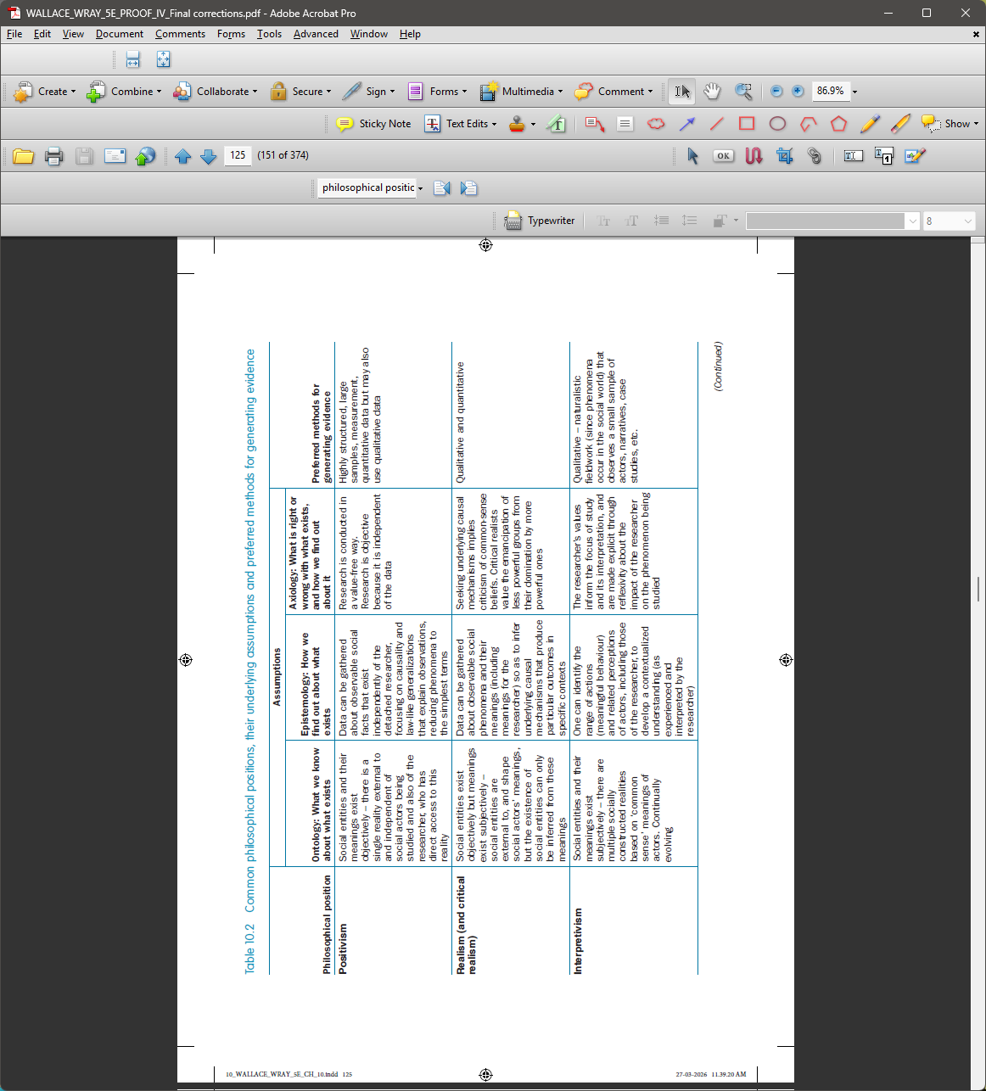

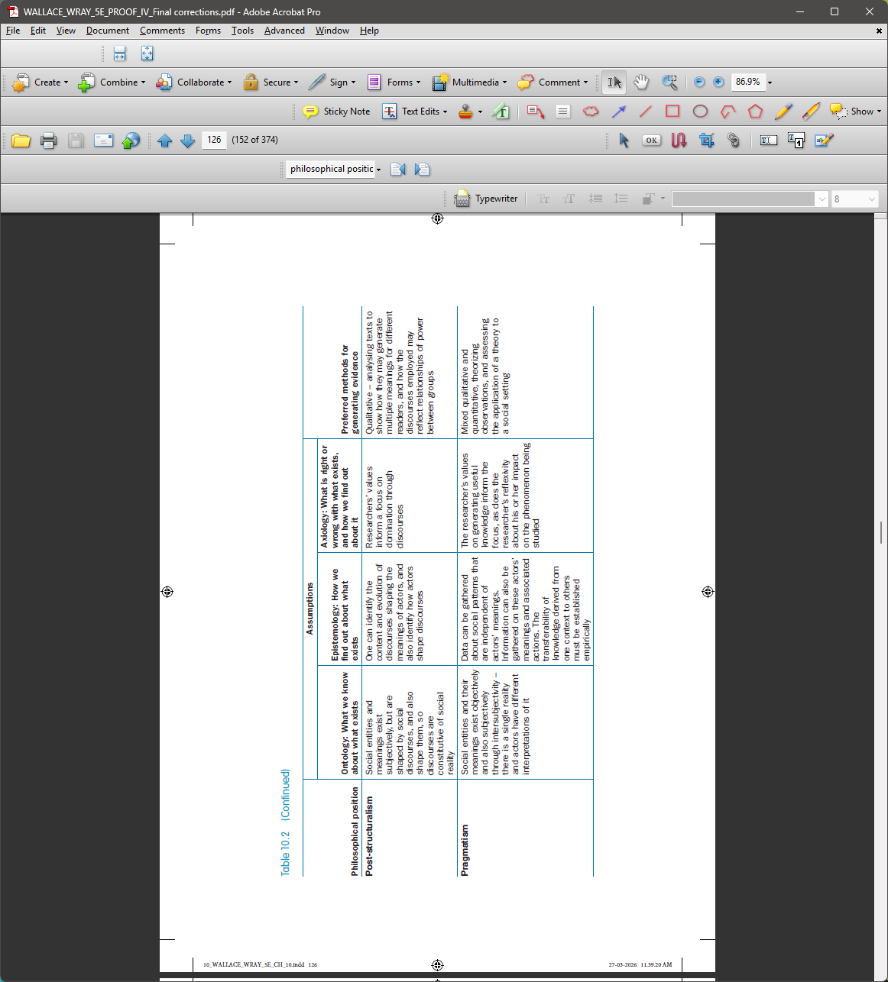

I: Assumptions underlying a philosophical position and affecting research methods used

Search your text for places where your authors write about aspects of their study methodology. Identify where:

- They make an assumption explicit and/or
- Leave the assumption implicit but leave clues that can help you identify what it is likely to be.

Try identifying the authors’ ontological, epistemological and axiological assumptions and their philosophical position. Each focus involves one or more of these assumptions:

1. Ontological assumption: Focus on what the authors are studying. What they think can be studied reflects their ontological assumption about what exists.

What the authors state in the text | Page numbers | What this evidence suggests is their ontological assumption

2. Epistemological assumption: Focus on how the authors are studying their phenomena of interest. The methods that they think can be used to generate evidence from appropriate sources reflect their epistemological assumption about how we can know about what exists.

What the authors state in the text | Page numbers | What this evidence suggests is their epistemological assumption

3. Axiological assumption (research ethics): Focus on how the authors treat any people involved or affected by their research. Their approach to researching people reflects their axiological (research ethics) assumption about how people involved or affected by their research should be treated.

What the authors state in the text | Page numbers | What this evidence suggests is their axiological (research ethics) assumption

4. Ontological and epistemological assumptions: Focus on what sort of claims the authors make about generating new knowledge. What they study reflects their ontological assumption about what exists, plus their epistemological assumption about how we can know about what exists.

What the authors state in the text | Page numbers | What this evidence suggests are their ontological and epistemological assumptions

5. Axiological assumption: Focus on what values the authors express about what they study and what they claim to have found out. What they study and claim to know about it reflects their axiological assumption about what is interesting, important, right or wrong, or how it could be improved.

What the authors state in the text | Page numbers | What this evidence suggests are their axiological assumptions

6. Ontological, epistemological and axiological assumptions: Focus on what audience the authors are seeking to convince about their claims to knowledge and associated values. Why this knowledge matters, and for whom, reflects the authors’ ontological assumption about what exists, their epistemological assumption about how we can know what exists, plus their axiological assumption about why it is interesting, important, or right or wrong for the target audience, and whether this audience can bring about some improvement.

What the authors state in the text | Page numbers | What this evidence suggests are their ontological, epistemological and axiological assumptions

7. Explicit indication of the philosophical position reflected in ontological, epistemological and axiological assumptions: Focus on whether the authors directly comment on any of the assumptions they make in their text (they may not). Look for any mismatch between what they say and what you’ve found in 1–6 above to be what they actually do.

What the authors state in the text | Page numbers | What this evidence, plus their ontological, epistemological and axiological assumptions, together suggest is their philosophical position

Critical assumption check: How clear is it what the authors’ implicit or explicit ontological, epistemological and axiological assumptions and philosophical position are, and how mutually consistent are these assumptions with each other, and with this philosophical position?

II: Ideologies affecting the choice of research topic, focus of the investigation, knowledge claims, recommendations

Ideologies are broad systems of beliefs, attitudes and opinions about one or more aspects of the social world (e.g. politics, economics, social wellbeing, education, environment). They are based on axiological assumptions (see above) about what is right and wrong for a particular group in society, different groups or society as a whole.
Ideologies tend to imply that actions associated with these beliefs will benefit (and so are right for) all groups in society. However, it is possible that an unintended consequence of actions informed by a particular ideology will disadvantage (and so be wrong for) others.
For example, an educational ideology advocating parental freedom to choose a private school for their child could, unintentionally, disadvantage any parents who cannot afford to pay private school fees.
Authors’ ideology can inform their choice of study focus (and so what aspects of the phenomenon they attend to or ignore), what they find out, and the views they express, based on their findings, about ways in which policy or practice are wrong, or how they might be improved.
Authors rarely make their own ideology explicit. But they often leave clues that can help you identify what it is likely to be, either from the value assumptions reflected in their research, or from factors you are aware of that they have not taken into account. You can then assess whether and, if so, how the authors’ ideology might have impacted on their choice of topic, research focus, findings and any judgements about what is wrong with the phenomenon, and how to improve it.

Try looking for places in your text where your authors state, or otherwise leave clues about, their ideology and its impact on their claims to knowledge and improvement:

1. Focus on how the authors justify their choice of topic to study (and whether it reflects their system of beliefs about this aspect of the social world) (e.g. the topic is the introduction of electronic voting in elections, which they believe is feasible and desirable)

What the authors state in the text | Page numbers | What this evidence suggests is their political, economic, social or other ideology

2. Focus on whether the authors fail to take into account any implications of their study’s focus and findings for disadvantaged groups (e.g. They overlook the barriers to using computers and smartphones that some people encounter)
What the authors state in the text | Page numbers | How this evidence suggests that no account is taken of implications for disadvantaged groups

3. Focus on specific factors you are aware of that could have implications for disadvantaged groups that the authors have not taken into account (e.g. I’ve seen that some older people struggle with technologies already, and electronic voting might mean they couldn’t vote)

Factors ignored with implications for disadvantaged groups | How are you aware of these factors (e.g. specified literature sources, personal experience?)

4. Focus on values underlying any claims about what is wrong with the phenomenon studied, or how it might be improved (e.g. They view the existing approach to voting as old-fashioned, which reflects the value of being ‘up to date’ even if it’s not best for some people)

What the authors state in the text | Page numbers | Values reflected in the authors’ statements

Critical ideology check: How might the authors’ implicit or explicit ideology affect what they claim to have found out, their values underlying any claims about what is wrong or how improvements can be made, and what they might have downplayed or ignored?

EXERCISE C: Reasons for studying and trying to make an impact

(First read Chapter 11 of Wallace, M. & Wray, A. (2026) Critical Reading and Writing for Postgraduates (5th Edition). London: Sage).

Intellectual projects – authors’ motivation for their study

What are the authors of your chosen article trying to achieve through their investigation? And how do they go about achieving it? Their approaches will have implications for the kinds of claim they make about what they have found out, and how they attempt to have an impact on their target audience by informing and influencing their understanding, policy or practice.
Making yourself aware of the authors’ rationale for their study, and their values about the phenomenon they have chosen to investigate will help you to see why they make the claims they do in the way that they do. This understanding is important for you, because when you evaluate their claims, you will more easily recognize how things they foreground and background could blind them to important issues that, when added into the picture, weaken the convincingness of their claims.
In sum, understanding what the authors’ intellectual project is can inform your evaluation of their claims to knowledge with regard to:

- How far their claims really do answer the research question that the authors asked;
- How their values about the phenomenon affect the nature of these claims;
- Whether you share or reject the value assumptions that the claims reflect.

Here is a summary of the core difference between the four types of intellectual project that authors might adopt:

- Knowledge-for-understanding – authors are neutral about the phenomenon being studied;
- Knowledge-for-critical evaluation – authors are negative about this phenomenon;
- Knowledge-for-action – authors are positive and want to inform improvement efforts;
- Training – authors are positive and want to improve practice through their specific programme.

The grid below adds in their reason for studying and attitude towards what they’re studying, and it provides a typical research question they might ask if they are pursuing that intellectual project.

1. Intellectual project (purpose for studying) | 2. Rationale (reason for studying) | 3. Value stance (attitude to phenomenon studied) | 4. Typical (research) question asked
Knowledge-for-understanding  (but not changing policy and practice) | Understand policy and practice through theory and research | Relatively impartial (so neutral) towards policy and practice | What happens and why?
Knowledge-for-critical evaluation  (exposing negative aspects of policy and practice) | Evaluate policy and practice through theory and research | Critical (and so negative) about policy and practice | What is wrong with what happens?
Knowledge-for-action  (helping to improve policy and practice) | Inform efforts of policymakers and practitioners through research and evaluation | Positive towards policy and improving practice | How effective is practice and how can it be improved?
Training  (improving practice through a programme of skills development) | Improve practice through training and consultancy | Positive towards policy and improving practice | How may my programme improve practice?

Note that the distinctions drawn here between intellectual projects are simplistic. Authors’ activity in a study can span more than one intellectual project. Many researchers whose natural focus is knowledge-for-understanding expect to offer a pointer towards potential impact from their work (i.e. how their claims could be translated into making some sort of change in policy or practice). As a result, you’ll often find some comments on applications or significance (sometimes referred to as the so what? section!). For example, authors might seek primarily to understand an aspect of organizational change, but also draw on their findings to offer some advisory comments about good professional practice. Typically, however, a study mainly reflects a single intellectual project, which should be detectable early in the account, as it will be used to direct the account in relevant ways.

Authors rarely state outright what their intellectual project is, and some are not explicit about the outcomes that they are trying to achieve. But you can often work out their main intellectual project from what they write. Check:

- The title, chapter headings or subtitles. Authors usually indicate what their purpose is.
- The abstract if there is one. Authors might say what the focus and outcomes of the study are.
- The introduction. Look especially near the beginning, where authors often set out their purpose and specify their research question or questions. Look also near the end of the introduction, where they show how they will develop their argument in the remaining sections or chapters of the text (e.g. highlighting their research methods).
- The conclusion. This is where most authors state in detail their main claims about what they have found out from their study.

So, now try identifying the rationale and value stance of the authors of your research report article to inform your judgement about which intellectual project the authors are wholly or mainly pursuing:

1. Focus on the authors’ rationale for their study (why they are studying this phenomenon in this way – to understand it, evaluate it, inform policymakers and practitioners about it, directly improve practice?)

What the authors state in the text | Page numbers | What this evidence suggests is their sole or main intellectual project

2. Focus on the authors’ value stance towards the phenomenon they are studying (relatively impartial because it is intellectually interesting, critical because it is wrong or ineffective, positive because it is right – though there may be scope for improvement?)

What the authors state in the text | Page numbers | What this evidence suggests is their value stance towards the phenomenon

3. Focus on the authors’ sole or main intellectual sort of intellectual project (Knowledge-for-understanding, knowledge-for-critical evaluation, knowledge-for-action, training – why you have decided this?)

Authors’ intellectual project
Summary of evidence in the text

Critical intellectual project check: How clear is it what sole or main intellectual project the authors are pursuing, and how does it affect their study focus, methodology, their claims about what they have found out, and any claims about what is wrong with the phenomenon or how it may be improved? (Note: sometimes, if a research report article is quite confusing, it’s because the authors had not resolved a tension between different intellectual projects – they weren’t clear about what they were doing or why, either in the research as a whole or, more likely, with respect to the focus in this particular article).

EXERCISE D: Claims to knowledge: common limitations of research literature

(First read Chapter 12 of Wallace, M. & Wray, A. (2026) Critical Reading and Writing for Postgraduates (5th Edition). London: Sage).

Chapter 12 identifies four types of literature: theoretical, research, practice and policy. This exercise focuses only on research literature because you have selected a research article. You can, of course, do the same exercise for the other types of literature, simply by referring to the relevant part of Table 12.1 in the book (on p.142–143).

Here is a description of features and a list of common limitations of research literature (p.142).

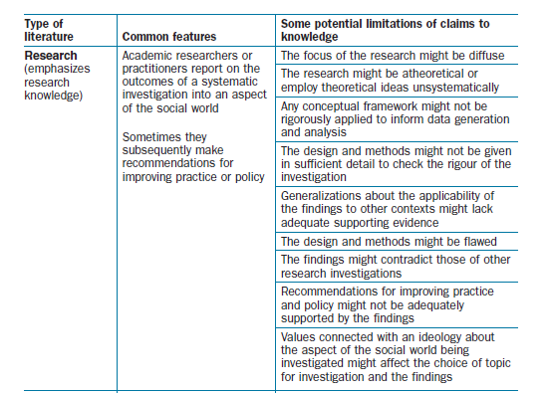

Critical research limitations check:
Do any of these common limitations apply to your chosen research article? If so, note up to two key limitations below, and consider in each case how the limitation affects your willingness to accept the authors’ claims about what they have found out. Note that although the best research articles will aim not to have major limitations, you will often find something from this list, because researchers cannot avoid every type of limitation (e.g. others’ findings contradict theirs). Some researchers will help you by actually acknowledging limitations, but keep in mind that they may be selective in what they mention and might not have been aware of some limitations that you can identify).

Limitation 1 reflected in the research report article
Evidence in the text (including page numbers)

Implications for the convincingness of the authors’ claims to knowledge
Limitation 2 reflected in the research report article
Evidence in the text (including page numbers)
Implications for the convincingness of the authors’ claims to knowledge

EXERCISE E: Claim characteristics – the degree of certainty and generalization

(First read Chapter 13 of Wallace, M. & Wray, A. (2026) Critical Reading and Writing for Postgraduates (5th Edition). London: Sage).

This exercise is perhaps the most powerful for you as a critical reader, because it enables you to get directly to the heart of the authors’ claims and judge, in a principled way, the extent to which they are convincing. The focus is on whether the authors have enough evidence to justify how certain they are about what they have found out in the context they studied, and how generalizable their findings are to other contexts.
The diagram below (p.149) shows how the degree of certainty and generalization of claims to knowledge can vary independently from low to high. What’s crucial here is looking for where the authors have chosen to locate their claims, because the higher they are on each dimension, the more evidence of the appropriate kind they’ll need to support the claim. To put it another way, the diagram indicates how claims made with different degrees of certainty and generalization vary in their vulnerability to being rejected by critical readers, who will see that the claims are inadequately warranted by sufficient, relevant evidence.
Identifying the degree of certainty and generalization of authors’ claims to knowledge gives you the basis for a ‘warranting check’: examining whether there is sufficient, relevant evidence from the specific context or contexts they studied, or from other contexts, to warrant a claim being accepted as convincing.
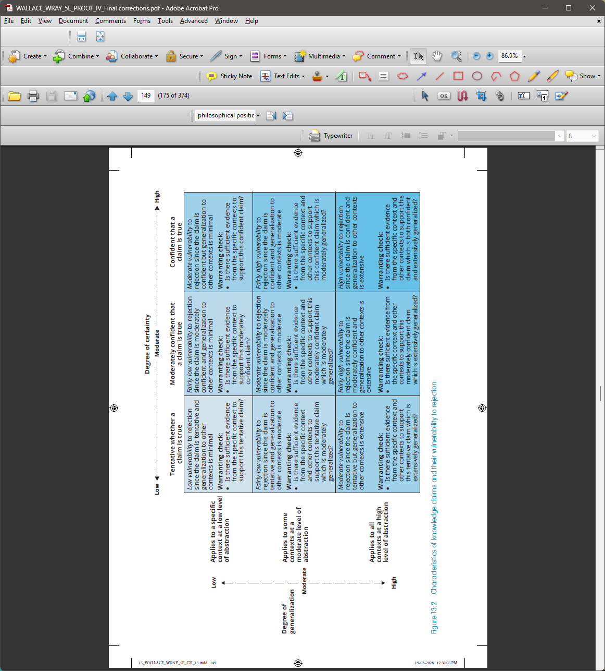

Identify the degree of certainty and generalization of the claims to knowledge made by the authors of your research report article:

Degree of certainty  (low - high) | Evidence in the text indicating the authors’ degree of certainty about what they have found out from the context or contexts studied | Page numbers
Degree of generalization (low - high) | Evidence in the text indicating the authors’ degree of generalization of what they have found out to other contexts | Page numbers

Where should you look in the text to work out whether this degree of certainty and generalization is adequately warranted by sufficient relevant evidence, and so convincing? (e.g. table of results; examples; summary analysis)

Critical claim characteristics check: How appropriate and adequate is the authors’ evidence to support the degree of certainty and generalization of their claims about what they have found out, and so make these claims convincing?

EXERCISE F: Reflection: How has the mental map informed your understanding of your chosen text?

To consolidate your learning, having completed the Mental Map Familiarization Exercises for your chosen research report article(s), you are invited to reflect on how applying the mental map components has helped you deepen your critical understanding. For this purpose, we’ll use the same sequence as the one in which the components are introduced in Chapter 8 of the textbook, and in the example referred to in the introduction to the Mental Map Familiarization Exercises.

- Did the authors’ account reflect any of the typical limitations associated with research literature (Exercise D), such that the authors didn’t notice, or take sufficient account of, some aspect of their design or data that justifies a query about the certainty and/or generalization?
- What did you conclude about whether the authors were expressing an appropriate level of certainty about what they had found out, given the data they had? (Exercise E)
- What did you conclude about whether the authors recognized the appropriate extent to which their findings could and should be generalized to contexts other than the one they studied? (Exercise E)
- If you identified any issues regarding the level of certainty or generalization, are you able to attribute them to what you found out through the other exercises? Specifically:
- Did the authors’ intellectual project (Exercise C) (or lack of clarity about what it was) lead them into an approach to their research or interpretation of the results that left them vulnerable to challenges about the certainty and/or generalizability of their claims?
- Did the authors’ assumptions, philosophical position or ideology (Exercise B) lead them to overlook important considerations that undermine their level of certainty and/or generalization (e.g. Were they too sure that the data they got really mean what they claim? Were they too sure that other populations than the one(s) they researched would generate similar outcomes?)
- Did the authors’ use and organization of concepts (Exercise A) direct them towards certain ways of understanding of the phenomena they were investigating that might have left them unable to recognize the limitations of their claims? (e.g. Did they assume that a certain metaphor was a suitable way to frame their complex phenomena more simply, but in doing so distort the nature of those phenomena in a manner that later influenced their level of certainty and/or generalization?)

These questions crystallize the power of the mental map in helping you to determine where and why authors’ claims have become open to challenge by you as a critical reader. Instead of just saying I find this claim implausible, you are able to point to exactly where the limitation is. In doing so, you are warranting your claim about the claim’s implausibility, using evidence generated through your critical reading, so that critical readers of your evaluation of the research article will see why you think what you think – that is, they will find your claim plausible!
The more you practise applying the mental map to navigate different texts from the academic literature, the more familiar you will become with each component, and the more automatically you will be able to apply it to any text you read.

