Further readings and templates

Chapter 9: Communicating effectively

Active listening
Active listening is a perceptual process: firstly, we sense and receive information; secondly, we interpret that information; we then subsequently evaluate that information (separating out fact from opinion); and finally, we respond.

Gathering information
In order to gather accurate and complete information, we need to ensure our objectivity to the person and to the information being given to us. There are a variety of factors which can impact on the extent to which we are objective about the information we are given, and a number which can affect how much information we actively receive in the first place (see the following figure).
Figure: Barriers to gathering accurate information when listening
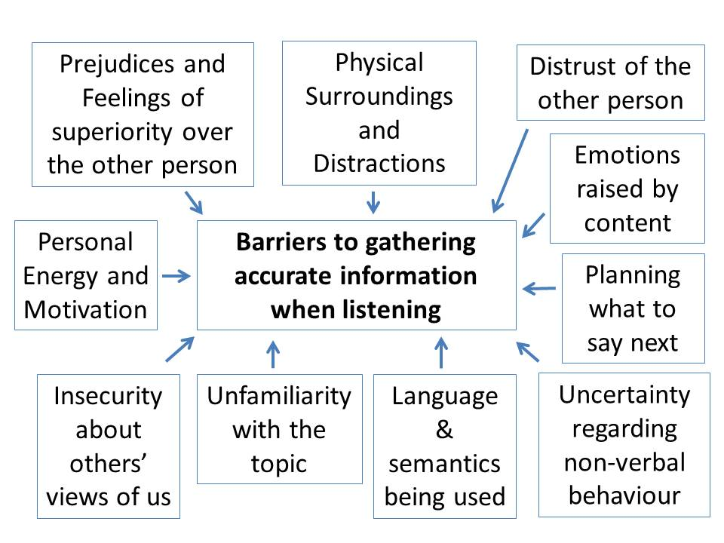
• Our own feelings of superiority can mean that we don’t believe the other person will say anything important and so we don’t attend to what they are telling us.
• Our physical surroundings can distract us: noise, others’ conversations and environments which are too cold or too hot can mean that our attention is drawn away from what the other person is saying and towards how we can change our environment.
• Our distrust of another person can mean that we don’t believe they will be saying anything that is true, so we pay little attention to it.
• If we get emotional (upset or angry) about the content of what the other person is saying, then we may well miss information which is relevant but becomes ‘hidden’ or is initially seen as irrelevant.
• Planning what to say next is common, but if we concentrate on this, then we will not be attending properly to what the other person is saying. By the time we have prepared our response, we are usually ready to give it, and may have a tendency to interrupt the speaker.
• There are times when we can be communicating with someone whose non-verbal behaviour is unfamiliar or about which we are uncertain – especially if they come from another culture. If that is the case, then we may be focusing on trying to understand the non-verbal behaviour more than the content of the message.
• We might not understand the language or the words being used, especially if English is not our native language. If so, then there will be gaps in our information.
• The same is true with technical subjects: if we don’t understand the words relevant to a particular topic, then there will be gaps in our understanding.
• If we are insecure about others’ views of us, then we will spend our time worrying about what others are thinking of us, rather than actually taking time to understand the information being given to us.
• Finally, if we are tired or have no energy or motivation to gather information, then we will be less likely to do so. Instead, we will find it much easier to get distracted.
The above can affect the way we gather information, but if the speaker stops talking, then there is no information to gather, of course. There are some quick tools we can use to facilitate (or ‘add oil to’) the conversation. We can do the following:
1) Use ‘minimal encouragers’ to show someone we are listening. These are small comments such as ‘uh-uh’ or ‘I see’ or nodding our head which show that we are engaged in the conversation.
2) Refer to emotion that seems to be present in the way someone is giving information – e.g. ‘You seem pretty angry about that … ’.
3) Refer back to earlier content that seemed to be relevant or important to the speaker – e.g. ‘Earlier you were saying that … Do you want to explain a bit more?’
4) Invite further content – e.g. ‘Is there anything else that seems to be important to you about this situation?’
There are some key non-verbal behaviours we can consider when trying to gather information, sometimes abbreviated to S.O.L.E.R:
• Square Seating Position – consider the following situation: you are trying to encourage someone to talk to you about something they think is important, but for various reasons (possibly including their uncertainty about how you will react) they are wary of telling you. Which of the following seating arrangements would be most effective in such a situation (assume that the blue box is a table):
Figure: Seating arrangements when actively listening
A
You
Other person

B

You
C

You
Other person

Other person

Many people would probably say A. This seating plan might be perceived as confrontational, particularly because someone needing some encouragement to talk might not know where to look if there is something they might feel embarrassed about. For A, eye contact is generally direct and fairly constant, and whilst a few meetings really require a confrontational approach, this seating plan represents how many meetings are conducted. Of course, there are times when being confrontational is exactly what is needed (e.g. when conducting a disciplinary interview).
B is almost the exact opposite of A: it is the kind of arrangement two friends would have when watching a movie at home. It is very relaxed and gives a great deal of freedom for someone who wants to look away. On the other hand, it is very difficult to see the non-verbal facial expressions and possible to miss the occasional signals which might give an indication that the speaker wishes to say something but might need a little encouragement.
Often the best is C – for all of the issues mentioned above. It is not difficult to see someone’s facial expressions but they can look away if they need to. This is referred to as ‘Square Posture’, since it is across a corner.
• Open Posture – the way we position our hands, arms and legs gives an indication of how open we are to others’ messages. More comment on this is given in the section above on gestures. If someone is going to talk to us openly, then we need to indicate to others that we are ready for that, and our body language is crucial.
• Lean Forward – leaning forward is a sign that you are interested in what the other person is saying. Cultures and personalities will differ in how individuals feel about the issue of ‘personal space’: most individuals have a ‘personal physical space’, and will feel uncomfortable about someone coming too close, especially for a prolonged period of time. As with many things related to communicating with someone you don’t know, the most sensitive thing to do is often to mirror the behaviours of others (see the section above on establishing a rapport), so leaning forward when they do – and to the same extent that they do – is often important.
• Eye Contact – making eye contact is essential if you want to show that you are listening. As with leaning forward, making eye contact shows to the other person that you are paying attention.
• Relax – there can be many different things going through our minds when we are listening to someone talk, some of which can be unconnected with the conversation of course, but some will be relating to the issues outlined in in the figure above. Being relaxed is crucial if we are to properly attend to what someone is saying.
S.O.L.E.R gives some indications of non-verbal behaviour’s importance when trying to gather information. With the exception of the seating positions, there is one characteristic that the other aspects of this mnemonic have in common – the need not to demonstrate in inappropriate ways. Leaning forward too much, giving too much eye contact (i.e. staring) or being too relaxed (or even sleepy) can frustrate the listening process as much as not doing these things at all.
If we are failing to gather sufficient information, then our interpretation of that information and our understanding of its significance will be severely affected, with the consequences identified above.

Interpreting information – and checking that interpretation
If we are attending to the information properly, are aware and are able to overcome these issues, then the next stage in active listening is to interpret the information – verbal and non-verbal – that we have been given, and this is done unconsciously. However, we have to be sure that our interpretation is correct, which is why we use reflective questions.
Reflective questions actively check that we have understood the information (its importance as well as its meaning), usually rephrasing what someone else has said. We could restate the information but that would just demonstrate we can remember what someone has told us, not that we have actually understood it. The questions we ask could either reflect back the content of the message – ‘So what you are saying is that your group asked you to do the conclusion for the group project but then never provided the earlier content for you to summarise?’ – or the emotion expressed by the speaker caused by a particular action – ‘OK, so you’re saying that you were really angry about that?’ – or both. It is usually important to at least recognise the emotion that someone else has felt.
Reflective questions can be very powerful for ensuring that the speaker knows that we have been listening, but they also ensure that the feedback loop (mentioned in Part III) is closed and that we have an accurate understanding or decoding of the other person’s message. In conversations where you have to give a difficult message to another person, it can be quite powerful to ask the other person to summarise what you have agreed.

Helping to calm someone who is emotional
If someone is really emotional about something, then it is very hard to give information to that person, simply because they will be listening to their own emotion rather than anything you say. If what you say does not align with their own emotion or to what has happened, then it will be likely to make them even more emotional – not less.
There is a very simple technique for assisting someone to get rid of their emotion, and it goes beyond being a passive listener. That technique is simply to ask questions, especially probing questions (What did you do next? What happened then? Did anyone explain anything to you about these things?(and reflective questions (So you felt pretty irritated about that? And you felt that he was ignoring you, right? And the next thing he did was to meet with other group members without telling you?)
Most human beings cannot be both extremely rational and extremely emotional at the same time, and most human beings won’t respond to rational questions in an emotional way, assuming they are asked politely.
The implication is that by asking factual questions calmly, the emotion will start to disappear as the brain focuses on giving factual information. Sometimes, an individual will recognise the other side to an argument as good questions are asked. As these things happen, they will gradually calm down and be in a place (emotionally) to accept any information you wish to give.
Listening well is not a passive process. Instead it requires paying active attention to information and an ability to interpret non-verbal and verbal messages well, and a willingness to then check that information in order to ensure an accurate understanding.

