Further readings and templates

Chapter 10: Presentation skills

1. Oral presentations and essays
It may sound curious to refer to essays in the same sentence as oral presentations but if they are used for university assessment, then there will be a significant overlap between the criteria used for both, as the figure indicates. However, the areas of overlap won’t be discussed in detail here unless there are some significant issues that arise for oral presentations.
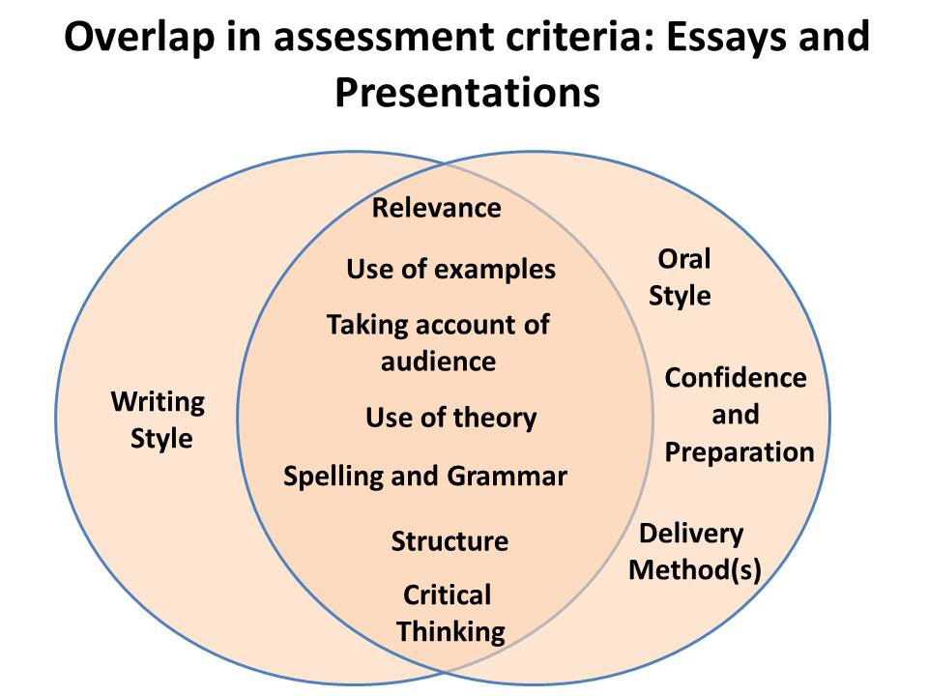
Figure: Overlap in assessment criteria between academic essays and academic presentations.
For the purposes here, we will give more insight into delivery methods and the impact(s) of different kinds of oral delivery. However, where there is overlap, an oral presentation can mean that the criteria are applied in a slightly different way –and sometimes with a little more flexibility – and so we shall briefly examine the areas where there is commonality first.
Table: Similarities and Differences between Academic Essays and Presentations
Criterion | Essay  You would probably be expected to… | Presentation  You would probably be expected to…
Demonstration of critical thinking skills | Provide evaluative and analytical information relation to theory and research | Provide evaluative and analytical information relation to theory and research  NO DIFFERENCE
Relevance | Ensure that all your content was relevant to the question being asked | Ensure that all your content was relevant to the question being asked  NO DIFFERENCE
Use of examples | Provide evidence and examples for the views you present | Provide evidence and examples for the views you present  NO DIFFERENCE
Support provided by citations and theory | Provide citations to theory and a bibliography for your work | Provide citations to theory and a bibliography for your work  NO DIFFERENCE
Grammar and spelling | Ensure that your grammar and spelling are good throughout your work  Use a spell checker | Ensure that your grammar and spelling are good throughout your work  Check your spelling  NO DIFFERENCE
Structure | Ensure that your work has a clear introduction (to interest and inspire the reader), middle and conclusion (which brings together the arguments well) | Ensure that your work has a clear introduction (to introduce yourself/ the group, which interests and inspire the listener), middle and conclusion (which brings together the arguments well)  SLIGHT DIFFERENCE
Taking account of the audience | Uses a register (language) and explains content in a succinct but easy manner | Uses a register (language) and explains content in a succinct but easy manner  Delivers using methods that shows an understanding of how the audience might react to the content given  DIFFERENCE IN APPLICATION OF CRITERION
Academic Style | Generally formal and impersonal | Generally formal and impersonal

