Doing Qualitative Research Online

Motivations to Elicit Data in Online Interviews
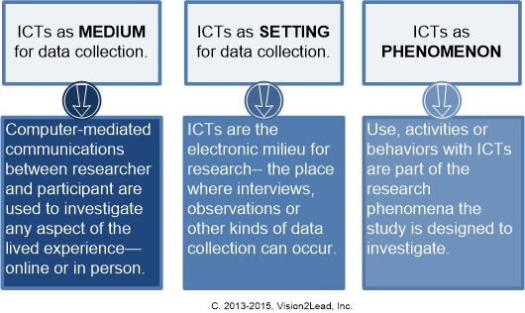
Why conduct interviews online? A question for careful thought is about the researcher’s motivations for collecting data through online interviews and the rationale for this choice in the context of the overall study. Two key questions are: (1) will the study use data collected through online interviews to investigate real-world, face-to-face phenomena? Or, (2) will the study use data collected through online interviews to investigate online phenomena or technology features?
For example, a researcher interested in ways people handle cancer diagnosis may conduct interviews online because it is convenient, and because it allows the researcher to collect data from participants anywhere. For this researcher, the phenomenon occurs offline, and technology is a medium and setting for communication.
Another researcher might be interested in ways people handle cancer diagnosis by participating in social networking communities with others in treatment. In this situation, the online technology is part of the research phenomenon, as well as a medium and setting for an interview.
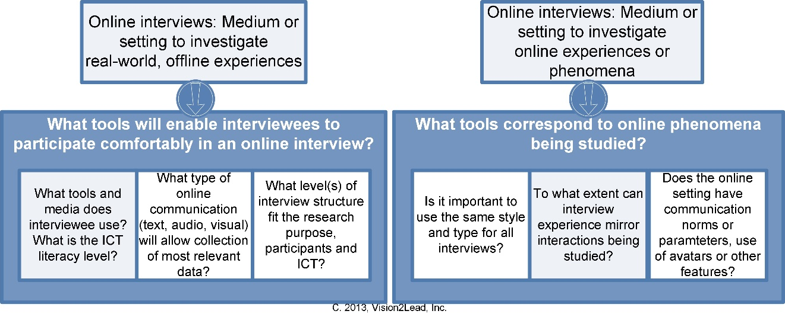
In the first case, the choice of communications technology may be deferred to the participants: what tools are available and comfortable for interviewees? If the study requires data collected in a certain way, it may be important to check for access and ICT literacy needed by participants. It may be necessary to meet the participant for a trial run in advance of the interviews. For example, if the researcher wants to generate visual data, the researcher may need to check whether the participant has a webcam, can use it, and is willing to appear on camera. Whatever ICT tool is used, we may need to make note of the desired visual data in the informed consent form.
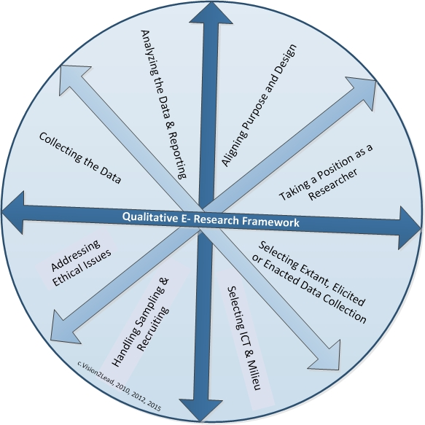
In the second case, the researcher plans to interact online with a research participant to investigate online behaviors, so may want to use the same Information and Communication Technology tools for the interview. This can simplify the process since a member of an online community or social media site would have the access, tools and skills needed to participate in an interview. If you want to use the online community, virtual world or other site as the place where the interview will occur, you will need to make sure that it is acceptable to the owner, moderator or the community members. Additionally, you will need to be sure that the interview dialogue will be private and free of interruptions, and that you can record the interview.
The Qualitative eResearch Framework (Salmons, 2016) is presented as a circle because choices made in one area create new considerations in other areas. As this overview shows, the researcher’s motivation to use data collected in online interviews has implications for ICT selection, timing, when a new tool must be introduced before the actual interview, as well as for items to include in the informed consent agreement. What are your design choices?

Salmons, J. (2016) Doing qualitative research online. London: Sage Publications.

