Doing Qualitative Research Online

Recording the Interview, Focus Group or Research Event

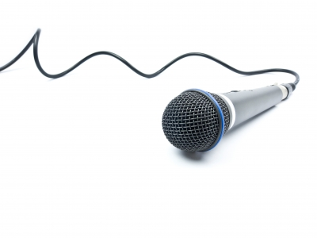
One of the benefits of online interviewing is the ability to easily record, save and archive the interaction for close viewing later. This frees the researcher to focus on questions and responses in the moment.

Before moving forward, make sure that you have answered two important questions: did the participant agree to be recorded and can you protect the data?

- Did the participant agree to be recorded and what restrictions did they place on its use?

Before you record audio or video of the interview, make sure that the participant understands what you are doing and why. Intentions for the recording and its use as data should be evident to the participant in the consent agreement.

Make sure that the participant has agreed to allow you to use visual images, since a participant who expects to be anonymous will not want identifiable pictures included in any documentation of the research. In such cases, the participant may agree to participate in a video call or videoconference with the agreement that the recording is for the researcher’s use only. You might want to add a statement in the Informed Consent agreement such as:

I grant permission for the research session to be recorded and saved for the purpose of review by the researcher. [If others, such as research supervisors, team members or assistants, will view the recording then note here.]
If you want to be able to use the recordings, you may want to offer participants a couple of options, such as:

Indicate your permission for audio or video clips or stills from the research session to be used in presentations or documentation of this study. Select your preferences below:
  - I grant permission for audio or video clips or stills from the interview session to be used in presentations or documentation of this study. Please indicate your preferences below.
  - I agree to allow audio and visual clips including images, video or still, in reports or presentations about this study.
  - I agree to allow audio clips only in reports or presentations about this study.
  - I do not permit the researcher to use images or audio from the interview.

- Can you protect the data?

Ethical researcher protect the data and to make sure it is only used for the purposes stated in the consent agreement. Researchers are required to destroy the data after a period of time, typically seven years.

A review of what Mann and Stewart (2000) call Principles of Fair Information Processing Online is relevant here:
- People should have access to the data collected about themselves;
- Personal data should be guarded against risks such as unauthorized access, modification or disclosure; and
- Personal data are not to be communicated externally without the consent of the subject who supplied the data.

When you look at products to use for recording online interviews, it is essential to assess the level of control afforded by the recording tools you want to use, in order to implement these principles:

- Can you allow participants to review the recording?
- Will you have the ability to restrict access to the recording?
- Can you be sure that no one else can forward, copy or share the recording?
- Will you be able to completely erase recorded files?

Practical Steps
Once you have determined the answers to the above issues, you are ready to look at more practical how-to steps for recording the interview.

Some free, trial or basic web meeting tools do not allow you to record or archive a recording. While you may be able to use another tool to record, keep in mind that the fewer tools being used, the fewer opportunities for error. Where possible, use the integrated recording capability – so choose a tool that includes such features. Follow guides or instructions for your selected product.

Some kinds of audio and video recordings can be imported into data analysis software, such as NVivo or Atlas.ti. If you are planning to use one of these tools, make sure that the format which your recording can produce will be accessible to your data analysis software.

