TRANSANA and Chapter 13 Interrogating data
Chapter 13 LINK from Chap 10 SX of Using Software in Qualitative Research discusses interrogation of data that can happen at varied levels and at many moments during analysis. Already in Chapter 6 we referred to Text search tools where the content is explored. Interrogation can also happen in terms of coding work you have previously achieved. You might wish to discover relationships between codes which co-occur in some way in the data or need to compare them across subsets of data (indicated by the application of variables or attributes to data). Types of queries vary from simple to complicated tasks; summarized, charted information where the results are already available in the background is available in some software. See all coloured illustrations (from the book) of software tasks and functions, numbered in chapter order. LINKTO

Sections included in the chapter:
Incremental and iterative nature of queries – Creating signposts for further queries – Identify patterns and relationships - Qualitative cross tabulations - Quality control, improving interpretive process – Tables and matrices – Charts and graphs

Interrogating the Dataset in Transana
by David K. Woods, Ph.D., Transana’s Lead Developer and Joseph H. Woods, Intern
13.1 Interrogating your Data

There are many ways to explore and interrogate your data in Transana. Many of these have been discussed in earlier chapters of the section of the web site discussing Transana. See Chapter 8 exercises, Basic Retrieval of Coded Data in Transana for an important discussion of ways of understanding your data. Exploring your Collection Structure, (Section 8.2,) including reviewing the Quote, Clip, and Snapshot information included in each Collection, is important. Quick Searches (Section 8.3) of the codes you’ve applied to Quotes, Clips, and Snapshots reveals additional information. Transana’s Reports, Maps, and Graphs (Sections 8.4, 8.5, and 8.3) discuss exploring your data based on Collections for one view of the data and based on Documents and Episodes for another, very different view. It’s important to recognize the critical role that the Filter Dialogs available in all of the Reports, Maps, and Graphs play in allowing you to explore your data in fine detail.

In the remainder of this chapter, we will discuss ways of interrogating your data set that go beyond using the tools already described.

13.2 Keyword Searches
As already discussed the term Keywords in Transana are often referred to as Codes in Using Software for Qualitative Research and at Table 12.4 (page 289), Phase Six of the organizational work on the Coca Cola case study is discussed. Organization is key to later interrogation. Table 13.3 (page 313) explores the questions that might be asked of this dataset, and the general processes of framing questions while making use of codes (keywords) that have been applied.
Quick Searchers (Section 6.3) allow you to explore the use of a single Keyword within your database. Transana also includes a more sophisticated Search Interface that allows you to create more complex queries into the use of coding in your data.

Suppose that we would like to find close-up shots of the actors in the 2013 Gardener commercial data. We can accomplish this with Transana’s Search functionality, which allows us to use Boolean search terms to construct queries for any coded data in the entire database.

We must first find our codes for all clips containing people — in our model, encapsulated by the Keywords ‘Gendered Techniques : Shots of women’ and ‘Gendered Techniques : Shots of workers’ — and allow for either of these Keywords to satisfy our search criteria. Additionally, Clips must contain the Keyword ‘Shot Type : Close-up’ and the Keyword ‘Source Ad : 2013 Gardener Coca Cola Commercial’. To initiate the search for this, we right-click the Search node and select “Search” from the popup menu to get Transana’s Search Interface.

The first thing you should always do when you open the Search Dialog is to name your search. When you are exploring your data, it is common to do a number of searches in a single session, and it can become difficult to remember which results are associated with which search if you don’t provide yourself with a sufficient search name.

The second thing you should do is to select the type of data items you want to include in your search results. By default, Transana includes Quotes, Clips and Snapshots while excluding the source data types of Documents and Episodes. That’s usually correct, but in this case, let’s limit our search results to Clips only.

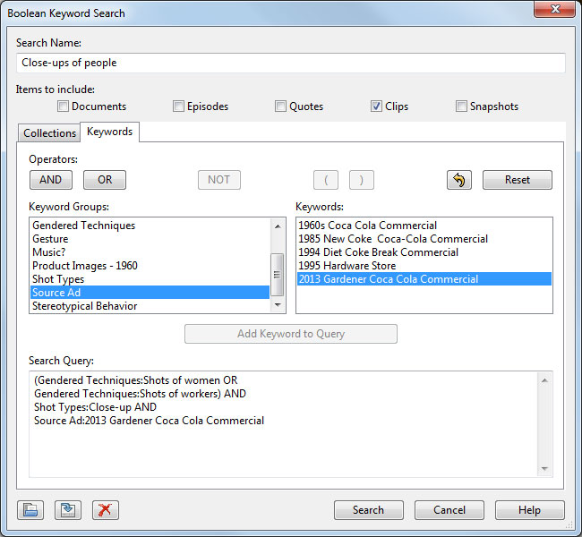

If we wanted to limit the scope of our search to only some of our Collections, we would next click on the Collections tab in the Search interface to select which Collections we want to include in or exclude from our search. In this case, our data set is small enough that we don’t need to worry about this, so we can safely ignore the Collections tab.

Finally, we go to the Keywords tab and use the search specification controls provided in the search interface to build our Search Query.

To build this query, first, open a set of parentheses and select the first Keyword, ‘Gendered Techniques : Shots of women’, from the list of Keyword Groups and Keywords. (Click the Keyword Group in the left panel to get a list of Keywords in that group on the right.) Then press the ‘Add Keyword to Query’ button. Then press the OR button, select and add the other Keyword, ‘Gendered Techniques : Shots of workers’, and close you parentheses. Then, since we would like to include only those shots of women or workers that are close-up footage, press the AND button and select the ‘Close-up’ Keyword from the ‘Shot Types’ Keyword Group. Finally, add another AND, and select the “Source Ad : 2013 Gardener Coca Cola Commercial” Keyword to limit our search to results from only the desired commercial.

It is important to construct your search queries carefully. For example, omitting the parentheses from this search would cause it to give all clips, from any image or media file, with the Keyword ‘Gendered Techniques : Shots of women’, along with data objects with both the Keywords ‘Gendered Techniques : Shots of workers’ and ‘Shot Types : Close-up’ from our Gardener ad, because AND operators are carried out before OR operators, all things being equal. It is generally a good idea to use parentheses liberally to ensure that your searches are being carried out precisely as you want them to be. Please see the ScreenCasts related to Searches on the Transana web site for additional details that are beyond the scope of this web site.

Transana’s Search interface is very carefully designed to prevent illegal searches from being conducted. If the Search button on the Search Dialog is not enabled, you can be sure it is because the search you are trying to specify is somehow improper. Missing parentheses and trailing Boolean operators are the most common causes of invalid search specifications.

You may label and save a search to reload later by using the buttons in the bottom left corner of the Boolean Search window. It is often helpful to be able to repeat a search as you add data to your database, code data files for new information, or make other changes.

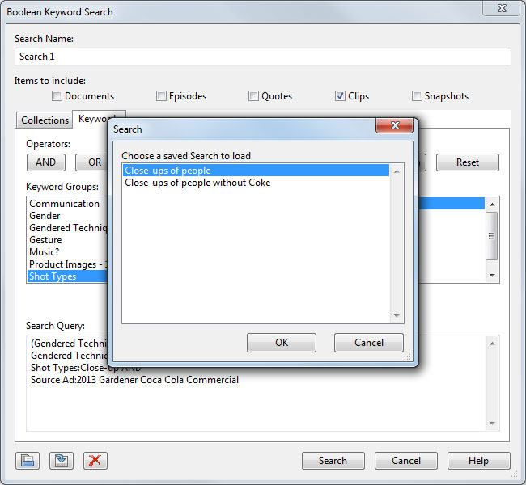

Transana returns the results of the Search operation in the form of a tree structure under the main Search node in the Database Tree. As described in the Quick Searches section (6.3), a Search Result acts very much like a Collection, allowing you to explore and manipulate the data returned by the Search in a variety of ways as you try to decide whether the search has returned meaningful information. Manipulating the Search Result in the database tree does not affect the underlying data in Transana, although loading Quotes, Clips, and Snapshots and manipulating them can.

We might want to compare these search results with another similar search. If we wished to omit shots of people consuming Coke products from these Clips, we could use the following Boolean operation to do so. Simply add an AND NOT operator, followed by the Keyword you’d like to leave out, in this case ‘Product present’ under ‘Shot Types’.

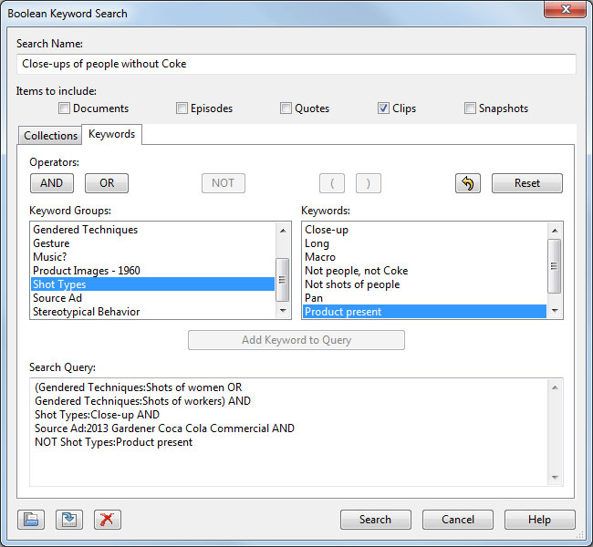

Further information on creating queries in Transana is available in Transana’s Manual and in the Transana ScreenCasts.

Our comparison between these sets of search results can occur in several ways. One of these is to simply compare results in the Search portion of the Database window. Right-clicking the search output offers a report in the form of the Search Collection Results. This functions identically to using a Collection Report.

Should you want to save the results of a Search for future Transana sessions, you can create a Collection out of a Search result by right-clicking the Search title and selecting the ‘Convert to Collection’ menu item. Note that this will duplicate all Quotes, Clips, and Snapshots in your search results.

13.3 Mixed Methods Analysis of Data in Transana

Transana is software for the qualitative analysis of text, still image, and media data and does not do any quantitative analysis. Although Transana’s Reports provide information about coding usage in the form of counts and total time covered by codes, but counting is not quantitative analysis.

That being said, Transana can provide data that can be used in the quantitative portion of mixed methods analyses. Data file creation is handled by Transana’s “Analytic Data Export” function, which can be generated with a variety of different scopes.

- Analytic Data Export for a Library provides information about all Quotes and Clips created from all Documents and Episodes in the selected Library.
- Analytic Data Export for a Document provides information about all Quotes created from the selected Document.
- Analytic Data Export for an Episode provides information about all Clips created from the selected Episode.
- Analytic Data Export for the root Collections node provides information about all Quotes and Clips contained in all Collections in the database. This is how you export ALL of your data for mixed methods analysis.
- Analytic Data Export for a Collection provides information about all Quotes and Clips contained in the specified Collection, and, optionally, all nested Collections contained therein.

The file created by Analytic Data Export includes information such as the Data Item Name and type, Collection information, source file name, start, stop, and length, and information about coding assigned to each Quote or Clip. The data is placed in a tab-delimited text file that can be loaded into SPSS, Excel, and a variety of other software packages for analysis.

Thus, Transana can be a data provider for mixed methods analysis, but all such analysis needs to be performed outside of Transana by other software.

