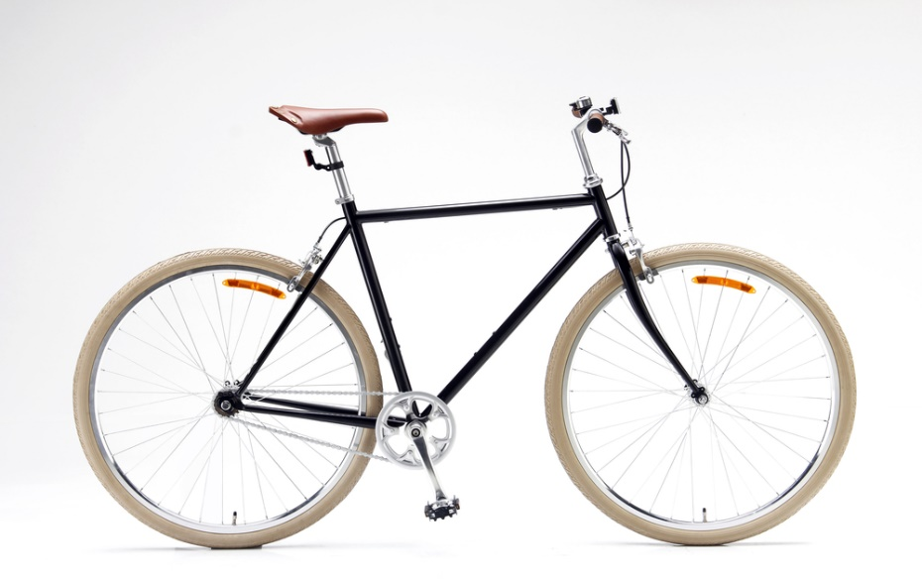  This bike belongs to a boy aged 14  Statements in envelope:  - His mum remarried last year and he doesn’t like his step-father  - He has asthma  - He is unsure of his sexual identity  - A friend at school is encouraging him to try illegal drugs  - His biological father lives abroad and he sees him once a year | 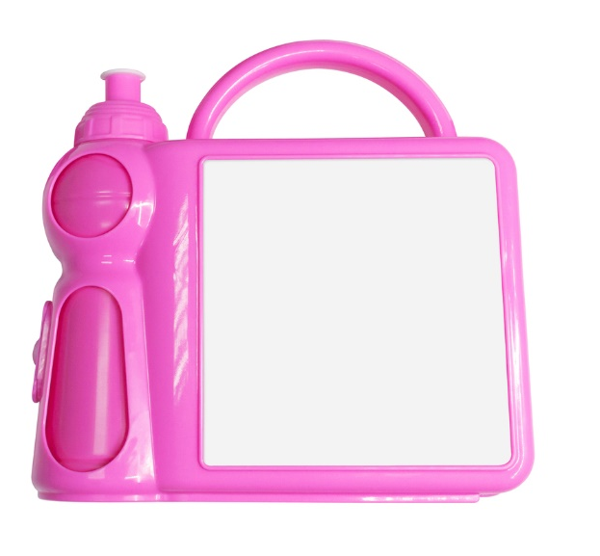  This lunchbox belongs to a girl aged 6  Statements in envelope:  - The box always contains jam sandwiches  - She shares a bed with her three-year-old brother so is often tired  - Her brother is autistic  - She has just learnt to read  - Her mum bought the box in a charity shop
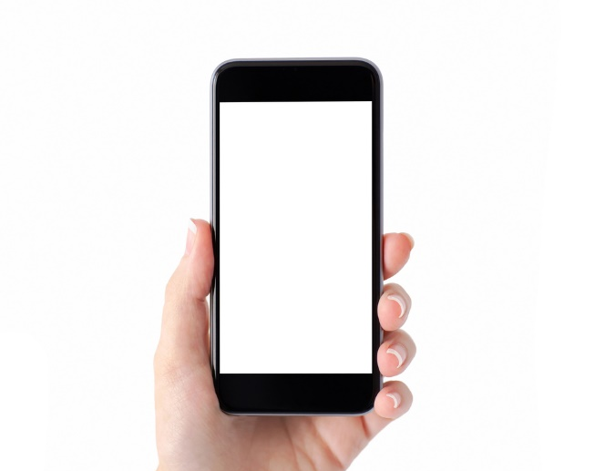  This phone belongs to a girl aged 16  Statements in envelope:  - She is a carer for her mum who has multiple sclerosis  - No-one at school knows she has a disabled parent  - She loves to dance  - She can speak three languages  - She spent two years in a refugee camp | 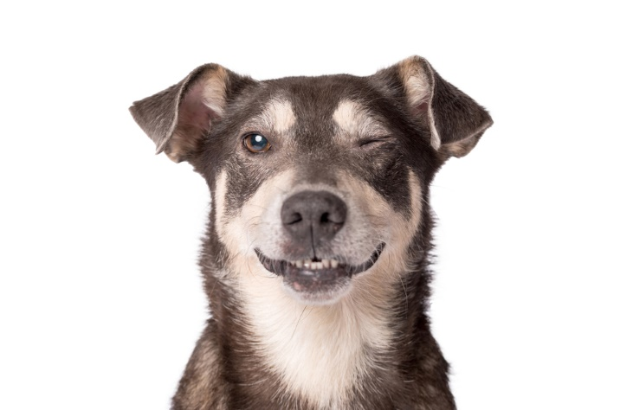  This dog belongs to a boy aged 11  Statements in envelope:  - He found the dog on the street two years ago  - His family won’t let the dog into the house  - Both his parents work long hours  - He is an only child  - He walks other people’s dogs before school to get money to buy dog food

Figure 10.1 Who do we think we are?
Photocopiable: Circle Solutions for Student Wellbeing 3e Sue Roffey, 2020 (SAGE)

