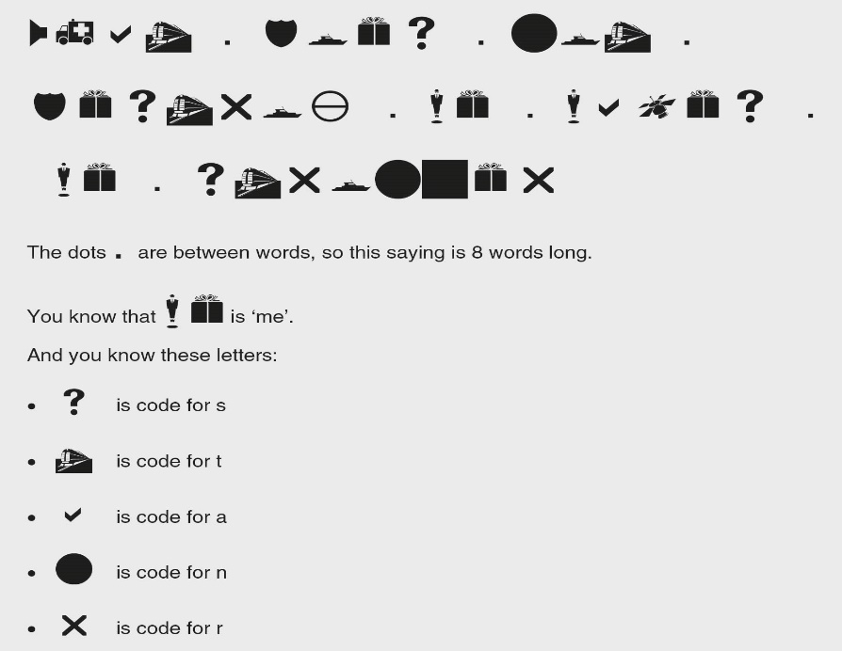

Figure 10.2 Coded sentence
Photocopiable: Circle Solutions for Student Wellbeing 3e Sue Roffey, 2020 (SAGE)

