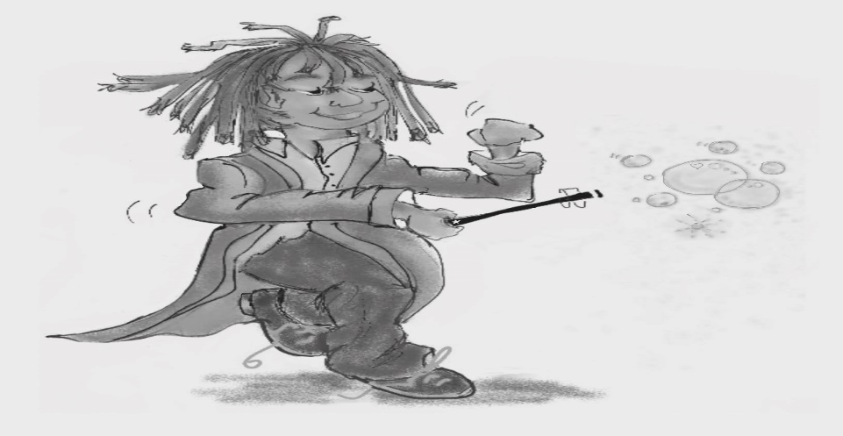
Mindfulness Magician stops us worrying too much about what happened in the past and what might happen in the future. He puts a bubble around the moment you are in and helps you savour the good things. This can help you feel calm and peaceful.

Figure 11.11 Mindfulness Magician
Photocopiable: Circle Solutions for Student Wellbeing 3e Sue Roffey, 2020 (SAGE)

