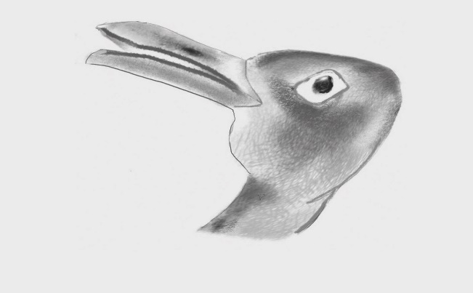

Figure 11.1 Duck rabbit
Photocopiable: Circle Solutions for Student Wellbeing 3e Sue Roffey, 2020 (SAGE)

